CM2307 Deferral Coursework

Key Items:
Student Number (mandatory): | C24062219 | Note: Do not write your name anywhere in the document.
Link to Git (git.cardiff.ac.uk) Repo (mandatory): |  | Note: Ensure all necessary files are made available and committed to the repository and relevant people have been provided access.
Access to Git Repo has been provided to the teaching and marking team? (mandatory): | Yes / No | Note: If the access is not provided, zero (0) marks will be awarded for the component.
Link to Panopto Recording (mandatory): |  | Note: Ensure that the demo is clear and showcases the specific functional requirements chosen by you for the application. Ensure relevant people have been provided access to view the recording.
Access to Panopto Recording has been given to the teaching and marking team? (mandatory): | Yes / No | Note: If the access is not provided, zero (0) marks will be awarded for the component.

I declare that I have used Generative AI software to support me in producing parts of this work. I have used Gen AI in line with the usage defined by the assessment guidance and have maintained academic integrity throughout my work. I have rewritten any Gen AI content in my own words and validated it through using reliable independent sources.
I understand that declaring the use of GenAI tools will not lead to a lower mark, provided that my use is in accordance with the assessment guidelines and I maintain academic integrity.

All AI chats and general usage have been declared in a folder called
“inf. AI Chats for Declaration” in the provided GitHub repository.
You may request further Information if required.

It is my responsibility to retain copies of all GenAI prompts and outputs after submission in case of any concerns over academic misconduct, as I may be asked to produce these as evidence of how I’ve used Gen AI as part of any investigation into academic misconduct.
I have also tracked all of my progress and work throughout, using Git Trees.

ASSUMPTIONS FILE

- I assume that the Test Files (used purely for demonstration purposes) can be generated with AI (all chats provided) due to the fact that I am using Artificial Intelligence as a tool to save time. I would not have otherwise wasted time making them and it is not affecting my learning of the subject in any meaningful way.
- I have taken the liberty of using some home-made tools to help me optimise this assessment before publishing it. This is after the recommendation from my Sr. Personal Tutor DR. LANGBEIN. Please ignore any remanences of code used for this optimisation process.
- I assume, although git.cardiff.ac.uk is suggested, that GitHub is perfectly permissible and that the use of GitHub over GitLab won’t affect my grades, as access has still been provided as requested to the specified emails in the requirements folder. “If the code is not provided in git.cardiff.ac.uk as mentioned above and/or proper access is not provided to the marking team, it will not be marked and the component associated with the code will be awarded ZERO (0).”
- I assume, that if a corruption on Learning Central were to occur, and that there is sufficient evidence that this is NOT my fault, that a re-upload of my submission be requested at no cost to my grade (this happens more often than you expect). I also assume that meta-data and Git Repo History may be used to prove I haven’t touched the files since the first submission date.
- I assume, that although I AM using the provided template, I am allowed to edit it according to my tastes, and make it look like my other submissions without it costing 10% of my grade.

System Design
  - Some exports of “Use Case”, “Class” & “Sequence” diagrams from the improved implementation of the StudentJobPortal.

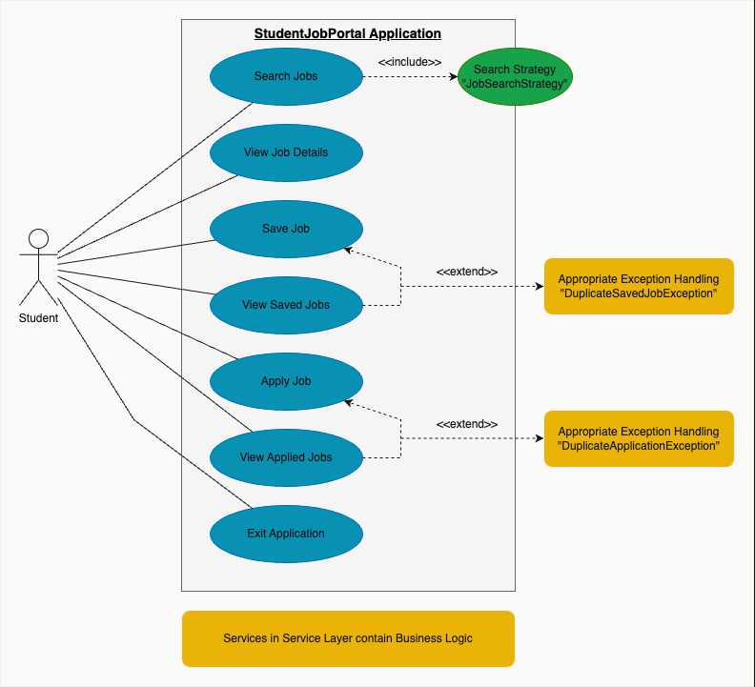
Export of “Use Case Diagram” from Draw.io MacOS taken the 12th Aug 2026.

next page >>
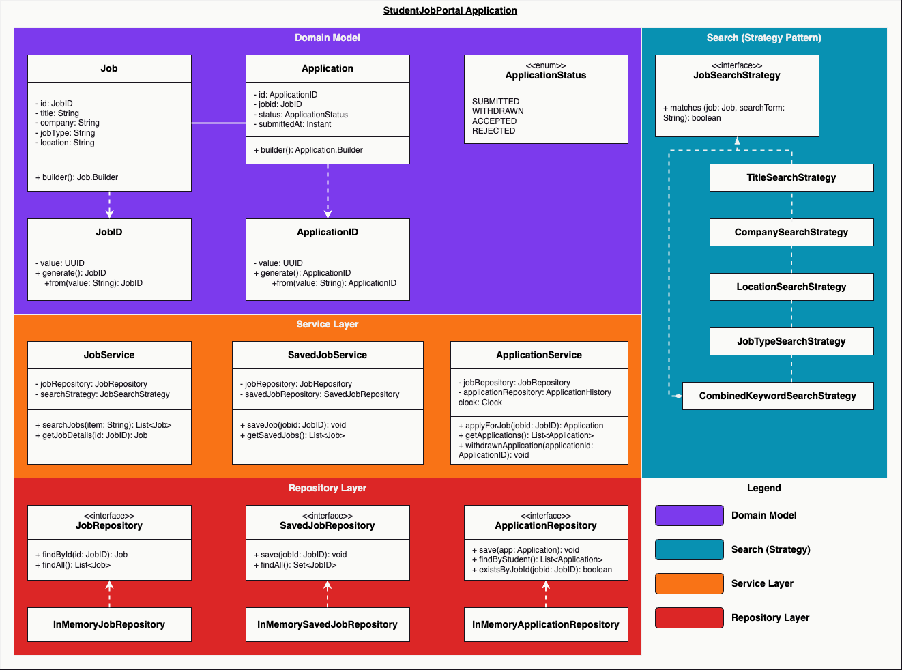
Export of “Class Diagram” from Draw.io MacOS taken the 12th Aug 2026.

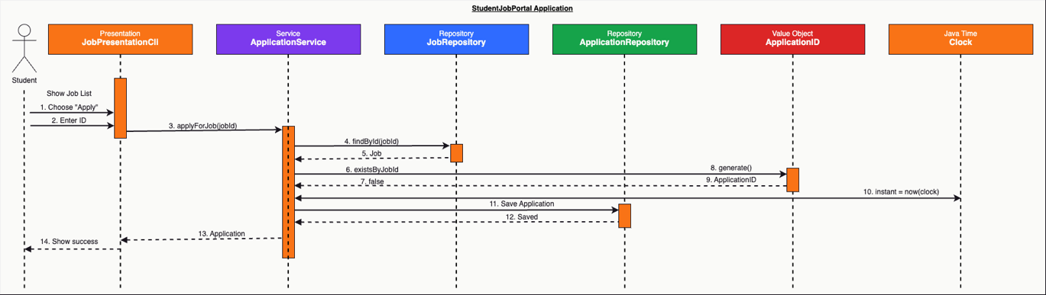
Export of “Sequence Diagram” from Draw.io MacOS taken the 12th Aug 2026.

next page >>

Evidence and Evaluation

Part 1: (max of 1500 words)
Using evidence, evaluate how you have applied correct Object-oriented design principles in your refactoring by comparing it to the principles that were broken in the original code. Provide a clear explanation of which design patterns were implemented, why they are appropriate and how they improve the design of your refactored system.

The improved implementation of the student job portal manages to use object oriented (O.O.) principles to render the program more maintain-able, extend-able and test-able. It does this thanks to encapsulation, abstraction and polymorphism supported by several design patterns like immutability, value objects (UUIDs), composition, dependency injection and many more.

In the original application (seen to the right in this instance), the entire system was comprised in one file: “StudentJobPortal.java” inside its main() method. Generally, having more than 1 responsibility inside a file makes things complicated, maintenance heavy, hard to test and very difficult to improve upon in future iterations.
On top of that, job information is represented in the form of 5 separate mutable static lists, which is generally not good practice, because the program is expecting very specific information, and if that information isn’t filled out as it’s expected (for some reason) this could cause errors, or worst-case scenario, crashes further down the line.

This is known as “breaking encapsulation”, because there is no “Job” object responsible for protecting and validating the state belonging to a single job; instead, a job only exists through matching indexes across several different lists.
For example, in this instance: jobTitles.get(i), companies.get(i), jobTypes.get(i) etc…

If a programming error occurs that adds an element to one of the lists, it would place the system in to an “error / inconsistent state”.

The updated version of the program addresses this by introducing an immutable domain class, and a job is now represented using the following;

Extract from “src/main/java/com/studentjobportal/model/Job.java” on the 13th Aug 2026.

This on the other hand, does demonstrate encapsulation, because first of all; the internal state is private which means it can’t be modified, it can only be read using controlled “accessor methods” such as getTitle() to get the job title.
This also demonstrates immutability, because fields are marked as “final”, which means the classes expose no setters, and a valid job can’t be changed unexpectedly by another part of the application. Their construction is controlled through the Job.Builder(), which validates identifiers and text fields before allowing a “job” to be made thanks to its “build()” method.

This moves me swiftly to my implementation of the Gang of Four (G.o.F.) Builder Creational Pattern. It’s appropriate here because the object in question (a job) contains several related properties and validation rules. This prevents us from having a multitude of indexed lists to create a single job and makes construction much clearer.

The same approach is used in model/Application.java where Application is also immutable and created using the Application.Builder.

Part 2: (max of 1000 words)
With evidence, justify the improved design of data structures and algorithm in the Object-oriented context with reference to time complexity, comparing the original and refactored approaches using appropriate Big-O notation.

