**FOR WEI JIE or idk**

To dump the initial files inside since the version you gave me might be a bit old

Do a Git Clone using : <https://github.com/Marcus-tlj/GDP_Project.git>

After that navigate to that file in ur pc

For me its C:\Users\JustA\Documents\GitHub\GDP_Project

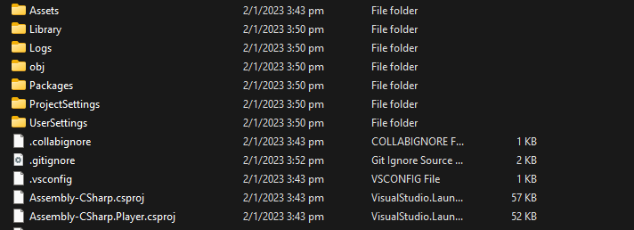

Dump all of these inside the folder

Then in Github Desktop

Press commit to main

Main is a local branch and is basically the version thats on your pc

Next it will prompt you to commit to origin , origin is the master copy of the file and is what everyone will get if they fetch origin etc

**Fetching Origin**

If your feature depends on something that was recently changed or something, you are gonna want to sync your file to the latest version.

Jus press this