IENG6923

Distribution Management

PROJECT

on

Labor Scheduling for WTP Construction Site

by

Kaushal Bharatkumar Prajapati

B00945730

Under the guidance of

J. PEMBERTON CYRUS

Associate Professor

Industrial Engineering Department



Dalhousie University

**TABLE OF CONTENTS**

|  |  |  |
| --- | --- | --- |
| Topics | | Page no. |
| 1. | ABSTRACT…………………………………………………………... | 3. |
| 2. | INTRODUCTION……………………………………………………. |  |
| 3. | PROBLEM DESCRIPTION.…………………………………………. |  |
| 4. | LITERATURE REVIEW...…...……………………………………. |  |
| 5. | FORMULATION OF THE PROBLEM……………………………… |  |
| 6. | METHODOLOGY…….……………………………………………… |  |
| 7. | SOLUTION……………………………………………………………. |  |
| 8. | EXPERIMENTS………………………………………………………. |  |
| 9. | CONCLUSTION AND FUTURE SCOPE……………………………. |  |
| 10. | REFERENCES………………………………………………………… |  |

**TABLE OF FIGURES**

|  |  |  |
| --- | --- | --- |
| Topics | | Page no. |
| Fig 1. |  |  |
| Fig 2. |  |  |
| Fig 3. |  |  |
| Fig 4. |  |  |
| Fig 5. |  |  |
| Fig 6. |  |  |
| Fig 7. |  |  |
| Fig 8. |  |  |
| Fig 9. |  |  |
| Fig 10. |  |  |
| Fig 11. |  |  |

**1. ABSTRACT**

The labour scheduling problem is a critical issue encountered by various organizations worldwide. It requires the optimal allocation of human resources to satisfy operational needs while taking into account factors such as availability, skill requirements, personnel assignments, scheduling limitations and cost restrictions. In this project, I have gone through the major goals of labour scheduling, such as optimizing labour utilization, lowering costs, guaranteeing happiness, and adhering to legal and contractual requirements. This project includes scheduling the required number of daily wage labourers for a WTP (Water Effluent Treatment Plant) construction site over a period of 2 years approximately, while taking into consideration enough constraints, thus minimizing total labour overhead(cost). In conclusion, I optimized labour utilization, increase operational efficiency, while adopting to my formulated mathematical models of optimization, which resulted in better performance and success overall for the construction project. I also employed OpenSolver on the formulated models in Excel to get a feasible and optimal solution for which I made use of the Gurobi Solver engine; a little bit of python programming was also required for this Assignment Problem.

**2. INTRODUCTION:**

The construction of a Water Effluent Treatment Plant is a challenging project that calls for careful planning, coordination, and resource management. One of these essential resources i.e., effective labour management, assures the highest standards of quality and safety throughout construction as well as the timely completion of the project. Here I aimed to maximize productivity, reduce delays, and improve the project's overall efficiency by thoroughly addressing the management of available labourers. This project aims to offer useful insights into labour management strategies that can be used to optimize resource utilization, mitigate risks, and complete project milestones within the specified time and budget constraints through the analysis of industry best practices, case studies, and pertinent research. For this project, I have classified the construction activities into two categories running simultaneously: 1) Site Execution activities (Excavation and pipe-laying for the water intake and delivery system, Construction of structures at the WTP plant site, Construction of intake pump house, construction of OHT (Overhead Tanks), 2) Warehouse activities (loading unloading of pipe, fittings, pumps and valves supply).

**2.1 DATA EXPLANATION:**

I have divided the whole construction project, approximately 2 years of length, into three phases based on the labour requirements i.e., 1) Procurement Phase (6 months), 2) High Mobilization Phase (16 months) and 3) De-mobilization Phase (2 months). Procurement Phase is the beginning phase of the project which mainly includes activities corresponding to warehouse like unloading of pipes and fittings supply, pump and valve supply, etc., coming to the warehouse from different vendors and loading them on the trucks to supply them to the sites where needed. In-addition, there will be few construction-works like excavation works for pipe-laying and some components of the WTP starting at the site as well. Thus, during the procurement period major requirement of labourers will be at the warehouse more than that of the construction site. During the second phase, a large amount of construction work will start on the site needing a greater number of labourers as the construction work will be at its peak and thus the name ‘High-mobilization’ phase. And the last phase is the end phase of the project in which small activities like commissioning, QA, relocating the remaining from site to the new site, etc., are involved. Hence, the labour requirement for that will be the lowest of all three phases and the company will be relocating the labourers from that site to a new site, hence ‘De-mobilization’ phase. Additionally, I have considered two categories of labourers -Skilled and Unskilled. Skilled have the skills to do electric works and supervising the sites. And, I have considered 18 CAD and 22 CAD as hourly wages for Un-skilled and Skilled construction labourers respectively as per today’s labour market rules [9]. Besides this, I have taken 1 shift to be 8 hours long. Activities involved throughout the construction project are mentioned below with the labour requirements as well:



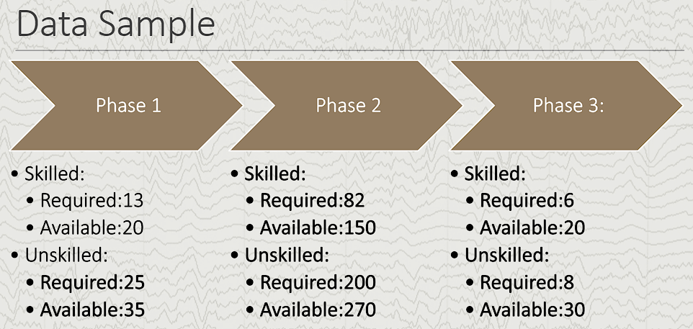

**3. PROBLEM DESCRIPTION:**

**Objective/Value proposition:** Reduction in labor cost can increase productivity and/or it can compensate against increasing transportation costs.[1] Sub-optimal scheduling increases an industry’s tangible costs, not only through the consumption of a manager's time but also through over-allocation (Loss due to over-labor cost) and under-allocation of employees (Loss due to bad service).Thus, During different phases of the construction work, the labour requirements will differ and how ***to get the best utilization out of the available men hours to maximize the productivity and minimize the fraction overhead of construction project’s total cost value allocated to labour management without hindering any regulations and adhering to every constraint***, is the basic aim of this project. Another objective is to provide a fair schedule in such a way that every workman would get enough working hours per week.

**Subjected to:**

* Daily minimum worker requirement per activity.​
* Phase-wise worker availability.
* Binary assignment constraint​
* Skill requirements​.
* Maximum six days work stretch.​
* 1 day off per week​.
* 1 weekend (Sunday or Saturday) off per week​.
* At-least one shift per week.

**4. LITERATURE REVIEW**

It's true that the staff scheduling issue has drawn a lot of interest from academics and researchers. The assignment of personnel to shifts, jobs, or projects while taking various limitations and goals into account is the focus of this subject. Factors including staff availability, skill sets, labour rules, task balancing, and cost optimization contribute to the complexity of this issue.

The people scheduling problem has been approached from many different angles by academics, from conventional optimization techniques to more contemporary machine learning and artificial intelligence techniques. The following common methods and strategies have been researched:

1. *Integer programming and linear programming*: To develop and resolve personnel scheduling issues, mathematical optimization techniques like integer programming and linear programming are frequently applied. These techniques seek to achieve goals and restrictions while determining the best employee shift assignments.

2. *Heuristic Algorithms*: Because many real-world scheduling issues are computationally complicated, heuristic algorithms are frequently used to quickly identify approximations of solutions. Heuristics used for staff scheduling include tabu search, simulated annealing, and genetic algorithms.

3. *Constraint programming*: In constraint programming, the constraints of the scheduling issue are specified declaratively, and constraint solvers are used to locate workable solutions. Complex restrictions and dependencies can be properly managed using this strategy.

4. *Local Search and Metaheuristics*: A number of local search techniques, including iterated local search and hill climbing, as well as metaheuristic algorithms, including ant colony optimization and particle swarm optimization, have been tailored for personnel scheduling issues.

5. *Machine Learning and Artificial Intelligence*: With the development of machine learning and artificial intelligence, researchers have looked at the application of these methods for staff scheduling. Deep learning, reinforcement learning, and neural networks may all be used in this process to simulate complicated scheduling patterns and come to wise judgements.

6. *Multi-Objective Optimization*: A lot of scheduling issues for employees entail balancing competing goals, such reducing labour costs while enhancing employee happiness. Finding a collection of solutions that balance multiple objectives is the goal of multi-objective optimization techniques.

7. *Real-Time and Dynamic Scheduling*: Some studies concentrate on real-time and dynamic scheduling, where plans must be modified as fresh information becomes available or unanticipated occurrences take place.

8. *Software and Tools*: To address certain staff scheduling issues, researchers have created software platforms and tools. For practical usage, these technologies frequently combine several algorithms and optimization strategies. Examples: 7shifts, Agendrix, MakeShift, Wrike, etc. [10]

It's important to note that the personnel scheduling problem can vary greatly depending on the specific context and industry. Whether it's healthcare, transportation, retail, or manufacturing, each domain presents its own unique challenges and constraints.The employee personnel scheduling problem was an interesting subject which motivated me to explore academic databases, journals, and conference proceedings related to operations research, scheduling theory, and optimization, some of them are briefed below:

**Kasirzadeh et. al**. [3] Based on a set of anonymous pairings, they have focused on the personalized monthly assignment problem for a fixed number of pilots. They believed that the airline offers for two kinds of preferences: vacations and preferred flights. They utilized the sequential strategy. The definition of the problem is stated below:(for notations refer to [3])

Objective: Minimizing the cost of schedule and the cost of not covering flight (preferences).



Subject to:

1. Constraint to ensure each pairing is covered exactly once. (Simple assignment)



1. Constraint on a minimum number of preferred flights.



1. Constraint on a minimum number of satisfied vacation preferences.



1. Constraint to ensure assignment of at most one schedule to each pilot.



1. Integrality constraint.



**Jumard, et. al.** [4] proposed a 0 - 1 mixed-integer linear programmed (MIP) master problem to tackle the nurse tour scheduling problem. They used a diverse workforce that was based on nursing specializations or talents, overlapping shifts, and nurse preferences. The master problem featured a set of possible planning horizon adjustments that met all of the criteria. The master problem's purpose was to match nurses with each shift schedule. The master issue also included limitations such as a minimum number of nurses with skill level l planned at any one moment and a ratio of less experienced to more experienced nurses. To solve the master issue and maximize the nurses' preferences, a branch and bound strategy was used.

**Love and Hoey [5]** defined a mixed-integer linear program (MILP) for shiftscheduling and tour-scheduling for a fast-food restaurant. They showed that a tour-scheduling problem canbe solved with a minimum cost network flow. Their objectives were (1) Satisfy half-hourly personnel requirements with a minimum of surplus scheduled hours. (2) Give each employee the same number of workdays and work hours, with marginal workdays given to employees with better skill ratings. (3) Assign employees to work areas where they perform best. (4) Schedule each employee during his or her preferred work times as much as possible. The entry of employee availability data was accomplished using a seven-day half-hour matrix structure with free-form cursor movement and a single letter designator for the availability status. The system produced schedules that would require very little manual adjustment; excessive adjustment would defeat the purpose of computerization.

**Easton and Rossin** [7] examine the issue of staffing at a minimum cost while providing acceptable levels of service and employee satisfaction. The scheduling of a mixed workforce with an even distribution of over-staffing yielded consistent customer and employee satisfaction levels. Over-staffing provides higher customer satisfaction with better and more consistent service and higher employee satisfaction with the availability of more flexible work hours. They propose that in the service industry staffing at a minimum cost is not as important a factor as customer and employee satisfaction**.** The maintenance of high satisfaction levels retains customers and minimizes employee turnover.

**Mohan [6]** studied a workforce scheduling problem consisting of part-time workers who had availabilities, preferences for the shifts, maximum and minimum allowable working hours in a day and a week, and seniority levels. They modeled the problem as an integer program in which the objective was to maximize employee satisfaction while considering their seniority and availability and to meet the demand requirements for each shift. The part-time employee scheduling model was solved using standardenumeration schemes available in commercial solvers like CPLEX.

**Van Den Berg Y and Panton DM** [2] analyzed the existing condition and network models for the final stage of employee scheduling problem i.e. shift assignment to days worked in the schedule. Results generated for a number of test problems demonstrated, first, that the networkdevised to search for continuous solutions produces these solutions in a high proportion of cases wheresuch solutions are known to exist. Second, for more general problems, the algorithm was shown to be efficientin its ability to generate either continuous or rotating solutions.

**Emmons and Burns days-off Scheduling** [8] is concerned with an employee scheduling problem including various shifts and work centers, in which employees are classified into a hierarchy with downward substitutability. A higher-level employee may execute the tasks of a lower-level employee, but not vice versa. A higher category employee, on the other hand, is paid more than a lower category employee. The demand for each category at a specific work center during a given shift is fixed throughout the week and may change on weekends. Two goals must be met: the first is to find the lowest-cost workforce mix of employee categories required to meet specified demand requirements, and the second is to assign the selected employees to shifts and work centers based on their preferences for shifts, work centers, and off-days. A mixed-integer programming model is first built for the issue, and then a specialized scheduling heuristic is developed for it. Computational studies show that the suggested heuristic finds solutions that are within 92-99% of optimality for a variety of genuine test cases.

From this thorough literature review, I realized that there is a need for days-off scheduling along-with weekend-off scheduling in my problem since the personals are assigned to the job over a period of 28 days (i.e., 4 weeks) and follow continuing the pattern of rotation till the rest of the phase. After getting the output from days-off scheduling model, I would then have to schedule each employee based on an assignment problem using Big M for penalties.

**5. FORMULATION OF THE PROBLEM**

*Indices used*: i, j and k.

*Sets used*: Xij, Yij, Eij, Gi, Hij, Cij, aj, bj and Fij.

*Nomenclature*: n 🡪number of unskilled labourers available per day per phase.

m 🡪number of skilled labourers available per day per phase.

n+m 🡪number of total labourers available per day per phase

d 🡪number of days involved in a shift rotation. (i.e., 28 in this case for 4 weeks).

aj 🡪number of minimum unskilled labourers required per day per phase.

bj 🡪number of minimum skilled labourers required per day per phase.

**5.1Model 1 formulation:** (based on Emmons and Burns days-off scheduling model)

**Objective function:** To reduce the minimum number of days-off that can be given to each labourer for a shift rotation of d days per phase.

Minimize Z1 =; where d = 28; n = 35(Phase 1), 270(Phase 2), 30(Phase 3)

; m=20(Phase 1), 150(Phase 2), 20(Phase 3)

**Subjected to:**

1. is binary (ϵ {0,1})

= 0; for schedulable days.

= 1; for days off.

1. Minimum number of un-skilled labourers required per day per phase:

; where =25(Phase 1), 200(Phase 2), 8(Phase 3)

1. Minimum number of skilled labourers required per day per phase:

; where = 13(Phase 1), 82(Phase 2), 6(Phase 3)

1. Maximum available un-skilled labourers per day per phase:

[i.e.,]

1. Maximum available skilled labourers per day per phase:

[i.e., ]

1. Weekends off: at-least one weekend off (either Sunday or Saturday):

 = +++++++

.

1. At-least one day off per week:

 ; ; ; 

; where k = 1 to 4.

1. Maximum six days work stretch:

;;;;;;;;;;;;;;;;;;;;;;;;;;;

.

**5.2 Model 2 formulation:** (Assignment Problem to find the allocations of daily shifts)

**Objective function:** To optimize the total labour overhead per phase of our construction project.

Minimize Z2 =; where is the cost matrix obtained by modifying the output of Model 1 i.e.,.

**Subjected to:**

1. is binary (ϵ {0,1})

= 0; if worker is not working.

= 1; if worker is working.

1. Minimum requirement for skilled and un-skilled per day per phase:

; .

1. At-least one shift per labourer in a week:

;;;;

.

1. Availability Constraints: This can be taken care by cost matrix itself.

= 10000 for the day-offs and worker’s unavailability.

= 144 CAD (i.e., 8hours per day * 18 CAD per hour) for un-skilled labourers.

= 176 CAD (i.e., 8hours per day * 22 CAD per hour) for skilled labourers.

**6.** **METHODOLOGY**

To begin with, I decided to formulate two models, one for days-off scheduling and the other for using the output of model 1 to produce a perfectly feasible day wise schedule for 4 weeks (i.e.,28 days) rotation for every available labourers for that particular phase. This 4-week schedule will be rotated for the rest of the phase. Both the models were created in Excel and by using Gurobi solver engine in Open-solver, initial solution was reached. Objective function and Constraints were established according to the algebraic model shown in 5.1 and 5.2. Later on, by adding or editing certain constraints or even by making some changes in the given data experiments were conducted to end up with a feasible and practically useful solution. Given below are some screenshots of models formulated in Excel along with the constraints; similar models were created for all three phases (please refer the excel file uploaded).

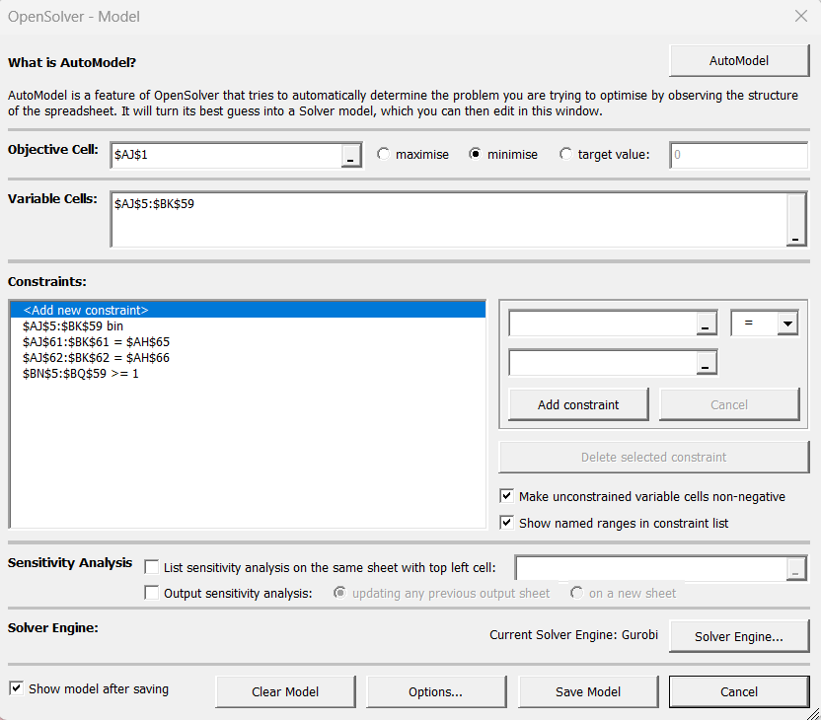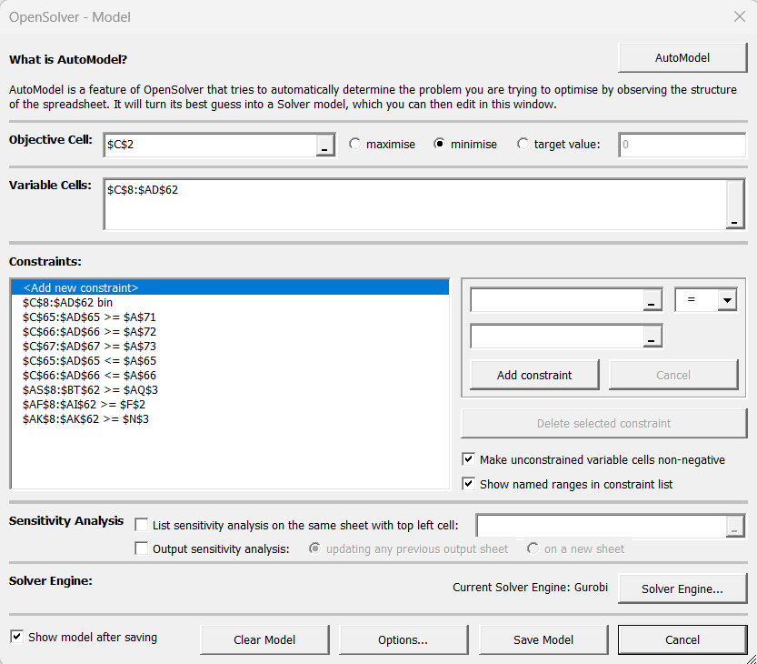

Model 1 Model 2

**7. SOLUTION:**

*Phase 1(Model 1):* Below figure shows the solution of Model 1( ). Here, 1 day that are non-schedulable while 0 means the free to schedule shift.

|  |  |
| --- | --- |
| Objective Days off | 262 |



The objective value of 262 days suggests that we need to schedule the shift pattern in such a way that in the rotation period of 4 weeks (i.e., 4weeks * 7days a week * 55workers available =1540 available shift days) at-least 262 days will be needed to be scheduled off. Thus, leaving only 1540-262 =1278 workman-days as shift schedulable days for phase 1.



*Phase 1(Model 2):*

Input: Cost Matrix formulated by replacing 144 and 176 in place of 0s for Un-skilled and Skilled labourers respectively and 10000 as a big number to show penalty in place of 1s in the set . Below figure shows the cost matrix for phase 1:





The objective value of 164,864 CAD represents the optimal total labour cost for every 4 weeks of rotation period of phase 1 after considering all the constraints mentioned above. Similarly, both the models for phase 2 and phase 3 were also operated to get the optimal values of 1,210,496 CAD and 61,824 CAD respectively. Thus, the total labour overhead for the whole construction project turns out to be: (164,864*6) + (1,210,496*16) + (61,824*2) = 20,480,768 CAD. Below figures show the final solution indicating the shifts schedule for each available labourer for phase 1.





Similarly, for phase 2 and phase 3, the same type of scheduled shift pattern is generated which is in the Excel file, hence fulfilling the objective of my project.

**8. EXPERIMENTS**

Numerous experiments were performed on this model giving fruitful and practically feasible responses, thus checking the robustness of my model.

**8.1 Experiment 1:**

Considering Sunday and Saturday together as a weekend for which what are the constraint changes and what’s the solution.

**8.2 Experiment 2:**

Changes in the number of minimum labourers required per day

**8.3 Experiment 3:**

Changes in per hour wages: Considering 10 percent hike in hourly labour wages per 6 months phase.

**8.4: Experiment 4:**

Scheduled shifts for 10 weeks rotation period instead of 4 weeks rotation period.

**9. CONCLUSION AND FUTURE SCOPE**

**The feasible solution obtained from this project was**

**More constraints such as personal constraint, regional holidays off, …. Can be added and even the model could be perfected by doing….. The final feasible**

**Other viable applications of the model.**

**Alternate weekends off.**

**A lot can be done with a lotmore constraints**

**Can make a 10 weeks rotating schedule or 5 weeks rotating schedule and follow the same methodology to end up with a feasible solution.**

Can use emmons and burns substitutable type worker scheduling model considering 1:5 ratio

Can use emmons and burns substitutable type worker scheduling model considering 1:5 ratio

Can use emmons and burns substitutable type worker scheduling model considering 1:5 ratio **New model in which we can consider that skilled labourers can fill gaps for un-skilled labourers too in like 1:5 ratio, thus trade off between hourly pay per head and work done.**

**Aj and bj can be changed considering the min requirments of each day being different for a phase.**

Number of laboueres chosen and available, Experiments add more, Comment about the variables involved and cpu speed

*References:*

*[1] Ağralı S, Taşkın ZC, Ünal AT. Employee scheduling in service industries with flexible employee availability and demand. Omega. 2017 Jan 1;66:159-69.*

*[2]* *Van Den Berg Y, Panton DM. Personnel shift assignment: existence conditions and network models. Networks. 1994 Oct;24(7):385-94.*

*[3]* *Kasirzadeh A, Saddoune M, Soumis F. Airline crew scheduling: models, algorithms, and data sets. EURO Journal on Transportation and Logistics. 2017 Jun 1;6(2):111-37.*

*[4] Jaumard, B., F. Semet, & Vovor, T. A generalized linear programming model for nurse scheduling. European Journal of Operational Research. 1998 107(1), 1–18.*

*[5] Love, R. & Hoey, J. Management science improves fast food operations. Interfaces, 1990 20(2), 21–29.*

*[6]* *Mohan S. Scheduling part-time personnel with availability restrictions and preferences to maximize employee satisfaction. Mathematical and Computer Modelling. 2008 Dec 1;48(11-12):1806-13.*

*[7] F. Easton, D. Rossin, Overtime schedules for full-time service workers, Omega 25 (1997) 285–299.*

*[8] Emmons and Burns days off scheduling.*

*[9]* [*https://www.payscale.com/research/CA/Job=Construction_Laborer/Hourly_Rate*](https://www.payscale.com/research/CA/Job=Construction_Laborer/Hourly_Rate)

*[10]*[*https://www.capterra.com/sem-compare/employee-scheduling-software/?utm_source=ps-google&utm_medium=ppc&v=pvp_wci_a&utm_campaign=:1:CAP:2:COM:3:All:4:INTL:5:BAU:6:SOF:7:Desktop:8:BR:9:Employee_Scheduling&network=g&gclid=CjwKCAjw8symBhAqEiwAaTA__C0VVhKbR4OW0Zud_BjtgxLIn9J2cRA-_XNp3Y9LotYIy7MT4uY4GxoC8UcQAvD_BwE*](https://www.capterra.com/sem-compare/employee-scheduling-software/?utm_source=ps-google&utm_medium=ppc&v=pvp_wci_a&utm_campaign=:1:CAP:2:COM:3:All:4:INTL:5:BAU:6:SOF:7:Desktop:8:BR:9:Employee_Scheduling&network=g&gclid=CjwKCAjw8symBhAqEiwAaTA__C0VVhKbR4OW0Zud_BjtgxLIn9J2cRA-_XNp3Y9LotYIy7MT4uY4GxoC8UcQAvD_BwE)

*[11]* *Davis, Randall, and Douglas B. Lenat. Knowledge-Based Systems in Artificial Intelligence: 2 Case Studies. McGraw-Hill, Inc., 1982.*

*[12] Krajewski, Lee J., Larry P. Ritzman, and Phil McKenzie. "Shift scheduling in banking operations: A case application." Interfaces 10.2 (1980): 1-8.*