To calculate flying distance:

Considering the plane flies at about 10-12 Km from the surface of the Earth. We need to calculate the arc length by considering that 10 Km as shown in the figure below.

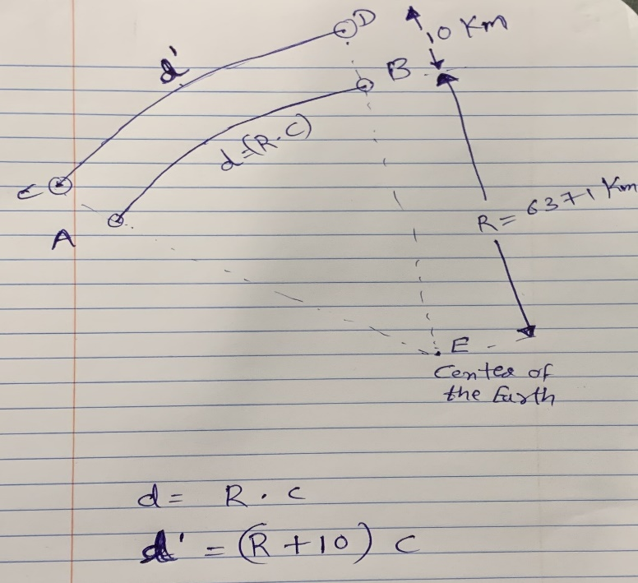i.e., new D = (R+10) \*c, where R= radius of the Earth, c = arc angle.

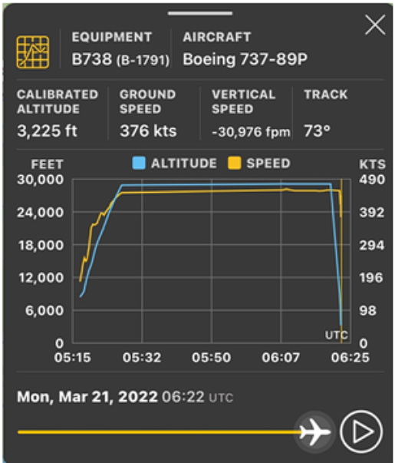

Thus, by considering the above equation, we can see that the flying distance is going to be more than the distance obtained from the haversine formulae. In addition to this, the flying distance might be impacted by numerous other factors like as shown in the right-side figure, the trajectory of a plane will be very much different than just an circular arc.