**The Diary of Jem Finch …**

[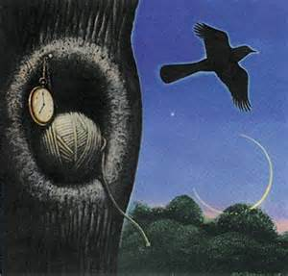](http://www.bing.com/images/search?q=Knot+Hole+Tkam&view=detailv2&&&id=566831F2454298824E134A1F4E738FD59BDF220D&selectedIndex=15&ccid=VxrF3Ipa&simid=607996395626696582&thid=JN.Cpic9M%2bcDqruguI72DUguQ)