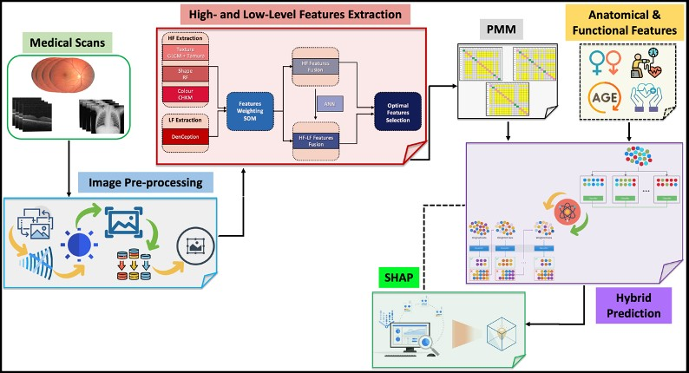

User Presentation

Explainable Method Analysis

GCN Prediction

Drug ID/Side Effect Pairs

Data Pre-Processing

Data Gathering/Cleaning