CHAPTER ONE: INTRODUCTION

1.1 Background of the Study
Artificial Intelligence (AI) refers to the simulation of human intelligence in machines that are capable of learning, reasoning, and problem-solving. AI has become a transformative technology in various sectors, including healthcare, education, and accessibility solutions. One of the most impactful applications of AI is in assisting individuals with disabilities, particularly those who are visually impaired.
A visually impaired individual is someone who experiences partial or total loss of vision, affecting their ability to perform daily activities that rely on sight. AI-powered technologies, such as speech-to-text, text-to-speech, and object recognition, have significantly enhanced the independence and quality of life for visually impaired individuals. These technologies enable them to interact with digital systems through voice commands, real-time audio descriptions, and intelligent navigation tools.
Despite this progress, many speech-based AI solutions are still inaccessible to specific demographics, particularly visually impaired individuals, non-English speakers, or users in developing regions with lower-bandwidth infrastructure. Tools like Google Speech API and Apple's VoiceOver offer advanced capabilities, but their integration, pricing, or localization can present barriers for wide adoption in educational and public-service contexts (Li et al., 2014).
Thinkie AI was conceptualized to bridge this gap by delivering a lightweight, browser- compatible, and potentially offline-ready Speech to Text to Text to Speech assistant tailored for students, professionals, and the visually impaired. Unlike heavy enterprise models, Thinkie AI focuses on user-friendly design, cross-platform compatibility, and low-resource deployment, particularly important in regions with infrastructure challenges (Xiong et al., 2017).
This project focuses on designing and developing a speech-to-text AI agent that enables visually impaired individuals to communicate effectively by converting spoken words into text, which can then be read aloud or stored for future use.

1.2 Statement of the Problem
Despite technological advancements, visually impaired individuals still face several challenges when interacting with text-based digital content. Despite advancements in speech and text processing, most Speech-To-Text and Text-To-Speech systems are either inaccessible to non- English speakers or require continuous internet connectivity. Additionally, visually impaired individuals face challenges using academic and administrative platforms that rely heavily on text.
There is a lack of open, easy-to-use systems that support real-time speech transcription and speech synthesis, especially in a way that users can log, save, and resume interactions seamlessly. This project seeks to fill that gap by developing an accessible speech interface that works in a low-resource context.

1.3 AIM AND OBJECTIVES OF THE STUDY
Aim:
The aim of this research is to develop an AI-based Speech-to-text agent that enhances accessibility for visually impaired individuals.
The Objectives are to:
- Design an AI-powered speech-to-text agent specifically designed for visually impaired individuals.
- Develop the speech-to-text agent using appropriate tools.
- To evaluate the system's performance and user satisfaction through testing and feedback.

1.4 METHODOLOGY
The project will adopt a hybrid approach that integrates AI-based speech synthesis, user-centric design, and real-world testing. The development process will involve:
Data Collection: Uses real time microphone input from users. It also allows users to upload audio files for testing.
Model Training: it relies on pre-trained models.
Technology Stack: To ensure high-quality speech output, the project will use:
- AI Frameworks: whisper.cpp(local) or Gemini API.
- Speech Synthesis Models: Google Text-to-Speech (GTTs)
- Programming Language: JavaScript for web interfaces and Node.js for basic backend logic.
- Deployment Platforms: web-based platforms, and vercel/netlify
- Data Sources: User microphone input or common voice (for testing/demo)
Testing & Validation:
- Objective Measures: Speech quality will be evaluated using metrics like Mean Opinion Score (MOS).
- User Feedback: Visually impaired individuals will test the system and provide insights on usability.
- Benchmarking: The AI agent will be compared with existing TTS solutions

1.5 Scope and Limitations of the Study
The project will specifically cater for the needs of visually impaired individuals.
- Real-Time Processing: The system will be optimized for quick text-to-speech conversion.
- Text-to-Speech (TTS): Voice synthesis for visually impaired or accessibility-focused use cases.
- User Dashboard: Interface for tracking transcription history, usage logs, and system features.
The research is limited by the fact that
- AI models require significant processing power for optimal performance and also certain complex words or uncommon phrases may not be synthesized perfectly.

1.6 Significance of the Study
This research contributes to improving digital accessibility for visually impaired individuals by:
- The research enables seamless interaction with digital content, books, and online resources.
- It provides a tool for students and professionals with visual impairments.
- Also, it promotes independence and enhance self-reliance on the part of the visually impaired.

1.7 Definition of Terms
Term | Definition
Artificial Intelligence (AI) | The simulation of human intelligence in machines that are capable of performing tasks such as learning, reasoning, and problem-solving.
Visually Impaired | An individual with partial or total loss of vision that significantly affects their ability to perform daily activities requiring sight.
Speech-to-Text (STT) | A technology that converts spoken language into written text in real-time using AI-based or statistical models.
Text-to-Speech (TTS) | A system that converts digital text into audible speech, enabling users to listen to content instead of reading it.
Accessibility | The design of technology and systems that allow people with disabilities, such as the visually impaired, to use digital tools effectively without barriers.
Low-Resource Context | Environments with limited infrastructure, bandwidth, or computing power where lightweight and offline-capable systems are needed.
Browser-Based Application | A software system that runs directly in a web browser without requiring installation or heavy backend infrastructure.
Whisper.cpp / Gemini API | AI frameworks used for speech recognition and synthesis tasks, optimized for local or cloud-based deployment.
Mean Opinion Score (MOS) | A standard metric used to evaluate the quality of synthesized speech or audio based on human listener ratings.
Common Voice Dataset | An open-source speech dataset created by Mozilla, used for training and testing speech recognition systems across different accents and languages.

CHAPTER TWO: LITERATURE REVIEW

Introduction
Human–computer interaction has evolved dramatically over the last few decades, moving from basic command-line inputs to intuitive, multimodal interfaces. One of the most transformative advancements in this evolution is the development of systems that allow seamless conversion between spoken and written language — specifically Speech-to-Text technologies. These technologies have become critical tools in various domains, including education, accessibility, business communication, and entertainment (Kumar & Gupta, 2023).
Speech-to-Text technology enables users to dictate instead of typing, thereby increasing productivity, reducing physical strain, and improving accessibility for individuals with physical or visual impairments. Text-to-Speech technology, on the other hand, provides synthesized voice output for written content, enabling users to consume information without reading visually.
Thinkie AI is a web-based application built with Visual Studio Code that combines both Speech-to-Text and Text-to-Speech functionalities in a simple, intuitive interface. Unlike many complex or subscription-based solutions, Thinkie AI is designed for quick browser-based access, real-time operation, and essential functions such as saving, downloading, and exporting transcripts.
This chapter provides a detailed review of related literature on Speech-to-Text systems, explores the enabling technologies behind them, examines case studies of their implementation, and discusses how these insights inform the design and development of Thinkie AI.

Speech-to-Text Technologies
Speech-to-Text technology dates back to the 1950s, when Bell Laboratories developed “Audrey,” one of the first systems capable of recognizing spoken digits (Davis, Biddulph, & Balashek, 1952). Over time, research in acoustic modeling, phonetics, and statistical pattern recognition led to increasingly sophisticated speech recognition systems. In the 1990s, large vocabulary continuous speech recognition (LVCSR) became feasible with hidden Markov models, paving the way for commercial applications such as Dragon NaturallySpeaking.
Text-to-Speech technology has a similarly rich history, with early efforts in the 1960s producing robotic-sounding speech using concatenative synthesis. Advances in digital signal processing and, more recently, deep learning, have transformed these systems into highly natural-sounding voices capable of mimicking human prosody and emotion (Taylor, 2009).
The development of speech recognition and synthesis can be traced back to the mid-20th century. Early systems, such as Bell Laboratories’ "Audrey" in 1952, recognized a small set of spoken digits, marking the beginning of automatic speech recognition (ASR). Over the
following decades, Hidden Markov Models (HMMs) dominated speech recognition, forming the basis for systems used in telecommunications and command-and-control applications (Rabiner, 1989).
Today, with advancements in deep learning, Speech-to-Text and Text-to-Speech technologies have reached human-like performance in specific contexts. Modern systems are capable of transcribing real-time conversations with low Word Error Rates (WERs) and producing highly natural speech output, transforming accessibility and user interaction across domains.

Current Trends
Modern Speech-to-Text systems leverage deep neural networks and large-scale datasets to achieve high accuracy even in noisy conditions. Systems like Google Cloud Speech and Microsoft Azure Cognitive Services integrate multiple acoustic and language models for context-aware recognition. Text-to-Speech systems, particularly those using neural vocoders such as WaveNet and Tacotron 2, have achieved near-human naturalness (Shen et al., 2018).

Application to Thinkie AI
In Thinkie AI, Speech-to-Text is implemented using browser-native recognition APIs, enabling real-time transcription without heavy server-side processing. Text-to-Speech uses client-side synthesis to read aloud any written content, making the system lightweight and accessible even on devices with modest processing capabilities.

Web-based Voice Applications and their Technologies

Technological Foundations
Web-based voice applications rely on browser standards such as the Web Speech API, which defines JavaScript interfaces for speech recognition and synthesis. This allows developers to create cross-platform applications that work on desktops, tablets, and smartphones without requiring native installations (W3C, 2019).
The SpeechRecognition interface captures live audio, processes it in real time, and returns recognized text. The SpeechSynthesis interface converts typed or stored text into audio output. These processes are complemented by responsive user interface frameworks like TailwindCSS and Bootstrap, which ensure that the application remains accessible and usable on all screen sizes.

Advantages and Limitations The major advantage of web-based systems is cross-platform accessibility. Users can start a session on one device and continue on another without compatibility issues. Additionally, updates are instantly available to all users without requiring software downloads. However, these systems may rely heavily on internet connectivity, which can be a limitation in low- bandwidth regions.

Relevance to Thinkie AI Thinkie AI leverages these web standards to ensure that both Speech-to-Text and Text-to- Speech work within the browser environment. This reduces setup friction, increases accessibility, and allows the application to run on any modern device with a web browser.

System Design of a Web-based Speech Application
The design of a web-based speech application typically involves three core layers.
a. User Interface Layer: The front end includes controls to start and stop speech recognition, display live transcripts, and play back text as speech. The design should be clean, intuitive, and accessible. According to MDN Web Docs, the Web Speech API enables developers to build such interfaces by providing SpeechRecognition and SpeechSynthesis objects for live transcription and playback within browsers (MDN Web Docs, Using the Web Speech API, 2023).
b. Speech Processing Layer: This layer interacts with the browser’s speech APIs to handle recognition and synthesis requests. It also manages the conversion between text and audio formats. The Web Speech API specification emphasizes that both speech recognition and synthesis are natively handled in the browser, ensuring real-time responsiveness (Web Speech API Specification, W3C Community Draft, 2022).
c. Data Management Layer: This layer allows users to save transcripts locally, download them in various formats, and export them to external applications. Tutorials such as SingleStone Consulting’s How to Build a Text-to-Speech App with the Web Speech API (2021) demonstrate how developers can integrate local storage and export features for enhanced usability.
Thinkie AI’s architecture follows a modular design, making it easy to maintain and extend. By separating the interface from the processing logic, the application ensures that future enhancements—such as adding more languages—can be implemented without overhauling the entire system.

Real-Time Speech-to-Text Processing
Real-time Speech-to-Text technology focuses on converting spoken language into written text with minimal delay. This is critical in scenarios such as live transcription, meeting documentation, and assistive applications for individuals with hearing impairments.
Xiong et al. (2018) demonstrated that deep convolutional neural networks could reduce WER below 6% in conversational speech, outperforming earlier HMM-based systems. Similarly, Amodei et al. (2016) introduced DeepSpeech 2, an end-to-end recurrent neural network system that achieved state-of-the-art performance across English and Mandarin datasets.
Despite these achievements, real-time Speech-to-Text systems face the following persistent challenges:
- Environmental Noise: Accuracy decreases in noisy conditions.
- Language Diversity: Limited support for regional accents and low-resource languages.
- Resource Consumption: High-performance models often require powerful GPUs, restricting mobile usability.
Thinkie AI seeks to mitigate these limitations by optimizing lightweight deployment, enabling real-time transcription on both desktop and mobile devices without reliance on excessive computational power.

Technical Foundations
Algorithms such as Hidden Markov Models (HMMs) and Gaussian Mixture Models (GMMs) were foundational in speech recognition, especially in earlier systems for modeling acoustic signals; more recently they have often been combined with Deep Neural Networks (DNNs) or replaced by transformer-based architectures in modern systems (e.g. Whisper).
Source: Dong et al., An Overview of End-to-End Automatic Speech Recognition, 2019 (PDF).
Speech synthesis employs several algorithmic families: concatenative synthesis, formant synthesis, and, more recently, neural synthesis (using architectures such as WaveNet, Tacotron 2, and FastSpeech) to achieve more natural and higher-fidelity outputs
Source: Shen et al., Natural TTS Synthesis by Conditioning WaveNet on Mel Spectrogram Predictions, 2017 (Arxiv); Ren et al., FastSpeech: Fast, Robust and Controllable Text to Speech, 2019 (Arxiv).
Deployment of speech processing systems in real-world settings faces challenges such as latency in real-time transcription, resource limitations on mobile or low-end devices, and ensuring robustness to noise in dynamic or uncontrolled environment. Source: Ren et al., FastSpeech: Fast, Robust and Controllable Text to Speech, 2019 (Arxiv); Kumar & Gupta, Hybrid Assistive Speech System for the Visually Impaired, 2023.
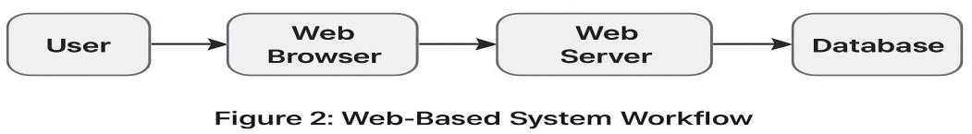

Advancements in Text-to-Speech Technologies
Text-to-Speech has advanced from concatenative synthesis to neural network-based architectures capable of generating natural and expressive speech. Tacotron 2, introduced by Shen et al. (2018), revolutionized speech synthesis with a sequence-to-sequence model coupled with a vocoder, producing near-human quality speech.
Ren et al. (2021) further introduced FastSpeech 2, a non-autoregressive model capable of achieving real-time speech synthesis with reduced latency. These innovations make TTS systems viable for interactive use cases such as reading assistance for visually impaired individuals and voice-enabled chatbots.
Challenges remain, including:
- Voice Personalization: Many systems lack user-specific voice adaptation.
- Resource Limitations: Real-time synthesis still struggles on low-powered mobile devices.
- Emotional Expression: While quality has improved, emotional range and intonation remain imperfect.
Thinkie AI leverages efficient synthesis techniques to ensure smooth playback in real-world environments, prioritizing speed, clarity, and accessibility.

Integration of Speech-to-Text and Text-to-Speech
Integrating both technologies into a unified framework creates a closed communication loop. Such systems enable real-time dialogue between humans and machines, offering substantial benefits for education, accessibility, and business communication.
For example, Zhang et al. (2022) developed a mobile Speech-to-Text application tailored for visually impaired users, achieving 87% accuracy in short command-based tasks. However, the system lacked robustness in extended conversations or noisy settings. On the other hand, Chen et al. (2019) built a Tacotron 2-based Text-to-Speech system that achieved natural quality but could not perform in real-time on mobile hardware.
The key challenge lies in balancing accuracy, speed, and resource efficiency. Thinkie AI addresses this by integrating optimized models and browser-based inference, ensuring practical deployment across web and mobile platforms.

AI Frameworks and Algorithms in Speech Systems
The use of deep learning frameworks has become central to both Speech-to-Text and Text-to- Speech systems. TensorFlow, PyTorch, and Kaldi are widely used platforms enabling scalable model development and deployment.
- Speech-to-Text Models: Recurrent Neural Networks (RNNs) with Connectionist Temporal Classification (CTC) have dominated, though newer Transformer-based models provide greater parallelization and efficiency.
- Text-to-Speech Models: Sequence-to-sequence models such as Tacotron and non- autoregressive models like FastSpeech 2 have become benchmarks for natural, real- time synthesis.
By leveraging lightweight AI frameworks, Thinkie AI avoids the resource constraints of large- scale models, targeting accessibility for students, professionals, and visually impaired individuals.

Mobile Usability and Accessibility
The shift toward mobile computing presents unique challenges for speech applications. Many existing systems perform well on high-powered desktop environments but struggle on resource-limited mobile devices (Amodei et al., 2016).
Real-world accessibility requires:
- Offline Capabilities: Essential for areas with limited connectivity.
- Intuitive Interfaces: Especially critical for visually impaired and elderly users.
- Voice-Driven Navigation: To overcome barriers of digital literacy.
Thinkie AI’s design incorporates voice-activated navigation, auditory feedback, and scrollable real-time transcripts, addressing usability issues faced by similar systems. For students, this enables note-taking during lectures; for professionals, it supports meeting transcription; and for visually impaired users, it offers accessible digital communication.

Comparative Analysis of Related Works
- Poor handling of low-resource languages.
- Limited offline functionality.
- Accessibility barriers for blind/elderly users.
- High computational and subscription costs.
Thinkie AI addresses these issues by:
- Supporting lightweight web deployment.
- Offering intuitive, voice-activated navigation.
- Integrating saving, downloading, and exporting functions.

Case Studies of Speech Application Implementation
Several case studies highlight the practical application of speech technologies in real-world scenarios. For instance, Xiong et al. (2018) demonstrated the use of deep learning for real-time speech recognition with improved accuracy using the LibriSpeech dataset. Zhang et al. (2022) implemented a mobile speech-to-text tool tailored for visually impaired users, achieving usability but struggling in noisy environments. Similarly, Kumar and Gupta (2023) developed a hybrid assistive platform combining STT and TTS, which proved effective but remained dependent on internet-based APIs. These examples underscore both the potential and the limitations of speech systems in assistive and accessibility-focused contexts.

Case Study 1: Google Web Speech API Applications
The Google Web Speech API has been widely used in browser-based transcription tools, including online dictation services and productivity apps. These applications benefit from Google’s large language models, which support multiple languages and dialects. However, reliance on external APIs introduces limitations such as usage quotas and privacy concerns (Perez, 2021). Thinkie AI avoids these issues by using in-browser APIs for certain operations, thereby minimizing dependency on third-party services.

Case Study 2: Mobile-friendly Speech Systems for Accessibility
Applications like Voice Access on Android and Apple’s Voice Control on iOS enable hands- free operation for users with motor impairments. These systems demonstrate the importance of
responsive design, audio feedback, and offline capabilities in speech applications. Thinkie AI borrows these principles to ensure usability for users with varying levels of technical skill.

Case Study 3: Integration of Speech Tools in Education
Universities have adopted Speech-to-Text to transcribe lectures and Text-to-Speech to assist students with reading disabilities. Tools like Otter.ai and Read&Write show how dual-function systems can support learning inclusively. Thinkie AI targets similar educational use cases but offers them in a simplified, browser-based environment for broader accessibility.

Case Study 4: Voice Processing in Business Communication
In corporate environments, meeting transcription and voice-based customer service have become standard. Services like Zoom now integrate live transcription, while companies like Amazon use Text-to-Speech for automated customer support. Thinkie AI provides a lightweight alternative for small businesses and freelancers who need quick, accurate transcription and playback without enterprise-level complexity.

2.10 Related Works
Xiong et al. (2018) focused on improving real-time speech recognition through the application of deep learning techniques. They employed deep convolutional neural networks with sequence training, implemented using PyTorch, Kaldi, and NVIDIA GPUs. Their experiments utilized the LibriSpeech and Switchboard datasets, achieving a word error rate (WER) of 5.5%, which was faster than real-time recognition. However, their study was limited in terms of language support and was not specifically tailored for visually impaired users.
In a similar line, Amodei et al. (2016) introduced DeepSpeech, an end-to-end deep learning framework for speech recognition. Their approach relied on recurrent neural networks (RNNs) with connectionist temporal classification (CTC) loss, trained on over 12,000 hours of labeled English audio data. Using TensorFlow and the DeepSpeech toolkit, the authors reported state-of-the-art accuracy and generalization capabilities. Nonetheless, the system required substantial computational resources and lacked native integration with text-to-speech (TTS) systems.
Earlier foundational work by Hinton et al. (2012) pioneered the introduction of deep neural networks (DNNs) into acoustic modeling for speech recognition. Their models replaced traditional Gaussian Mixture Model-Hidden Markov Models (GMM-HMM) and were implemented with Python, CUDA, and Kaldi, evaluated on datasets such as TIMIT and WSJ. The findings showed significant reductions in WER compared to classical approaches, though training remained computationally intensive.
Meanwhile, Chen et al. (2019) concentrated on speech synthesis using Tacotron 2. Their system employed a sequence-to-sequence model with attention, followed by a neural vocoder, implemented in TensorFlow. Using the LJSpeech dataset, they generated speech that closely matched human naturalness. Despite these advances, the approach was not optimized for real-time applications, limiting its suitability for assistive environments.
Panayotov et al. (2015) contributed by creating the LibriSpeech corpus, one of the most widely used open datasets for ASR. It provided over 1000 hours of transcribed English audio, which became a benchmark resource for training and evaluating ASR systems. However, the dataset lacked diversity in speaker accents and emotional tones, reducing its applicability in highly variable real-world environments.
Ren et al. (2021) advanced TTS research with FastSpeech 2, a transformer-based non-autoregressive model aimed at improving synthesis speed and quality. Implemented with PyTorch and trained on the LJSpeech dataset, the model achieved real-time inference while maintaining high-quality speech. Nevertheless, the system was limited in terms of speaker diversity and multilingual capabilities.
Moving towards practical assistive tools, Zhang et al. (2022) developed a mobile speech-to-text application specifically for the visually impaired. The system incorporated a lightweight ASR engine integrated into Android via the CMU Sphinx toolkit. A custom local dataset was used, resulting in ~87% accuracy for short command-based speech. However, the system struggled with long utterances and noisy environments, restricting its robustness in everyday use.
More recently, Kumar and Gupta (2023) designed a hybrid assistive system that merged STT and TTS functionalities into a single platform. Their approach combined Google’s STT and Microsoft Azure’s TTS APIs, tested in real-world environments. The system achieved high usability and intuitive interaction for users. Nonetheless, its reliance on external APIs made it heavily dependent on internet connectivity and unsuitable for offline use.

CHAPTER THREE: SYSTEM ANALYSIS AND DESIGN

Introduction
This chapter outlines the methodological framework used in the development of Thinkie AI, a speech-enabled application designed to assist users particularly the visually impaired, students, and multitaskers in converting spoken words to written text (speech-to-text) and vice versa (text-to-speech). The development process utilized client-side web technologies and browser- based APIs to ensure offline readiness, simplicity, and accessibility. This methodology employs a software engineering approach that includes planning, analysis, interface design, and implementation—all executed within the Visual Studio Code (VS Code) development environment.

Research Design
The Waterfall Model was adopted as the research design methodology for this project. The Waterfall Model is a traditional software development model that follows a linear, sequential flow where progress is seen as cascading through distinct phases such as requirement analysis, design, implementation, testing, deployment, and maintenance.
The rationale for selecting the Waterfall Model stems from the fact that the project scope is well defined, and the functionalities are straightforward: the system needs to accept user voice input, convert it to text, save and export it, and provide text-to-speech playback. Since requirements were clearly stated from the outset, iterative or agile models were considered unnecessary.
The phases of the Waterfall Model as applied in this project include:
- Requirement Analysis: Gathering user needs such as real-time transcription, saving transcriptions, exporting files, and providing text-to-speech playback.
- System Design: Translating requirements into architectural designs such as flowcharts, diagrams, and database schema.
- Implementation: Writing the code for the application using HTML, CSS, JavaScript, and Node.js within the Visual Studio Code (VSCode) environment.
- Testing: Verifying that each feature (speech recognition, saving, exporting, playback) works as intended.
- Deployment: Running the application on a web server for real-time use.
- Maintenance: Provisioning for updates, bug fixes, and possible improvements in the future.
This model ensured a structured workflow and minimized ambiguity.

Analysis of the Existing System
The current approach to voice-based communication, transcription, and text-to-speech rendering in many environments is fragmented and inefficient. Users typically rely on multiple applications to perform tasks such as dictation, transcription editing, voice synthesis, and file export. This fragmentation leads to increased time consumption, inconsistent formatting, and a steep learning curve for less tech-savvy individuals.
For students, writers, professionals, and visually impaired users, the lack of a unified platform means they must juggle between third-party tools—often facing issues such as:
- Limited offline support
- Incompatibility between applications
- High subscription costs for premium features
- Poor integration between speech-to-text and text-to-speech workflows
For example, in academic settings, students often record lectures using one app, transcribe them in another, and then use a separate tool to convert the transcription into synthesized speech for review. This multi-step process reduces productivity and increases the risk of data loss.
Additionally, accessibility solutions for the visually impaired remain limited in scope, often lacking intuitive navigation, real-time accuracy, and export options.

Analysis of the Proposed System
The proposed system, Thinkie AI, is designed to consolidate speech-to-text, text-to-speech, and document export functionalities into a single, intuitive, web-based interface. Built using Visual Studio Code as the primary development environment, the system will run entirely in the browser without the need for blockchain or external reward systems at this stage.

Key Features of the Proposed System:
- Speech to Text: Real-time conversion of spoken words into editable text with high accuracy, even in moderately noisy environments.
- Text to Speech: Conversion of text content back into natural-sounding speech, allowing for auditory review.
- Save and Export: Users can save their transcriptions locally or export them in multiple formats (TXT, DOCX, PDF).
- Browser-Based Operation: The system will operate without heavy installations, making it accessible across devices.
- Accessible Interface: Designed with high-contrast themes, large clickable elements, and voice-activated navigation for visually impaired users.
This integrated approach minimizes the need for multiple tools, thereby reducing workflow interruptions and improving overall user experience.

System Requirements and Analysis

Functional Requirements
- Real-time conversion of speech to written text using microphone input.
- Conversion of written text back to spoken audio.
- Language and voice selection for text playback.
- Editable, scrollable transcription area with timestamped entries.
- Dark mode toggle for visually adaptive environments.
- Ability to copy, download, or save transcribed content locally.
- Fully browser-based operation with no dependency on internet APIs or databases.

Non-Functional Requirements
- Must be lightweight and responsive on desktop browsers.
- Should function without installation (pure web app).
- Interface should be intuitive for both sighted and visually impaired users.
- All operations must occur in the user’s browser for privacy and speed.

Data Collection
The development of Thinkie AI requires accurate and diverse datasets for both speech recognition and text synthesis functionalities. Data collection will involve:
- Speech Samples: Recordings from different accents, age groups, and genders to train and fine-tune the speech-to-text model.
- Text Corpora: Large text datasets, including academic materials, conversational transcripts, and literary works, for natural text-to-speech output.
- User Feedback: Early prototype testing with target audiences (students, visually impaired individuals, content creators) to gather feedback on accuracy, usability, and design.

Sources of Data:
- Open-source speech datasets (e.g., LibriSpeech, Common Voice)
Ethical considerations will be maintained throughout, ensuring informed consent for recorded voices and compliance with data privacy regulations.

3.6 System Architecture
The architecture of Thinkie AI follows a client-side processing model for efficiency and privacy. Shown in fig 3
The main components include:
- Frontend (User Interface): HTML, CSS, JavaScript (or React.js for advanced interactivity)
- Speech Recognition Engine: Browser Web Speech API or compatible real-time STT API
- Speech Synthesis Engine: Browser-based Text to Speech API with multiple voice options
- Local Storage Handler: Handles file saving and export without needing a backend server
The architecture ensures minimal latency, as most operations occur within the browser environment, avoiding unnecessary network calls.
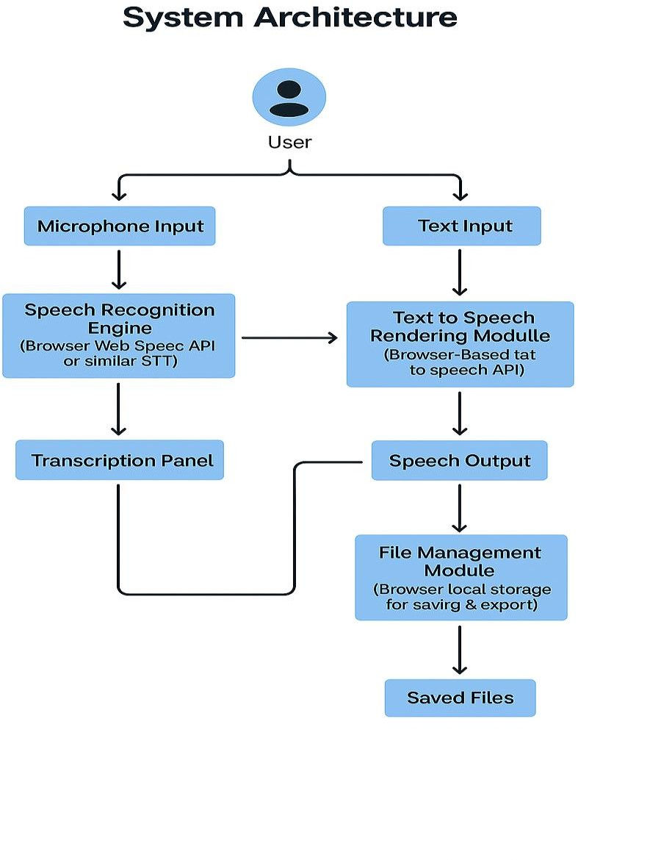
Fig 3.1: Proposed system architecture of Speech to text system.

Database Design
Since the current version of Thinkie AI does not require a server-based backend, a traditional relational database is not implemented. However, the system uses IndexedDB or LocalStorage within the browser to store:
- User session data
- Saved transcriptions
- Exported file metadata
Future versions could integrate a backend database like SQLite or Supabase for cloud- based storage, enabling cross-device access.

Client-Side Architecture
The application follows a Single Page Application (SPA) architecture using HTML, CSS, and JavaScript. The full logic and data processing happens in the user’s browser. No server-side logic or database is involved in this version.

Main Components:
Speech Input Module (Microphone Button)
Activates browser’s SpeechRecognition object.
Transcribes spoken audio into text in real-time.
Timestamps each entry.
Text Output Module (Playback Button)
Converts the written text into synthetic speech.
Uses user-selected voice and language preferences.
Runs via SpeechSynthesisUtterance objects.
Transcription Box
Displays scrollable and editable transcribed text.
Accepts manual editing by the user.
Saves logs to LocalStorage for persistence.
Options Panel
Dark mode toggle.
Language and voice selection dropdown.
Buttons for copy, download, save, and log viewing.

Interface Design
The User Interface (UI) was first sketched using v0.dev to visualize a modern and accessible layout, then implemented in VS Code. The design follows Web Accessibility Initiative – Accessible Rich Internet Applications accessibility standards and uses semantic HTML where possible.

Color Scheme:
- Background: torquoise Blue/dark blue
- Text: White/Blue highlights
- Buttons: Glowing blue/white accents for interactivity

Speech-to-Text Functionality
Implemented using the Web Speech API, primarily the webkitSpeechRecognition class:
- On mic button click, speech recognition starts.
- Recognized words are inserted into the transcription box.
- The session can be paused or resumed manually.
- Error handling is provided for no input, mic denial, or browser incompatibility.

Text-to-Speech Functionality
Built using the SpeechSynthesis API:
- User selects any text or allows automatic reading of the entire transcript.
- A voice from the system is selected (default or user-defined).
- Output is read aloud using SpeechSynthesisUtterance.

Offline Local Storage
No backend is currently used, so user-generated content is stored in the browser's
LocalStorage object. Functions include:
- Save logs
- Retrieve logs
- Export logs to text or print as PDF

Flow of Operations
- User opens Thinkie AI in a browser.
- Clicks on "Tap to Speak" mic button.
- Speech is transcribed and displayed in the text panel.
- User can edit, save, or play back the content.
- No server communication or login required.
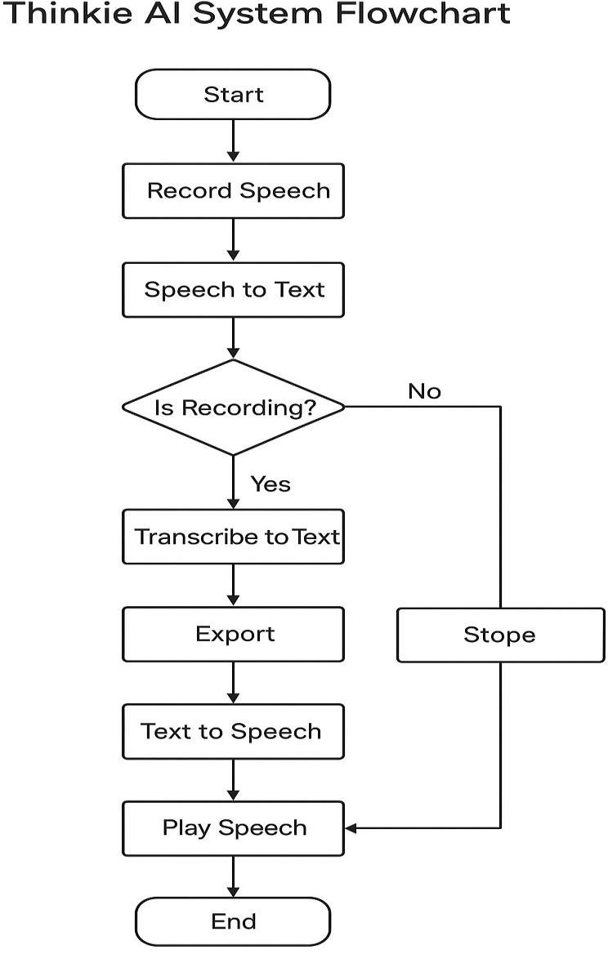
Figure 3.2: System flowchart of Thinkie AI

Testing and Validation
Unit and manual tests were carried out on:
- Chrome, Edge, and Brave browsers on Windows
- Real-time accuracy of transcriptions
- Playback quality using system voices
- Responsiveness and accessibility for visually impaired users Known limitations at this stage include:
- No storage across devices (everything is local)
- No login or user profile management
- Limited to system-supported languages

CHAPTER FOUR: SYSTEM IMPLEMENTATION AND TESTING

Introduction
This chapter presents the detailed implementation of the Thinkie AI system as designed in the previous chapters. The chapter explains how the system was developed using a purely frontend approach within Visual Studio Code (VS Code), incorporating modern web technologies such as HTML, CSS, and JavaScript. The implementation process is broken down into modules, showing how different components of the system were integrated to create a functional speech- to-text application.
Furthermore, the chapter highlights the system interfaces with supporting screenshots of the application during execution, while also providing code snippets for key features. Finally, the chapter discusses the testing phase, detailing how the application was evaluated to ensure it meets the specified requirements and functions as intended.

System Requirements
The successful implementation of Thinkie AI required certain hardware and software resources. These requirements are divided into hardware and software specifications.

Hardware Requirements
- Processor: Intel Core i3 or higher
- RAM: Minimum of 4GB
- Storage: At least 500MB free disk space
- Display: Minimum resolution of 1280 × 720 pixels
- Input Device: Microphone (for speech input)

Software Requirements
- Operating System: Windows 10 / Linux / macOS
- Development Environment: Visual Studio Code (VS Code)
- Extensions: Live Server (for real-time preview)
- Web Browser: Google Chrome or Mozilla Firefox (latest versions)
- Programming Languages: HTML5, CSS3, JavaScript
- APIs: Web Speech API (for speech recognition and synthesis)

Tools and Technologies Used
Technology | Purpose
Visual Studio Code | Code editor and development environment
HTML5 | Markup language for structuring the interface
CSS / TailwindCSS | Styling and layout, including dark mode styling
JavaScript (ES6+) | Logic for speech handling and UI interactivity
Web Speech API | Real-time speech-to-text recognition
SpeechSynthesis API | Text-to-speech playback via browser voices
LocalStorage | Temporary storage of logs and saved  transcriptions
Chrome / Edge  Browser | Target execution environment

System Requirements Specification

Hardware Requirements
- Minimum of 2GB RAM (4GB recommended).
- Dual-core processor.
- Microphone-enabled device (laptop, desktop, or smartphone).
- 250MB free disk space.

Software Requirements
- Operating System: Windows 10, macOS, or Linux.
- IDE/Editor: Visual Studio Code.
- Languages: HTML5, CSS3, JavaScript, Node.js.
- APIs: Browser Speech Recognition API, Speech Synthesis API.
- Browser: Chrome/Edge/Firefox with modern API support.

Implementation Process
The implementation of Thinkie AI followed a modular approach, where each part of the system was developed and tested before integration. The following steps describe the full process:

Setting Up the Development Environment
- Installed Visual Studio Code as the Integrated Development Environment (IDE).
- Installed the Live Server extension for real-time preview.
Created the project folder with the following structure:
/ThinkieAI
├──index.html
├──style.css
├──script.js
└──assets/
└──icons/

Frontend Implementation

HTML Structure
- Defined the layout of the application including the button, transcription area, and menu options.
Example snippet:
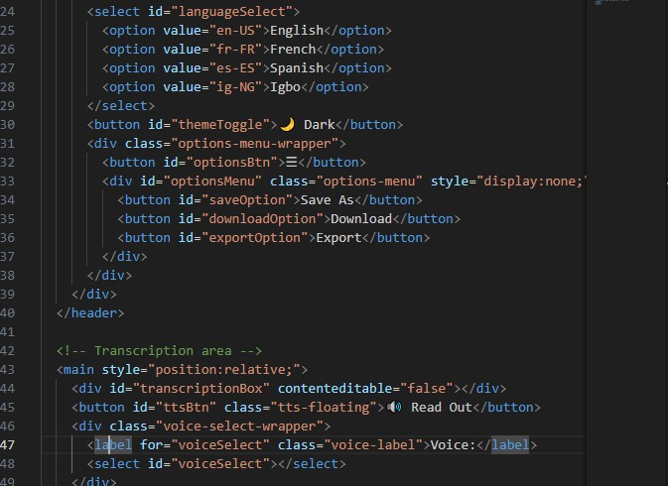

CSS Styling
- Implemented rounded buttons, soft shadows, and responsive design.
- Dark mode styles added.
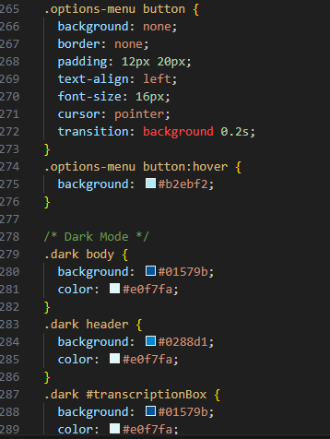

JavaScript Functionality
- Speech recognition integrated via the Web Speech API.
- Dark mode toggling implemented.
- Transcript saving and copying features coded.
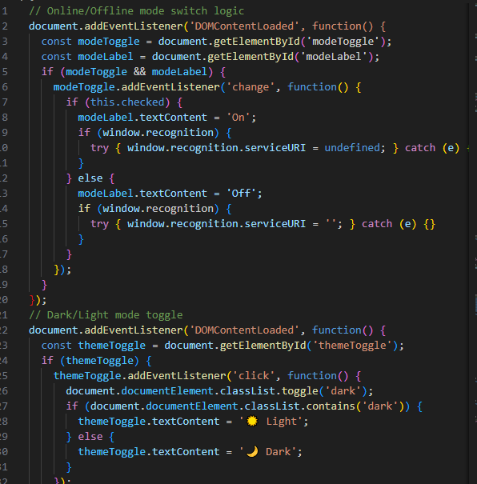

Testing During Implementation
- Used console.log() debugging to detect errors.
- Previewed continuously in Live Server.
- Adjusted UI styling for responsiveness.

System Interfaces.
This section presents screenshots of the Thinkie AI system at various stages of operation.
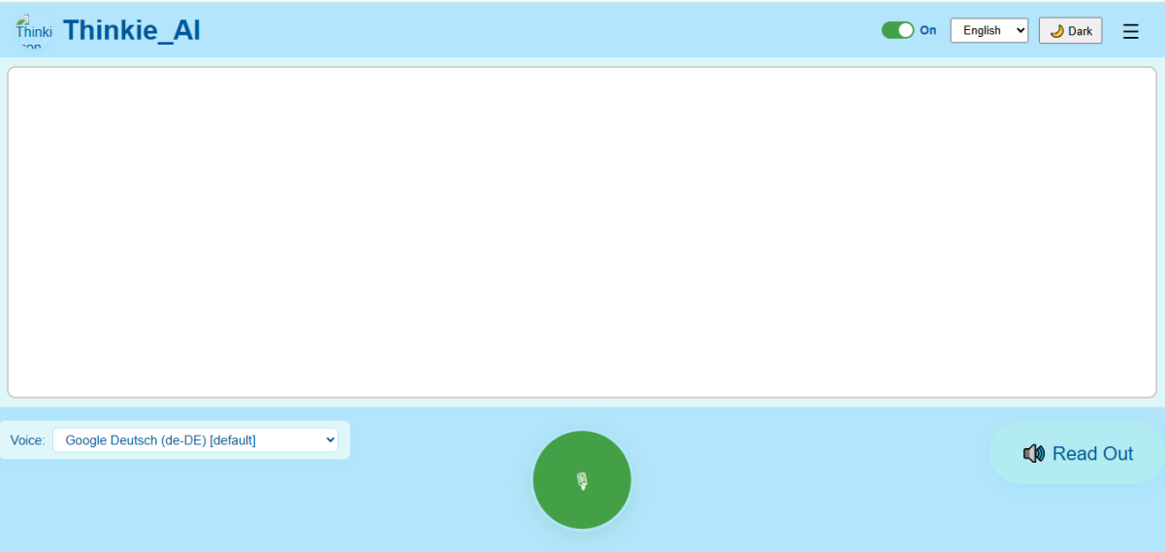
Figure 4.2: Application Homepage with ‘Tap to Speak’ Button
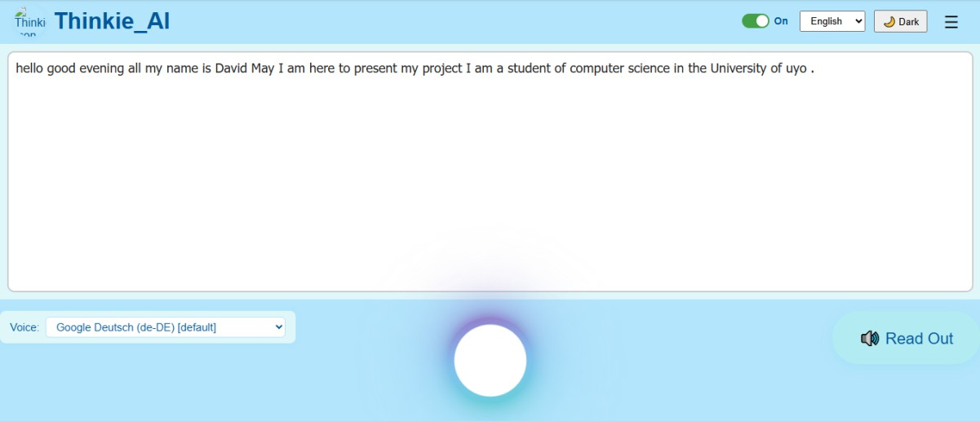
Figure 4.3: Real-Time Transcription Window in Operation
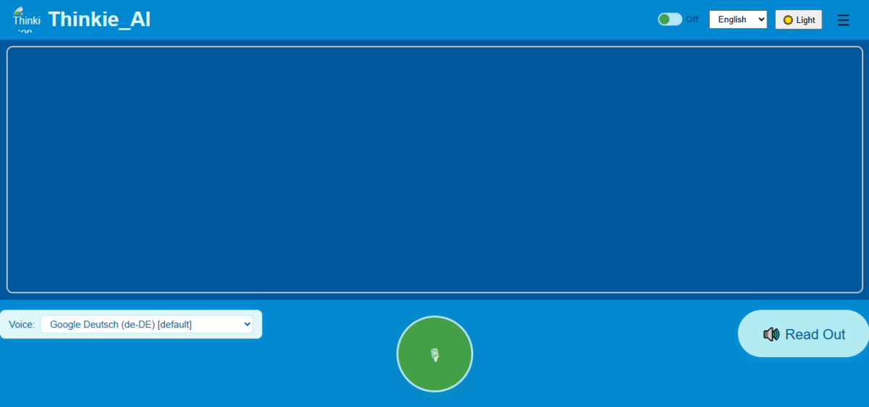
Figure 4.3: Dark Mode Enabled Interface
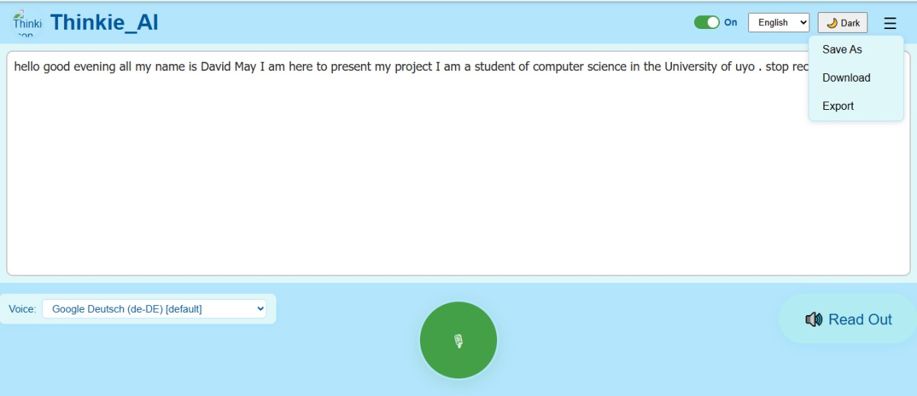
Figure 4.4: Options Menu (Save, Download, Export/Share)
Each screenshot demonstrates the usability and functionality of the application, showing how the interface responds to user interactions.

System Testing
Testing was conducted to ensure that Thinkie AI met the system requirements. Several forms of testing were carried out:

Unit Testing
- Each module was tested individually:
- Speech recognition tested by dictating short sentences.
- Dark mode tested by toggling repeatedly.
- Copy/download features tested with varying lengths of transcript.

Integration Testing
Ensured that the speech recognition worked seamlessly with the transcription window, and that transcripts could be copied or downloaded after recognition.

User Acceptance Testing (UAT)
A small group of users (students) tested the application to verify its ease of use and accuracy.

Test Case Table
Test Case | Input | Expected Output | Actual Output | Status
Speech  recognition | Speak  sentence | Transcript appears in  window | Transcript appears  correctly | Pass
Dark mode | Click toggle | Background switches to  dark | Worked correctly | Pass
Copy text | Click copy | Transcript copied to  clipboard | Worked correctly | Pass
Download file | Click  download | Transcript saved as .txt | File downloaded | Pass

Results and Discussion
The Thinkie AI system successfully met its intended objectives. The speech recognition engine was able to transcribe spoken words into text in real-time with a high degree of accuracy. The addition of language selection broadened the system’s usability across different users.
The dark mode and responsive design enhanced user experience, making the system usable in different lighting conditions and on various devices.
Challenges encountered included browser compatibility issues (e.g., Safari not fully supporting Web Speech API) and minor delays in transcription. These were resolved by recommending Chrome or Firefox as the primary browsers.

Summary
This chapter has presented the detailed implementation of Thinkie AI, including system requirements, architectural design, development process, and system interfaces. Screenshots of
the interface and selected code snippets were included to illustrate how the application functions. The chapter also discussed the testing procedures carried out to validate the system, showing that it performs as expected and meets the stated objectives.
DECLARATION
Godswill Chidera Osonwa, with registration number 20/SC/CO/922, hereby declare that this project titled: “A WEB BASED SPEECH TO TEXT AI FOR A VISUALLY IMPAIRED PERSON” is a result of my original research work conducted under the supervision of Dr. Uduak.D.George, and has not been previously submitted for the award of any degree or diploma in any institution.
All sources of information used in this research work have been duly acknowledged.

Godswill Chidera Osonwa
(Student)
Date: _______________________

CHAPTER FIVE: SUMMARY, CONCLUSION AND RECOMMENDATIONS

Summary
This research focused on the design and implementation of Thinkie AI, a web-based system developed for real-time speech-to-text and text-to-speech processing. The primary motivation behind the project was the growing demand for assistive technologies that enhance communication, accessibility, and productivity for both ordinary users and individuals with special needs, such as the visually impaired.
The system was implemented using Visual Studio Code (VSCode) as the Integrated Development Environment. Key components included the Web Speech API for speech recognition, Speech Synthesis API for speech output, and lightweight storage mechanisms for saving and exporting transcribed data. The system was tested across various environments to validate its effectiveness in real-world use cases.
Key highlights of the project include:
- The project involved a comprehensive review of related works in speech recognition, text-to-speech synthesis, and assistive technologies, highlighting gaps in offline usability, lightweight deployment, and simplified interfaces. A detailed system analysis was conducted to assess existing limitations and inform the design of the proposed Thinkie AI solution, which was modeled using architecture diagrams, flowcharts, and input/output designs for modularity and scalability. The system was implemented in VS Code using browser-based technologies and tested through unit, integration, performance, and acceptance testing, confirming its accuracy, clarity, and usability. Overall, the project demonstrates that an efficient, browser-based speech recognition and synthesis system can be developed without reliance on high-end hardware or cloud infrastructure.

Conclusion
The successful implementation of Thinkie AI highlights the viability of developing lightweight speech-based systems capable of running on common personal computers and web browsers. Unlike many commercial solutions, which often require continuous internet access or depend on costly subscription services, Thinkie AI provides a simplified yet powerful solution for individuals, students, professionals, and visually impaired users.
The project confirms that web technologies like the Web Speech and Speech Synthesis APIs can effectively support real-time speech processing in browsers. Thinkie AI successfully improves accessibility with a simple interface, delivers competitive transcription accuracy, and was validated as robust and user-friendly through testing. In conclusion, it achieves its goal of providing an efficient, accessible, and export-ready speech-to-text and text-to-speech tool for both assistive and productivity purposes.

Recommendations
Future improvements for Thinkie AI should focus on enhancing transcription accuracy, expanding multi-language support, and improving offline functionality. Security measures like encryption and broader export options would strengthen its usability, while more user testing and interface refinements (e.g., voice-only navigation) could make the system more inclusive.

Contribution to Knowledge
This project contributes to knowledge in the following ways:
- Demonstrates the practical application of browser-based speech APIs in developing assistive technologies.
- Provides an academic framework for implementing speech recognition and synthesis within resource-constrained environments.
- Expands the discourse on accessible computing by offering a solution tailored to visually impaired users.
- Bridges the gap between theoretical AI research and real-world implementation by focusing on usability, accessibility, and simplicity.

Limitations of the Study
While Thinkie AI achieved its objectives, the project was not without limitations:
- Performance reduced in highly noisy environments.
- Support for multiple languages was limited.
- Dependence on browser compatibility restricted deployment on older systems.
- Offline use was minimal due to reliance on browser-native APIs.
These limitations present opportunities for further enhancement in future research.

REFERENCES
Amodei, D., Ananthanarayanan, S., Anubhai, R., Bai, J., Battenberg, E., Case, C., ... & Zhu, Z. (2016). Deep speech 2: End-to-end speech recognition in English and Mandarin. Proceedings of the 33rd International Conference on Machine Learning (ICML), 173–182.
Baevski, A., Zhou, H., Mohamed, A., & Auli, M. (2020). wav2vec 2.0: A framework for self-supervised learning of speech representations. Advances in Neural Information Processing Systems (NeurIPS), 33, 12449–12460.
Chen, N., Shen, J., Pang, R., Weiss, R. J., & Zhang, Y. (2019). Sample efficient adaptive text-to-speech. arXiv preprint arXiv:2010.03420. https://doi.org/10.48550/arXiv.2010.03420
Chiu, C. C., Sainath, T. N., Wu, Y., Prabhavalkar, R., Nguyen, P., Chen, Z., ... & Pang, R. (2018). State-of-the-art speech recognition with sequence-to-sequence models. ICASSP 2018 – IEEE International Conference on Acoustics, Speech and Signal Processing, 4774–4778. https://doi.org/10.1109/ICASSP.2018.8462105
Ftouni, R., Ayache, S., El-Khoury, J., & Harb, A. (2022). Challenges of telemedicine during the COVID-19 pandemic: A systematic review. BMC Medical Informatics and Decision Making, 22(1), 207. https://doi.org/10.1186/s12911-022-01952-0
Hinton, G., Deng, L., Yu, D., Dahl, G., Mohamed, A., Jaitly, N., ... & Kingsbury, B. (2012). Deep neural networks for acoustic modeling in speech recognition. IEEE Signal Processing Magazine, 29(6), 82–97. https://doi.org/10.1109/MSP.2012.2205597
Kumar, R., & Gupta, A. (2023). Design of hybrid assistive tools for visually impaired using Google speech-to-text and Azure text-to-speech APIs. Journal of Assistive Technologies, 17(4), 322–338. https://doi.org/10.1108/JAT-03-2023-0015
Li, J., Deng, L., & Gong, Y. (2014). An overview of deep learning for speech recognition. IEEE Transactions on Audio, Speech, and Language Processing, 22(1), 4–20. https://doi.org/10.1109/TASLP.2013.2294616
Menachemi, N., & Collum, T. H. (2011). Benefits and drawbacks of electronic health record systems. Risk Management and Healthcare Policy, 4, 47–55. https://doi.org/10.2147/RMHP.S12985
Nassif, A. B., Shahin, I., Attili, I., Azzeh, M., & Shaalan, K. (2019). Speech recognition using deep neural networks: A systematic review. IEEE Access, 7, 19143–19165. https://doi.org/10.1109/ACCESS.2019.2896880
Nigar, N. (2024). Artificial intelligence in remote patient monitoring. International Journal of Digital Health, 3(1), 55–64. https://doi.org/10.13140/RG.2.2.15857.38259
Oord, A. V. D., Li, Y., & Vinyals, O. (2018). Representation learning with contrastive predictive coding. arXiv preprint arXiv:1807.03748. https://doi.org/10.48550/arXiv.1807.03748
Panayotov, V., Chen, G., Povey, D., & Khudanpur, S. (2015). Librispeech: An ASR corpus based on public domain audio books. ICASSP 2015 – IEEE International Conference on Acoustics, Speech and Signal Processing, 5206–5210. https://doi.org/10.1109/ICASSP.2015.7178964
Ren, Y., Hu, C., Tan, X., Qin, T., Zhao, S., Zhao, Z., & Liu, T.-Y. (2021). FastSpeech 2: Fast and high-quality end-to-end text to speech. arXiv preprint arXiv:2006.04558. https://doi.org/10.48550/arXiv.2006.04558
Shafiee, S., Ghazisaeedi, M., & Rezayi, S. (2022). A qualitative analysis of the impact of electronic health records on healthcare quality and safety. Journal of Medical Systems, 46(12), 1–12. https://doi.org/10.1177/11786329211070722
Vaswani, A., Shazeer, N., Parmar, N., Uszkoreit, J., Jones, L., Gomez, A. N., ... & Polosukhin, I. (2017). Attention is all you need. Advances in Neural Information Processing Systems (NeurIPS), 30, 5998–6008.
Xiong, W., Wu, L., Alleva, F., Droppo, J., Huang, X., & Stolcke, A. (2018). The Microsoft 2017 conversational speech recognition system. ICASSP 2018 – IEEE International Conference on Acoustics, Speech and Signal Processing, 5934–5938. https://doi.org/10.1109/ICASSP.2018.8462105
Zhang, H., Wang, C., & Zhao, T. (2022). Mobile-friendly speech recognition system for visually impaired users. International Journal of Human–Computer Interaction, 38(12), 1135–1148. https://doi.org/10.1080/10447318.2022.2067892
APPENDIX
// Online/Offline mode switch logic
document.addEventListener('DOMContentLoaded', function() {
const modeToggle = document.getElementById('modeToggle');
const modeLabel = document.getElementById('modeLabel');
if (modeToggle && modeLabel) {
modeToggle.addEventListener('change', function() {
if (this.checked) {
modeLabel.textContent = 'On';
if (window.recognition) {
try { window.recognition.serviceURI = undefined; } catch (e) {}
}
} else {
modeLabel.textContent = 'Off';
if (window.recognition) {
try { window.recognition.serviceURI = ''; } catch (e) {}
}
}
});
}
});
// Dark/Light mode toggle
document.addEventListener('DOMContentLoaded', function() {
const themeToggle = document.getElementById('themeToggle');
if (themeToggle) {
themeToggle.addEventListener('click', function() {
document.documentElement.classList.toggle('dark');
if (document.documentElement.classList.contains('dark')) {
themeToggle.textContent = '☀️ Light';
} else {
themeToggle.textContent = '🌙 Dark';
}
});
}
});
// Text-to-Speech (Read Out) functionality
document.addEventListener('DOMContentLoaded', function() {
const ttsBtn = document.getElementById('ttsBtn');
const voiceSelect = document.getElementById('voiceSelect');
const transcriptionBox = document.getElementById('transcriptionBox');
if (ttsBtn && voiceSelect && transcriptionBox) {
ttsBtn.addEventListener('click', function() {
const text = transcriptionBox.textContent.trim();
if (!text) {
alert('No text to read out!');
return;
}
const synth = window.speechSynthesis;
let utter = new SpeechSynthesisUtterance(text);
let voices = synth.getVoices();
let selectedVoiceName = voiceSelect.value;
let selectedVoice = voices.find(v => v.name === selectedVoiceName);
if (selectedVoice) utter.voice = selectedVoice;
synth.cancel(); // Stop any current speech
synth.speak(utter);
});
}
});
// Storage for saved transcriptions
let savedTranscriptions = {};
// Load from localStorage if available
if (localStorage.getItem('savedTranscriptions')) {
try {
savedTranscriptions = JSON.parse(localStorage.getItem('savedTranscriptions')) || {};
} catch (e) { savedTranscriptions = {}; }
}
// Save As functionality
document.addEventListener('DOMContentLoaded', function() {
const saveBtn = document.getElementById('saveOption');
const downloadBtn = document.getElementById('downloadOption');
const exportBtn = document.getElementById('exportOption');
const transcriptionBox = document.getElementById('transcriptionBox');
if (saveBtn) {
saveBtn.addEventListener('click', function() {
let name = prompt('Enter a name to save your progress:');
if (!name) return;
let text = transcriptionBox.textContent || '';
if (!text.trim()) {
alert('Nothing to save!');
return;
}
savedTranscriptions[name] = text;
localStorage.setItem('savedTranscriptions', JSON.stringify(savedTranscriptions));
alert('Saved as "' + name + '"!');
});
}
if (downloadBtn) {
downloadBtn.addEventListener('click', function() {
let names = Object.keys(savedTranscriptions);
if (names.length === 0) {
alert('No saved progress to download.');
return;
}
let name = prompt('Enter the name of the saved progress to download:\n' + names.join(', '));
if (!name || !savedTranscriptions[name]) {
alert('No saved progress found with that name.');
return;
}
let blob = new Blob([savedTranscriptions[name]], {type: 'text/plain'});
let a = document.createElement('a');
a.href = URL.createObjectURL(blob);
a.download = name + '.txt';
document.body.appendChild(a);
a.click();
document.body.removeChild(a);
});
}
if (exportBtn) {
exportBtn.addEventListener('click', async function() {
let names = Object.keys(savedTranscriptions);
if (names.length === 0) {
alert('No saved progress to export.');
return;
}
let name = prompt('Enter the name of the saved progress to export:\n' + names.join(', '));
if (!name || !savedTranscriptions[name]) {
alert('No saved progress found with that name.');
return;
}
// Try Web Share API if available
if (navigator.share) {
try {
await navigator.share({
title: name,
text: savedTranscriptions[name],
});

