1.

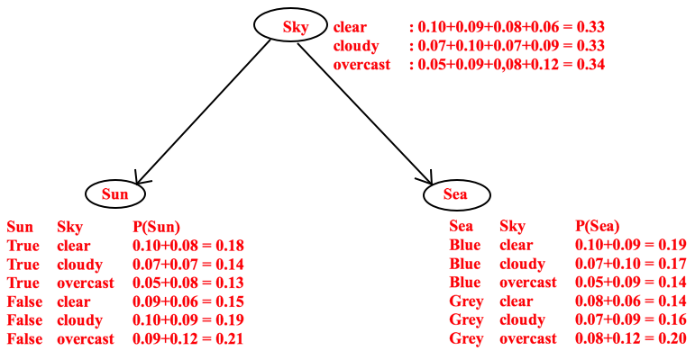

2.

For all parts a through e of problem 2:

Let t be Time = day and ¬t be Time = night

Let sk1 be Sky = clear

Let sk2 be Sky = cloudy

Let sk3 be Sky = overcast

Let sn be Sun=true and ¬sn be Sun=false

Let mn be Moon=true and ¬mn be Moon=false

Let se be Sea=blue and ¬se be Sea=gray

a. P(Time=day, Sky=clear, Sun=true, Moon=false, Sea=blue)

P(t ^ sk1 ^ sn ^ ¬mn ^ se)

Given:

P(t ^ sk1 ^ sn) = 0.9

P(t ^ sk1 ^ ¬mn) = 0.8

P(sn ^ se) = 0.8

P(t ^ sk1 ^ sn ^ ¬mn ^ se) = P(t ^ sk1 ^ sn) P(t ^ sk1 ^ ¬mn) P(sn ^ se) = 0.9 * 0.8 * 0.8 = 0.576

b. P(Moon=true | Time=night, Sky=cloudy)

This is given on the Bayesian network as 0.5

c. P(Time=day | Moon=true)

Choose the minimal set of parents.

Time has no parent.

Moon has two parents: Time and Sky.

Moon and Time are independent of Sun.

Moon and Time are independent of Sea.

$$P\left(t | mn\right)=αP\left(t,mn\right)=αP(t,mn,sk)$$

P(mn) is not given, solve by normalization:

$$P\left(t | mn\right)=α<P\left(t,mn\right),P(¬t,mn)>$$

P(t,mn) = sum of all possible ways this can be true: 0.2 + 0.1 + 0.0 = 0.3

P(¬t,mn) = sum of all possible ways this can be true: 0.9 + 0.5 + 0.1 = 1.5

**P**(t|mn) = α<0.3,1.5>

α = 1 / 1.8 = 0.555

**P**(t|mn) = <0.166, 0.833> => <0.17, 0.83>

P(t|mn) = 0.17

d. P(Sea=blue | Time=day, Sky=clear)

Choose a minimal set of parents:

Sea is independent of Moon.

Sea has a parent Sun.

Sun has parents Time, and Sky

Calculate the distribution of P(Sea=blue):

$$P\left(se | t,sk1\right)=αP\left(se,t,sk1\right)=α\sum_{sn}{P(se,t,sk1,sn)}$$

$$P\left(se | t,sk1\right)=α\sum_{sn}{P(se|sn)P(sn|t,sk1)P(t)P(sk1)}$$

$$P\left(se | t,sk1\right)=αP(t)P(sk1)\sum_{sn}{P(sn|t,sk1)P(se|sn)}$$

and:

$$P\left(¬se | t,sk1\right)=αP\left(se,t,sk1\right)=α\sum_{sn}{P(¬se,t,sk1,sn)}$$

$$P\left(¬se | t,sk1\right)=α\sum_{sn}{P(¬se|sn)P(sn|t,sk1)P(t)P(sk1)}$$

$$P\left(¬se | t,sk1\right)=αP(t)P(sk1)\sum_{sn}{P(sn|t,sk1)P(¬se|sn)}$$

Bayesian Networks:

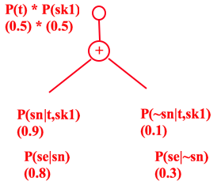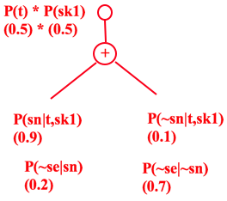

=>

P(se|t,sk1)= α (0.5)(0.5) * ((0.9 * 0.8) + (0.1 * 0.2)) = α0.1875

P(¬se|t,sk1)= α (0.5)(0.5) * ((0.9 * 0.2) + (0.1 * 0.7)) = α0.0625

=> **P**(se|t,sk1) = α<0.1875,0.0625> => <0.75,0.25>

P(se|t,sk1) = 0.75

e. P(Time=day | Sea=blue, Moon=false)

Choose minimal set:

Time has no parent

Sea has parent Sun

Moon has parents Time and Sky

$$P\left(t | se,¬mn\right)=αP\left(t,se,¬mn\right)=α\sum_{sk}{\sum_{sn}{P(t,se,¬mn,sk,sn)}}$$

$$P\left(t | se,¬mn\right)=α\sum_{sk}{\sum_{sn}{P(t)P(se|sn)P(¬mn|t,sk)P(sn|t,sk)}}$$

Moon is independent of Sun so it moves in front of Sun summation,

Time is independent of Sun and Sky so it moves in front of each summation:

$$P\left(t | se,¬mn\right)=αP(t)\sum_{sk}{P(¬mn|t,sk)P(sn|t,sk)\sum_{sn}{P(se|sn)}}$$

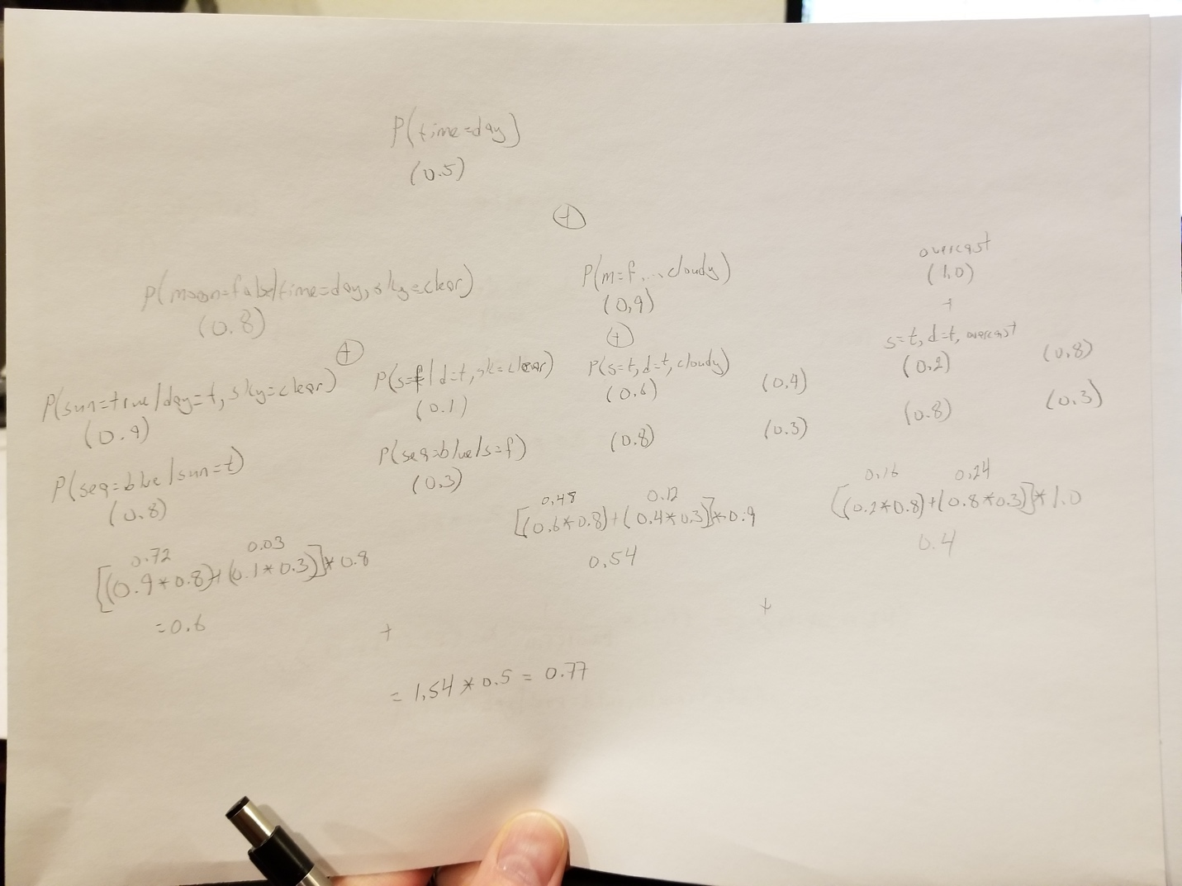

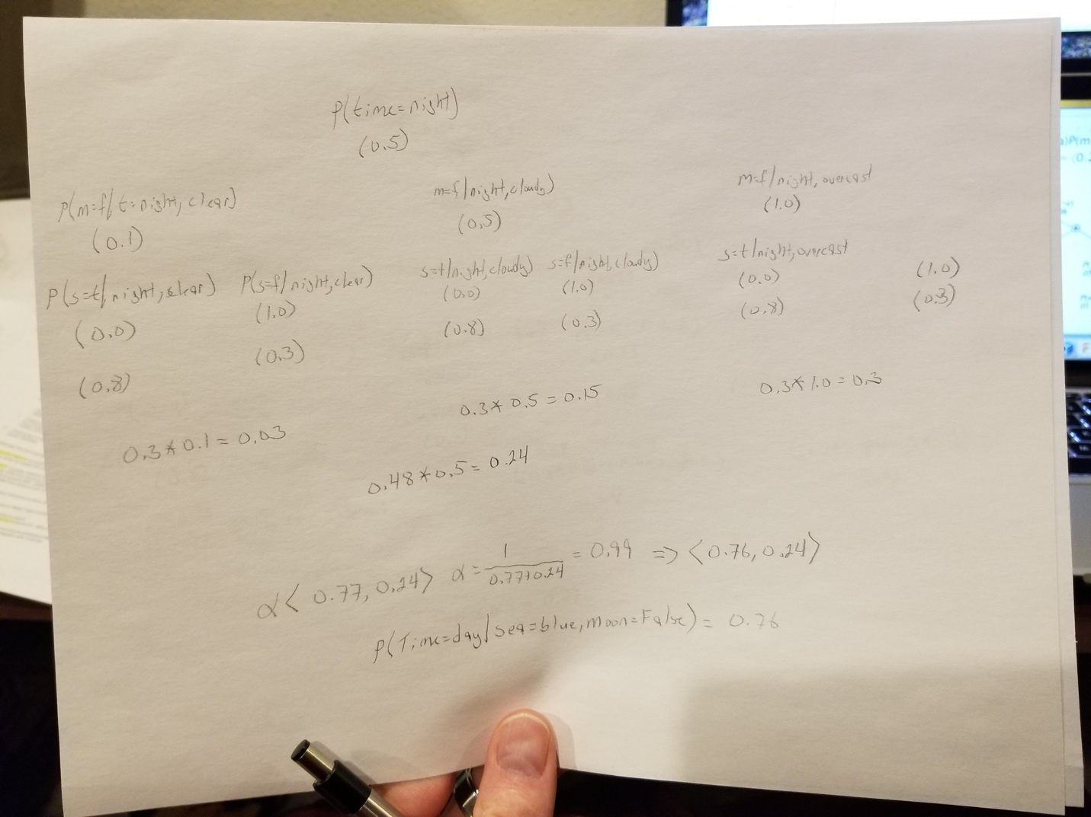

=> α<0.77,0.24> => <0.76,0.24>

P(t|se, ¬mn) = 0.76

3.

a.

Given T=day:

Sky is independent of T, choose highest probability, 0.5, Clear

Sun is dependent on T and Sky, if T=Day and Sky=Clear, highest probability is 0.9, True

Moon is dependent on T and Sky, if T=Day and Sky=Clear, highest probability is 0.8, False

Sea is dependent on Sun, if Sun=True, highest probability is 0.8, Blue

So:

Sky=Clear

Sun=True

Moon=False

Sea=Blue

b.

Given:

Time=Night

Sky=Overcast

Sun is dependent on T and Sky, if T=Night and Sky=Overcast, highest probability is 1.0, False

Moon is dependent on T and Sky, if T=Night and Sky=Overcast, highest probability is 0.9, False

Sea is dependent on Sun, if Sun=False, highest probability is 0.7, Gray

So:

Sun=False

Moon=False

Sea=Gray