P(Moon=true | Time=night, Sky=cloudy) = α \* P(Moon=true, Time=night, Sky=cloudy)

$P\left(X | e\right)=αP\left(X,e\right)=α\sum_{y}{P(X,e,y)}$ so:

$$P\left(mn | ¬t,sk2\right)=αP\left(mn,¬t,sk2\right)=α\sum_{sn}{\sum_{se}{P(mn,¬t,sk2,sn,se)}}$$

Sun has time and Sky as parents

Sea has Sun as parent

So:

$$P\left(mn | ¬t,sk2\right)=α\sum_{sn}{\sum_{se}{P\left(mn\right)P\left(¬t\right)P\left(sk2\right)P\left(sn | ¬t,sk2\right)P(se|sn)}}$$

mn, ¬t, sk2 do not depend on sn or se

sn does not depend on se

so:

$$P\left(mn | ¬t,sk2\right)=αP\left(mn\right)P\left(¬t\right)P(sk2)\sum_{sn}{P(sn|¬t,sk2)\sum_{se}{P(se|sn)}}$$

In Bayesian network form:

==

P(Moon=true | Time=night, Sky=cloudy) = α \* P(Moon=true, Time=night, Sky=cloudy)

$P\left(X | e\right)=αP\left(X,e\right)=α\sum_{y}{P(X,e,y)}$ so:

$$P\left(mn | ¬t,sk2\right)=αP\left(mn,¬t,sk2\right)=α\sum_{sn}{P(mn,¬t,sk2,sn)}$$

Sun has time and Sky as parents

So:

$$P\left(mn | ¬t,sk2\right)=α\sum_{sn}{P\left(mn\right)P\left(¬t\right)P\left(sk2\right)P\left(sn | ¬t,sk2\right)}$$

mn, ¬t, sk2 do not depend on sn or se

so:

$$P\left(mn | ¬t,sk2\right)=αP\left(mn\right)P\left(¬t\right)P(sk2)\sum_{sn}{P(sn|¬t,sk2)}$$

In Bayesian network form:

==

c.

Of 5 variables, we know 2. 3 are unknown. Enumerate across all possible values of the unknown variables.

$$P\left(t | mn\right)=αP\left(t,mn\right)=α\sum_{sky}{\sum_{sn}{\sum_{se}{P(t,mn,sky,sn,se)}}}$$

Time has no parent and is known

Sky has no parent and is unknown

Sun has Time and Sky as parents and is unknown

Moon has Time and Sky as parents and is known

Sea has Sun as a parent and is unknown

$$αP(t)P(mn)\sum_{sky}{P(sky)\sum_{sn}{P(sn|t,sky)\sum_{se}{P(se|sn)}}}$$

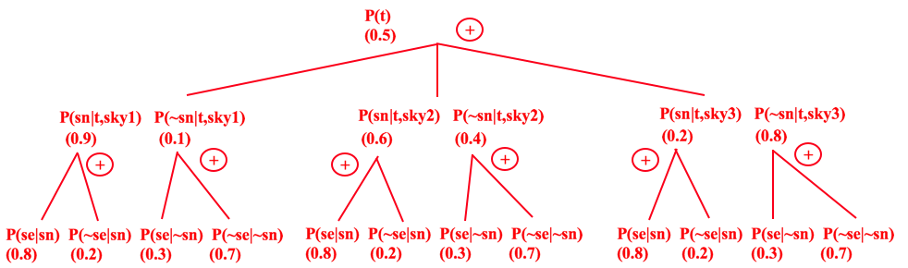

t: (0.5) \*[ ( (0.9)\*((0.8)+(0.2)) + (0.1)\*((0.3)+(0.7)) )

+ ( (0.6)\*((0.8)+(0.2)) + (0.4)\*((0.3)+(0.7)) )

+ ( (0.2)\*((0.8)+(0.2)) + (0.8)\*((0.3)+(0.7)) ) ]

= (0.5) \* [ (0.9) + (0.1) + (0.6) + (0.4) + (0.2) + (0.8) ]

= 1.5

¬t: (0.5) \*[ ( (0.9)\*((0.8)+(0.2)) + (0.1)\*((0.3)+(0.7)) )

+ ( (0.6)\*((0.8)+(0.2)) + (0.4)\*((0.3)+(0.7)) )

+ ( (0.2)\*((0.8)+(0.2)) + (0.8)\*((0.3)+(0.7)) ) ]

= (0.5) \* [ (0.9) + (0.1) + (0.6) + (0.4) + (0.2) + (0.8) ]

= 1.5

α<1.5,1.5> = <0.5,0.5>