**Milestone 3:**

Draw the detailed class diagrams, package diagrams, and CRC index cards, indicating relationships between classes.

**Team: CABS**

Marcus Blaisdell

Vivek Sandhinti

Christian Asivido

Joseph Crissey

**Class Diagrams:**

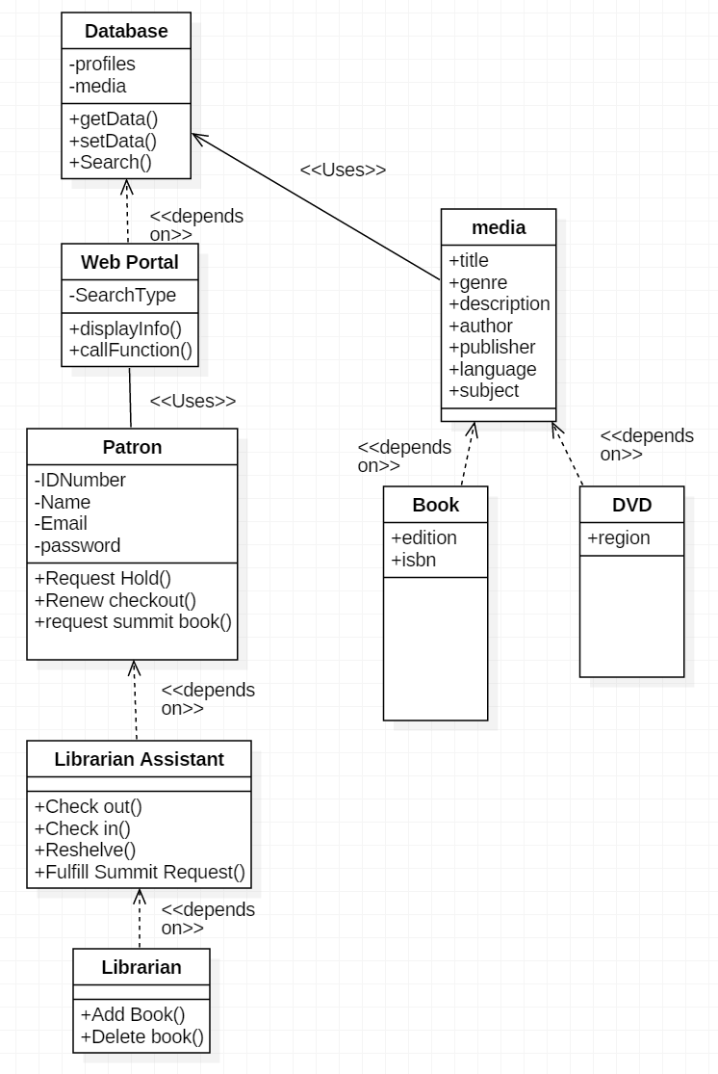

**Package Diagram:**

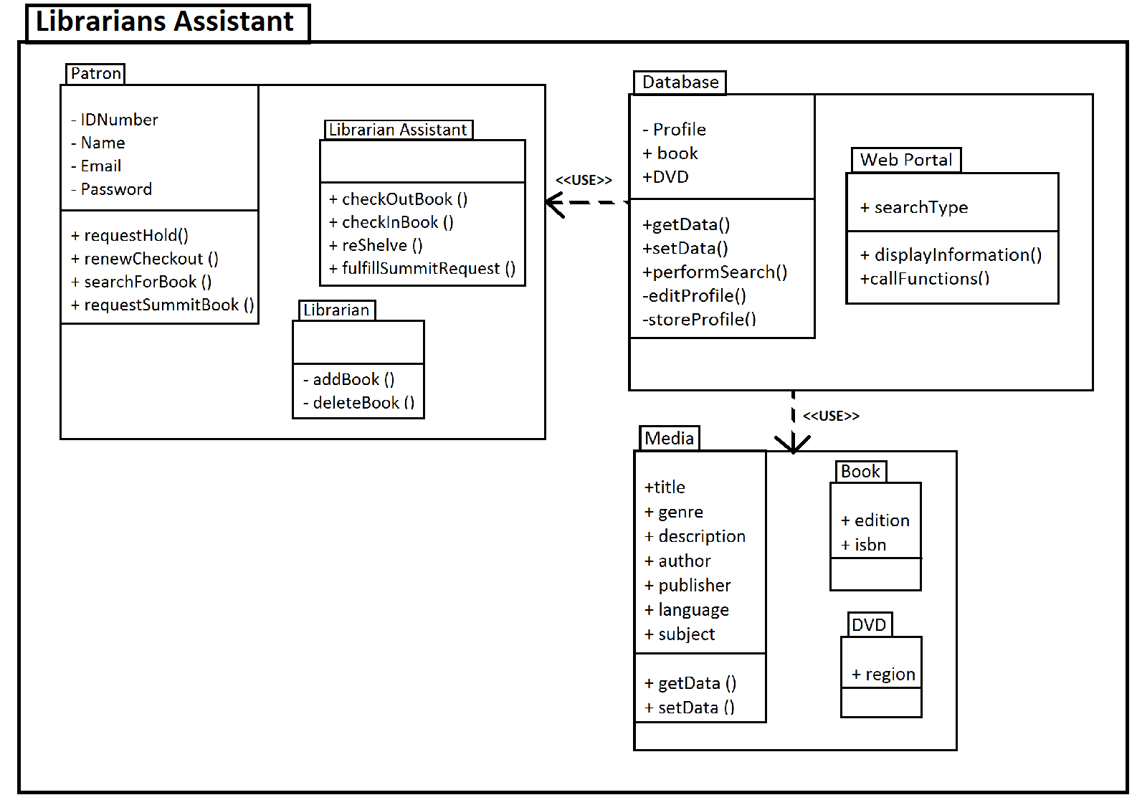

**CRC Index Cards:**

|  |  |  |
| --- | --- | --- |
| **Class: Database** |  |  |
| **Responsibility:** |  | **Collaborator:** |
| get data |  | Web Portal |
| set data |  | Web Portal |
| perform search |  | Web Portal |
| edit profiles |  | Web Portal |
| Stores the Data |  | Web Portal |
| Stores profiles |  | Web Portal |
|  |  |  |
|  |  |  |
| **Class: Web portal** |  |  |
| **Responsibility:** |  | **Collaborator:** |
| display information |  | Database |
| call functions |  | Database |

|  |  |  |
| --- | --- | --- |
| **Class: Patron** |  |  |
| **Responsibility:** |  | **Collaborator:** |
| request hold |  | Database |
| renew checkout |  | Librarian Asst. |
| request summit book |  | Database |
| input search parameters |  | Web Portal |
|  |  |  |

|  |  |  |
| --- | --- | --- |
|  |  |  |
| **Class: Librarians Assistant** |  |  |
| **Responsibility:** |  | **Collaborator:** |
| Checks in books |  | Database |
| checks out books |  | Database |
| reshelve |  | Database |
| fullfil summit request |  | Database |
|  |  |  |
|  |  |  |
| **Class: Librarian** |  |  |
| **Responsibility:** |  | **Collaborator:** |
| Add book |  | Database |
| Delete book |  | Database |

|  |  |  |
| --- | --- | --- |
| **Class: DVD** |  |  |
| **Responsibility:** |  | **Collaborator:** |
| store info |  | database |
| get and set special attributes |  | database |
|  |  |  |
| **Class: media** |  |  |
| **Responsibility:** |  | **Collaborator:** |
| getters |  | database |
| setters |  | database |
|  |  |  |
| **Class: book** |  |  |
| **Responsibility:** |  | **Collaborator:** |
| store info |  | database |
| get and set special attributes |  | database |