**Milestone 5:**

1. Include elaborated class diagram for each design class, with data type and initial value annotated for each data attribute, and with processing logic elaborated for each operation that contains non-trivial steps. (That is, for some very simple operations, the implementation would be just a few lines of code, thus the processing logic does not have to be elaborated here.)

2. Draw the elaborated component diagram for each component, with attributes and operations added and interface clearly indicated, by using the elaborated design classes associated with the component. (The elaborated behavioral models are used as intermediate resources for deriving component-level details,

**Team: CABS**

Marcus Blaisdell

Vivek Sandhinti

Christian Asivido

Joseph Crissey

1. Elaborated Class Diagram:

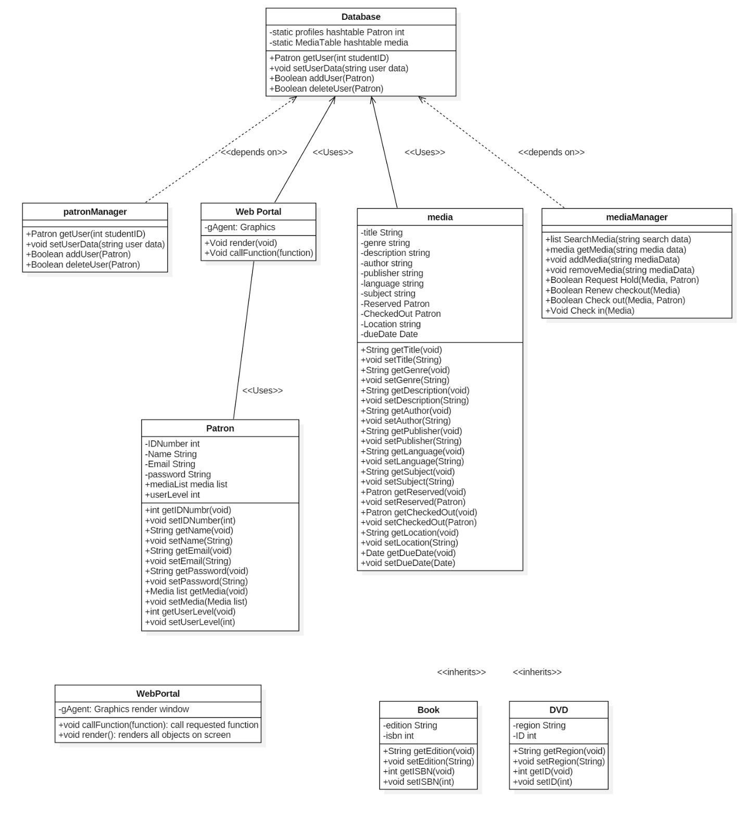

2. Elaborated Component Diagram

