CptS 443/543—Human-Computer Interaction

Cognitive Walkthrough Form

Briefly describe the system being evaluated:

The ALVIS Live!, novice programming environment. A graphical, drag-and-drop programming tool that is intended to teach the basics of computer programming.

Briefly describe the target users of this system (background, experience, etc.):

This is targeted to people with little to no experience in computer programming.

Briefly describe the task(s) to be evaluated:

We are evaluating the task of writing an algorithm that will use: variables, arrays, loops, and conditionals.

Task 1: Create an array
Task Steps for Task 1 | Will the user know what to do next to make progress? | Will the user notice how to perform the correct action? | Will the user interpret the system response correctly?
1.1  Click on Create Array icon | The “Create Array” button is clearly labeled with its function. It says “Create Array” and it creates an array. This seems clear. | Unless the person is new to Graphical User Interfaces on computers, they should be familiar with “clicking” on icons. Yes, the user should notice how to perform the correct action. | When the button is clicked, it turns grey and when the cursor is moved, it seems to be holding something to indicate that the user has picked something up which would imply that it can be put down somewhere else.
1.2  Click on animation window | As has been pointed out in the sample, the animation window lacks a signifier. Had the sample not identified it as such, I would have called it a workspace or canvas. As the cursor is moved around, the item it is carrying only appears when it is over this area which would suggest that is the only area where that element can be used. | Clicking again inside the area would be a logical next step for even most novice computer users. | After clicking in the animation window, the cursor is no longer carrying the array and the array appears in the window. This seems sufficient to indicate that an array has been created.
1.3  Click on array to reveal double-arrows | The array has no indications that any additional actions can be taken until it is clicked on. A user with a modicum of computer experience would likely attempt this to see if anything changes. | No, it is not noticeable. Using prior knowledge of basic GUI interactions will drive most users to click on the array to see if more options are available but they won’t notice the arrows until they click on it. | Clicking on the element creates a dashed border and the double-arrows appear that suggest resizing.
1.4  Drag double-arrows to resize array to desired size | The double-arrows are a signifier for resizing. They are fairly common but may not be well-known to novices. Once the user begins resizing, it is discovered that it can be resized by rows and columns. Novice users are unlikely to know that arrays begin at zero and that size n will end at index n-1. | The array can be resized by rows and columns. If the user is just asked to create an array of size 6, a novice is not likely to understand the difference between rows and columns and may instead create a matrix instead of an array. | It needs to be specified that the array needs to have 1 row, and six columns. It needs to be specified that arrays count from zero so an array of size six will end with index 5, not 6.
1.5

Task 2: Populate the array with random values

Task Steps for Task 2 | Will the user know what to do next to make progress? | Will the user notice how to perform the correct action? | Will the user interpret the system response correctly?
2.1  Click on Populate icon | The populate button is clearly labelled. | Yes, if they have a modicum of experience with a GUI. | When the button is clicked, it turns grey and when the cursor is moved, it is holding a bucket that is pouring into an array suggesting that it contains something that will go into the array.
2.2  Click anywhere in the array | The pouring bucket and array image only appear if the cursor is hovering on the array, if it is anywhere else in the window, it shows a red X, and shows nothing if it is not within the animation window. | Since the green array image with the bucket only appear when the cursor is above the array, yes. | The images clearly show that the array can take the populate action and that nothing else in the animation window can and the action has no effect outside the animation window.
2.3

2.4

2.5

Task 3: Create a variable to store the max value

Task Steps for Task 3 | Will the user know what to do next to make progress? | Will the user notice how to perform the correct action? | Will the user interpret the system response correctly?
3.1  Click on create variable button | The “Create Variable” button is clearly labelled. | Yes. By this point, clicking on buttons and adding their function to the animation window will be familiar. | Yes. The button turns grey and the cursor will have an image that it is “carrying” that is the same action already seen when creating the array. If that step was completed successfully, the user will relate with this step.
3.2  Click in the animation window, outside the array, to place the variable | The cursor image shows a box with what looks like a running stick figure. | The cursor image is the same when it is over the array and over empty space in the animation window but gives an error if the user tries to create the variable inside the array when the value is already populated. | Yes. A new image is created on the animation window. The fact that it has a label and a box that can contain information may not be yet apparent but is not necessary at this stage.
3.3  Change name of variable to “maxsofar” | Hovering over the variable with the cursor brings up a note box that clearly states to double-click to modify | Yes. The help notice that appears when hovering over the icon has relevant information in clear language. | Yes. The required action is spelled out in plain language.
3.4

3.5

Task 4: Create an array index at index 0

Task Steps for Task 4 | Will the user know what to do next to make progress? | Will the user notice how to perform the correct action? | Will the user interpret the system response correctly?
4.1  Click on create index button | “Create Index” button is clearly labelled. | Yes. Again, this type of operation has already been performed and the user will be familiar with the process. | Yes. The button turns grey, the same as it has for the earlier operations. The behavior is consistent.
4.2  Place index at position 0 of the array | After clicking on “Create Index” button, a help message appears that states to click on an array cell to create an index at that location | Yes. The instruction states to place the index at position 0, position 0 is labelled. | After placing the index, a red arrow appears that is pointing at that index indicating that this is where the index is located.
4.3

4.4

4.5

Task 5: Create a loop to iterate through the array

Task Steps for Task 5 | Will the user know what to do next to make progress? | Will the user notice how to perform the correct action? | Will the user interpret the system response correctly?
5.1  Click on “Iterate Loop” | Button is clearly labelled. | Yes, familiar at this point. | Yes, familiar at this point.
5.2  Click on the red arrow above index zero and drag it inside the last box in the array. | When the cursor hovers over the red arrow, a new image appears with an arrow that indicates that the index can be dragged to a new location, however, dragging it strictly horizontally, above the array, causes it to delete the index, the fact that the index has to be drug down from its position above the array to inside the array is not obvious and resulted in me deleting the index three times before re-watching the youtube video to find out what I was doing wrong. | No, having to drag the index marker down onto the array itself was not obvious. The image attached to the cursor did show a red X on top of the red arrow but it was not easily noticeable until I went looking for it. | If they do the operation correctly, then new text appears in the Script Editor window but no new graphic appears on the animation window so, maybe yes, maybe no.
5.3

5.4

5.5

Task 6: Create a conditional statement to evaluate the array element against the variable

Task Steps for Task 5 | Will the user know what to do next to make progress? | Will the user notice how to perform the correct action? | Will the user interpret the system response correctly?
6.1  Click on “If” button | Yes, familiar. | Yes, familiar. | Yes, familiar.
6.2  Click on the first element of the array | Yes, familiar from the creating index step. | Yes, clicking on specific parts of the array has been performed already so this is a now familiar operation. | Yes, by clicking on the first element, a new popup window appears prompting the user for more actions. The box has green buttons that could be interpreted as good signs.
6.3  In the popup window, select an array index, a1[i1], as ‘x’ | Yes, if this step specifies to select the button labelled a1[i1]. | Yes, they need only click on a button, a simple step. | Clicking on the correct button brings up a new window with more actions so yes, it shows progress.
6.4  Click on the “greater-than” symbol, “>” | Yes, as long as the correct button to be pressed is specified. | Yes, this is very similar to the previous step. | Yes, clicking on the button brings up the next window.
6.5  Select “Variable” and click “OK” button | Yes, the radio button is next to the “Variable” option. | Radio buttons are a bit different, this does depend on the user’s familiarity. The previous steps were green buttons, these are different so there is a possibility for some confusion. | If the user correctly clicks the radio button then the black dot moves from “Number” radio button to the “Variable” radio button and the Variable label now has a dashed border.
6.6  Click on the variable “maxsofar” | Yes, the variable is clearly labelled in the animation window. | Yes, clicking on an icon is a familiar task at this point. | After clicking on the variable, there are no more pop-ups and new code appears in the Script Editor window.

Task 7: Update variable if condition is satisfied

Task Steps for Task 5 | Will the user know what to do next to make progress? | Will the user notice how to perform the correct action? | Will the user interpret the system response correctly?
7.1  Click on “Set” button | Yes, familiar. | Yes, familiar. | Yes, familiar.
7.2  Click on variable “maxsofar” | Yes, familiar. | Yes, familiar. | Yes, familiar.
7.3  Select “Variable” and click “OK” button | Yes, the user will now be familiar with radio buttons and this window will be familiar. | Yes, the user will now be familiar with radio buttons and this window will be familiar. | Yes, after clicking OK, a new window appears prompting for new action.
7.4  Click on the array | Yes, this step is similar to a previous step. | Yes, the user has seen this type of task earlier so this will be familiar. | Yes, after clicking inside the array, a new box appears prompting the user for more information, it is similar to an earlier task.
7.5  Choose “a1[i1]” as x | Yes, this is similar to an earlier step. | Yes, the user did a similar action earlier. | After clicking the button, the pop-up window disappears and the user is no longer prompted for more actions.
7.6

Task 8: Run program

Task Steps for Task 5 | Will the user know what to do next to make progress? | Will the user notice how to perform the correct action? | Will the user interpret the system response correctly?
8.1  Click on the button with the right-pointing double-arrows | The double-arrows may be familiar to some users as the fast-forward button on a media player and they may not think this is the right action. The single right-facing triangle is familiar as a play button and would have been my first instinct for the correct button at this point. | If they are instructed to press the double-arrows button, then noticing that button and clicking on it is straightforward. | The animation begins and the double-arrows are held at grey while the green arrow increments through the code in the script editor and the values of the variable and position of the index marker change showing the progress of the program. The user will understand that this is an animation of the program running.
8.2  Watch as program runs step by step and updates the “maxsofar” variable as it steps through the array with the largest value found so far and after the program runs, it contains the largest value that was in the array. | At this point, they need only observe, the step instructs them to watch, yes, they will know what to do. | Yes, watching an animation is straightforward. | Since this is an animation of a running program that executes an algorithm, the user will understand that for what it is.
8.3

8.4

8.5

Summary of results:

Aspects of design that worked: [Fill in]

The toolbar buttons are clearly labelled. They use plain-text signifiers combined with graphic icons that give some indication of their purpose. The icons afford clicking.

All of the buttons and icons also afford additional notes when the cursor is hovered over them. They afford hovering help. (Figures 1, 2, 3)

When they are selected, an image is then carried around with the cursor while it is inside the animation window indicating that that is where that action is relevant. This is a signifier that the desired action has been selected and indicates that there is a next step to complete by dropping the image onto the animation window.

There are additional signifier red X’s that appear to indicate areas where a feature cannot be placed.

There is feedback in that when I click on an icon, an image appears on the cursor and more feedback in that when the cursor is over the animation window, the image is visible on the cursor but it is absent if the cursor is outside the animation window. This let me know that the operation was valid inside the animation window and invalid elsewhere.

There is additional feedback when the action is placed on the animation window as a new image appears in the window and is removed from the cursor. This clearly indicates that the operation has completed successfully. Additionally, code appears in the Script Editor window as the operation is completed.

Color is used to indicate differences in operations. For example, the rewind/reverse play operations are orange and the play forward, one-step-at-a-time buttons are blue. The images on their icons are similar so the different colors help distinguish that the buttons have similar yet different operations.

The animation on the program is well-paced. Each operation is easily distinguishable and I can shift my attention from the animation window to the Script Editor window and still follow the progress of the program. The timing is good and within a human -readable range.

Potential usability issues: [Fill in here. For each issue, describe why the user may face difficulties, using concepts from class were possible.]

The user can try to create a variable inside a populated array index, there is no indication that this will cause an error. The error message appears after the user has completed the incorrect action. This lacks the signifier that other operations have in the red X to indicate that the action is not viable.

Creating an iteration requires the user to drag the index arrow from above the array to inside the array. This was very confusing and I deleted the index three times before re-watching the youtube video to learn what I was doing wrong. This is a break in the consistency of the operation. The signifier marker triangle is above the array and I wished to place it in a new position at the end of the array where I would have assumed it would still be above the array. Moving it from above the array to inside the array was outside the conceptual model I had formed in my mind of how the operation would work.

After creating the iteration, new code appears in the Script Editor but nothing changes on the animation window, this could be missed leaving the user to wonder if the operation performed successfully or not. There is feedback in the additional code appearing in the Script Editor window but it can be missed because it is not at the in the area that my visual attention is focused on. My peripheral vision did detect the change and alerted me to look over at the Script Editor window but this does depend on my remembering what the code was before the iteration was added and could be missed.

The right-facing double-arrows icon to me is more indicative of a fast-forward operation. I would have instinctively believed that a single, right-facing triangle which is more associated with play, would have been the correct button to press. This would have been more consistent with the existing technology I am already familiar with. There is a helper text window signifier that appears when hovering over the button to explain its operation that was helpful.

Proposed Design Changes:

For each usability issue, suggest a concrete design change that could remedy the issue. You are encouraged to use annotated sketches to illustrate your suggested design changes.

Add a signifier to the “animation window” that identifies it as such. (Figure 4)

A new variable cannot be created inside a populated array index but the cursor image does not change to a red X to indicate this. It appears to allow the variable to be created but shows an error message in the “Errors” window. The cursor image should have an additional signifier and change to a red X if the user attempts to create a variable in a location that is already populated.

When creating an iterative loop, the index arrow must be dragged from above the array to on the array at the proper box. It should be able to drag the arrow across the top of the array from it’s start point to it’s end point rather than requiring the user to move the cursor from above the array to inside the array. This operation should be consistent in design that the marker action is above the array and does not need to move from above it to within it. (Figures 5, 6)

After creating the iteration, there should be a visual feedback at the area the user is looking at in the animation window. The user shouldn’t have to remember what the code looked like before the operation.

The right-facing double-arrows image is more indicative of fast-forward, I would have instinctively believed that a single, right-facing triangle which is more associated with play because of existing technology that uses those types of images for their operations such as music and video players, would have been the correct button to press. The button I would have regarded as a play button is the one-step-at-a-time button. It would fit my personal conceptual model to have the single right-facing triangle be the “Play forward” button and to change the one-step-at-a-time button image to something else like a single right-facing triangle pointing at a double-vertical line “>||” that could indicate a combination of play/pause. Leveraging the transfer effect of existing technology that uses the same icons, this could be refined to be more in line with tools users are likely to already be familiar with. (Figures 7, 8)

Annotated images:

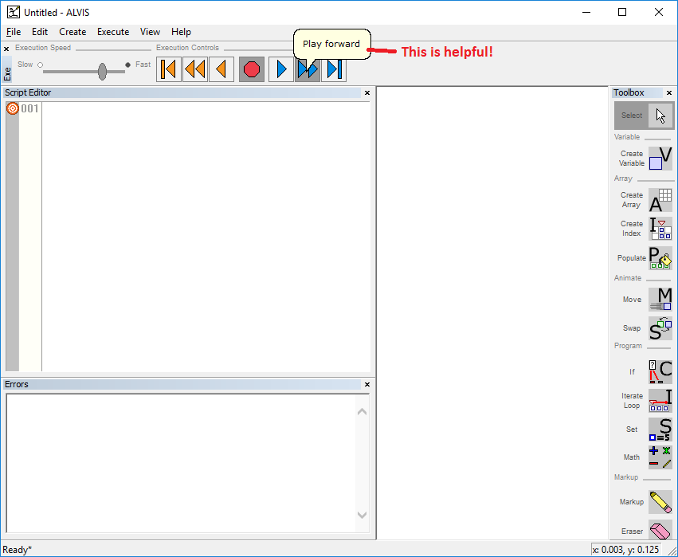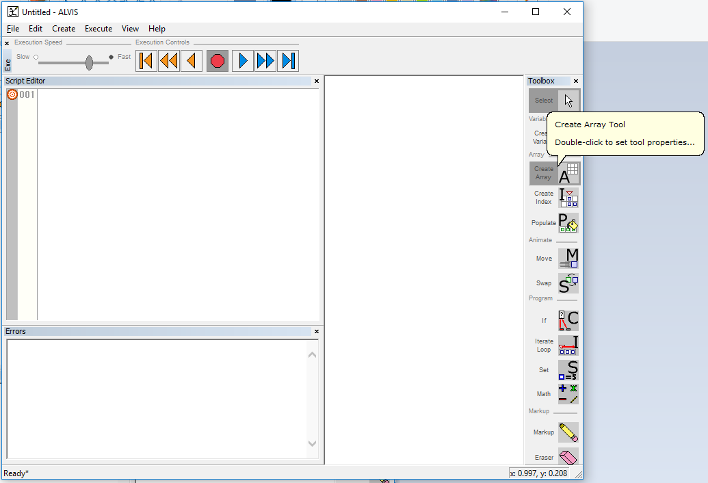
Figures 1, 2: The pop-up helper notes when hovering over an icon
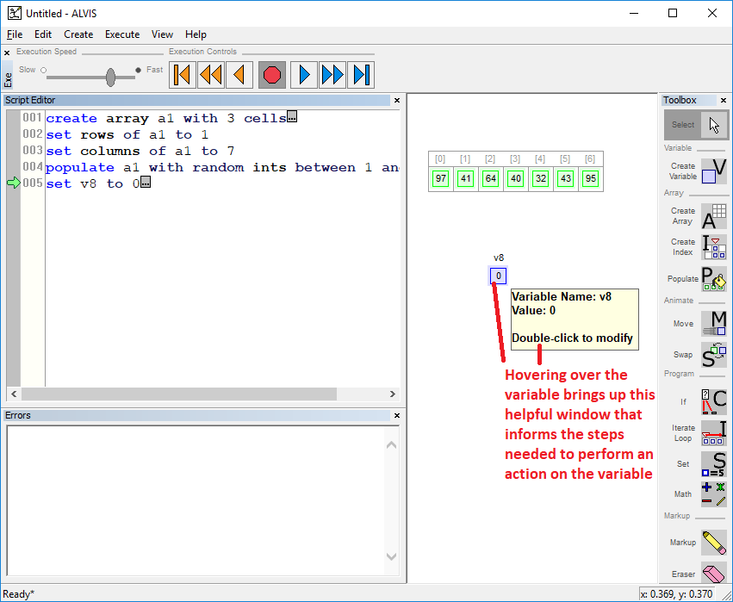
Figure 3: Hovering over the variable enables helpful pop-up window
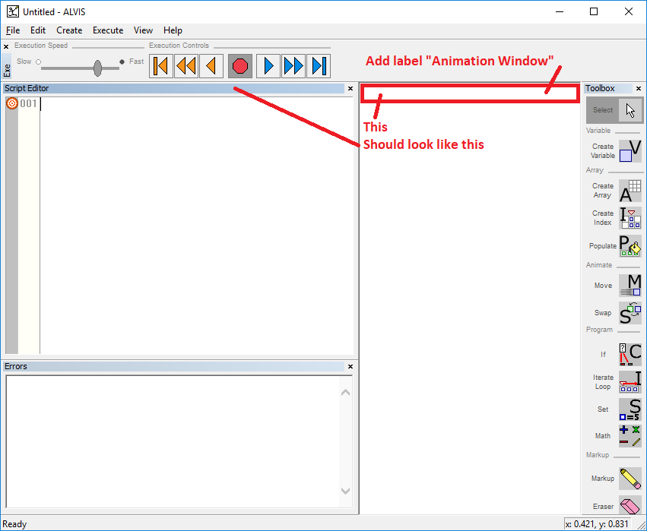
Figure 4: Animation window should have a signifier label
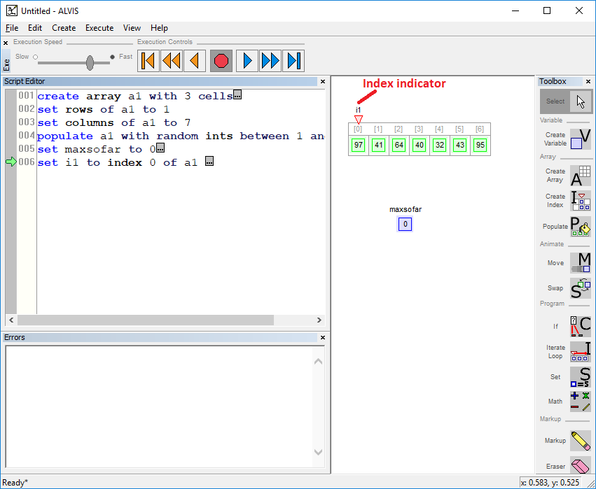
Figure 5: Index indicator before creating iteration, the indicator is above the array
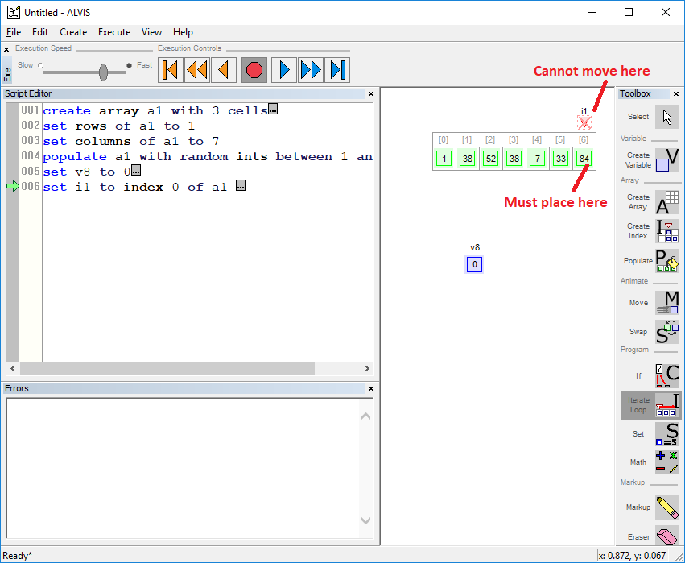
Figure 6: The red X inside does appear when trying to move the iteration index indicator above the array but is hard to notice
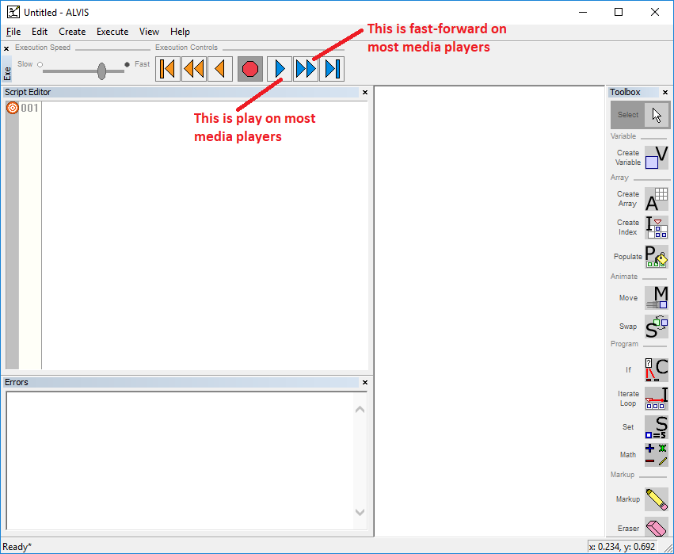
Figure 7: Confusing icons on play one-step-at-a-time and play-forward buttons
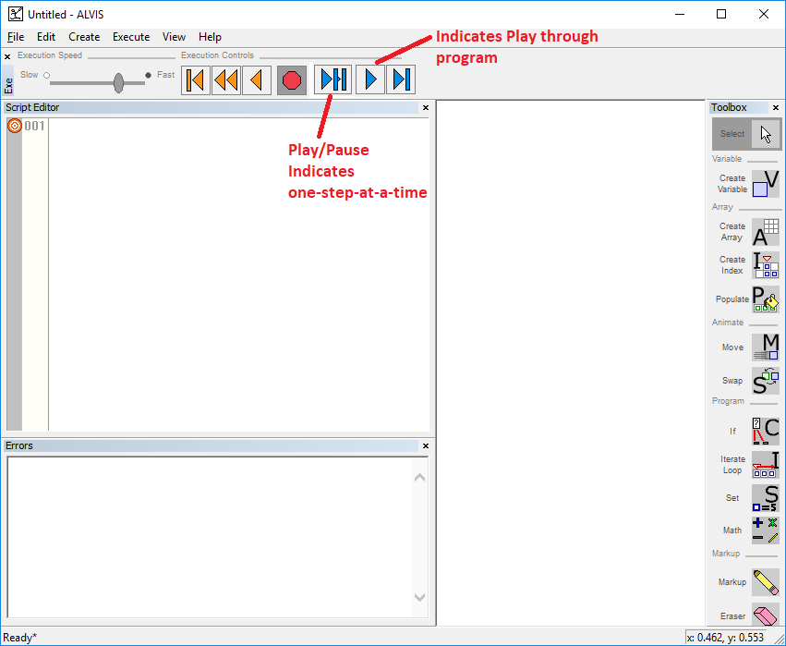
Figure 8: Proposal for new button icon images

