Cpt S 411 Assignment Cover Sheet

(To be turned in along with each homework and program project submission)

Assignment #
4

For individual assignments:

Student name (Last, First):
Blaisdell, Marcus

For team projects:

List of all students (Last, First):

List of collaborative personnel (excluding team participants):

I certify that I have listed above all the sources that I consulted regarding this assignment, and that I have not received or given any assistance that is contrary to the letter or the spirit of the collaboration guidelines for this assignment. I also certify that I have not referred to online solutions that may be available on the web or sought the help of other students outside the class, in preparing my solution. I attest that the solution is my own and if evidence is found to the contrary, I understand that I will be subject to the academic dishonesty policy as outlined in the course syllabus.

Please print your names.
Marcus Blaisdell

Assignment Project Participant(s):

Today’s Date:
11/15/19
Speedup:

I used an n-value of 1,073,741,824 and ran the program 10 times each for p={1,2,4,8} with 8 nodes, 8 threads, and took the average time of the 10 runs. The speedup was calculated as the (time to run on one process) / (time to run on p processes). The speedup is very small with 2 and 4 processes and shows a more notable decline with 8:

n=1073741824 | pi | Average time | Speedup
p=1 | 2.99991 | 11.8132026 | 1
p=2 | 2.999913 | 11.7335062 | 1.00679221
p=4 | 2.999753 | 11.7847146 | 1.00241737
p=8 | 2.999812 | 11.9939137 | 0.9849331
Table 1: speedup

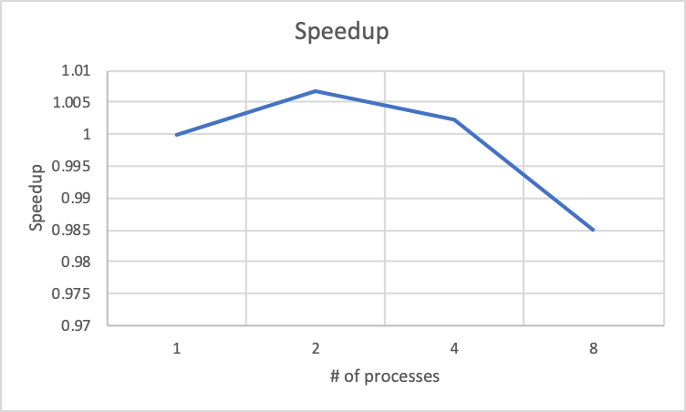
Chart 1: Speedup

Precision testing:

For precision testing, I held n/p fixed to n/p =134217728 and ran it for p = {1, 2, 4, 8, 16, 32}:

There was a slight improvement in the estimation of pi as the number of processes increased to 16 and then a slight decrease at 32. Therefore, increasing the number of processes did improve the estimation up to 16 but increasing processes after that had a reduction in effectiveness. The total processing time decreased notably as the number of processes increased:

processes | time (us) | pi estimation
1 | 1.483565 | 2.999753
2 | 0.734089 | 2.999729
4 | 0.366541 | 2.999913
8 | 0.186804 | 2.999913
16 | 0.092201 | 3.000058
32 | 0.049500 | 2.999826
Table 2: Precision testing

If you worked as a team, then the word “I” includes yourself and your team members.

