Mercury
Master Technical Report

GPU-Class PDN Test Platform
Revision 1.0
Marcus Cropley
RMIT University — Electronics and Computer Systems Engineering

PCBWay Design Competition — 11th Place + Popular Design Prize

1. Introduction and Scope
Mercury is a GPU-class power delivery network (PDN) test platform designed to evaluate the behaviour of high-current PCB power distribution under transient conditions representative of modern discrete graphics processing units. The board addresses a specific engineering question: what are the physical and geometric limits of PCB-level power delivery when subjected to GPU-class current transients of approximately 500 A at 1.0 V?

The project was motivated by a clear industry signal. Modern high-performance GPU and AI accelerator designs require power delivery engineers who understand not just circuit theory, but the geometric and physical constraints that dominate real transient behaviour. The Mercury board was designed to demonstrate this understanding through a fabrication-valid, industry-representative hardware design — one that operates within the same electrical regime as RTX 4090-class boards and is documented to the standard expected of a commercial engineering deliverable.

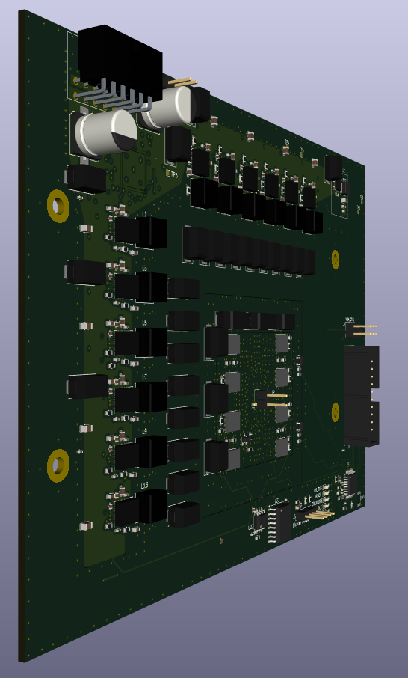
Figure 1.1 — Mercury GPU-Class PDN Test Board: three-quarter perspective render showing the 12-phase VRM (left column), inductor array, bulk decoupling, and load region

1.1 Definition of a GPU-Class PDN Test Board
The term 'GPU-class' refers specifically to the electrical operating regime, not to physical or functional compatibility with any commercial GPU system. A GPU-class PDN is characterised by sub-milliohm target impedance, sub-microsecond transient response requirements, and load currents in the hundreds of amperes range at voltages below 1.2 V. Mercury operates within this regime, targeting a peak current capability of approximately 500 A at 1.0 V with a maximum allowable voltage droop of 40 mV.

Mercury is not a concept board, a simplified academic exercise, or a developer evaluation platform. It is a fabrication-valid design, implemented with industry-grade layout practices, a realistic multi-phase VRM architecture, and a controlled load injection system capable of stimulating the PDN with meaningful transient events.

1.2 Scope Boundaries
This document is a technical design and analysis report covering the architectural decisions, modelling methodology, and implementation details of the Mercury board. It does not claim:

- Silicon validation of any kind. No GPU die or ASIC is present on this board; the load is implemented as a MOSFET-based transient injection system.
- A complete firmware validation stack. The onboard STM32 microcontroller controls load injection and current monitoring but does not implement a full GPU power management interface.
- Thermal predictions beyond first-order reasoning. Thermal behaviour is discussed qualitatively where relevant; no formal thermal simulation was performed.
- Experimental confirmation of the 40 mV droop target under full 500 A transient conditions. The design was developed and optimised with this target as a bound; physical measurement to validate the full transient envelope was not completed within the scope of this revision.

1.3 Audience
This document is written for power delivery engineers and hardware designers with working familiarity in PDN design, multi-phase VRM topologies, and PCB-level power integrity. Familiarity with LTspice or an equivalent simulation tool is assumed. Where fundamental concepts are introduced, they are presented briefly for completeness rather than as tutorial material.

2. System Requirements and Design Constraints
This project addresses the problem of delivering large, fast transient currents to a low-voltage load in a form factor representative of modern GPU power delivery systems. The primary design objective was to evaluate the physical and geometric limits of PCB-level power distribution when subjected to GPU-class current transients.

2.1 Electrical Requirements
The system was designed to support a peak load current step of approximately 500 A with a maximum allowable voltage droop of 40 mV at the load node. This corresponds to an effective target impedance of approximately 0.08 mΩ.

This requirement was selected to be representative of contemporary high-end GPU power delivery systems and was informed by publicly observable characteristics of RTX 4090-class boards as well as external guidance from industry power delivery engineers. The objective was not to replicate a specific commercial design, but to operate within a comparable electrical regime.

The nominal output voltage of the power delivery network is 1.0 V, placing the system in the ~500 W output power class. Input power is supplied from a 12 V source, with the effective upper bound on deliverable power constrained by the selected input connector to approximately 600 W. This input limitation was treated as a hard constraint and intentionally defines the maximum operational envelope of the board.

Parameter | Target Value
Output Voltage (VCORE) | ~1.0 V
Peak Load Current | ~500 A
Maximum Voltage Droop | ≤ 40 mV
Target Impedance (Ztarget) | ~0.08 mΩ
Input Supply Voltage | 12 V
Maximum Input Power | ~600 W (connector-limited)
VRM Phase Count | 12
Switching Frequency | 400–500 kHz
Phase Inductor Value | ~150 nH per phase

2.2 Power Delivery Architecture Constraints
The VRM architecture was constrained to a 12-phase topology, reflecting the largest readily accessible controller available without proprietary or NDA-restricted components. While higher phase counts are common in commercial GPU designs, increasing controller count or synchronising multiple controllers was deliberately avoided due to added complexity and risk, particularly given the exploratory nature of the project.

As a result, the design emphasises PDN geometry, plane structure, and decoupling strategy rather than brute-force phase multiplication.

2.3 PCB Geometry and Layer Constraints
Given the target current levels and transient performance requirements, solid copper pours were treated as non-negotiable for both the 12 V input distribution and the VCORE output distribution. Narrow trace-based routing was explicitly rejected for high-current paths.

The PCB stackup was constrained to six layers, which was determined to be the minimum layer count that allowed: dedicated low-impedance return planes, continuous high-current power planes, and controlled vertical current transitions, while remaining economically feasible for fabrication.

Although a higher layer count (e.g., ten layers) would have enabled additional routing flexibility — such as placing the 12 V distribution on an internal plane — the incremental benefit was not justified relative to cost for a non-product, testbench-oriented design.

2.4 Board Size and Mechanical Constraints
The board dimensions were selected based on component placement requirements, connector clearances, and mechanical mounting constraints rather than adherence to an existing GPU form factor. While inspired by RTX 4090-class layouts, the final board size of approximately 165.5 mm × 120 mm reflects a compromise between compactness and the need to maintain spatial separation between high-power circuitry and low-power digital control elements.

Board size was intentionally allowed to exceed the theoretical minimum to simplify routing, improve accessibility, and reduce coupling between high-di/dt regions and sensitive control signals.

2.5 Decoupling and Load Representation Constraints
A critical limitation of PCB-level testing relative to real GPU systems is the absence of on-die capacitance, which provides extremely low inductance energy storage at very high frequencies. This constraint fundamentally limits the ability of board-level capacitance to replicate true GPU transient behaviour.

To account for this, the applied load transient edge rates were intentionally moderated to reflect a realistic excitation that a PCB-level load could meaningfully evaluate. The load was implemented using a MOSFET-based transient injection approach, selected for cost, availability, and controllability.

While more sophisticated programmable electronic loads are used in professional validation environments, such equipment was not available within the scope of this project. The chosen load strategy reflects a pragmatic balance between realism and feasibility, and its limitations are explicitly acknowledged.

2.6 Project Scope and Intent
This board is not intended to function as a complete GPU power solution, nor to compete directly with commercial implementations. It is a power delivery test platform, designed to isolate and study the physical behaviour of high-current PDNs under fast transient conditions.

All design decisions were evaluated primarily through the lens of transient impedance and current path geometry, rather than efficiency optimisation, cost minimisation, or long-term reliability.

3. Power Delivery Architecture Overview
The Mercury power delivery network consists of three primary functional blocks: a multi-phase voltage regulator module (VRM) responsible for converting 12 V input to a regulated 1.0 V output; a distributed PDN comprising power planes, a hierarchical decoupling capacitor network, and a controlled via structure; and a MOSFET-based load injection system that approximates GPU workload transients. These three blocks interact across a defined set of voltage domains and are described below at the architectural level, prior to the detailed analysis presented in subsequent sections.

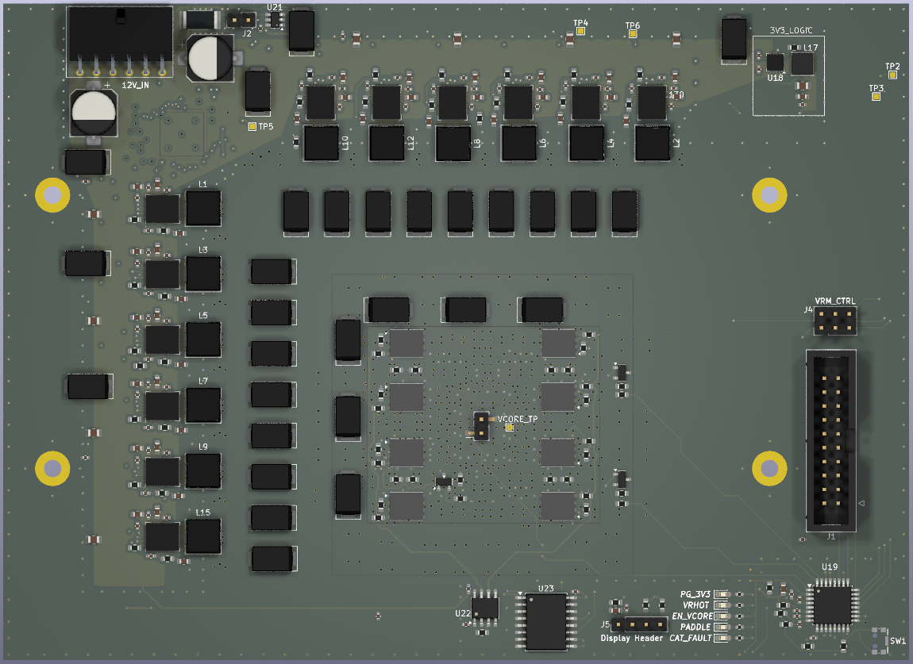
Figure 3.1 — Mercury board top-side overview: input connector and VRM controller (top-left), 12-phase DrMOS array and inductor column (left), MLCC carpet and load region (centre), PMBus and control interface (right)

3.1 Voltage Domains
The board operates across three voltage domains:

- 12 V — Input supply rail. Distributed from the input connector via a top-layer copper pour directly to the DrMOS power stage inputs. This is the highest-voltage, highest-impedance domain on the board.
- VCORE (~1.0 V) — The primary output rail. Delivered from the DrMOS phase outputs through output inductors, then distributed via a dedicated internal copper plane (L3) to the load region. This is the lowest-impedance, highest-current domain.
- 3.3 V — Auxiliary supply for logic, MCU operation, current sensing, and PMBus telemetry. Routed on L5, spatially isolated from the high di/dt power regions on L1.

3.2 VRM Block
The VRM is implemented using a Renesas ISL68229 multi-phase PWM controller driving up to 12 DrMOS power stages (MP86956 or equivalent class). Each DrMOS device integrates the high-side MOSFET, low-side MOSFET, and gate driver into a single package, reducing switching node parasitics and simplifying layout.

The ISL68229 controls phase timing, current sharing between phases, and output voltage regulation. It also provides a PMBus interface for telemetry access and configuration, connected via a 2×3 header with 0 Ω isolation resistors between the MCU and bus — allowing either firmware-based or external-tool-based access during debug.

For the purposes of PDN analysis, the VRM is modelled as a controlled voltage source with finite output impedance and limited control bandwidth. The VRM responds to sustained load changes at low frequencies; it does not materially influence the earliest portion of a fast transient event.

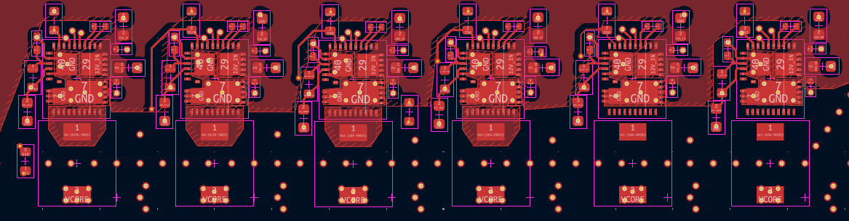
Figure 3.2 — DrMOS phase row detail: six of twelve phases shown, each comprising a DrMOS device (top), gate-drive connections, phase output inductor (bottom), and VCORE via array feeding L3

3.3 PDN Block
The PDN encompasses all copper, capacitors, and interconnects between the VRM output and the load node. It is the primary subject of this document. Its function is to maintain the VCORE voltage within the 40 mV droop limit as load current steps occur.

The PDN is structured hierarchically:

- Bulk capacitors at the VRM output provide energy storage for sustained load events and bridge the control loop response gap.
- Mid-range capacitors outside the load region contribute at intermediate frequencies, supporting the transition between bulk and high-frequency response.
- An MLCC carpet beneath the load region provides the primary high-frequency response, with placement optimised for minimum loop inductance.
- The VCORE plane (L3) provides a continuous, low-inductance current delivery path across the entire load footprint.

3.4 Load Block
The load is implemented as an array of N-channel power MOSFETs arranged in parallel banks, collectively referred to as the PADDLE load system. Each bank is controlled independently by the STM32G030K6T6 microcontroller, allowing configurable current step amplitudes and pulse widths. The load block replaces a real GPU die as the current sink, generating repeatable transient events for PDN evaluation.

Current monitoring is performed using a low-side shunt resistor and an INA181 current sense amplifier, with the output fed to an ADC channel on the MCU. This provides real-time current measurement for fault protection and telemetry logging.

A more detailed treatment of the load abstraction, its assumptions, and its limitations is presented in Section 10.

4. Target Impedance Theory and Application
Target impedance is commonly used as a first-order design constraint for power delivery networks, relating allowable voltage deviation to an expected load current step. In its simplest form, the relationship may be expressed as:

Ztarget ≈ ΔV / ΔI = 40 mV / 500 A = 0.08 mΩ

While this formulation is useful for bounding acceptable behaviour, it does not, by itself, describe how a physical PDN will respond to fast transient events.

For this project, the allowable droop was set to approximately 40 mV for a 500 A current step, corresponding to an effective target impedance of 0.08 mΩ. This places the system within the electrical regime of modern high-performance GPU power delivery networks and provides a concrete benchmark against which architectural and layout decisions can be evaluated.

4.1 Frequency-Domain Interpretation
In practice, target impedance is inherently frequency-dependent. Different elements of the power delivery network dominate system behaviour across different frequency ranges:

- The VRM control loop governs low-frequency response.
- Bulk capacitance influences mid-frequency energy delivery and recovery behaviour.
- High-frequency MLCCs and plane geometry dominate the earliest transient response.

As a result, meeting a target impedance curve in simulation does not imply uniform transient performance across all time scales. Frequency-domain tools are best interpreted as indicators of where a PDN may struggle, rather than guarantees of acceptable time-domain behaviour.

4.2 Practical Limits of Z-Target Thinking
A critical limitation of Z-target-based design is that it assumes the PDN behaves as a lumped, linear system. In real hardware, physical geometry and inductance dominate the earliest portion of a load transient, often well before capacitive energy storage or control-loop response can meaningfully contribute.

Consequently, two designs that appear similar in impedance plots may exhibit substantially different transient droop depending on: current path length, loop area, plane adjacency, and vertical current transitions. In this regime, additional bulk capacitance provides diminishing benefit, as the dominant constraint becomes the effective series inductance between the energy source and the load rather than the total stored charge.

4.3 Application to This Design
In the context of this board, the target impedance was used as a design boundary, not as an optimisation objective. Rather than attempting to tune the impedance curve to a specific shape, the target informed higher-level priorities: minimising distribution inductance, emphasising continuous copper planes over trace routing, and placing high-frequency decoupling as close as physically possible to the load region.

Capacitor selection was therefore guided by frequency coverage and physical placement feasibility, with the understanding that layout geometry would ultimately determine early transient performance more strongly than nominal capacitance value.

4.4 Scope and Boundary Conditions
It is important to note that target impedance alone does not guarantee silicon stability, does not account for on-die capacitance, and does not replace time-domain validation. Its role in this project is limited to defining an electrical operating envelope and informing architectural tradeoffs.

The transient behaviour of the system, particularly during the first microseconds of a load step, must therefore be examined explicitly. This motivates the transient response analysis presented in Section 6.

5. PDN Modelling Approach
Modelling was used in this project to establish first-order behaviour, explore sensitivity to key parameters, and identify dominant mechanisms affecting transient performance. The intent was not to produce a predictive, fabrication-accurate model, but to bound system behaviour and guide architectural decisions.

5.1 Modelling Tools and Analysis Types
All simulations were performed using LTspice, selected due to familiarity, flexibility, and its ability to support both frequency-domain and time-domain analyses within a single environment.

Two primary classes of simulations were developed:

- AC impedance analysis, used to examine the aggregate impedance profile of the PDN as a function of frequency.
- Transient time-domain simulations, used to observe voltage droop and recovery behaviour in response to large, fast load current steps.

These two approaches were treated as complementary rather than interchangeable, with each providing insight into different aspects of system behaviour.

5.2 Initial Assumptions and Abstractions
To keep simulations tractable, the PDN was modelled using lumped representations of capacitance, resistance, and inductance. Current delivery paths were represented as single series elements rather than distributed copper geometries.

These abstractions implicitly assume: a single dominant current path, uniform current distribution, and linear component behaviour. While these assumptions simplify analysis, they do not fully represent the multi-dimensional current spreading and parallel conduction that occur in real PCB power planes.

5.3 Observed Modelling Limitations
The simulations consistently indicated that series inductance, particularly loop inductance, dominated early transient voltage droop. Variations in bulk capacitance value produced relatively small changes in initial droop once inductance reached a practical minimum.

This behaviour highlights a known limitation of lumped PDN models: they struggle to accurately represent the effects of wide copper pours, plane adjacency, and distributed current return paths. In practice, these features reduce effective inductance through parallel conduction and geometric current spreading — effects that are difficult to capture without prohibitively complex models. As a result, the simulations should be interpreted as conservative indicators of sensitivity rather than precise predictors of absolute performance.

5.4 Role of Modelling in Design Decisions
Despite their limitations, the simulations were instrumental in shaping the final design. They identified inductance as the dominant constraint for early transient behaviour, demonstrated diminishing returns from increasing bulk capacitance beyond a certain point, and informed capacitor value selection and hierarchy.

Most importantly, the modelling process clarified which aspects of the PDN were likely to benefit from further optimisation and which were fundamentally constrained by physical geometry rather than component selection.

5.5 Modelling Scope and Intent
The models developed for this project are not intended to replicate the behaviour of a complete GPU power delivery system, nor to substitute for physical measurement. Instead, they serve as a structured framework for reasoning about PDN behaviour and for guiding layout and architectural tradeoffs.

Time-domain transient behaviour, particularly during the earliest portion of a current step, must therefore be examined in the context of physical implementation. This motivates the explicit transient response analysis presented in the following section.

6. Transient Response Analysis
Transient behaviour in high-current, low-voltage power delivery systems is dominated by different mechanisms across distinct time scales. For the purposes of this analysis, it is useful to separate transient response into early droop behaviour and recovery behaviour, as these are governed by fundamentally different elements of the PDN.

6.1 Early Transient Behaviour
The earliest portion of a load transient — typically within the first few hundred nanoseconds to microseconds — is dominated by local, low-inductance energy storage. In commercial GPU systems, this role is largely fulfilled by on-die capacitance, which provides extremely low inductance and immediate charge delivery.

In the absence of silicon-integrated capacitance, early transient behaviour on this board is dominated by the smallest MLCCs placed directly beneath the load region. Capacitors in the 220 nF to 1 µF range, when placed with minimal loop inductance, provide the primary response to the initial current step.

The effectiveness of these capacitors is determined less by nominal capacitance value and more by effective loop inductance, which is a function of placement, plane adjacency, and vertical current transitions.

6.2 Dominance of Series Inductance
Simulation results consistently indicate that series inductance is the dominant factor governing initial voltage droop. As the physical distance between a capacitor and the load increases, both loop inductance and response latency increase, reducing the capacitor's contribution to early transient mitigation.

This behaviour explains the hierarchical placement strategy commonly observed in high-performance PDNs: small, high-frequency capacitors are placed closest to the load, while larger bulk capacitors are placed progressively farther away. Although bulk capacitors retain significance at lower frequencies, their inductive separation prevents them from meaningfully influencing the first voltage dip.

6.3 Bulk Capacitance and Recovery Behaviour
Bulk capacitors primarily influence transient sustain and recovery, rather than initial droop magnitude. In this system, capacitors in the hundreds of microfarads range act as an energy reservoir that supports the load until the VRM control loop can respond.

Similarly, the VRM itself operates predominantly in the lowest frequency band and therefore does not materially affect early droop behaviour. Increasing switching frequency can reduce response latency, but it does not eliminate the inductive constraints that dominate the earliest transient window.

As a result, transient response naturally decomposes into two distinct design challenges: minimising early droop through inductance reduction and local decoupling; and ensuring stable recovery through adequate bulk capacitance and VRM capability.

6.4 Implications for This Design
Within the context of this board, recovery behaviour is comparatively strong relative to early droop performance. This imbalance is an expected consequence of the absence of on-die capacitance and reflects the fundamental limitations of PCB-level energy storage at very high frequencies.

Commercial GPU power delivery systems mitigate this limitation by combining dense on-die capacitance, high phase-count VRMs, and moderate bulk capacitance, allowing each element to operate within its optimal frequency range. In contrast, this board emphasises PCB-level decoupling and geometry to explore the limits of transient performance in isolation.

This distinction is critical for interpreting results and reinforces the importance of separating early transient behaviour from longer-term recovery dynamics when evaluating PDN performance.

7. Capacitor Network Design
The capacitor network was designed as a hierarchical system, with each capacitor class serving a defined frequency range and physical role within the power delivery network. Rather than maximising total capacitance, the design prioritises effective inductance reduction, controlled current paths, and diminishing-return awareness.

7.1 Capacitor Hierarchy and Functional Roles
Bulk capacitance is implemented using two primary classes: 330 µF and 100 µF capacitors. The 330 µF capacitors are placed directly at the VRM output and function primarily as an energy reservoir to support sustained load events and bridge the response until the VRM control loop stabilises.

The 100 µF capacitors are placed closer to the load region, just outside the designated chip area. This placement reduces loop inductance relative to the VRM output capacitors and allows the 100 µF class to contribute at higher frequencies, while still operating below the regime dominated by small MLCCs.

This arrangement preserves the central load region for high-frequency decoupling, where the lowest possible inductance is required.

7.2 MLCC Carpet Design
High-frequency decoupling beneath the load region is provided by a carpet of MLCCs spanning 220 nF, 1 µF, 4.7 µF, and 22 µF values. These values were selected due to their widespread availability, favourable electrical characteristics, and overlapping frequency coverage.

Rather than targeting discrete frequency bands, the MLCC values were chosen to overlap and collectively suppress impedance across the mid- to high-frequency range. This overlapping behaviour improves robustness to parasitic variation and placement-induced inductance differences.

The MLCC carpet is optimised for proximity and inductance minimisation, recognising that effective contribution is governed more by physical placement than nominal capacitance.

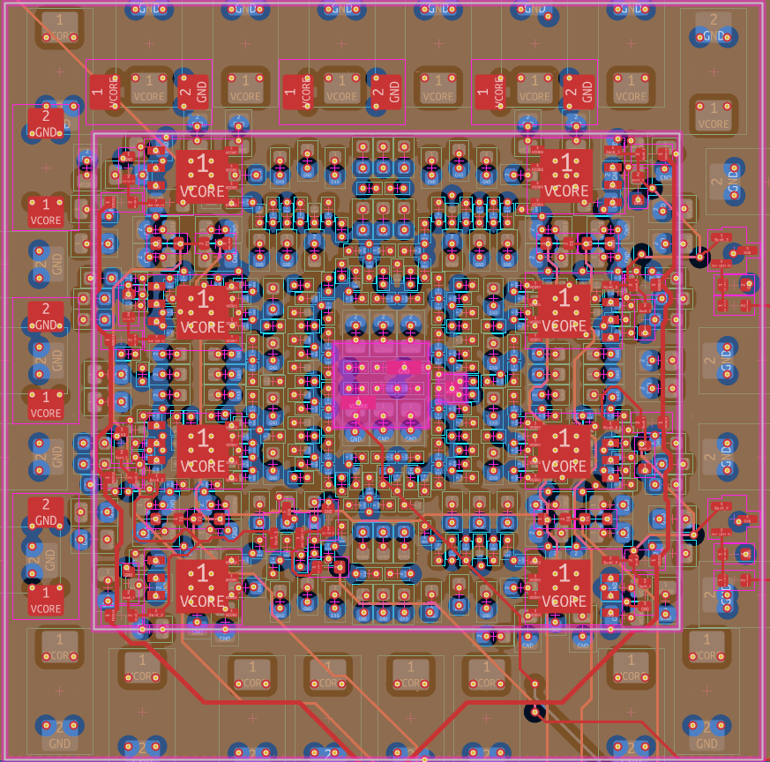
Figure 7.1 — MLCC carpet close-up: hierarchical decoupling arrangement beneath the load region. VCORE and GND net labels are visible on individual via connections. Innermost capacitors are the smallest values (220 nF / 1 µF), with progressively larger values placed outward.

7.3 Via Strategy and Vertical Current Transitions
Via allocation was treated as a first-order design variable due to its impact on both electrical performance and plane integrity.

- Small MLCCs (≤1 µF) use one via per pad, as additional vias provided negligible benefit relative to their cost in plane real estate.
- Mid-value MLCCs (4.7 µF and 22 µF) were evaluated for higher via counts, but the incremental reduction in inductance was not sufficient to justify additional plane perforation in the dense load region.
- Larger bulk capacitors (100 µF and 330 µF), placed outside the chip area, employ two vias per pad to support higher current flow and reduce effective series inductance.

For the 330 µF capacitors directly connected to inductor outputs, via density is further increased to support current sharing and minimise vertical bottlenecks, with asymmetry applied where appropriate to balance power and return paths. This tiered via strategy reflects a deliberate tradeoff between inductance reduction, manufacturability, and plane continuity.

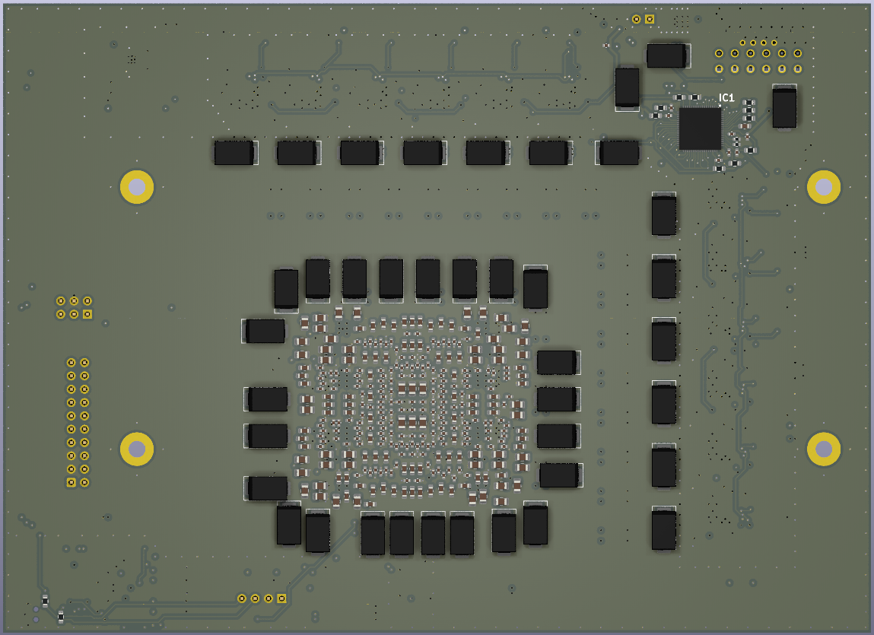
Figure 7.2 — Board underside (3D render): dense MLCC carpet visible in the central load region, surrounded by 100 µF mid-range decoupling capacitors. STM32 MCU and control circuitry visible top-right. Load MOSFET bank (PADDLE) footprints visible at top.

7.4 Practical Limits and Diminishing Returns
While additional capacitance could theoretically further reduce impedance, practical limits are imposed by board area, cost, and inductance dominance. In the absence of on-die capacitance, PCB-level capacitors cannot replicate the ultra-low inductance energy storage present in commercial GPU systems.

Beyond a certain point, increasing capacitor count yields diminishing returns for early transient mitigation, reinforcing the importance of geometry, placement, and current path optimisation over raw capacitance.

The final capacitor network therefore represents a balanced solution that maximises effective performance within realistic physical and economic constraints.

8. Plane Geometry and Stackup Design
The PCB stackup was selected to prioritise low-inductance power delivery, continuous return paths, and controlled vertical current transitions while maintaining fabrication practicality.

8.1 Stackup Definition
The final stackup consists of six layers, summarised in the table below.

Layer | Primary Function | Electrical Role
L1 | Components + high-current pours | 12 V distribution, switching nodes, phase outputs
L2 | Solid ground plane | Primary return reference
L3 | VCORE plane | High-current distribution
L4 | Solid ground plane | Secondary return + field containment
L5 | Logic + 3.3 V routing | Low-current routing and control
L6 | Ground plane + secondary placement | MLCC return and bottom copper continuity

This configuration was chosen to ensure that the primary high-current plane (VCORE on L3) is directly adjacent to ground on both sides, minimising the distance between forward and return current paths and reducing effective loop inductance throughout the load region.

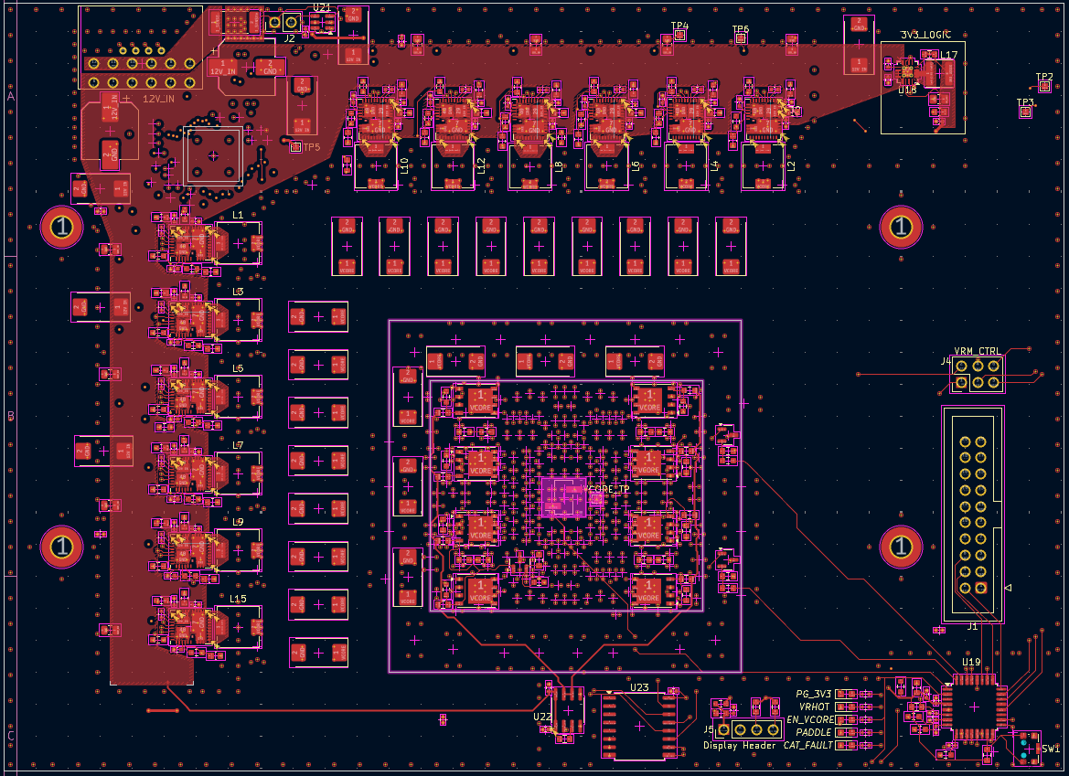
Figure 8.1 — L1 copper layout: 12 V input pour (top-left, red fill) fed directly from the input connector, DrMOS switching nodes and phase output connections, 100 µF bulk capacitor placements, and VCORE test point (VCORE_TP) at the load region centre

8.2 Plane Adjacency and Return Path Control
Placing the VCORE plane (L3) between two solid ground planes (L2 and L4) reduces effective loop inductance by: minimising separation between forward and return paths, promoting broad current spreading, and reducing loop area for transient current flow.

This sandwich structure improves both transient performance and noise containment, as return currents can flow directly beneath the power distribution layer rather than being forced into elongated or fragmented paths.

Similarly, locating the logic and 3.3 V routing layer (L5) adjacent to a ground plane ensures controlled return paths for lower-current digital signals and isolates them from high di/dt power regions.

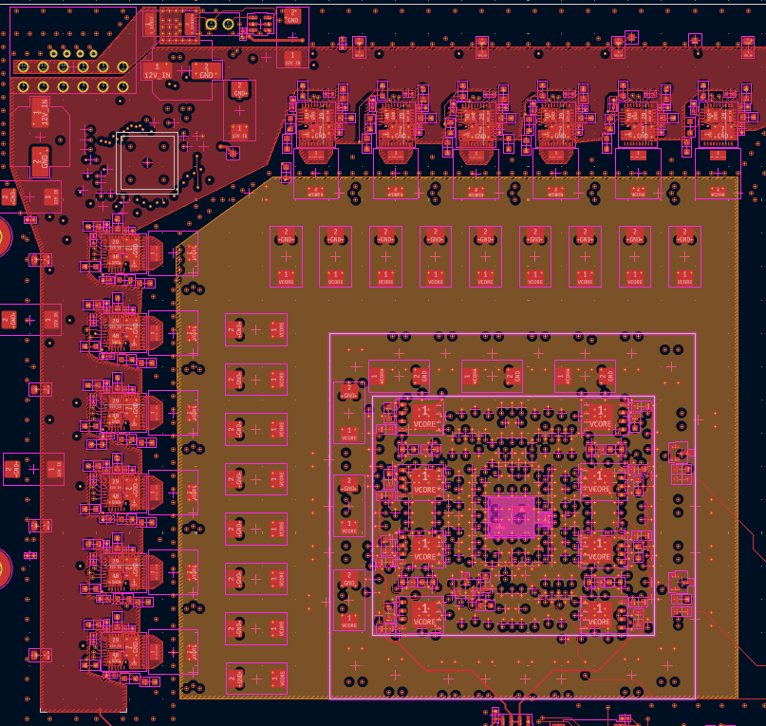
Figure 8.2 — 12 V and VCORE copper distribution: 12 V pour (left, red) feeding DrMOS inputs directly from the connector; VCORE plane (centre, gold/brown) extending as a continuous pour beneath the load region. The spatial separation between input and output current domains is visible.

8.3 Current Spreading and Plane Integrity
Continuous ground planes were treated as non-negotiable, with minimal interruptions. Plane perforation due to vias and routing was managed carefully to avoid constriction points that could locally increase impedance or create current crowding.

The use of a ground layer on the bottom side (L6) enables dense MLCC placement beneath the load region while minimising the number of vias required to connect to ground. This reduces fragmentation of the VCORE plane and maintains broader copper continuity, improving overall current spreading behaviour.

8.4 Tradeoffs and Layer Count Considerations
Additional layer counts were evaluated. Increasing to eight layers would have allowed a dedicated internal 12 V distribution plane, improved routing flexibility, and reduced fragmentation of high-current copper on the top layer. However, the incremental benefit in inductance reduction and routing convenience did not justify the additional fabrication cost for a test-oriented platform.

Conversely, further increasing layer count beyond this range would provide diminishing returns relative to board size and current density. For the physical dimensions and current targets of this design, six layers represent a balanced compromise between electrical performance, manufacturability, and cost.

9. Via Strategy and Current Vertical Transitions
Via placement and density represent a critical third dimension of PDN design. On a six-layer board, every current flowing vertically between planes must pass through vias, and the inductance and resistance of those vias directly influences transient performance and thermal behaviour. Via strategy cannot be treated as a routing afterthought; on a high-current board it is a first-order design variable.

9.1 Via Density Principles
The general principle applied across this design is that via count and density should scale with current magnitude and current path criticality. Power-carrying vias must provide sufficient cross-sectional area to carry current without exceeding copper thermal limits, and sufficient parallel count to minimise effective series inductance through the vertical transition.

For DrMOS power stage pads — the highest-current vertical transitions on the board — the following via counts were applied:

- VCORE output pads: approximately 6 vias per pad, transitioning current from the inductor output into the L3 VCORE plane.
- GND return pads: 4 to 6 vias per pad, providing low-inductance return paths into the L2 and L4 ground planes.

This density reflects the per-phase current of approximately 40–50 A under steady-state load sharing, and the requirement to minimise vertical inductance in the highest di/dt region of the board.

9.2 Capacitor Via Allocation
Via allocation for decoupling capacitors follows a tiered strategy with clearly diminishing returns at higher via counts:

- Small MLCCs (≤1 µF): One via per pad. At these capacitance values and placement distances, additional vias provide negligible inductance benefit while consuming plane real estate and increasing fragmentation of both the VCORE and GND planes in the most inductance-sensitive region of the board.
- Mid-value MLCCs (4.7 µF and 22 µF): One via per pad, with a staggered chessboard arrangement where placement density allows. This distributes return currents across a wider plane area and avoids localised plane weakening beneath the load region.
- Bulk capacitors (100 µF and 330 µF): Two to three vias per pad. These components carry higher current during sustained load events and benefit meaningfully from the reduced vertical resistance and inductance provided by additional vias.

9.3 Shared Versus Dedicated Vias
In the dense MLCC carpet beneath the load region, via sharing between adjacent capacitors was avoided where possible to maintain independent, well-defined return paths and prevent current crowding in any single via. Independent via connections to the VCORE and GND planes ensure that each capacitor can source current through the shortest available path without interference from adjacent devices.

Outside the load region, where component density is lower and current per via is reduced, limited strategic via sharing was permitted to reduce total hole count, preserve plane continuity, and simplify DRC compliance.

9.4 Thermal Considerations
At full rated current, via thermal performance is primarily constrained by via barrel diameter, copper plating thickness, and the thermal mass of the connected copper pours. For the power stage output vias, thermal load is distributed across the via array and conducted away by the VCORE plane and associated copper mass. No individual via is expected to carry the full phase current.

Formal via current rating calculations were not performed for this revision. Via sizing was guided by industry rules of thumb (approximately 500 mA per 0.3 mm via at standard plating thickness) and cross-referenced against standard fabrication design rules. Thermal validation through measurement or simulation is identified as a gap in Section 12.

9.5 Fabrication Constraints and Total Via Count
The via strategy was constrained by standard fabrication design rules covering minimum drill diameter, minimum annular ring, and minimum via-to-via spacing. All vias on this design are standard through-hole vias; blind and buried vias were not used, as the incremental inductance and impedance benefit did not justify the additional fabrication cost and complexity for a six-layer testbench platform.

The total via count across the board is approximately 1,000. This reflects the density required to support high-current vertical transitions throughout the PDN — particularly beneath the load region and at the DrMOS power stages — without excessive fragmentation of either the VCORE or GND planes.

10. Load Modelling and Transient Injection Philosophy
In a production GPU system, the load consists of billions of CMOS switching elements on a silicon die, capable of demanding current steps of hundreds of amperes with nanosecond-scale rise times. Replicating this behaviour at the PCB level requires a deliberate abstraction strategy, since neither the silicon die nor its on-die capacitance can be present on a test platform.

10.1 GPU Load Abstraction
The Mercury load system abstracts GPU workload transitions as discrete current step events, representing transitions from low to high current draw that occur when compute activity changes — for example, shader core enable events, clock domain transitions, or memory controller bursts. Each step event is characterised by four parameters:

- Step amplitude: the magnitude of the current change, in amperes.
- Rise time: how quickly the transition occurs, governed by MOSFET gate drive characteristics.
- Pulse width: the duration of the elevated current state.
- Repetition rate: how frequently transitions occur during sustained testing.

This abstraction captures the primary mechanism by which GPU workloads stress the PDN — fast, large-magnitude current steps — while omitting the fine-grained stochastic behaviour that exists only in real compute silicon. The simplification is appropriate for the purpose of evaluating PDN transient response at the board level.

10.2 MOSFET-Based Load Implementation
Load current injection is implemented using arrays of N-channel power MOSFETs arranged in parallel banks — collectively referred to as the PADDLE load system. Each bank consists of two MOSFETs connected in parallel to share current and reduce individual device stress. Multiple independent banks are present on the board, providing staged or simultaneous current step capability.

Gate signals for each bank are driven by the STM32G030K6T6 microcontroller. Gate timing, pulse width, and individual bank enabling are software-controlled, allowing a range of transient conditions to be tested without hardware modification. Each bank is capable of sourcing approximately 150 A of load current during the active phase; enabling multiple banks simultaneously approaches the 500 A target envelope.

10.3 Heat Dissipation in the Load System
A critical physical reality of MOSFET-based load systems is that dissipated power is converted to heat within the MOSFET channel itself, not distributed across the board. During conduction, power is dissipated as I²·RDS(on) in the device channel; during switching transitions, additional dissipation occurs in the Miller plateau region of the gate charge curve.

For short-duration pulsed testing, the device junction temperature rise is bounded by the thermal mass of the die and package. For sustained or high-repetition-rate testing, active or passive cooling must be considered to avoid exceeding maximum junction temperature ratings. The current design does not include integrated thermal management for the load MOSFETs; this is acknowledged as a known design gap in Section 12.

10.4 Failure Modes Avoided by Design
The load injection design explicitly avoids several potential failure modes:

- Uncontrolled latch-up: gate drive is managed by MCU firmware with defined timing constraints. Load MOSFETs switch independently rather than in a half-bridge topology, eliminating shoot-through risk.
- Voltage overshoot damage to VCORE: inductive kickback from interconnect inductance during MOSFET turn-off is managed by the load-side decoupling network. The VCORE rail has no high-side supply connection through the load path.
- VRM overcurrent damage: maximum load current is bounded by the aggregate MOSFET conductance and the 600 W input power constraint imposed by the input connector, providing a hard upper limit on total deliverable energy.

These design choices reflect a preference for robust simplicity over precision control, consistent with the exploratory and testbench nature of the platform.

11. PCB Layout Implementation
PCB layout for a high-current PDN is an exercise in translating analytical decisions — impedance targets, capacitor hierarchy, stackup selection — into physical geometry that realises those decisions under real fabrication and assembly constraints. This section describes the key layout strategies applied throughout the Mercury board.

11.1 Component Placement Strategy
Component placement was governed by a strict priority hierarchy based on current magnitude and frequency criticality. The highest-priority placement constraint was minimising the current loop area between the DrMOS power stages and the load region.

The DrMOS devices are arranged in a linear row along one edge of the board, oriented to allow direct phase output routing toward the load zone with minimal path length. Phase output inductors are placed between the DrMOS output pads and the VCORE plane via arrays, keeping the high-current switching-node-to-inductor loop as small as possible.

The load region — representing the GPU die footprint — occupies the central area of the board and is surrounded on all sides by the MLCC decoupling carpet. Bulk capacitors are placed at the periphery of the load region and adjacent to the VRM output side. Digital control circuitry (MCU, current sensing, PMBus header) is placed in a dedicated low-power zone spatially separated from the high di/dt switching region on L1.

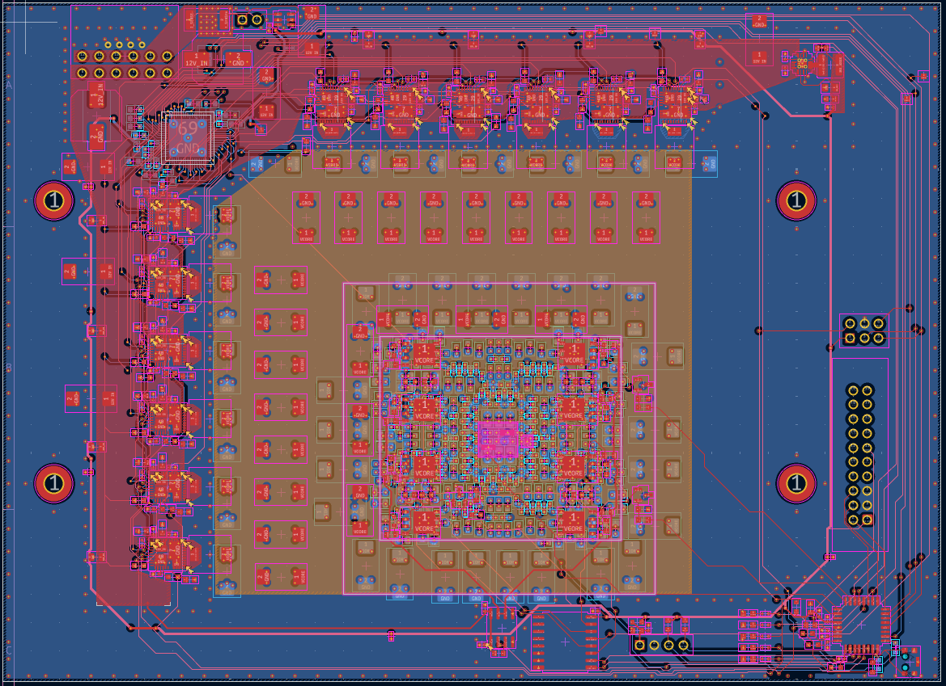
Figure 11.1 — All-layer composite view (KiCad): overlay of all six copper layers, silkscreen, and courtyard boundaries. The density gradient from the MLCC carpet (centre) through bulk capacitors to the DrMOS phase row (left) is clearly visible. The total via count of approximately 1,000 is apparent from the via density in the power region.

11.2 High-Current Routing Philosophy
All high-current paths — the 12 V input distribution and the VCORE output distribution — are implemented exclusively as solid copper pours rather than routed traces. This eliminates the resistance, current density limitations, and inductance penalties associated with narrow trace routing at these current levels.

The 12 V copper pour occupies L1 and is directly fed by the input connector. It extends continuously across all DrMOS source pads, providing a wide, low-impedance supply path to every phase simultaneously. The solid GND plane on L2 sits immediately beneath, creating a tight loop for the 12 V supply current and minimising the enclosed loop area.

The VCORE plane on L3 is fed by the DrMOS phase output inductors via via arrays and extends as a continuous plane beneath the entire load footprint, providing uniform voltage distribution and broad current spreading to the load region.

11.3 Decoupling Proximity Rules
The MLCC decoupling carpet was placed with the highest-frequency capacitors — 220 nF and 1 µF — positioned closest to the centre of the load region, and progressively larger values (4.7 µF, 22 µF) placed outward. This maintains the lowest possible loop inductance for the capacitors that must respond earliest in the transient event.

Capacitor orientation was standardised with component pads aligned perpendicular to the primary current flow direction wherever possible, minimising the via-to-via current loop area. In the densest areas of the carpet, individual capacitor positions were iteratively adjusted to maintain DRC compliance while preserving placement proximity to the load centroid.

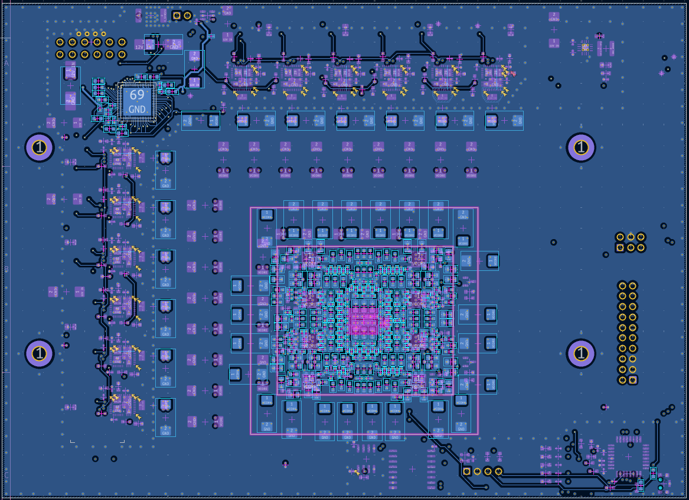
Figure 11.2 — Back copper and via distribution view: bottom layer (L6) showing MLCC return connections and GND plane structure. The via density beneath the load region (centre) is visible from the via pad density. The MCU and control routing is visible top-left, with the PMBus header connections at top.

11.4 Noise and Coupling Considerations
Switching noise generated at the DrMOS SW nodes — which transition at 400–500 kHz with significant dV/dt — represents the primary source of conducted and radiated interference within the board. Mitigation strategies applied in the layout include:

- Minimising the physical copper area of SW nodes on L1 to reduce radiating antenna area.
- Ensuring uninterrupted GND plane coverage on L2 beneath all switching regions, providing a low-inductance return path for high-frequency switching currents.
- Routing all PMBus and MCU signal traces on L5, physically separated from the high di/dt power region by two intermediate ground planes (L2 and L4), providing substantial shielding.
- Using 0 Ω series resistors between the MCU and the PMBus lines, allowing the MCU to be optionally decoupled from the bus during external debug without board modification.

M3 mounting holes with stitching vias are placed at board corners and along edges to maintain GND plane continuity around the perimeter and provide chassis grounding attachment points.

12. Design Limitations and Known Gaps
This section documents the known limitations of the current design revision. Explicitly identifying gaps prevents misinterpretation of the design's scope and supports honest assessment of what the work does and does not demonstrate.

12.1 Absence of Physical Measurements
The primary validation gap in this revision is the absence of physical waveform measurements. The board design was completed to fabrication-ready status and submitted for evaluation, but transient droop waveforms under full load conditions have not been captured. As a direct consequence, the 40 mV droop target at a 500 A current step has not been experimentally confirmed or refuted.

All performance assertions in this document are derived from simulation results and first-order analytical estimates. These are presented as indicators of design sensitivity and architectural direction, not as validated hardware performance claims. This distinction is critical for interpreting the work accurately.

12.2 Thermal Modelling Exclusions
No formal thermal simulation was performed for this design revision. First-order estimates based on phase current, RDS(on), and copper mass suggest that the DrMOS devices operate within their rated junction temperature at moderate duty cycles, but this has not been verified through thermal imaging or detailed simulation.

The MOSFET-based load system presents a more significant thermal risk during sustained pulsed operation. Concentrated heat dissipation in the load MOSFET dies, without integrated thermal management, limits safe duty cycle and repetition rate for high-current transient testing. This is a known limitation that a subsequent revision would address.

12.3 Control-Loop Simplifications
The ISL68229 VRM controller is treated as a functional voltage-regulating black box in this design. Loop compensation values were not formally derived, and control bandwidth and phase margin were not characterised. In a production design, loop compensation would be explicitly analysed to ensure stability across the full load and line range.

MCU firmware implements open-loop load control: current is a function of gate drive voltage and MOSFET on-state resistance rather than a precisely regulated closed-loop value. This is adequate for the intended purpose of generating repeatable, bounded current steps, but does not provide the controlled-ramp or arbitrary-waveform load capability of a professional electronic load instrument.

12.4 What This Revision Does Not Validate
For completeness, the following items are explicitly outside the validation scope of this revision:

- Transient droop magnitude under full 500 A step conditions — physical measurement not performed.
- VRM control-loop stability across all operating conditions — loop compensation not formally characterised.
- Thermal performance of DrMOS devices or load MOSFETs under sustained high-current operation.
- EMI compliance or radiated emissions behaviour.
- Long-term component reliability under cyclic thermal and electrical stress.
- Behaviour of the PDN beyond the first transient droop event, including recovery time and settling dynamics.

These items constitute natural targets for a subsequent revision and are discussed further in Section 13.

13. Revision Strategy and Future Work
This section describes what a second revision of the Mercury platform would change, what would be preserved, and what measurement-driven follow-up work would have the highest engineering value. The intent is to demonstrate that the project is a living design effort with clear forward direction, not a frozen first attempt.

13.1 What a Revision Would Change
Based on the design analysis and identified limitations in Section 12, a second revision (Rev-A) would prioritise the following changes:

- Physical validation infrastructure: adding dedicated test points optimised for oscilloscope differential probing directly at the load node and at the VRM output, enabling clean voltage droop waveform capture without probe-induced parasitic corruption.
- Load system thermal management: adding copper spreading features or heatsink mounting provisions beneath the load MOSFET banks to extend safe operating duration for sustained transient testing.
- Current measurement bandwidth: evaluating higher-bandwidth current sense topologies — such as a Rogowski coil or di/dt sensing — to allow more accurate characterisation of fast current step rise times.
- Formal loop compensation: deriving and implementing ISL68229 compensation values based on measured or modelled VRM output impedance, enabling controlled bandwidth selection and stability verification.

13.2 What Would Stay Invariant
The following architectural decisions are considered well-justified by the analysis presented in this document and would be carried forward without modification into a second revision:

- Six-layer stackup with the VCORE plane sandwiched between two solid ground planes.
- Top-layer 12 V copper pour strategy for input distribution.
- Hierarchical MLCC decoupling network with overlapping frequency coverage.
- PMBus interface with 0 Ω MCU isolation resistors for flexible debug access.
- MOSFET-based load injection concept, with firmware-controlled bank switching.
- Placement-first layout philosophy: power device and decoupling placement determined before routing.

13.3 Measurement-Centric Follow-Ups
The highest-value measurement activity for a subsequent revision is a transient droop waveform captured differentially at the load node in response to a known, characterised current step. This single measurement would allow direct comparison against the 40 mV target impedance bound and provide ground truth for validating the simulation-derived insight that inductance dominates early droop.

Secondary measurements of significant value include:

- PDN impedance versus frequency, measured using a VNA-based injection technique at the load node, to compare against the simulated AC impedance profile.
- Thermal imaging of DrMOS devices under sustained partial-load operation, to validate first-order thermal estimates.
- Phase current balance verification across all 12 phases under steady-state load, confirming correct controller operation and inductor matching.

13.4 Potential Architectural Pivots
If physical measurements reveal that early transient droop substantially exceeds the 40 mV target, the most productive architectural response would be further reduction of load-region inductance through layout compression or exploration of embedded capacitance PCB materials. Both approaches directly address the dominant constraint identified in simulation.

Increasing phase count beyond 12 would not be the first-choice response to an inductance-driven droop problem. Additional phases improve steady-state current sharing and ripple cancellation but do not reduce the loop inductance between existing decoupling capacitors and the load node. If phase count were increased, a matched increase in switching frequency would be more valuable from a transient response perspective than phase multiplication alone.

14. Conclusion
Mercury was designed as a power delivery test platform targeting GPU-class current delivery: 500 A peak at 1.0 V, with a maximum allowable voltage droop of 40 mV and an effective target impedance of 0.08 mΩ. The primary engineering objective was not component selection or system integration, but the isolation and study of the physical constraints that govern transient PDN behaviour at this current class.

The central finding of the design and modelling process is that early transient droop in a PCB-level PDN is dominated by effective series inductance, not by total stored capacitance. Simulation results consistently demonstrated that bulk capacitance provides diminishing returns once inductance reaches a practical minimum, and that geometric decisions — plane adjacency, current path length, via density, and layer sandwiching — outweigh component value selection as determinants of peak droop performance. This conclusion aligns with established power integrity engineering practice and reflects how industrial GPU power delivery teams approach board-level PDN problems.

The work is honest about its own boundaries. Physical validation measurements were not completed in this revision, and the 40 mV droop target at full 500 A load has not been experimentally confirmed. The design and analysis presented here should therefore be read as a rigorous engineering framework, informed by simulation and grounded in theory, rather than as a validated performance claim. The path to closing that gap is clear and is described in Section 13.

The Mercury board is a legitimate engineering artifact. It operates within the electrical regime of RTX 4090-class power delivery systems, is designed to industry-grade PCB fabrication standards with approximately 1,000 vias, a six-layer stackup, solid copper power planes, and a controlled multi-phase VRM architecture. The design was submitted to the PCBWay Design Competition, where it placed 11th overall and received the Popular Design Prize — a meaningful outcome for a design-only entry with no silicon and no fabricated hardware in the judged submission.

What this project demonstrates is a working understanding of power integrity engineering at the system level: the ability to translate abstract PDN requirements into concrete architectural and layout decisions, to identify the dominant physical mechanisms in a complex multi-variable system, and to reason clearly about what a design does and does not claim. Those are the skills that matter in GPU, AI accelerator, and server CPU power delivery engineering — and they are what Mercury was built to prove.

Appendix A: Key Parameters and Assumptions
The following table summarises the primary design parameters and the basis on which each was selected or derived.

Parameter | Value | Basis
Output Voltage (VCORE) | 1.0 V | Design target
Peak Load Current | ~500 A | Design target
Maximum Voltage Droop | 40 mV | Design target
Target Impedance (Ztarget) | 0.08 mΩ | Derived: 40 mV / 500 A
Input Supply Voltage | 12 V | Board requirement
Maximum Input Power | ~600 W | Connector-limited
VRM Phase Count | 12 | Controller-limited
Switching Frequency | 400–500 kHz | DrMOS capability
Phase Inductor Value | ~150 nH | Design selection
PCB Layer Count | 6 | Design decision
Board Dimensions | 165.5 mm × 120 mm | Layout-driven
Total Via Count | ~1,000 | Layout output
VRM Controller | Renesas ISL68229 | Selected
Power Stage | MP86956 (DrMOS class) | Selected
MCU | STM32G030K6T6 | Selected
Current Sense Amplifier | INA181 | Selected

Key Modelling Assumptions

- The VRM control loop is treated as a regulated voltage source with finite output impedance; loop dynamics are not explicitly modelled.
- PDN simulations use lumped circuit models; distributed plane effects and geometric current spreading are not fully captured.
- Simulation results are interpreted as conservative sensitivity indicators, not as predictors of absolute hardware performance.
- Physical measurements were not performed in this revision; all performance estimates are simulation- or analysis-derived.

Appendix B: Simulation Summary
Two simulation classes were developed in LTspice for this project.

B.1 AC Impedance Analysis
Method: A 1 A AC current source is injected at the load node, and the voltage response is measured to derive impedance as Z = V/I across frequency. Distribution inductance is represented as a series L_DIST and R_DIST element between the capacitor network and the load node. The capacitor hierarchy is implemented as parallel RC branches with ESL for each capacitor class.

Key observation: The impedance profile is dominated at high frequencies by the distribution inductance L_DIST. Reducing L_DIST produces the largest improvement in impedance at the frequencies most relevant to early transient response.

B.2 Transient Time-Domain Analysis
Method: A step current source transitions from 0 A to the target step amplitude. Key parameters swept include: distribution inductance (L_DIST), bulk capacitance value, and MLCC placement inductance.

Key observations: Series inductance is the primary determinant of initial voltage droop magnitude. Increasing bulk capacitance beyond the designed value produces marginal improvement in initial droop. Reducing distribution inductance produces proportional improvement in peak droop for the same current step.

Note: All simulation results should be treated as sensitivity indicators. Lumped model abstractions underestimate the beneficial effects of wide copper pours, plane adjacency, and distributed conduction in the real PCB.

Appendix C: PCB Stackup Details
The following table provides the full stackup definition including copper weight per layer.

Layer | Function | Material | Copper Weight
L1 | Component layer + high-current pours | FR4 | 2 oz
L2 | Solid ground plane | FR4 | 1 oz
L3 | VCORE plane | FR4 | 2 oz
L4 | Solid ground plane | FR4 | 1 oz
L5 | Logic routing + 3.3 V distribution | FR4 | 1 oz
L6 | Ground plane + secondary component placement | FR4 | 1 oz

Board dimensions: 165.5 mm × 120 mm. Fabrication standard: IPC Class 2. Recommended finish: ENIG or HASL as available. Dielectric: Standard FR4, minimum Tg 150°C. Minimum via drill: per fabrication house capability (typically 0.2–0.3 mm finished hole).

Appendix D: BOM Excerpts
The following table covers primary power path and control components. This is not a complete BOM; passive components (decoupling capacitors, resistors, ferrite beads) are covered in the full BOM maintained separately.

Reference | Description | Part / Value | Qty
U1 | Multi-phase PWM controller | Renesas ISL68229 | 1
U2–U13 | DrMOS power stage | MP86956 (or equivalent class) | 12
U_MCU | Microcontroller | STM32G030K6T6 | 1
U_CSA | Current sense amplifier | INA181 | 1
L1–L12 | Phase output inductors (~150 nH, high-current rated) | Per design | 12
C_BULK | Bulk capacitors | 330 µF polymer electrolytic | Per BOM
C_MID | Mid-range decoupling | 100 µF ceramic | Per BOM
C_HF | MLCC decoupling carpet | 220 nF, 1 µF, 4.7 µF, 22 µF | Per BOM
Q_LOAD | Load injection MOSFETs (PADDLE system) | N-channel, high-current class | Per BOM
J_PMBUS | PMBus interface header (2×3) | Standard 2.54 mm pitch | 1
R_ISO | 0 Ω MCU isolation resistors | 0402 0 Ω | Per BOM

Appendix E: Abbreviations

Abbreviation | Definition
AC | Alternating Current
BOM | Bill of Materials
DC | Direct Current
di/dt | Rate of change of current with respect to time
DrMOS | Driver and MOSFET — integrated power stage device
dV/dt | Rate of change of voltage with respect to time
EMI | Electromagnetic Interference
ESL | Equivalent Series Inductance
ESR | Equivalent Series Resistance
MCU | Microcontroller Unit
MLCC | Multi-Layer Ceramic Capacitor
NDA | Non-Disclosure Agreement
PCB | Printed Circuit Board
PDN | Power Delivery Network
PMBus | Power Management Bus
PWM | Pulse Width Modulation
RDS(on) | Drain-source on-state resistance (MOSFET parameter)
VCORE | Core supply voltage rail
VNA | Vector Network Analyser
VRM | Voltage Regulator Module

