Mercury
Executive Summary

GPU-Class PDN Test Platform
Marcus Cropley | RMIT University — Electronics and Computer Systems Engineering
PCBWay Design Competition — 11th Place + Popular Design Prize

1. Project Overview
Mercury is a GPU-class power delivery network (PDN) test platform designed to evaluate the physical and geometric limits of PCB-level high-current power distribution under fast transient conditions. The board targets a peak load current of approximately 500 A at 1.0 V — the same electrical regime as a high-end discrete GPU — with a maximum allowable voltage droop of 40 mV, corresponding to a target impedance of 0.08 mΩ.

The project was built in direct response to an industry signal: AMD-level power delivery engineering roles require candidates who understand that PDN performance at these current levels is fundamentally a geometry problem, not a component selection problem. Mercury was designed to prove exactly that understanding through a fabrication-valid, fully documented hardware design.

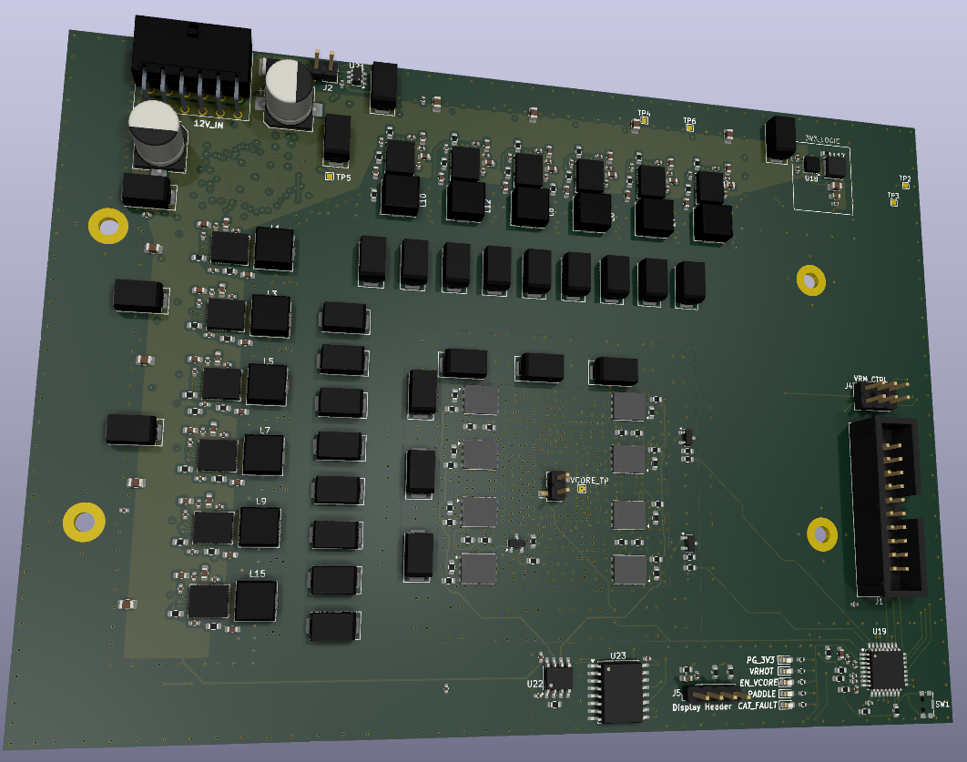
Figure ES-1 — Mercury GPU-Class PDN Test Board: 3D perspective render showing the 12-phase VRM (left), bulk decoupling, load region (centre), and control interface (right)

2. Key Specifications

Parameter | Value | Parameter | Value
Output Voltage | 1.0 V | VRM Phase Count | 12
Peak Load Current | ~500 A | Switching Frequency | 400–500 kHz
Maximum Droop | ≤ 40 mV | Board Dimensions | 165.5 × 120 mm
Target Impedance | 0.08 mΩ | Total Via Count | ~1,000
Input Supply | 12 V | PCB Layer Count | 6
Max Input Power | ~600 W | PCBWay Competition | 11th Place + Popular Prize

3. Architecture Summary
The board is structured around three functional blocks:

- VRM Block: Renesas ISL68229 12-phase PWM controller driving MP86956-class DrMOS power stages at 400–500 kHz. Each phase delivers approximately 40–50 A under rated load. PMBus telemetry is accessible via a 2×3 header with 0 Ω MCU isolation resistors, allowing firmware or external-tool access.
- PDN Block: Six-layer stackup with a dedicated VCORE plane (L3) sandwiched between two solid GND planes (L2, L4). High-frequency decoupling is provided by an MLCC carpet (220 nF to 22 µF) directly beneath the load region, with 100 µF and 330 µF bulk capacitors placed progressively farther from the load centroid.
- Load Block (PADDLE): N-channel MOSFET banks controlled by an STM32G030K6T6 MCU, providing repeatable current step injection up to approximately 150 A per bank. Current monitoring uses an INA181 sense amplifier on a low-side shunt.

4. Key Design Decisions

Design Decision | Rationale
6-layer stackup, VCORE between two GND planes | Minimises loop inductance through plane sandwiching; tightest return path physically achievable at this layer count
12V distribution as top-layer copper pour | Eliminates trace resistance/inductance on the highest-current input path; GND plane directly beneath creates tight supply loop
12-phase VRM (ISL68229 + MP86956 DrMOS) | Maximum accessible phase count without NDA-restricted controllers; 40–50 A per phase at rated load
Hierarchical MLCC carpet (220 nF → 22 µF) | Overlapping frequency coverage prioritising placement proximity over nominal value; inductance is the dominant variable
MOSFET-based PADDLE load system | Controllable, repeatable current steps without requiring GPU silicon; staged banks allow variable amplitude testing
PMBus with 0 Ω MCU isolation resistors | Allows VRM telemetry access via either firmware or external tool without board modification — production-grade debug practice

5. Central Technical Finding
The single most important finding of the Mercury project — confirmed consistently across LTspice simulation — is:

Early transient droop in a PCB-level PDN is dominated by effective series inductance, not by total bulk capacitance. Geometric decisions — plane adjacency, current path length, via density, and layer sandwiching — outweigh component value selection as the primary determinant of peak voltage droop.

This was validated by parametric sweeps in LTspice: removing bulk capacitors produced negligible change in initial droop, while increasing distribution inductance produced proportional increase in peak droop for the same current step. This finding directly aligns with how industrial GPU power delivery teams approach board-level PDN design.

6. Scope and Known Limitations
Mercury is a design and analysis platform, not a validated production system. The following limitations apply to this revision:

- Physical transient waveform measurements have not been performed. The 40 mV droop target has not been experimentally confirmed or refuted.
- VRM loop compensation was not formally derived; the ISL68229 is operated as a functional voltage source.
- No thermal simulation was performed. Load MOSFET thermal management is identified as a known gap for sustained testing.

These gaps are documented explicitly in the Master Technical Report (Section 12) and form the basis of the Rev-A design priorities.

7. Outcome
The Mercury board was submitted to the PCBWay International PCB Design Competition. It placed 11th overall and received the Popular Design Prize — the only design-only entry (no fabricated hardware) in the top results. The full Master Technical Report, layout files, Gerbers, and centroid data are available as supporting documentation.

The project directly demonstrates readiness for power integrity, PDN design, and physical design engineering roles in GPU, AI accelerator, and server CPU hardware development.

