**Task 2 -**

**Context Objects and Requirements Sources**

**for**

**Student Club Management System**

**Version <1.0>**

**Group No.: 5**

|  |  |  |
| --- | --- | --- |
| **MARCUS CHONG WEN XUAN** | **241UC2414J** |  |
| **KENG JING LI** | **1211106628** |  |
| **CHUAH YUN SHAN** | **1211107031** |  |
| **TAN YUN XUAN** | **1221309436** |  |
|  |  |  |

|  |  |
| --- | --- |
|  |  |
|  |  |
|  |  |
|  |  |
| **Date created:** | **22 April 2025** |

**Discussion Log**

|  |  |  |  |
| --- | --- | --- | --- |
| **Date** | **Platform** | **Participants** | **Discussion Summary** |
| 22/04/2025 | Teams chat | All members | Discussed context objects and requirements sources. |

**Screenshot of Discussion**

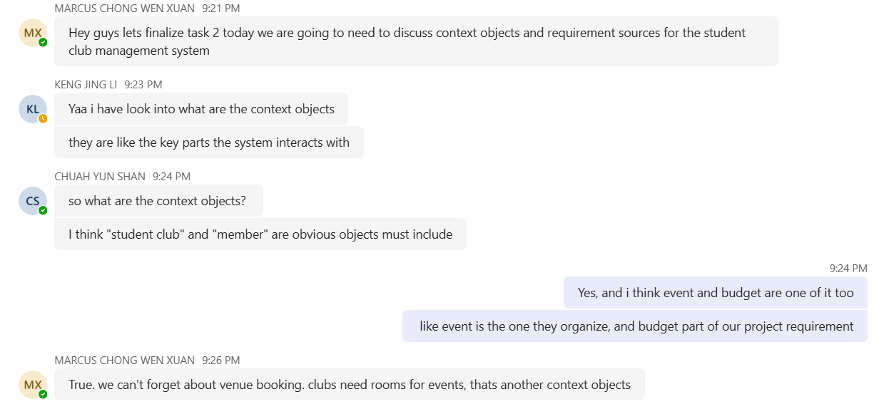

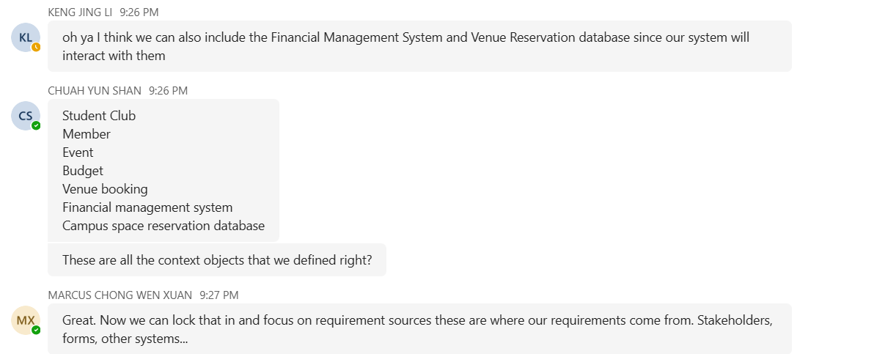

**Table of Contents**

1. Introduction 5

2. Context Objects 5

3. Requirement Sources 6

### Introduction

This document identifies the key context objects and requirement sources for the development of the Student Club Management System with Budget and Venue Integration. Understanding these elements is important to ensure that the system aligns with real-world operations and meets the needs of its stakeholders.

### Context Objects

Context objects are key elements within the environment of the system that it interacts with. Identifying these objects define what the system must support during development. The following are the context objects for the Student Club Management System:

|  |  |
| --- | --- |
| **Context Object** | **Explanation** |
| Student club | A student club is the group formed by students for extracurricular activities. Each club usually has a committee structure and a list of members. |
| Member | A student who are part of a student club. Each member may have roles such as president, treasurer, or general member. |
| Event | A club event is an activity organized by a student club, such as a workshop, seminar, or competition. |
| Budget | A club budget is a financial document prepared by a student club, which includes expected expenses and requested budgets for upcoming event. |
| Venue booking | A venue booking refers to the reservation of physical spaces on campus, such as lecture halls or meeting rooms, for club activities. |
| Financial management system | This system used by the university to manage budget disbursement, approvals, and financial compliance. |
| Campus space reservation database | The database that manages space availability, scheduling, and venue reservations. |

### Requirement Sources

Requirement sources are the stakeholders, systems, and documents from which the system’s needs can be identified. The following are the sources of requirements for the Student Club Management System:

|  |  |  |  |
| --- | --- | --- | --- |
| **Context Object** | **Source** | **Type** | **Explanation** |
| Student Club | Student | Stakeholder | A user who can view and join clubs. |
| Member | Membership registration form | Document | A form that includes personal details to join the club. They can post discussion in forum. |
| Event | Event planning form | Document | A form that shows details about a planned event for approval. |
| Forum | Club leader  (presidents, treasurers, secretaries) | Stakeholder | A user who manages memberships, forum, events, and budget proposals. |
| Club member | Stakeholder | A user who can post discussion in forum, join activities and participate in events. |
| Budget | Budget request form | Document | A form used by a club to request money for activities. |
| Finance system | System | The system used to submit, track, approve budget proposals. |
| Venue booking | Venue booking rules | Document | Regulations and procedures for reserving campus spaces. |
| Venue booking system | System | The system used to manage booking and availability of campus spaces. |
| Financial management system | Finance staff | Stakeholder | A university staff who reviews and handles budget approvals. |
| Campus space reservation database | Venue staff | Stakeholder | A staff who manages venue availability and approves venue bookings. |