**Task 4 -**

**Elicitation Execution**

**for**

**Student Club Management System**

**Version <1.0>**

**Group No.: 5**

|  |  |  |  |
| --- | --- | --- | --- |
| **MARCUS CHONG WEN XUAN** | | **241UC2414J** |  |
| **KENG JING LI** | | **1211106628** |  |
| **CHUAH YUN SHAN** | | **1211107031** |  |
| **TAN YUN XUAN** | | **1221309436** |  |
|  |  | |  |

|  |  |
| --- | --- |
|  |  |
|  |  |
|  |  |
|  |  |
| **Date created:** | **12 May 2025** |

**Table of Contents**

1. Introduction 3

2. Selected Elicitation Techniques Overview 3

2.1. Observation 3

2.2. Questionnaire 3

2.3. Brainstorming 3

3. Execution Details 4

3.1. Observation 4

3.2. Questionnaire 11

3.3. Brainstorming 25

4. Mapped Requirements with Kano Model 29

### Introduction

This document presents the execution of elicitation techniques for the Student Club Management System. The objective is to identify user expectations and essential features related to the system through three planned elicitation techniques applied, including observation, questionnaire, and brainstorming. The results as a foundation for system requirements and are categorized using the Kano Model to support design decisions.

### Selected Elicitation Techniques Overview

### Observation

This technique was conducted by observing how users interacted with the existing MMU CLiC system to identify useful functionalities and workflow challenges that users experience. One member performed club-related tasks (e.g., venue booking, budget and event proposal submission, club browsing) while another recorded system flow, delays, and limitations. This helps to define the requirements and usability issues that could be improved for Student Club Management System.

### Questionnaire

A questionnaire was distributed to collect feedback from students regarding their preferences and needs for the Student Club Management System. The questionnaire included a variety of question types to capture details on membership management, communication, event planning, and budget tracking. Responses from 27 participants were gathered over a week, which provide useful data to identify common challenges and desired features, such as club joining or leaving, notifications, discussion forums, attendance tracking, task assignments, and financial management tools.

### Brainstorming

This assistance technique was carried out to expand on possible system features and explore innovative functionalities, especially those that might delight users. The session encouraged open discussion and creativity among team members. The collected ideas were shared, grouped, and refined into a list of system requirements such as user profile management, event visibility, venue booking and budget recommendations, user-role dashboards.

### Execution Details

### Observation

**Execution**

During the observation session, one team member acted as a student and carried out several tasks using the MMU CLiC system. These tasks included booking a venue, submitting a Student Activity Proposal (STAP), submitting a budget request, organizing committee members, and viewing available club. The aim is to understand user interactions with the system to assess its functionality and user experience. Meanwhile, another team member observed the procedure carefully, noting any usability issues, useful features, and potential areas for improvement. Screen recording and screenshots were also taken throughout the session.

|  |  |
| --- | --- |
| Date | 28/04/2025 (Observation session)  29/04/2025 – 01/05/2025 (Observation Analysis) |
| Time | 7.30pm – 8.00pm (Observation session) |
| Format | Screen recording |
| Link | [Access link to observation session](https://mmuedumy-my.sharepoint.com/:f:/g/personal/1221309436_student_mmu_edu_my/EmPyZ2d1aHxJibK9098PJ4MBvacF5xfc9zyW1Sv2Kxa2Fw?e=hWQ0LW) |
| Participant | Team members |

Screenshot of the existing system (MMU CLiC) observed.

|  |
| --- |
|  |

**Outcomes**

**Observation of (1) book venue**

|  |
| --- |
| * **Book venue** |
| User can book venues by entering event type, description, date, time, and venue. Before submitting the request, user can click on the “Check Availability” button to confirm venue’s availability. This feature as a **must-be** requirement, as it is essential for organizing events. Without this feature, user cannot proceed with event planning. |

|  |
| --- |
| * **Track venue request status** |
| User can access “My Request” section to check the status of venue booking request. This ability to track approval or rejection of request categorized as a **dissatisfier**. Users expect to know whether their request has been approved or rejected. Absence of this feature would make users frustrated because of uncertain status. |

|  |
| --- |
| * **Check venue availability in a calendar view** |
| User can explore a calendar view to check venue availability, which help to avoid double bookings. This is marked as **delighter**, as user may not expect an interactive calendar view. It will add convenience to booking process but not a basic functionality. |

**Observation of (2) Student Activity Proposal (STAP)**

|  |
| --- |
| * **Create event proposal**    |
| User can create and submit event proposal by entering event details. This feature is a **must-be** requirement, as it is a basic function for planning events. User cannot propose events without this feature. |

|  |
| --- |
| * **Submit budget request** * **Track budget request status**    |
| The system allow user to submit expenditure details, which align with budget request feature as it is a **must-be** requirement. Additionally, users can track the approval status, this also considered as a **dissatisfier**, as it is a basic need for user to know the status of approvals. Without this, may lead to dissatisfaction. |

|  |
| --- |
| * **Organize event committee**    |
| Another observed function is the ability to organize committees and assign roles to members. This enhances event coordination and is considered a **satisfier**, as it improves efficiency and user satisfaction when this feature is available. |
| * **View event history**    |
| The system provides access to past event proposals, which support user to review previous events for better planning. This feature as a **satisfier** as its presence increases user satisfaction. |

**Observation of (3) view club**

|  |
| --- |
| * **View club** * **Join club** |
| The system enables users to view student clubs and access detailed member information when selecting a club. Navigating to the member details page, users can also join the club directly. In contrast, the existing MMU CLiC system displays only a limited number of clubs from MMU Melaka and does not include clubs from the MMU Cyberjaya campus. This highlights the need for club visibility, which is classified as a **must-be** requirement for user clarity. |

**Classification of Requirements (Observation)**

|  |  |
| --- | --- |
| **Kano Category** | **Requirement** |
| Dissatisfier | Book venue |
| Track approval status of venue booking request |
| Create event proposal |
| Submit budget request |
| Track approval status of budget request |
| View club |
| Join club |
| Satisfier | Organize event committee |
| View event history |
| Delighter | Check venue availability in a calendar view |

### Questionnaire

**Execution**

To better understand student needs and expectations regarding club management system, a questionnaire was conducted between May 3 and May 9, 2025. The form was created using Microsoft Forms and distributed through WhatsApp groups. The questionnaire included a mix of single-choice, multiple-choice, and short-answer questions, which covers areas such as club membership, event management, communication preferences, and budget tracking. Total of 27 students participated, which provides challenges faced and desired features.

|  |  |
| --- | --- |
| Date | 01/05/2025 - 02/05/2025 (Questionnaire Design)  03/05/2025 – 09/05/2025 (Questionnaire Distribution)  10/05/2025 – 11/05/2025 (Questionnaire Analysis) |
| Format | Microsoft Form distributed through WhatsApp group |
| Link | <https://forms.office.com/r/00HERLZths> |
| Participant | 27 university students |

Screenshot of the questionnaire created.

|  |
| --- |
|  |

**Outcomes**

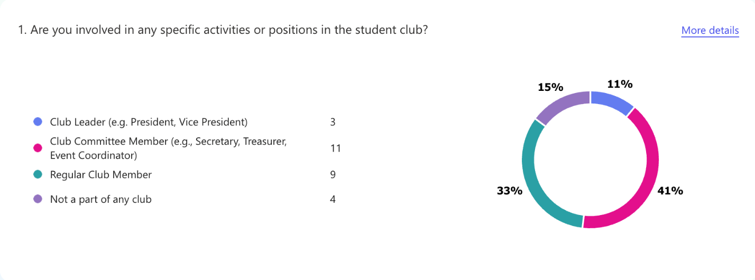*Figure 1*

Based on the pie chart on Figure 1, 41% of respondents are club committee members and 11% are club leaders, showing that over half are actively involved in student clubs. This shows leadership and committee who value deeper engagement and responsibility within their campus community.

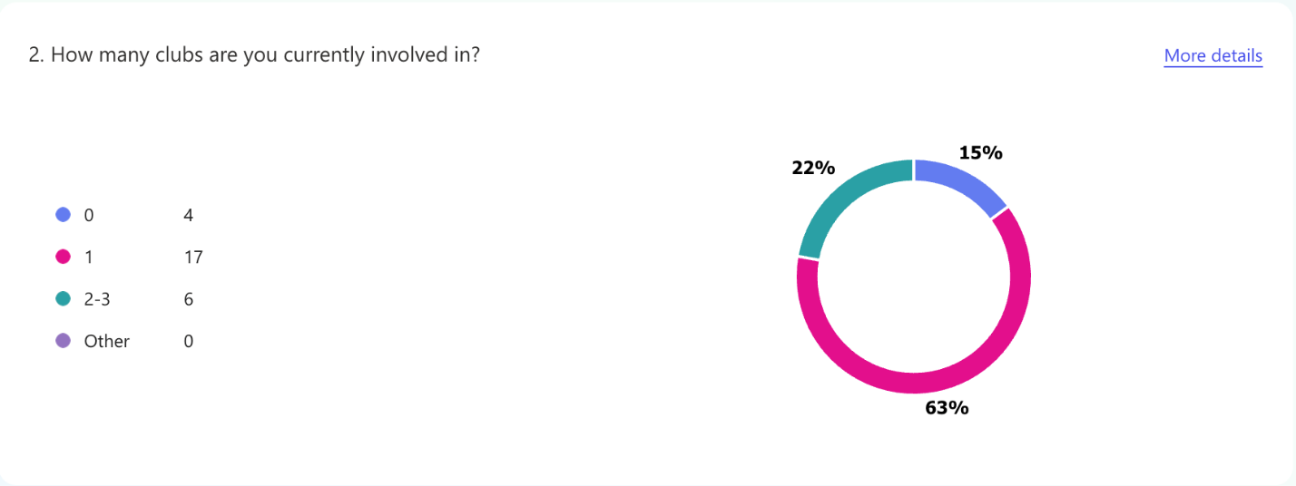*Figure 2*

Based on the pie chart on Figure 2, 63% of respondents are involved in one club, while 22% are part of 2 to 3 clubs. The 15% not in any club may indicate unmet basic expectations, showing potential for improved outreach or opportunities to boost inclusion.

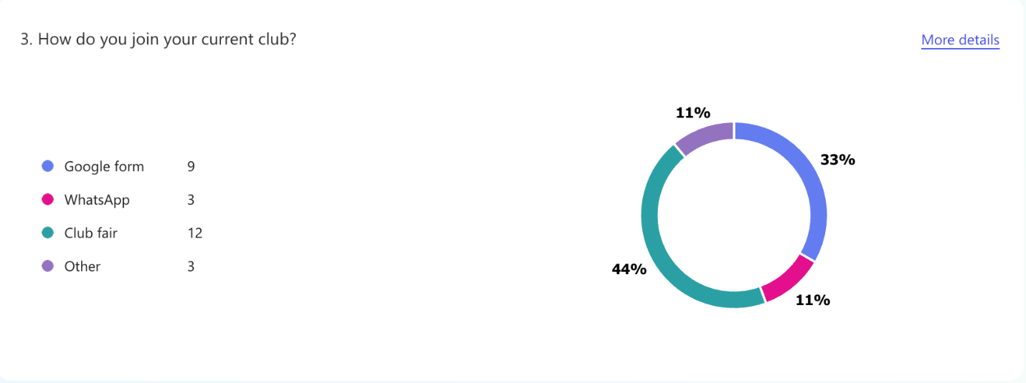*Figure 3*

Based on the pie chart on Figure 3, 44% of respondents joined their club through a club fair, followed by 33% via Google Forms. This shows that in-person recruitment (like club fairs) encouraging participation. Meanwhile, digital options like Google Forms offer convenient alternatives, which may act as basic expectations for some students. The presence of other methods (WhatsApp and others, each at 11%) reflects a need for diverse, flexible joining options to meet various preferences.

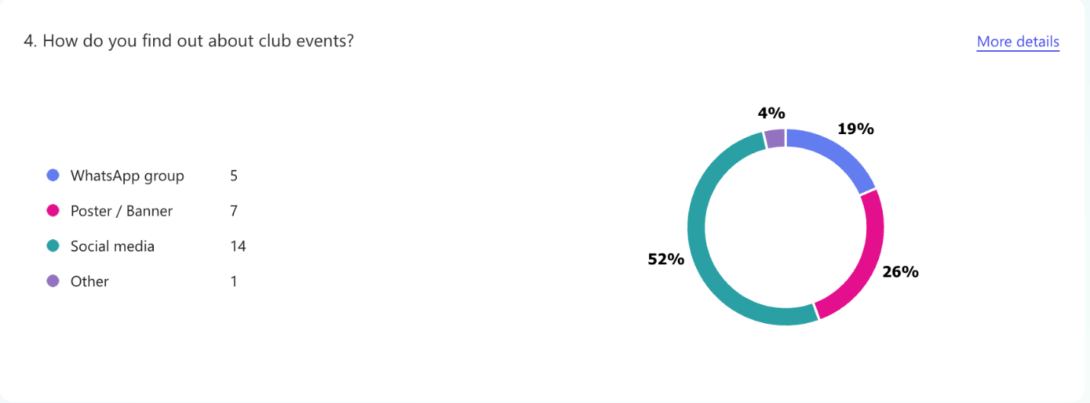*Figure 4*

52% of students find out about club events through social media, making it the most popular method. Posters and banners are next (26%), followed by WhatsApp (19%). This means clubs should focus more on digital platform like student club system for easier club joining. Only 4% use other methods, suggesting that they played minimum role in event awareness.

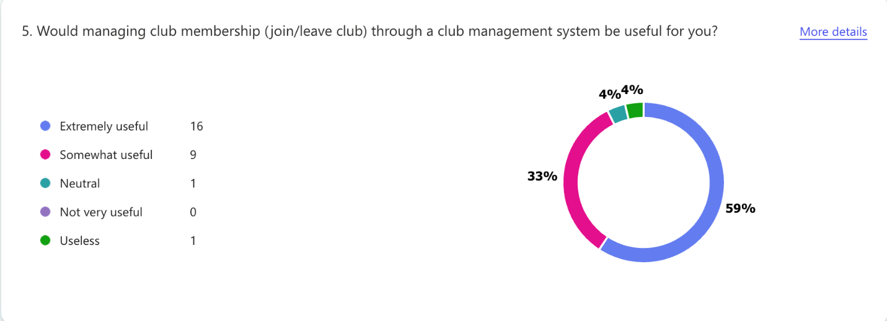*Figure 5*

According to the chart, 59% of respondents found a club management system for joining or leaving the club to be *extremely useful*, while another 33% considered it *somewhat useful*. This combined 92% shows strong support for implementing such a system. Only 4% were *neutral* and another 4% deemed it *useless*. This shows joining and leaving club is a basic feature. Without it, students may feel frustrated with manual processes.

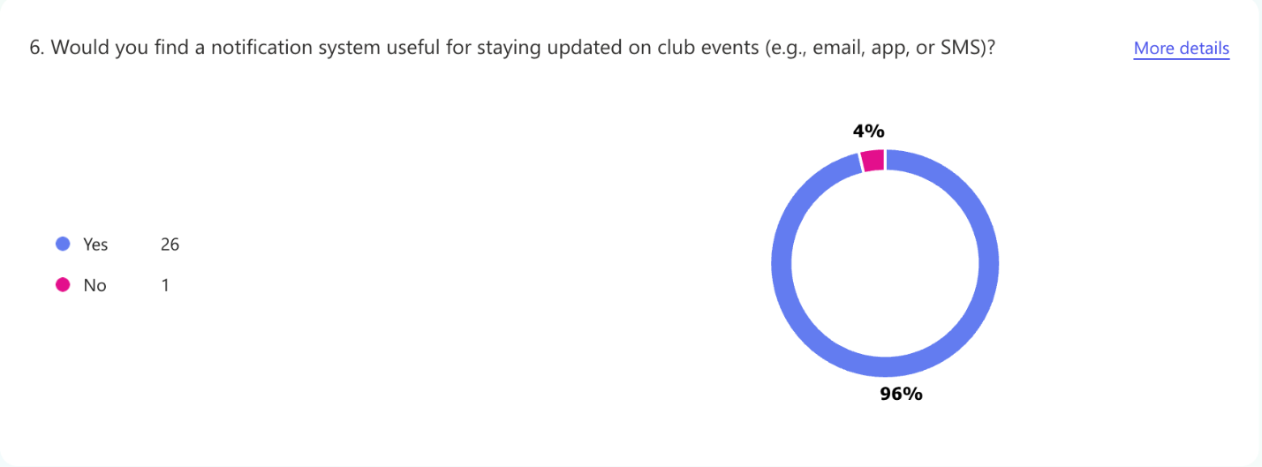*Figure 6*

Based on the pie chart, 96% of respondents (26 out of 27) indicated that a notification system be useful for staying updated on club events. Only 4% (1 respondent) did not find it beneficial. This overwhelming consensus highlights a strong demand for streamlined proactive communication tools. Introducing a reliable notification system could enhance engagement and attendance by ensuring members remain informed. This shows 96% of users expect this nice-to-have feature.

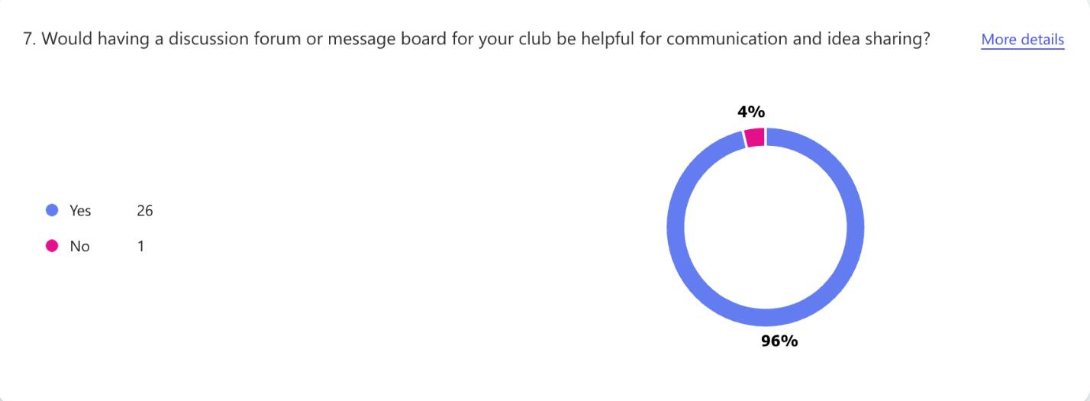*Figure 7*

Based on the chart results, a significant majority 96% (26 out of 27 respondents) indicated that having a discussion forum or message board for the club would be helpful for communication and idea sharing. Only 4% (1 respondent) disagreed. This shows it is a satisfier feature that improves the experience and encourages interaction. This overwhelming support underscores a strong interest in improving collaborative communication within the club.

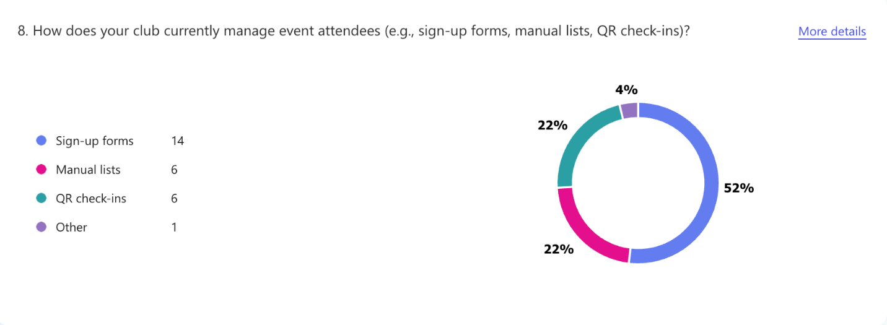*Figure 8*

The data reveals QR check-ins dominate (52%) as the preferred attendee management method, positioning it as a high-performing feature for clubs. Sign-up forms and manual lists trail significantly (22% and 4%, respectively), suggesting QR systems align better with user expectations for efficiency. The 22% “Other” responses indicate room to explore niche needs, but the strong adoption of QR codes underscores their role as a delightful, modern solution, especially for clubs prioritizing seamless event logistics.

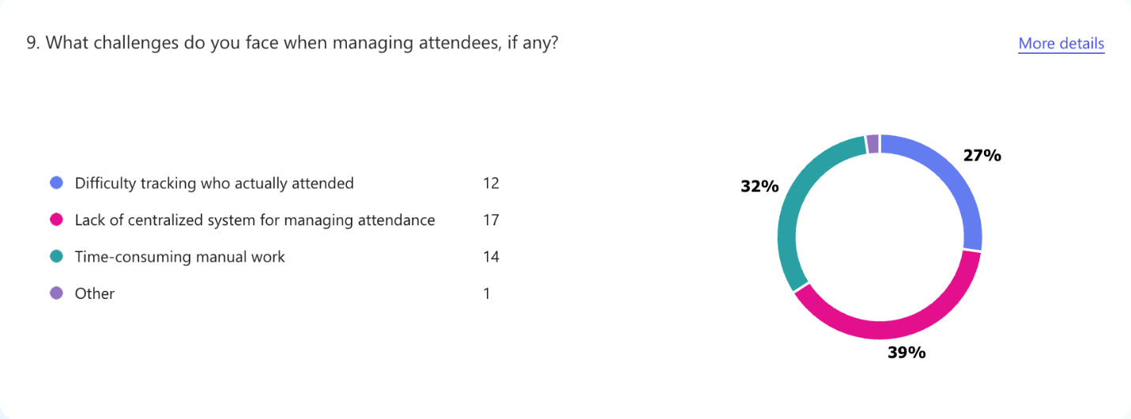*Figure 9*

The top challenge in attendee management is time-consuming manual work (39%), closely followed by lack of a centralized system (32%) and difficulty tracking actual attendance (27%). This reveals a clear pain point: clubs are burdened by inefficient processes, with nearly 40% struggling with outdated manual methods.

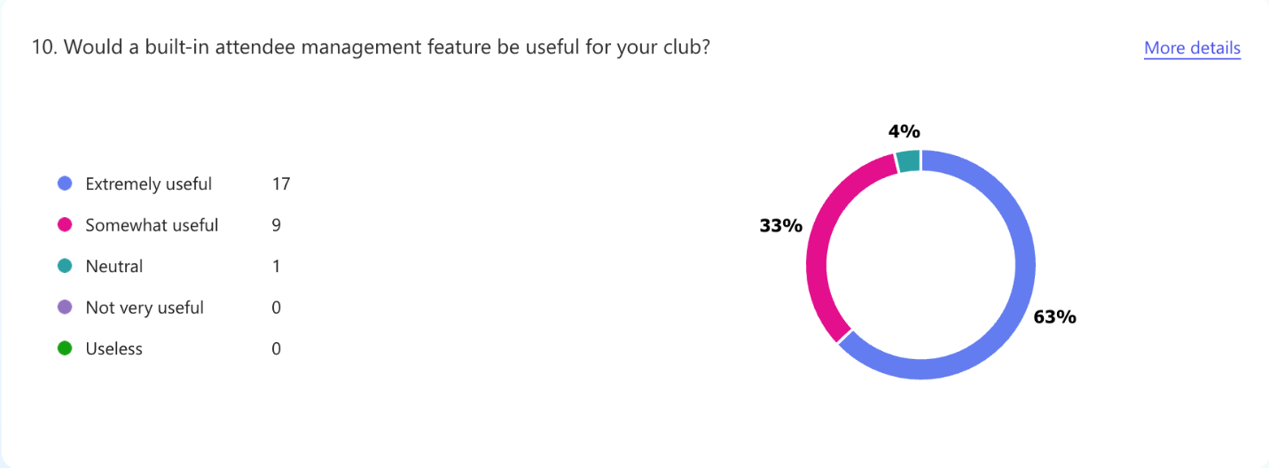*Figure 10*

The data shows 63% of respondents find a built-in attendee management feature *“Extremely useful”*, with another 33% considering it *“Somewhat useful”*. With 96% combined positive response, this satisfier feature clearly resonates as both essential and appealing for club organizers particularly those struggling with time-consuming manual processes.

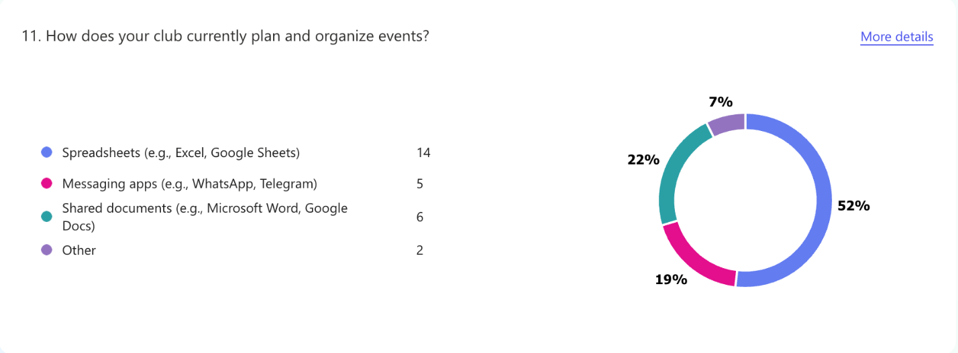*Figure 11*

A majority of clubs (52%) rely on shared documents (like Google Docs) for event planning, while spreadsheets (22%) and messaging apps (19%) serve as secondary tools. Only 7% use other methods.

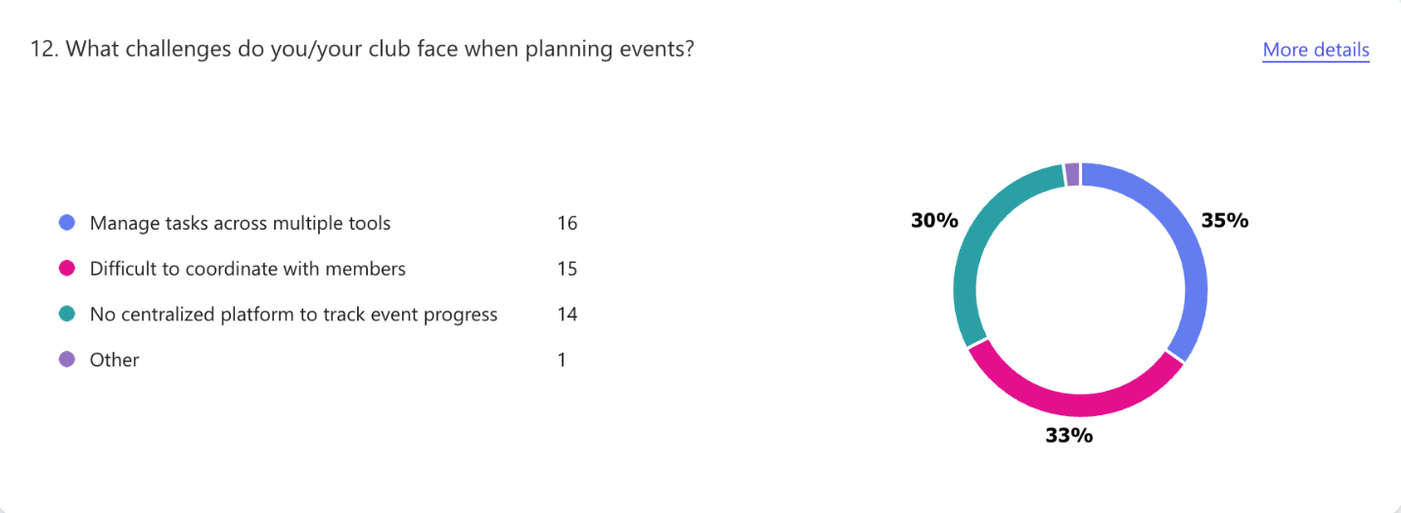*Figure 12*

The data reveals that 35% of clubs struggle most with *member coordination* during event planning, followed closely by *multi-tool management* (30%) and *lack of centralized tracking* (33%). These pain points impact 98% of respondents, indicating near-universal frustration with current planning methods.

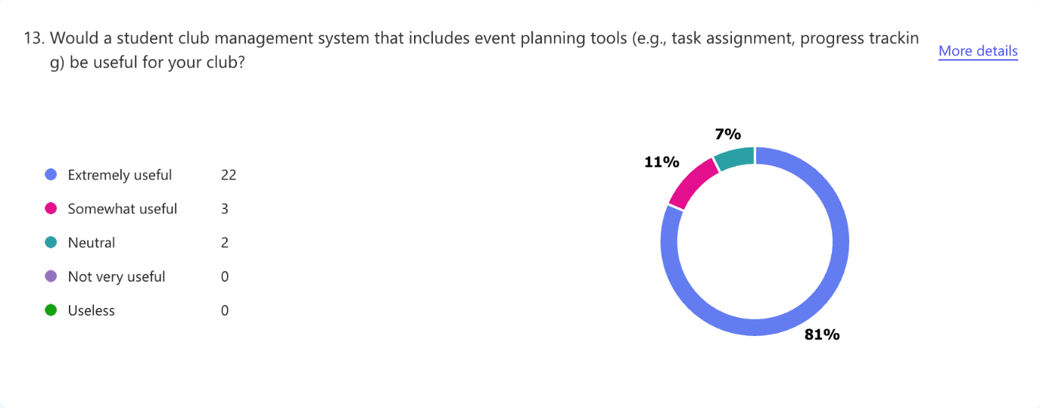*Figure 13*

The survey reveals overwhelming enthusiasm for a club management system, with 81% of respondents calling it *“Extremely useful”* and 11% *“Somewhat useful.”* This 92% approval rating demonstrates near-universal demand. 92% of respondents find this satisfier feature useful, as it helps clubs organize committee and assign task.

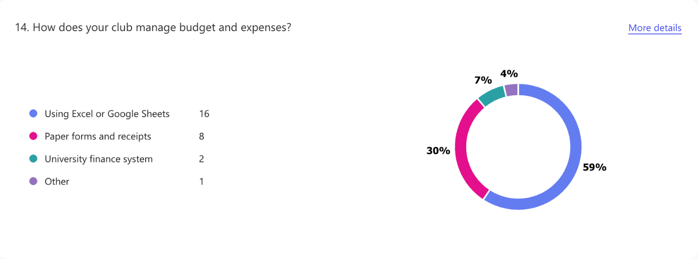*Figure 14*

The survey reveals 59% of clubs currently manage budgets through spreadsheets (Excel or Google Sheets), while 30% rely on paper-based methods, and only 7% utilize university finance platforms.

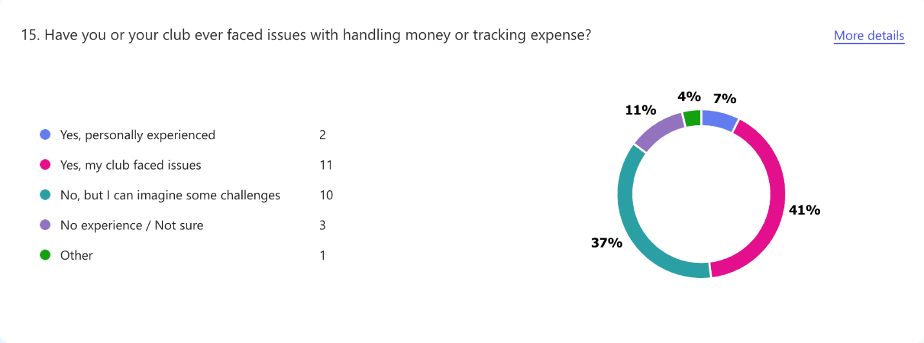*Figure 15*

A significant 41% of respondents report their clubs have faced financial tracking issues, with an additional 37% anticipating potential challenges. 78% recognize real pain points in money management, while only 11% claim no concerns.

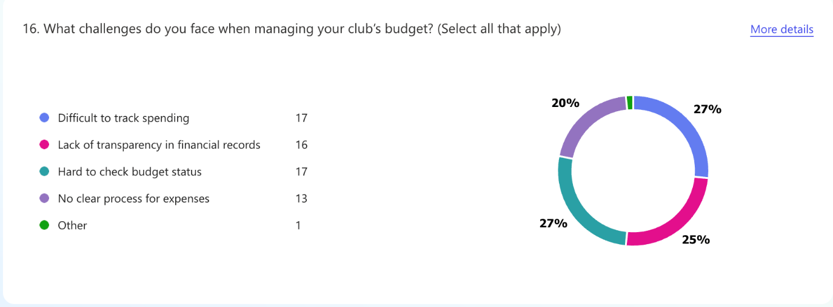

*Figure 16*

Budget management poses significant challenges for clubs, with 27% struggling to track spending, 25% finding it hard to check budget status, and 20% citing lack of transparency revealing widespread financial visibility issues.

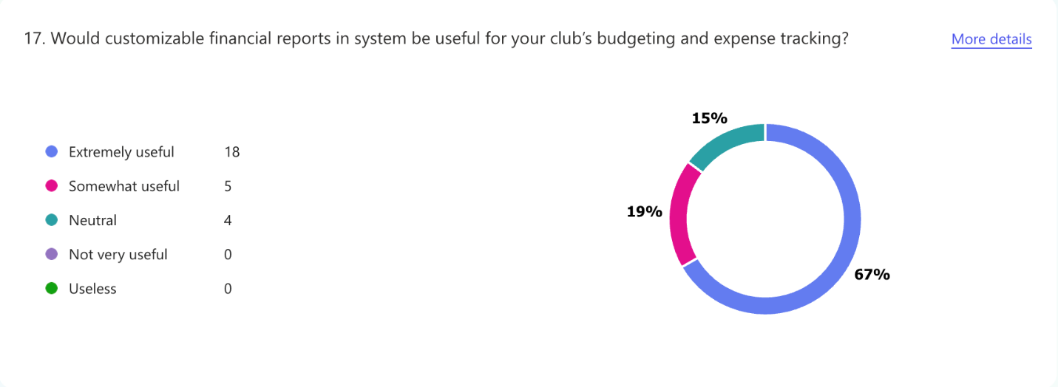*Figure 17*

A decisive 67% of respondents find customizable financial reports *“Extremely useful”*, with another 19% considering them *“Somewhat useful” a total of* 86% approval for this satisfier feature. Only 15% remain neutral, with zero negative responses.

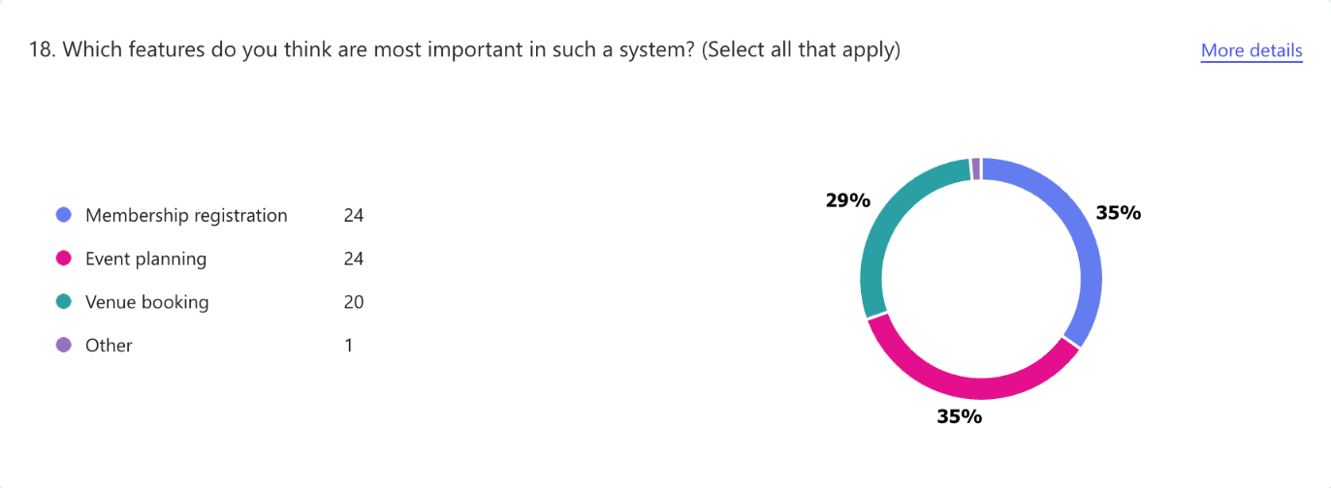

*Figure 18*

The survey reveals 35% of respondents prioritize *both* membership registration and event planning tools as most important, with venue booking close behind at 29%. Together, these three features account for 99% of all preferred functionalities, demonstrating their universal value.

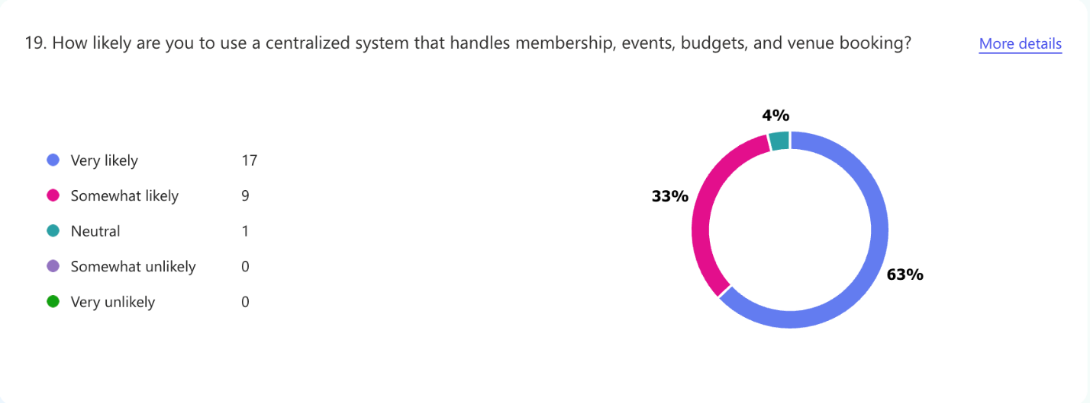*Figure 19*

An overwhelming 63% of respondents are *“Very likely”* to use a centralized club management system, with another 33% *“Somewhat likely”*, total 96% potential adoption. Only 4% remain neutral, with zero negative responses.

**Classification of Requirements (Questionnaire)**

|  |  |
| --- | --- |
| **Kano Category** | **Requirement** |
| Dissatisfier | Join or leave club |
| Organize event committee |
| Satisfier | Track event attendee |
| View financial report |
| Receive notifications for event updates and approvals |
| Use discussion forums |

### Brainstorming

**Execution**

A brainstorming session was conducted on May 11, 2025, through Microsoft Teams chat to generate innovative ideas for the proposed system. All project team members participated in the session. The meeting began with a recap of the project vision and the goals of our system. Team members then contributed ideas, followed by each member sharing ideas related to user needs, and possible system features.

|  |  |
| --- | --- |
| Date | 11/05/2025 |
| Time | 9.30pm – 10.10pm |
| Format | Microsoft Teams chat |
| Participant | Team members |

**Outcomes**

Screenshots of brainstorming session.

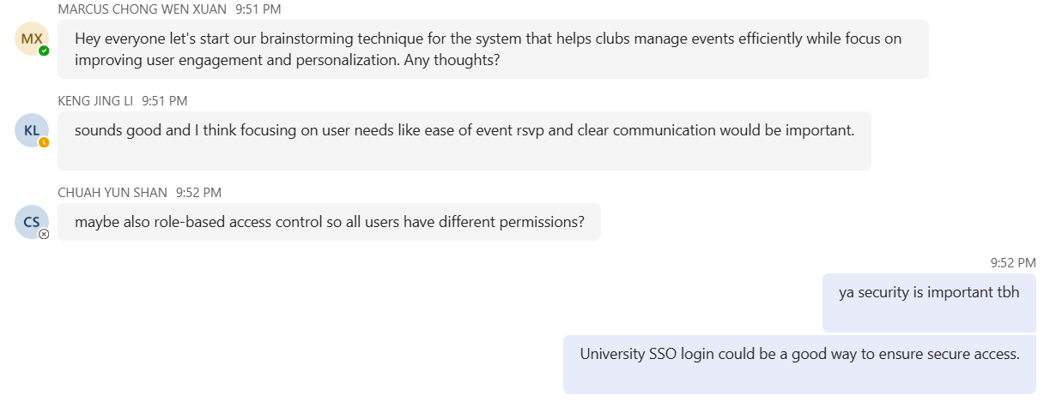

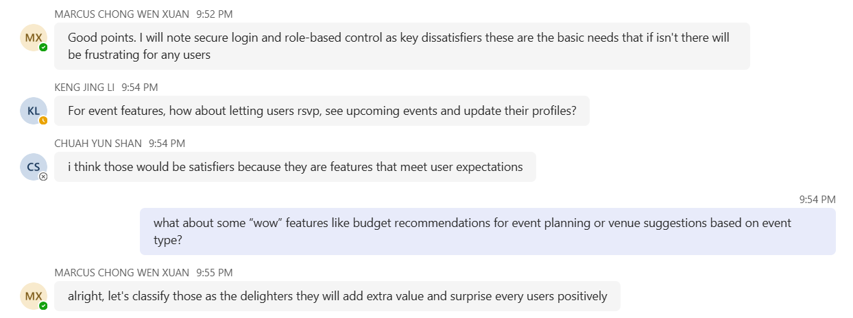

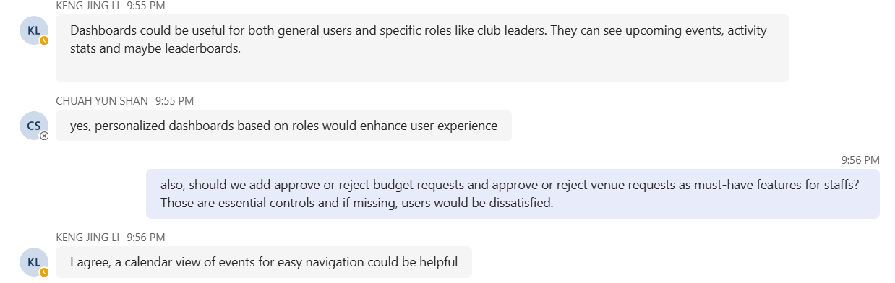

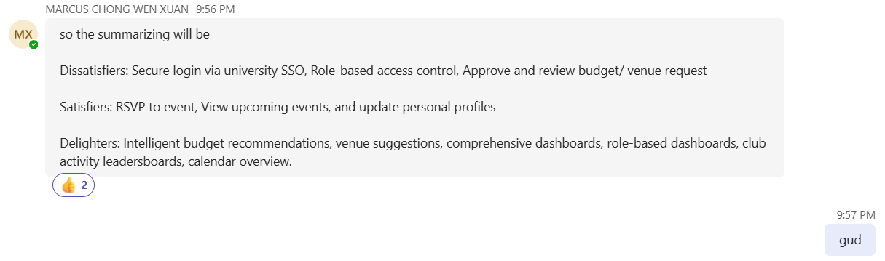

The brainstorming session identified and categorized system features using the Kano Model. Dissatisfiers included essential features like secure login using university SSO, role-based access control, and the ability for finance and venue staff to approve or reject budget and venue requests. Satisfiers include features that meet user expectations, such as RSVP to events, view upcoming events, and update personal profiles. Delighters enhance user engagement, included intelligent budget and venue suggestions, comprehensive and role-based dashboards and a calendar overview of events.

**Classification of Requirements (Brainstorming)**

|  |  |
| --- | --- |
| **Kano Category** | **Requirement** |
| Dissatisfier | Secure login via university SSO |
| Role-based access control |
| Approve or reject budget request |
| Approve or reject venue request |
| Satisfier | RSVP to event |
| View upcoming events |
| View and update personal profiles |
| Delighter | Receive intelligent budget recommendations |
| Receive venue suggestions based on event type |
| View comprehensive dashboards |
| Access role-based dashboards |
| View calendar overview of upcoming events |

### Mapped Requirements with Kano Model

* 1. **Dissatisfier**

|  |  |  |  |
| --- | --- | --- | --- |
| **Stakeholder** | **Requirement** | **Justification** | **Technique Used** |
| Club leader | Book venue | Events cannot be held without venue booking. | Observation |
| Track approval status of venue booking request | Must know whether a venue is confirmed to proceed with event planning. |
| Track approval status of budget request | Must know whether budget is approved to proceed with event planning. |
| Submit budget request | Club needs funding to organize event. |
| Create event proposal | Initial step to organize event. |
| Student | View clubs | Students need to know what clubs are available. |
| Join or leave club | Basic feature for student participation. | Observation,  Questionnaire |
| All users | Secure login via university SSO | Ensures only valid user access system. | Brainstorming |
| Role-based access control | Ensures task-specific access. |
| Finance staff | Approve or reject budget request | Manage event funding properly. |
| Venue staff | Approve or reject venue request | Manage booking requests efficiently. |

* 1. **Satisfier**

|  |  |  |  |
| --- | --- | --- | --- |
| **Stakeholder** | **Requirement** | **Justification** | **Technique Used** |
| Club leader | Organize event committee | Assigns roles for event preparation. | Observation,  Questionnaire |
| View event history | Review past events proposal and makes better event plans. | Observation |
| Track event attendee | Estimate how many people are coming to events. | Questionnaire |
| View financial report | Check club spending and expenses. |
| Club leader, Student | Use discussion forum | Allow member to discuss and share ideas about club activities. |
| All users | Receive notifications | Keep everyone stay informed about event and approval updates. |
| View and update personal profiles | Manage own account details. | Brainstorming |
| Student | RSVP to event | Confirmation of attendance so club can plan accordingly. |
| View upcoming events | Allow user to join events they interested. |

* 1. **Delighter**

|  |  |  |  |
| --- | --- | --- | --- |
| **Stakeholder** | **Requirement** | **Justification** | **Technique Used** |
| Club leader | Check venue availability in a calendar view | Makes it easier to see when venue available to book. | Observation |
| Receive intelligent budget recommendations | Saves time by suggesting how much money to request. | Brainstorming |
| Receive venue suggestions based on event type | Suggests suitable venues based on event type to make planning faster. |
| All users | View comprehensive dashboards | Shows everything in one place, like club performance, event trends. |
| Access role-based dashboards | Each user access information based on their roles. |
| Student | View calendar overview of upcoming events | User can quickly view upcoming events and dates. |