|  |
| --- |
|  |
| **EE489 Real-Time Embedded Systems** |
| Labs 4-6 (ST-IOT Board B-L475E-IOT01A0)  *Marcus Corbin* |
|  |
| *3/5/2020* |

|  |
| --- |
|  |

# Introduction

The purpose of these three labs is to see different behaviors of delays in FreeRTOS using CMSIS functions. In Lab4, an API will be used instead of using a for loop in previous labs. Lab 5 also uses an osDelay but calls for an OsDelayUntil which waits until the systick function. Lastly, in Lab 6 a continuous function will be called along with a period function that calls the osDelayUntil in Lab 5.

**LAB 4**

# CMSIS_v1 APIs used and the corresponding FreeRTOS APIs:

* osDelay ( uint32_t millisec )
  + Wait for a specified time period in milliseconds.
    - millisec: time delay value

1. **Screenshots of the program execution results (Tera Term window)**

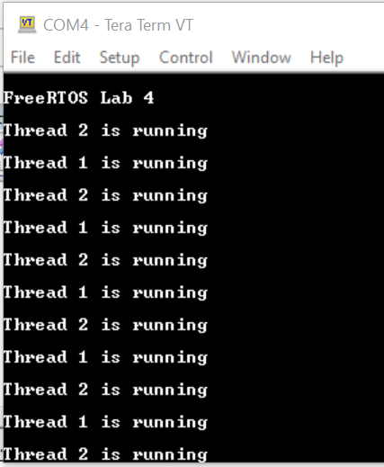 **Figure 1: Lab 4 Tera Term Output**

On the previous screenshot, a similar result is shown as if the for loop is used to create a delay. However, in this case the call to osDelay (1000) gives a 1 second delay instead. This allows Thread 2 to run first, wait one second, then run Thread 1. This then repeats forever in the ThreadFunc loop.

**LAB 5**

# CMSIS_v1 APIs used and the corresponding FreeRTOS APIs:

* osDelayUntil ( uint32_t ticks )
  + Waits until an absolute time (specified in kernel ticks) is reached.
    - ticks: absolute time in ticks
* osKernelSysTick ( void )
  + Get the value of the Kernel SysTick timer for time comparison.

# Screenshots of the program execution results (Tera Term window)

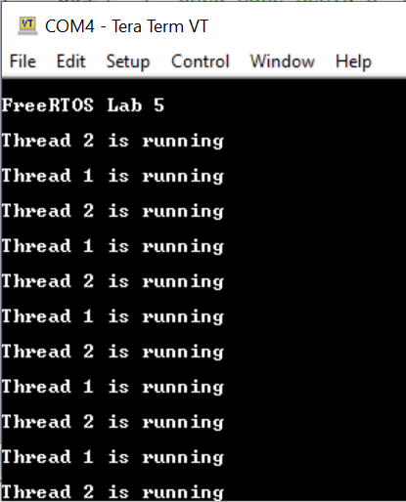  
**Figure 2: Lab 5 Tera Term Output**

On the previous screenshot, a similar result from using osDelay is shown. However, this shows the delay using the delay until the systick is called.

**LAB 6**

# CMSIS_v1 APIs used and the corresponding FreeRTOS APIs:

* osDelayUntil ( uint32_t ticks )
  + Waits until an absolute time (specified in kernel ticks) is reached.
    - ticks: absolute time in ticks
* osKernelSysTick ( void )
  + Get the value of the Kernel SysTick timer for time comparison.

# Screenshot of the program execution results (Tera Term window)

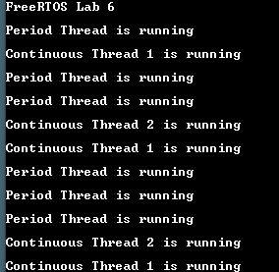

**Figure 3: Lab 6 Tera Term Output**

On the previous screenshot, the period thread runs first along with a continuous thread 1. Shortly after, the period thread runs a couple times and then a loop of the continuous thread 2 and continuous thread 1 run.

**Conclusion**

These three labs had good insight onto how delays can be used with threads. An osDelay function is great to use when a specified delay time is required. However, the osDelayUntil can be used in various ways. This could be used in a single thread or in multiple threads. Altogether, different types of delays can be used in threads and other cmsis_os APIs as well.

**Appendix: The edited source code.**

**LAB 4:**

/* Private variables ---------------------------------------------------------*/

UART_HandleTypeDef huart1;

osThreadId Thread1Handle;

osThreadId Thread2Handle;

//...

/* USER CODE BEGIN PFP */

#ifdef __GNUC__

#define PUTCHAR_PROTOTYPE int __io_putchar(int ch)

#else

#define PUTCHAR_PROTOTYPE int fputc(int ch, FILE *f)

#endif /* __GNUC__ */

/* USER CODE END PFP */

/* Private user code ---------------------------------------------------------*/

/* USER CODE BEGIN 0 */

PUTCHAR_PROTOTYPE

{

  /* e.g. write a character to the USART1 and Loop until the end of transmission */

  HAL_UART_Transmit(&huart1, (uint8_t *)&ch, 1, 0xFFFF);

  return ch;

}

// ...

int main(void)

{

// ...

/* USER CODE BEGIN 2 */

printf("\n\rFreeRTOS Lab 4\n\r");

  /* Create the thread(s) */

  /* definition and creation of Thread1 */

  osThreadDef(thread1, ThreadFunc, osPriorityNormal, 0, 128);

  thread1Handle = osThreadCreate(osThread(thread1), (void*)pcTextForThread1);

  /* definition and creation of thread2 */

  osThreadDef(thread2, ThreadFunc, osPriorityAboveNormal, 0, 128);

  thread2Handle = osThreadCreate(osThread(thread2), (void*)pcTextForThread2);

  /* Start scheduler using CMSIS abstraction*/

  osKernelStart();

   /* We should never get here as control is now taken by the scheduler */

  /* Infinite loop */

  /* USER CODE BEGIN WHILE */

  while (1)

  {

    /* USER CODE END WHILE */

    /* USER CODE BEGIN 3 */

  }

}

// ...

/* USER CODE END Header_ThreadFunc */

void ThreadFunc(void const * argument)

{

  /* USER CODE BEGIN 5 */

  volatile unsigned long ul;

  /* Infinite loop */

  for(;;)

  {

    printf("%s", (char*)argument);

//    for ( ul = 0; ul < 0xFFFFFF; ul++ )

//    {

//    }

    osDelay(1000);

  }

  /* USER CODE END 5 */

}

**LAB 5**

/* Private variables ---------------------------------------------------------*/

UART_HandleTypeDef huart1;

osThreadId Thread1Handle;

osThreadId Thread2Handle;

//...

/* USER CODE BEGIN PFP */

#ifdef __GNUC__

#define PUTCHAR_PROTOTYPE int __io_putchar(int ch)

#else

#define PUTCHAR_PROTOTYPE int fputc(int ch, FILE *f)

#endif /* __GNUC__ */

/* USER CODE END PFP */

/* Private user code ---------------------------------------------------------*/

/* USER CODE BEGIN 0 */

PUTCHAR_PROTOTYPE

{

  /* e.g. write a character to the USART1 and Loop until the end of transmission */

  HAL_UART_Transmit(&huart1, (uint8_t *)&ch, 1, 0xFFFF);

  return ch;

}

// ...

int main(void)

{

// ...

/* USER CODE BEGIN 2 */

  printf("\n\rFreeRTOS Lab5\n\r");

  /* Create the thread(s) */

  /* definition and creation of Thread1 */

  osThreadDef(Thread1, ThreadFunc, osPriorityNormal, 0, 128);

  Thread1Handle = osThreadCreate(osThread(Thread1), (void*)pcTextForThread1);

  /* definition and creation of Thread2 */

  osThreadDef(Thread2, ThreadFunc, osPriorityAboveNormal, 0, 128);

  Thread2Handle = osThreadCreate(osThread(Thread2), (void*)pcTextForThread2);

  /* Start scheduler using CMSIS abstraction*/

  osKernelStart();

   /* We should never get here as control is now taken by the scheduler */

  /* Infinite loop */

  /* USER CODE BEGIN WHILE */  
  while (1)

  {

    /* USER CODE END WHILE */

    /* USER CODE BEGIN 3 */

  }

}

// ...

/* USER CODE END Header_ThreadFunc */

void ThreadFunc(void const * argument)

{

  /* USER CODE BEGIN 5 */

  uint32_t PreviousWakeTime;

  PreviousWakeTime = osKernelSysTick();

  /* Infinite loop */

  for(;;)

  {

    printf("%s", (char *)argument);

    osDelayUntil(&PreviousWakeTime, 1000);

  }

  /* USER CODE END 5 */

}

**LAB 6**

/* Private variables ---------------------------------------------------------*/

osThreadId ContinuousT1Handle;

osThreadId ContinuousT2Handle;

osThreadId PeriodTHandle;

//...

/* USER CODE BEGIN PFP */

#ifdef __GNUC__

#define PUTCHAR_PROTOTYPE int __io_putchar(int ch)

#else

#define PUTCHAR_PROTOTYPE int fputc(int ch, FILE *f)

#endif /* __GNUC__ */

/* USER CODE END PFP */

/* Private user code ---------------------------------------------------------*/

/* USER CODE BEGIN 0 */

PUTCHAR_PROTOTYPE

{

  /* e.g. write a character to the USART1 and Loop until the end of transmission */

  HAL_UART_Transmit(&huart1, (uint8_t *)&ch, 1, 0xFFFF);

  return ch;

}

// ...

int main(void)

{

// ...

/* USER CODE BEGIN 2 */

  printf("\n\rFreeRTOS Lab6\n\r");

  /* Create the thread(s) */

  /* definition and creation of Thread1 */

  osThreadDef(ContinuousT1, ContinuousTFunc, osPriorityNormal, 0, 128);

  ContinuousT1Handle = osThreadCreate(osThread(ContinuousT1), (void*)pcTextForThread1);

  /* definition and creation of ContinuousT2 */

  osThreadDef(ContinuousT2, ContinuousTFunc, osPriorityNormal, 0, 128);

  ContinuousT2Handle = osThreadCreate(osThread(ContinuousT2), (void*)pcTextForThread2);

  /* definition and creation of PeriodT */

  osThreadDef(PeriodT, PeriodTFunc, osPriorityAboveNormal, 0, 128);

  PeriodTHandle = osThreadCreate(osThread(PeriodT), (void *)pcTextForThread3);

  /* Start scheduler using CMSIS abstraction*/

  osKernelStart();

   /* We should never get here as control is now taken by the scheduler */

  /* Infinite loop */

  /* USER CODE BEGIN WHILE */  
  while (1)

  {

    /* USER CODE END WHILE */

    /* USER CODE BEGIN 3 */

  }

}

// ...

/* USER CODE END Header_ContinuousTFunc */

void ContinuousTFunc(void const * argument)

{

  /* USER CODE BEGIN 5 */

  volatile unsigned long ul;

  /* Infinite loop */

  for(;;)

  {

    printf("%s", (char *)argument);

    for ( ul = 0; ul < mainDELAY_LOOP_COUNT; ul++)

    {

    }

  }

  /* USER CODE END 5 */

}

/* USER CODE BEGIN Header_PeriodTFunc */

/**

* @brief Function implementing the PeriodT thread.

* @param argument: Not used

* @retval None

*/

/* USER CODE END Header_PeriodTFunc */

void PeriodTFunc(void const * argument)

{

  /* USER CODE BEGIN PeriodTFunc */

  uint32_t PreviousWakeTime;

  PreviousWakeTime = osKernelSysTick();

  /* Infinite loop */

  for(;;)

  {

    printf("%s", (char *)argument);

    osDelayUntil(&PreviousWakeTime, 1000);

  }

  /* USER CODE END PeriodTFunc */

}