|  |
| --- |
|  |
| **EE489 Real-Time Embedded Systems** |
| Labs 7-9 (ST-IOT Board B-L475E-IOT01A0)  *Marcus Corbin* |
|  |
| *3/5/2020* |

|  |
| --- |
|  |

# Introduction

The purpose of these three labs is to see different behaviors in threads including suspending, resuming, changing priority, and deletion. In Lab 7, a counter will be initialized along with a total thread suspension. Once suspended, the count value will be printed out and then the threads will resume. In Lab 8, Thread 1 will be created and then raise the priority of Thread 2. Then, Thread 2 will lower its own priority. Finally, in Lab 9, a thread 2 will be created in thread 1 and then thread 2 will delete itself when ran.

**LAB 7**

# CMSIS_v1 APIs used and the corresponding FreeRTOS APIs:

* osThreadSuspendAll ( )
  + Suspend all the current threads.
* osThreadResumeAll ( )
  + Resume all the threads that were previously suspended.

1. **Screenshot of the program execution results (Tera Term window)**

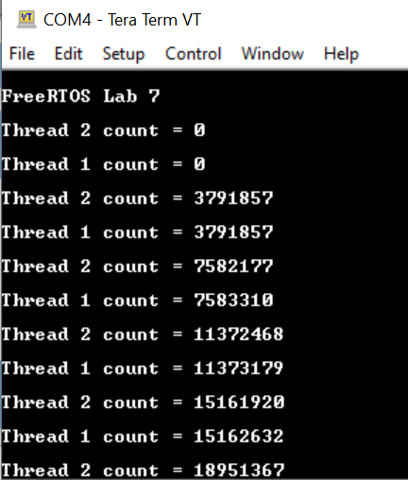 **Figure 1: Lab 7 Tera Term Output**

On the previous screenshot, the thread counts for thread 1 and 2 begin at zero. Once vPrintStringAndNumber is called, the tasks are previously running with a counter in the background but first get suspended. Tera term then prints out the new count value. After being printed, both threads resume.

**LAB 8**

# CMSIS_v1 APIs used and the corresponding FreeRTOS APIs:

* osThreadGetPriority ( osThreadId thread_id  )
  + Get the priority of an active thread.
    - thread_id: thread ID obtained by osThreadCreate or osThreadGetId.
* osThreadSetPriority ( osThreadId thread_id, osPriority priority )
  + Change the priority of an active thread.

# Screenshot of the program execution results (Tera Term window)

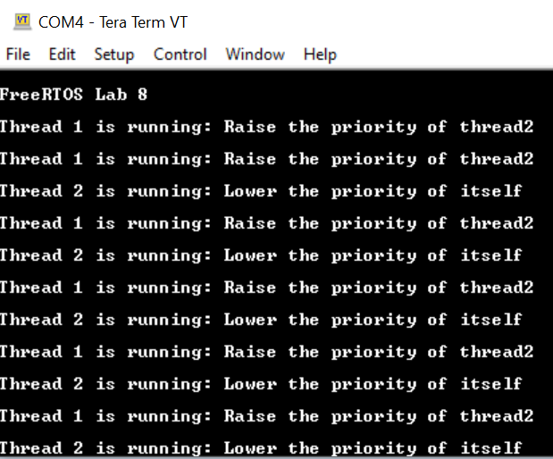  
**Figure 2: Lab 8 Tera Term Output**

On the previous screenshot, thread one runs and then calls to have thread 2 have a higher priority. Once thread 2 is printed, it will then lower the priority of itself. This then calls for thread 1 again which loops the pervious function of raising the priority of thread 2.

**LAB 9**

# CMSIS_v1 APIs used and the corresponding FreeRTOS APIs:

* osThreadTerminate ( osThreadId thread_id )
  + Remove the thread function from the active thread list. If thread is running, the execution will stop.
    - thread_id: thread ID obtained by osThreadCreate or osThreadGetId.

# Screenshot of the program execution results (Tera Term window)

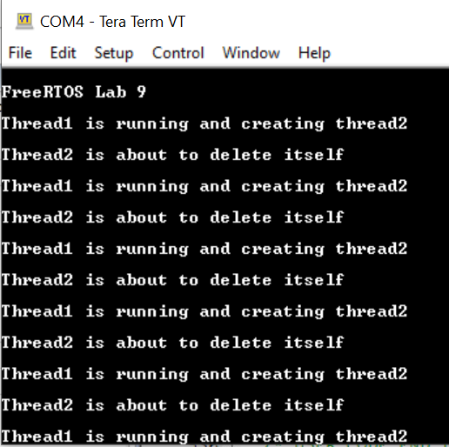  
**Figure 3: Lab 9 Tera Term Output**

On the previous screenshot, thread 1 is initially created and then creates thread 2. Once thread 2 runs, it will delete itself. However, since thread 1 always is creating thread 2, it creates a loop. This is a simple function that can end a task even if it is already running (as mentioned in the API definition).

**Conclusion**

These few labs are a good view of how tasks can be utilized in different ways. It was interesting to see how large the count number got in lab 7 once all the tasks were suspended. This shows how fast the microprocessor runs task 1 and 2. For lab 8, it was good to learn how a task can call a cmsis_os API to change the thread of itself or another thread. It can also delete a thread or the thread that is currently running. Altogether, these were good thread exercises to learn that can be used when creating and using threads.

**Appendix: The edited source code.**

**LAB 7:**

/* Private variables ---------------------------------------------------------*/

UART_HandleTypeDef huart1;

osThreadId Thread1Handle;

osThreadId Thread2Handle;

//...

/* USER CODE BEGIN PFP */

#ifdef __GNUC__

#define PUTCHAR_PROTOTYPE int __io_putchar(int ch)

#else

#define PUTCHAR_PROTOTYPE int fputc(int ch, FILE *f)

#endif /* __GNUC__ */

/* USER CODE END PFP */

/* Private user code ---------------------------------------------------------*/

/* USER CODE BEGIN 0 */

PUTCHAR_PROTOTYPE

{

  /* e.g. write a character to the USART1 and Loop until the end of transmission */

  HAL_UART_Transmit(&huart1, (uint8_t *)&ch, 1, 0xFFFF);

  return ch;

}

void vApplicationIdleHook()

{

  /* This hook function does nothing but increment a counter. */

  ulIdleCycleCount++;

}

void vPrintStringAndNumber(char const *pcString, unsigned long ulValue)

{

  /* Print the string, suspending the scheduler as method of mutual

  exclusion. */

  osThreadSuspendAll();

  {

    printf(pcString, ulValue);

  }

  osThreadResumeAll();

}

// ...

int main(void)

{

// ...

/* USER CODE BEGIN 2 */

  printf("\n\rFreeRTOS Lab 7\n\r");

  /* Create the thread(s) */

  /* definition and creation of Thread1 */

  osThreadDef(thread1, ThreadFunc, osPriorityNormal, 0, 128);

  thread1Handle = osThreadCreate(osThread(thread1), (void*)pcTextForThread1);

  /* definition and creation of thread2 */

  osThreadDef(thread2, ThreadFunc, osPriorityAboveNormal, 0, 128);

  thread2Handle = osThreadCreate(osThread(thread2), (void*)pcTextForThread2);

  /* Start scheduler using CMSIS abstraction*/

  osKernelStart();

   /* We should never get here as control is now taken by the scheduler */

  /* Infinite loop */

  /* USER CODE BEGIN WHILE */

  while (1)

  {

    /* USER CODE END WHILE */

    /* USER CODE BEGIN 3 */

  }

}

// ...

/* USER CODE END Header_ThreadFunc */

void ThreadFunc(void const * argument)

{

  /* USER CODE BEGIN 5 */

  /* Infinite loop */

  for(;;)

  {

    vPrintStringAndNumber((char *)argument, ulIdleCycleCount);

    osDelay(1000);

  }

  /* USER CODE END 5 */

}

**LAB 8**

/* Private variables ---------------------------------------------------------*/

UART_HandleTypeDef huart1;

osThreadId Thread1Handle;

osThreadId Thread2Handle;

//...

/* USER CODE BEGIN PFP */

#ifdef __GNUC__

#define PUTCHAR_PROTOTYPE int __io_putchar(int ch)

#else

#define PUTCHAR_PROTOTYPE int fputc(int ch, FILE *f)

#endif /* __GNUC__ */

/* USER CODE END PFP */

/* Private user code ---------------------------------------------------------*/

/* USER CODE BEGIN 0 */

PUTCHAR_PROTOTYPE

{

  /* e.g. write a character to the USART1 and Loop until the end of transmission */

  HAL_UART_Transmit(&huart1, (uint8_t *)&ch, 1, 0xFFFF);

  return ch;

}

// ...

int main(void)

{

// ...

/* USER CODE BEGIN 2 */

  printf("\n\rFreeRTOS Lab 8\n\r");

  /* Create the thread(s) */

  /* definition and creation of Thread1 */

  osThreadDef(Thread1, ThreadFunc, osPriorityNormal, 0, 128);

  Thread1Handle = osThreadCreate(osThread(Thread1), (void*)pcTextForThread1);

  /* definition and creation of Thread2 */

  osThreadDef(Thread2, ThreadFunc, osPriorityAboveNormal, 0, 128);

  Thread2Handle = osThreadCreate(osThread(Thread2), (void*)pcTextForThread2);

  /* Start scheduler using CMSIS abstraction*/

  osKernelStart();

   /* We should never get here as control is now taken by the scheduler */

  /* Infinite loop */

  /* USER CODE BEGIN WHILE */  
  while (1)

  {

    /* USER CODE END WHILE */

    /* USER CODE BEGIN 3 */

  }

}

// ...  
/* USER CODE END Header_Thread1Func */

void Thread1Func(void const * argument)

{

  /* USER CODE BEGIN 5 */

  osPriority uxPriority;

  volatile unsigned long ul;

  /* Infinite loop */

  for(;;)

  {

    printf("\n\rThread 1 is running: Raise the priority of thread2\n\r");

    for( ul = 0; ul < mainDELAY_LOOP_COUNT; ul++)

    {

      //Delay implementation

    }

    osThreadSetPriority(Thread2Handle, uxPriority + 1);

  }

  /* USER CODE END 5 */

}

/* USER CODE BEGIN Header_Thread2Func */

/**

* @brief Function implementing the Thread2 thread.

* @param argument: Not used

* @retval None

*/

/* USER CODE END Header_Thread2Func */

void Thread2Func(void const * argument)

{

  /* USER CODE BEGIN Thread2Func */

  osPriority uxPriority;

  volatile unsigned long ul;

  /* Infinite loop */

  for(;;)

  {

    printf("\n\rThread 2 is running: Lower the priority of itself\n\r");

    for( ul = 0; ul < mainDELAY_LOOP_COUNT; ul++)

    {

      //Delay implementation

    }

    osThreadSetPriority(Thread2Handle, uxPriority - 1);

  }

  /* USER CODE END Thread2Func */

}

**LAB 9**

/* Private variables ---------------------------------------------------------*/

UART_HandleTypeDef huart1;

osThreadId Thread1Handle;

osThreadId Thread2Handle;

//...

/* USER CODE BEGIN PFP */

#ifdef __GNUC__

#define PUTCHAR_PROTOTYPE int __io_putchar(int ch)

#else

#define PUTCHAR_PROTOTYPE int fputc(int ch, FILE *f)

#endif /* __GNUC__ */

/* USER CODE END PFP */

/* Private user code ---------------------------------------------------------*/

/* USER CODE BEGIN 0 */

PUTCHAR_PROTOTYPE

{

  /* e.g. write a character to the USART1 and Loop until the end of transmission */

  HAL_UART_Transmit(&huart1, (uint8_t *)&ch, 1, 0xFFFF);

  return ch;

}

// ...

int main(void)

{

// ...

/* USER CODE BEGIN 2 */

  printf("\n\rFreeRTOS Lab 9\n\r");

  /* Create the thread(s) */

  /* definition and creation of Thread1 */

  osThreadDef(Thread1, Thread1Func, osPriorityNormal, 0, 128);

  Thread1Handle = osThreadCreate(osThread(Thread1), NULL);

  /* Start scheduler using CMSIS abstraction*/

  osKernelStart();

   /* We should never get here as control is now taken by the scheduler */

  /* Infinite loop */

  /* USER CODE BEGIN WHILE */  
  while (1)

  {

    /* USER CODE END WHILE */

    /* USER CODE BEGIN 3 */

  }

}

// ...

/* USER CODE END Header_Thread1Func */

void Thread1Func(void const * argument)

{

  /* USER CODE BEGIN 5 */

  /* Infinite loop */

  for(;;)

  {

    printf("\n\rThread1 is running and creating thread2\n\r");

    /* definition and creation of Thread2 */

    osThreadDef(Thread2, Thread2Func, osPriorityAboveNormal, 0, 128);

    Thread2Handle = osThreadCreate(osThread(Thread2), NULL);

    osDelay(1000);

  }

  /* USER CODE END 5 */

}

/* USER CODE BEGIN Header_Thread2Func */

/**

* @brief Function implementing the Thread2 thread.

* @param argument: Not used

* @retval None

*/

/* USER CODE END Header_Thread2Func */

void Thread2Func(void const * argument)

{

  /* USER CODE BEGIN Thread2Func */

  /* Infinite loop */

  printf("\n\rThread2 is about to delete itself\n\r");

  osThreadTerminate(Thread2Handle);

  /* USER CODE END Thread2Func */

}