This is after demonstrating how IMU works.

In the JCMUCL1J member of “IMU.SFSYJCLS.HONGSW” dataset:

Line 25 is where the Easytrieve source code is.

//SYSIN DD DISP=SHR,DSN=**IMU.MUCONV.EZPLUS.SOURCE(CAV216)**

Line 26 is where the Easytrieve macros are.

//PANDD DD DISP=SHR,DSN=**IMU.MUCONV.EZPLUS.MACROS**

Line 28 is where the COBOL executable module is generated.

//SYSLMOD DD DISP=SHR,DSN=**IMU.MUCONV.LOADLIB**

Line 29 is where the COBOL source code is generated.

//FJSYSPH DD DISP=SHR,DSN=**IMU.MUCONV.COBSRC(CAV216)**

Line 30 is where the macros from Easytrieve is migrated to.

//DBRMLIB DD DISP=SHR,DSN=**IMU.MUCONV.DBRMLIB(CAV216)**

CHECKING WHERE THE MACRO #EZTPROC IS LOCATED

Go into the “IMU.SFSYEZTS(FSYPROCS)” member.

At line 30 is where the program is pointing to.

PROCLIB0 DC C’DSN=IMU.SFSYJCLS(#EZTPROC)’

Line 39 shows the library location looking at IMU

PRODUCT0 DC C’SYS1=IMU’

Line 46 should be there. As long as the client is on version 5.1, you will have the line, if not copy the line below.

PDFSPARM DC C’DSN=IMU.SFSYEZTS(#FSYDFSP)’

Exit the member with F3 AND to save the changes in the proc, submit the job in “IMU.SFSYJCLS(JCASMBAS)” dataset.

MIGRATION UTILITY CONVERSION PROJECT FLOW

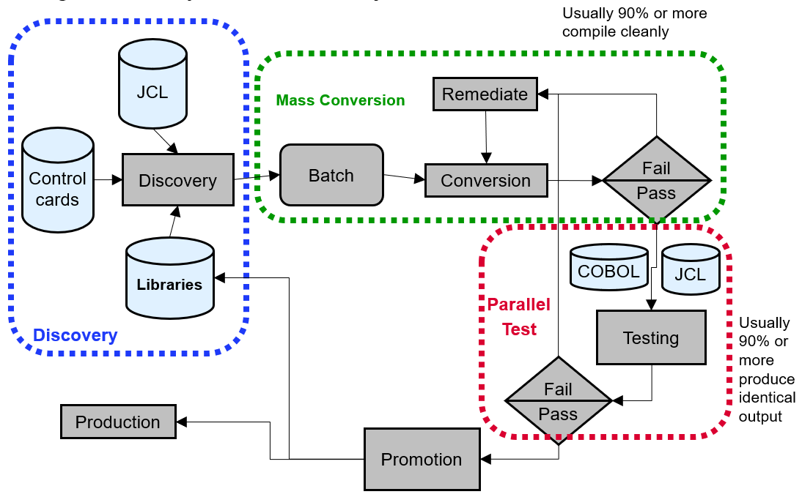

Figure 1: Migration Flow

Migration Flow: -

1. Discovery
2. Mass Conversion
3. Parallel Test

Discovery Utility (hlq.SFSYJCLS(JCYCNV50))

What does it do?

Locates Easytrieve Plus programs source and jobs and copies them into a common library for easy access. (In CPF’s SOW, there is no need for this function)

Conversion Utility

There are 2 types of conversions.

1. Single Conversion (hlq.SFSYJCLS(JCMUCL1J))

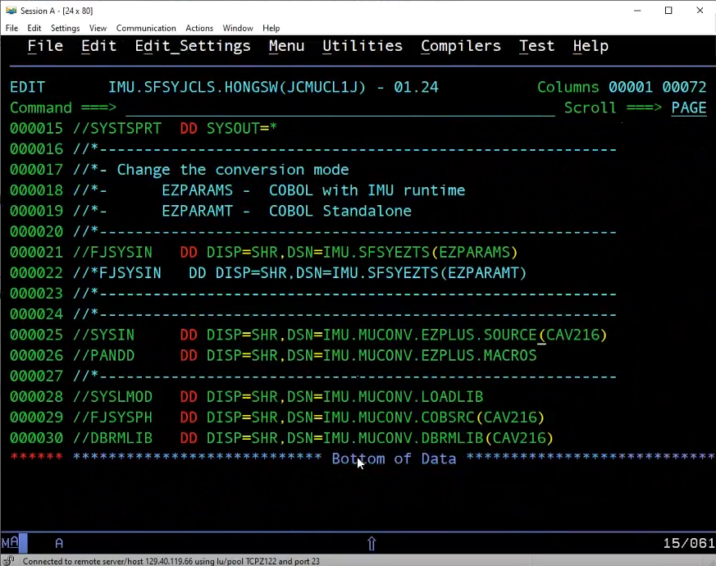

Figure 2: Single Conversion JCL

This is single conversion, where you only need to provide Easytrieve Plus source code(at line 25 of Figure 2), and Easytrieve macro(at line 26 of Figure 2).

Additionally, you can change the COBOL source code directory name(at line 29 of figure 2), and DBRM directory name(at line 30 of figure 2).

1. Mass Conversion (hlq.SFSYJCLS(JCMUCNV1))

Requirements: -

* A directory of where the Easytrieve source code.
* Names of the Easytrieve source code members.

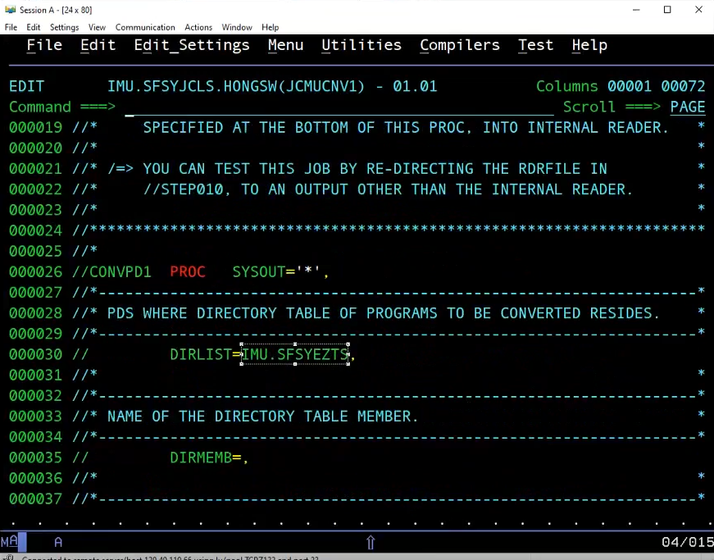

Figure 3: Mass conversion JCL

In figure 3, the line 30 is where you will be able to find the directory of the Easytrieve Plus source code members.

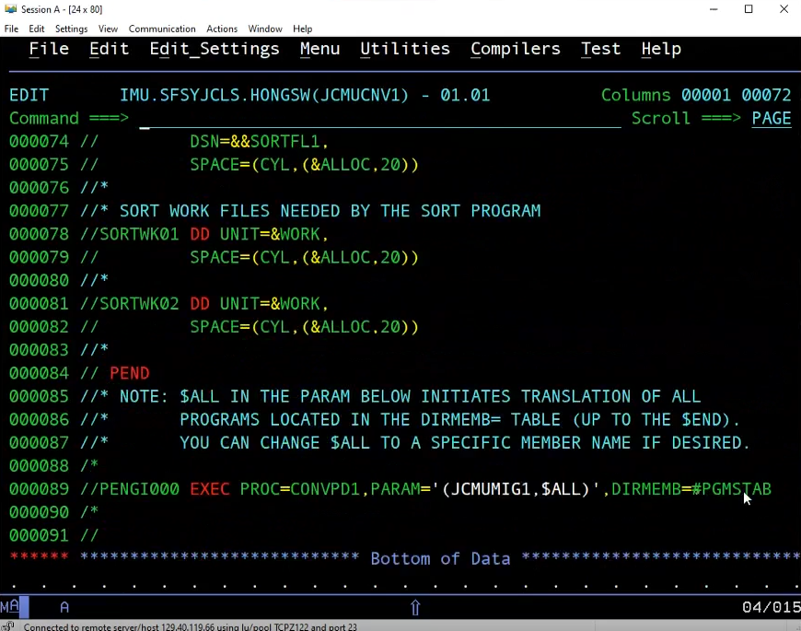

Figure 4: Showing Directory Member

In figure 4, the user is also required to make a member in the dataset HLQ.SFSYEZTS(#PGMSTAB) and insert all of the Easytrieve Plus Source Code members that the user wants to convert to COBOL source code into the member.

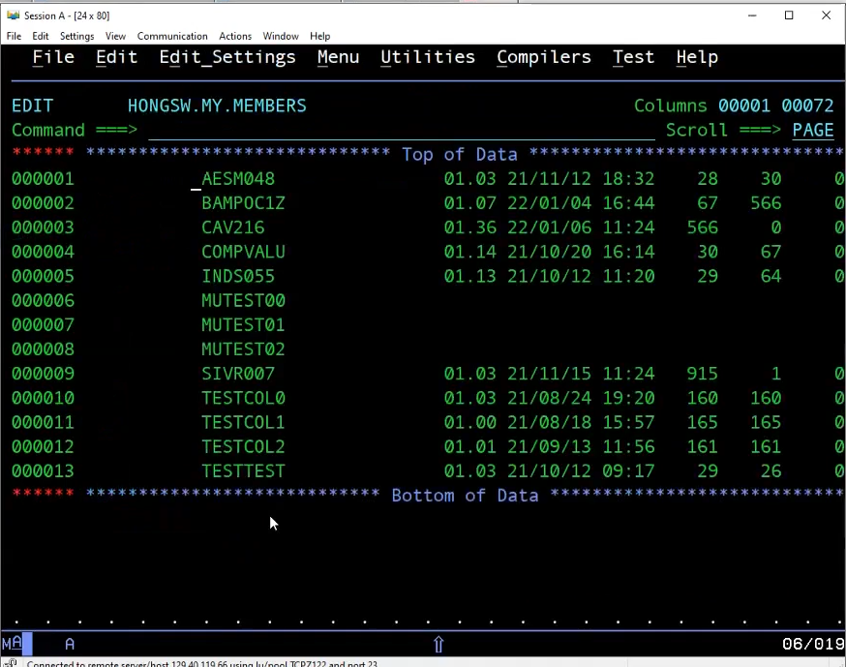

Figure 5: Showing how to easily copy members and add the files into #PGMSTAB.

The user can use the keyword “SAVE MY” and go into the user’s TSO ID.MEMBERS and copy the member names as shown in figure 5 but the user needs to remember to add in “#END” at the last line of the member.

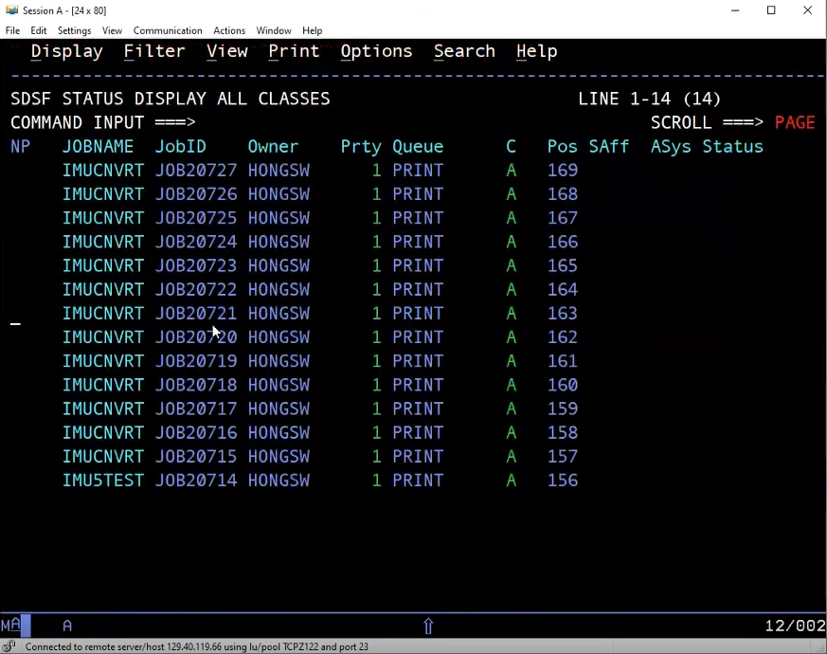

Figure 6: After submitting JCMUCNV1

After submitting the job JCMUCNV1, at the SDSF display page prefixing IMU*, the user will be able to see the migration jobs like in figure 6.

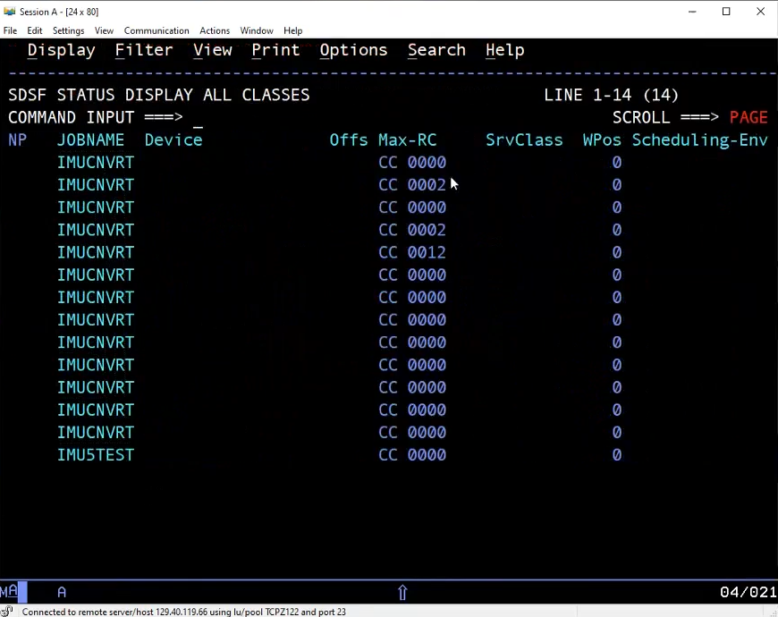

Figure 7: On the right side of the SDSF display panel

The user will be able to see the RC of the migration jobs that were submitted. 0002 is the nothing special, thus the user can ignore it. But 0012 is a problem with the DB2.

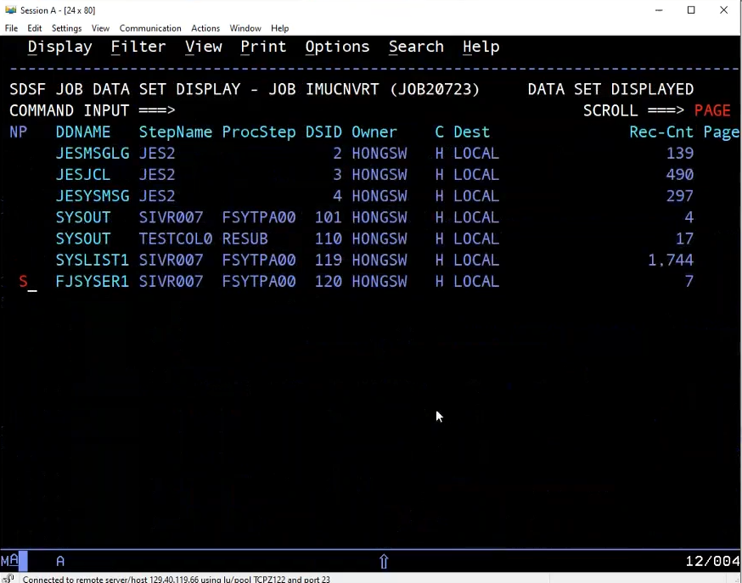

Figure 8: Going into FJSYSER1

By going into the migration that had an issue, the user can view the errors by going into FJSYSER1.

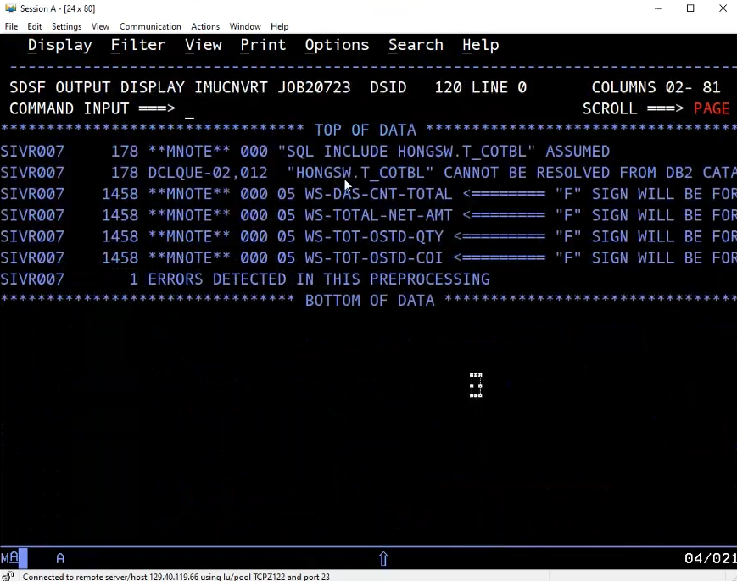

Figure 9: After selecting FJSYSER1

The user can now see the issue according to the line of the Easytrieve source code. In this scenario, it’s at line 178.

1. Parallel Testing (hlq.SFSYJCLS(JCYMIG00))

NOTE: Parallel testing or any other testing, will be done by CPF.

What is parallel testing?   
 In essence, there will be a new JCL that will run the JCL hlq.SFSYJCLS(JCYMIG00) and it will run both the COBOL source code and the pre-migrated Easytrieve source code that will make reports. Then, the JCL will compare both of the generated reports (COBOL report and Easytrieve report). If both of the reports return 0, then the generated reports are the same.