|  |
| --- |
| Close-up image showing the leaf-sides of two oversized books side-by-side on a bookshelf, with additional books in soft focus background |
| Testing Document  Project Programming III |
| |  |  |  | | --- | --- | --- | | Mark Xie | 12/6/19 | Programming III | |

### Test Case

# Project Overview

The purpose of this project is to create a music player application that allows user to login and access the fundamental functions for a music player, but also have features to save the file to the database, display file to the Playlist so the next time when the user successfully logged in to the music application they gain direct access to the existed music file again.

The system will be composed into two different side. Server side and user’s side. The server side component will be using MySQL database which stores user information from Register and their current playlist file path to the system. The Client side component will be a graphical interface which has all the core functions and features for a music player. The application will guide user to add all the music files from local path, and supports user with a quick search function that allows user to find the music they wanted within a second.

# UI Design

Login & Register

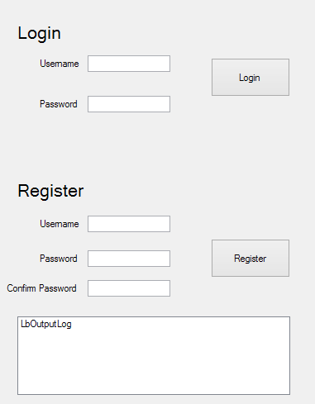

## Music player

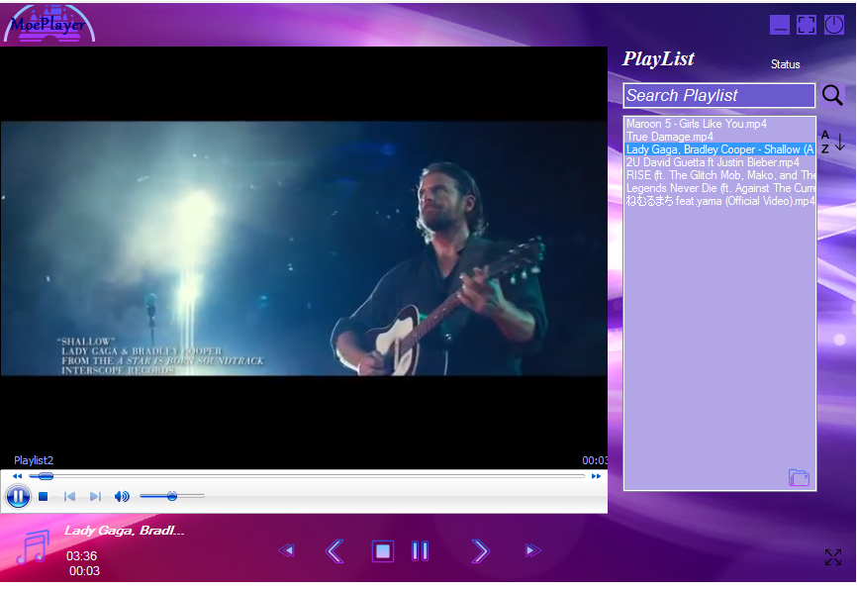

# Test Case

Test Case 1: Check results on entering empty user Id &password in register section

|  |  |  |
| --- | --- | --- |
| Testing Inputs: empty |  |  |
|  |  |  |

Test Case 2: Check results on entering valid User Id & Password in login section

Test Case 3: Check results on entering Invalid User ID & Password

Test Case 4: Check response when a User ID is Empty & Register Button is pressed, and many more

The purpose of this project and the document is to design and build an online music player application that allows user to register and login, save file to the database from client side and display file to the list box so the next time when the user logged in to the music application they gain access to the existed music file again.

The system will be composed into two different side. Server side and client’s side. The server side component will be using MySQL database which manages that allows admin to delete user and manage their file storage. The Client side component will be a graphical interface which has all the core functions and features for a music player. The application will guide user to add all the music files from local path, and supports user with a quick search function that allows user to find the music they wanted with in a second.