Iteration Plan — Custom-CMS
Marcus Morrisey
today

Iteration Plan
Iteration 1 is complete. Data Cleaning & Migration (Iteration 6) runs independently Apr 14–28 under a separate team with no formal UAT. All remaining iterations target completion by the first week of June 2026. Dates are subject to revision following the re-baselined project timeline (A-112).

Schedule
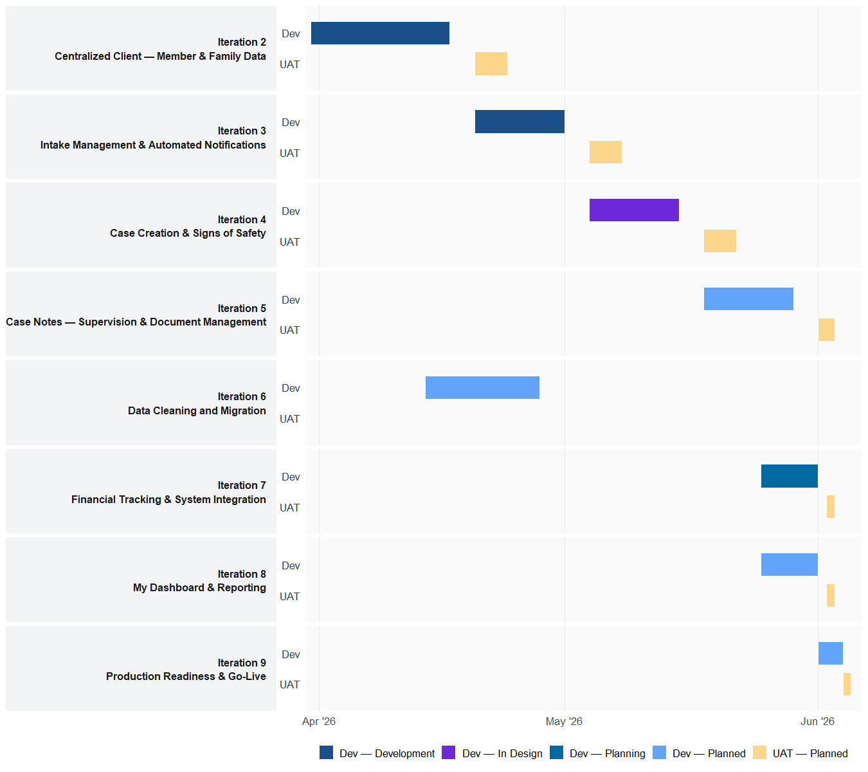

Iteration Scope

[Development] Iteration 2 — Centralized Client — Member & Family Data (Mar 31 – Apr 17, 2026)
- Testing environments activated and configured on PCFS Azure server this week
- Genogram (relations) tab in development — Add Connection modal, relationship types, and three-generation family mapping (active on genogram branch)
- Current Household view in development — household composition auto-generated from shared addresses and relationships (active on household branch)

[Development] Iteration 3 — Intake Management & Automated Notifications (Apr 20 – May 01, 2026)
- Intake workflow module — structured intake creation with mandatory field validation, lifecycle status (Awaiting Approval / Active / Closed), and supervisor assignment
- Intake-to-case escalation logic — ability to resolve intake without opening case; intake record links to case when escalated
- Automated in-app and email notifications for pending approvals, task assignments, and scheduled supervisor reviews

[in Design] Iteration 4 — Case Creation & Signs of Safety (May 04 – May 15, 2026)
- Case file module — creation, lifecycle management, worker/supervisor assignment, and caseload visibility
- Signs of Safety–aligned 13-step practice model — progress tracking, placement decisions, and workflow checklists
- Case reassignment with approval chain; historical case and intake visibility per family

[Planned] Iteration 5 — Case Notes — Supervision & Document Management (May 18 – May 29, 2026)
- Case notes — timestamped entries with role-based locking, audit logging, and Signs of Safety tagging
- Supervisory oversight — mandatory face-to-face follow-up tracking, QA automation, and review checklists
- Document management across person, intake, and case levels — role-based visibility and long-term encrypted storage

[Planned] Iteration 6 — Data Cleaning and Migration (Apr 14 – Apr 28, 2026)
- ETL extraction and transformation from FamCare — deduplication and CFSIS field validation rules
- Trial migrations in sandbox environment — accuracy verification and data reconciliation against source records
- Live migration execution — minimal downtime strategy, parallel running period, and data integrity sign-off

[Planning] Iteration 7 — Financial Tracking & System Integration (May 25 – Jun 01, 2026)
- Intake-level emergency support budgets and case-level spending caps with approval thresholds and real-time tracking
- Finance-restricted role access, approval workflows, audit logging, and responsive finance form submissions
- Sage 300 integration-ready financial data export and two-way alignment for reporting (full API integration in future phase)

[Planned] Iteration 8 — My Dashboard & Reporting (May 25 – Jun 01, 2026)
- Role-based dashboards for workers, supervisors, admin, and finance — task lists, pending approvals, and alert widgets
- Custom and automated reporting (weekly / monthly / quarterly) with CFSIS-compliant export and Chief & Council summaries
- Address-based search tab — search address fields across existing records and return associated individuals and cases prioritized by open status

[Planned] Iteration 9 — Production Readiness & Go-Live (Jun 01 – Jun 04, 2026)
- Load testing, performance optimization, and security hardening for production scale
- Backup, disaster recovery, and production rollout verification against readiness checklist
- Staff training documentation and go-live support preparation

Outstanding Questions
# | Question
Q-01 | What exact Sage 300 version and build is in use? Required to finalize integration design scope.
Q-02 | What are the complete requirements for role-based access, high-profile cases, and conflict-of-interest restrictions?
Q-03 | What agency email account will be used for external notification sends (Microsoft REST API)?
Q-04 | What additional requirements does the after-hours team have for address-based search?
Q-05 | What finance requirements emerge from CFO / Director of Finance engagement beginning April 7th?
Q-06 | Is it possible to have two intakes open simultaneously?
Q-07 | What is an assessment worker exactly, and how is a given intake assigned to a specific worker?
Q-08 | Can a data entry worker start or edit Intakes, or only verify them and enter into CFSIS? How is the work currently distributed?
Q-09 | Who can submit a finance sheet — only supervisors? What is the complete list of finance sheet request types we need to support?

