Kim Long

TAFE Queensland  [Company address]

User Guide

1. Main page

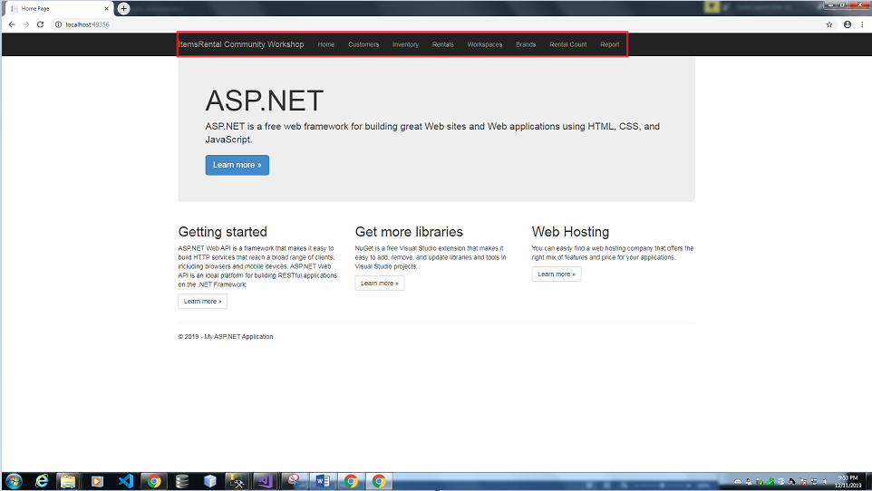

* This is the main page of the website. To use other function, please select the functions from the tab (in the red square)

1. Add new record

* After select where you want to go from the tab, the web will display the data you want to see. To add new record, click on the “create new”

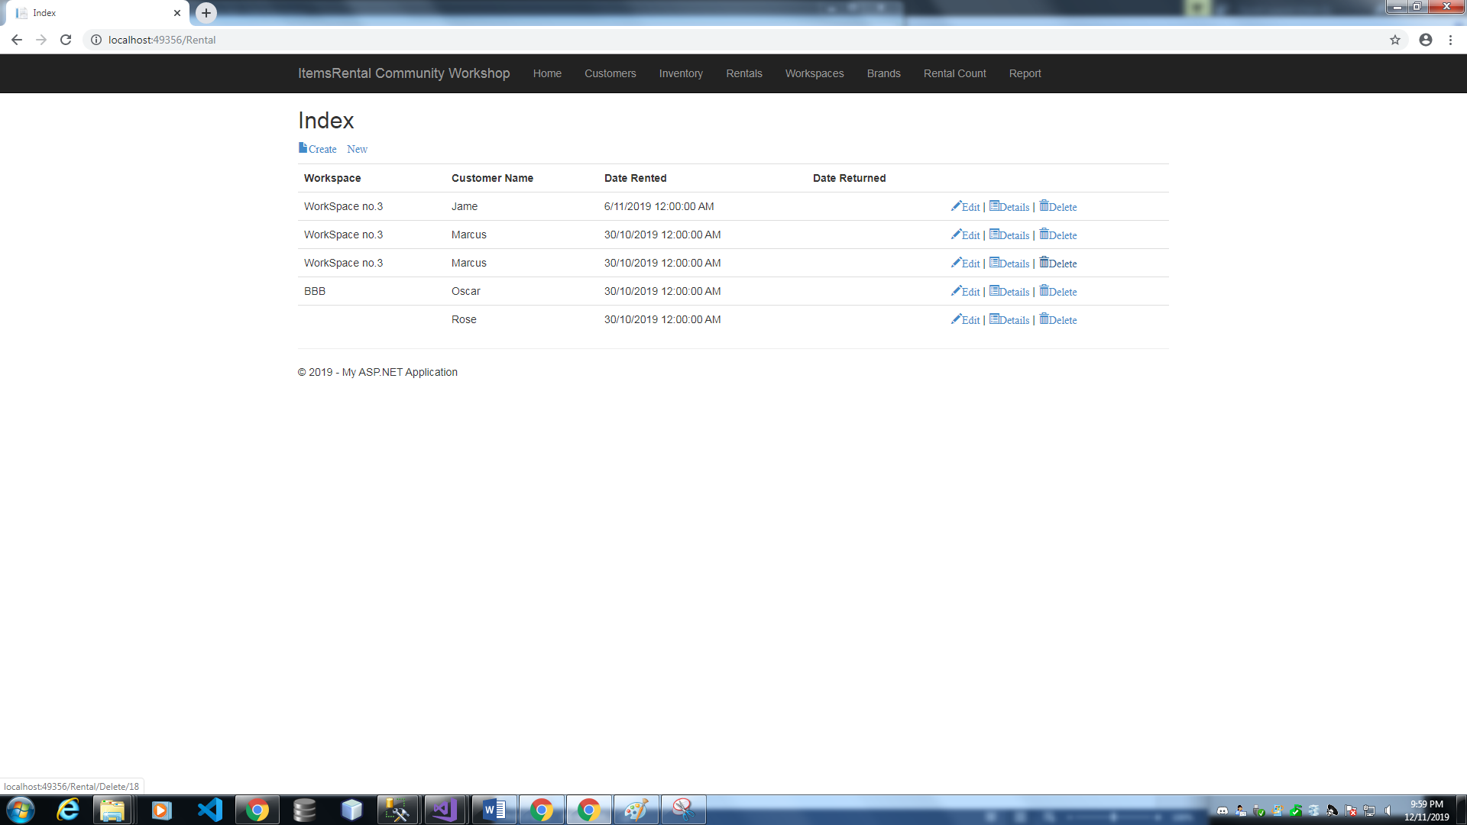

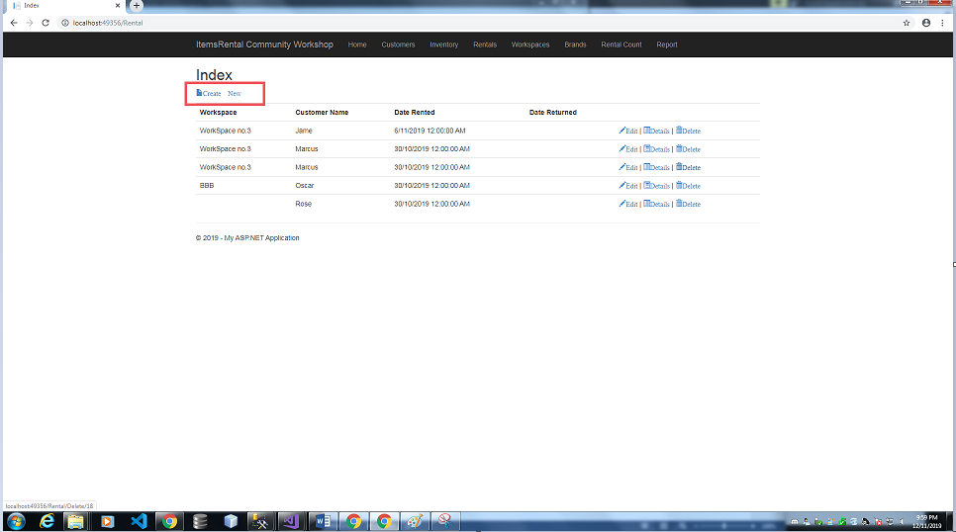

Then insert the data. After that press create

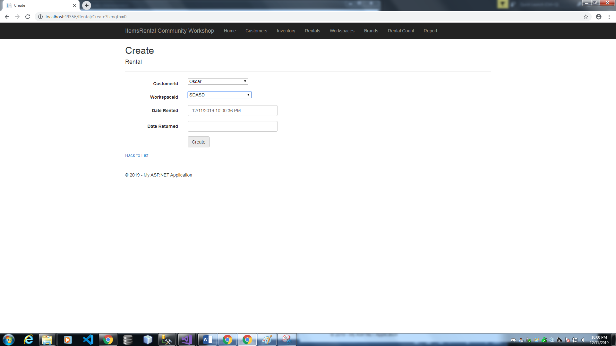

1. Modify a record

From the list page, you can see the “Edit”, “Detail”, Delete for each record. To modify a record, click on the correct function you want.

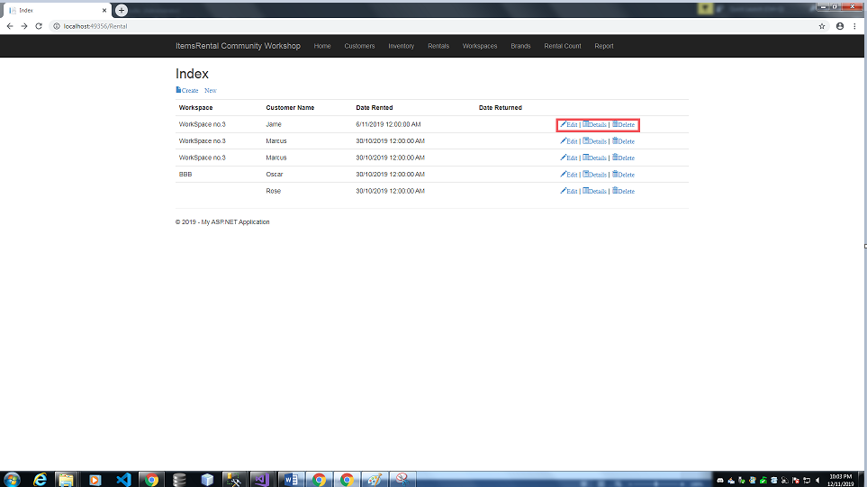

The website will navigate you to the correct page of function

* + Detail

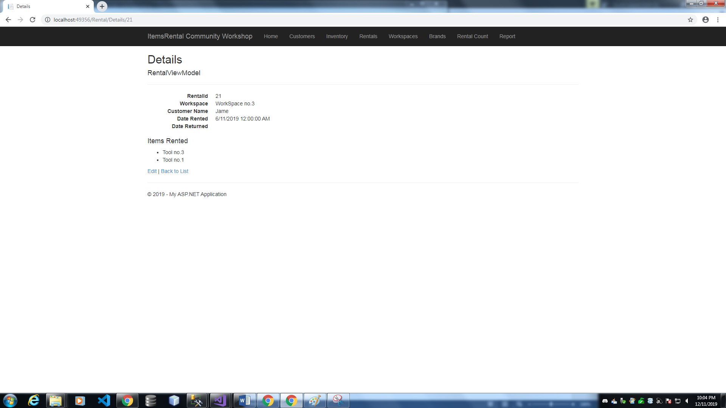

* + Delete (at this page, you will have the last chance to view the record and think again before it will be permanently delete)

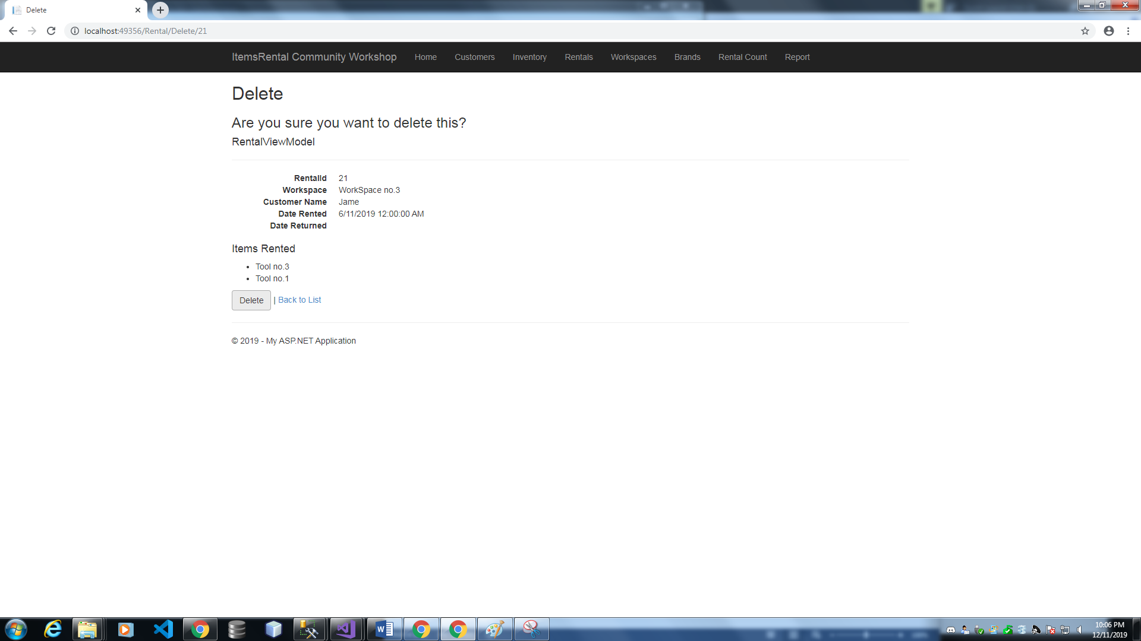

Press delete if you really want to delete. The record will be permanently delete and you cannot find it back again. Careful when deleting records.

* + Edit

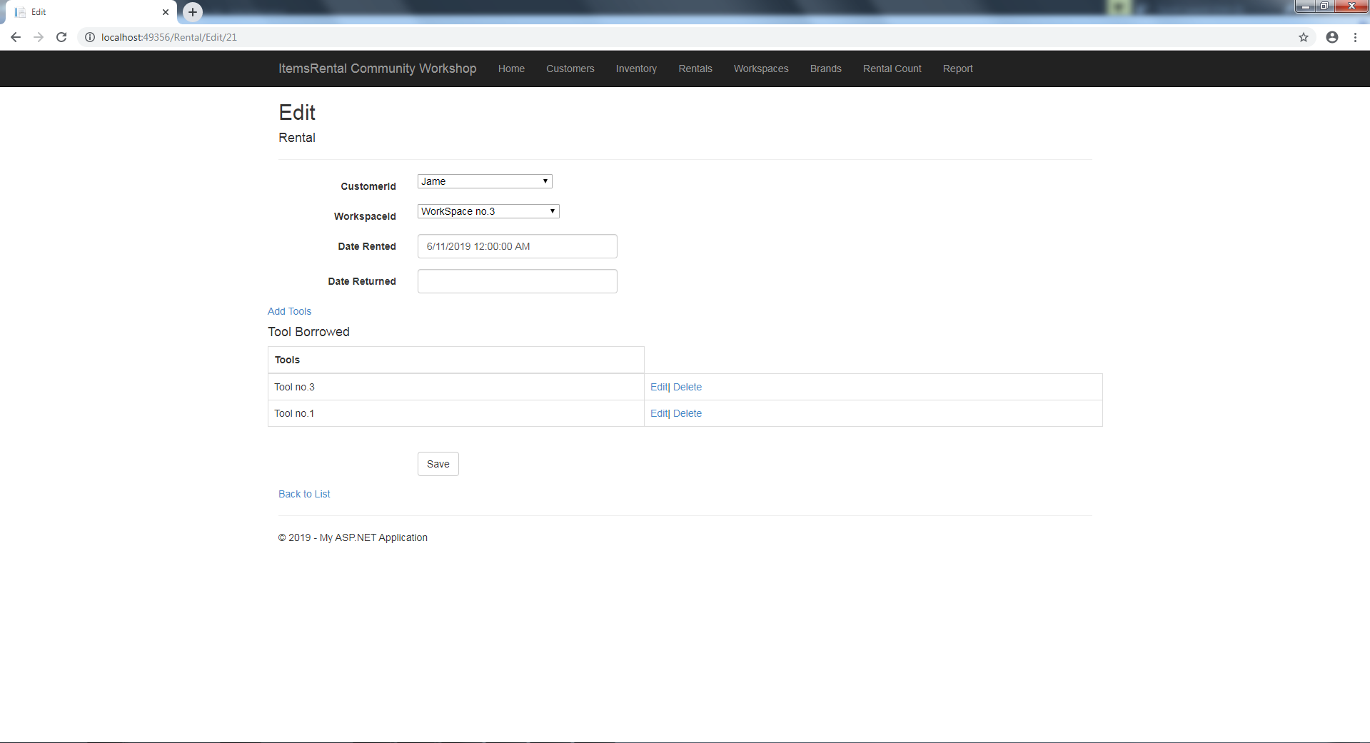

* After edit the data, press save to save the record.

A message will be display on the bottom right if the action was successful

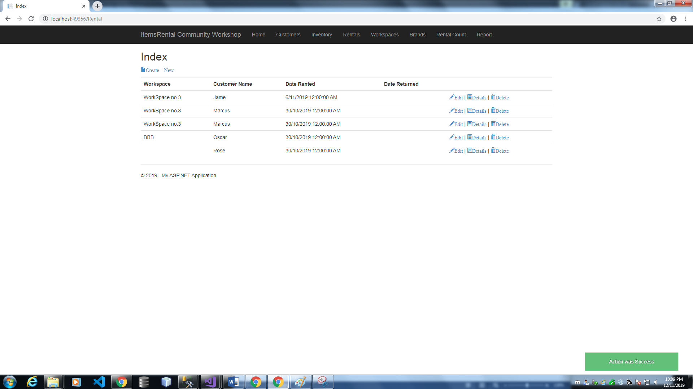

1. Drag and drop

* Open the file you want to upload

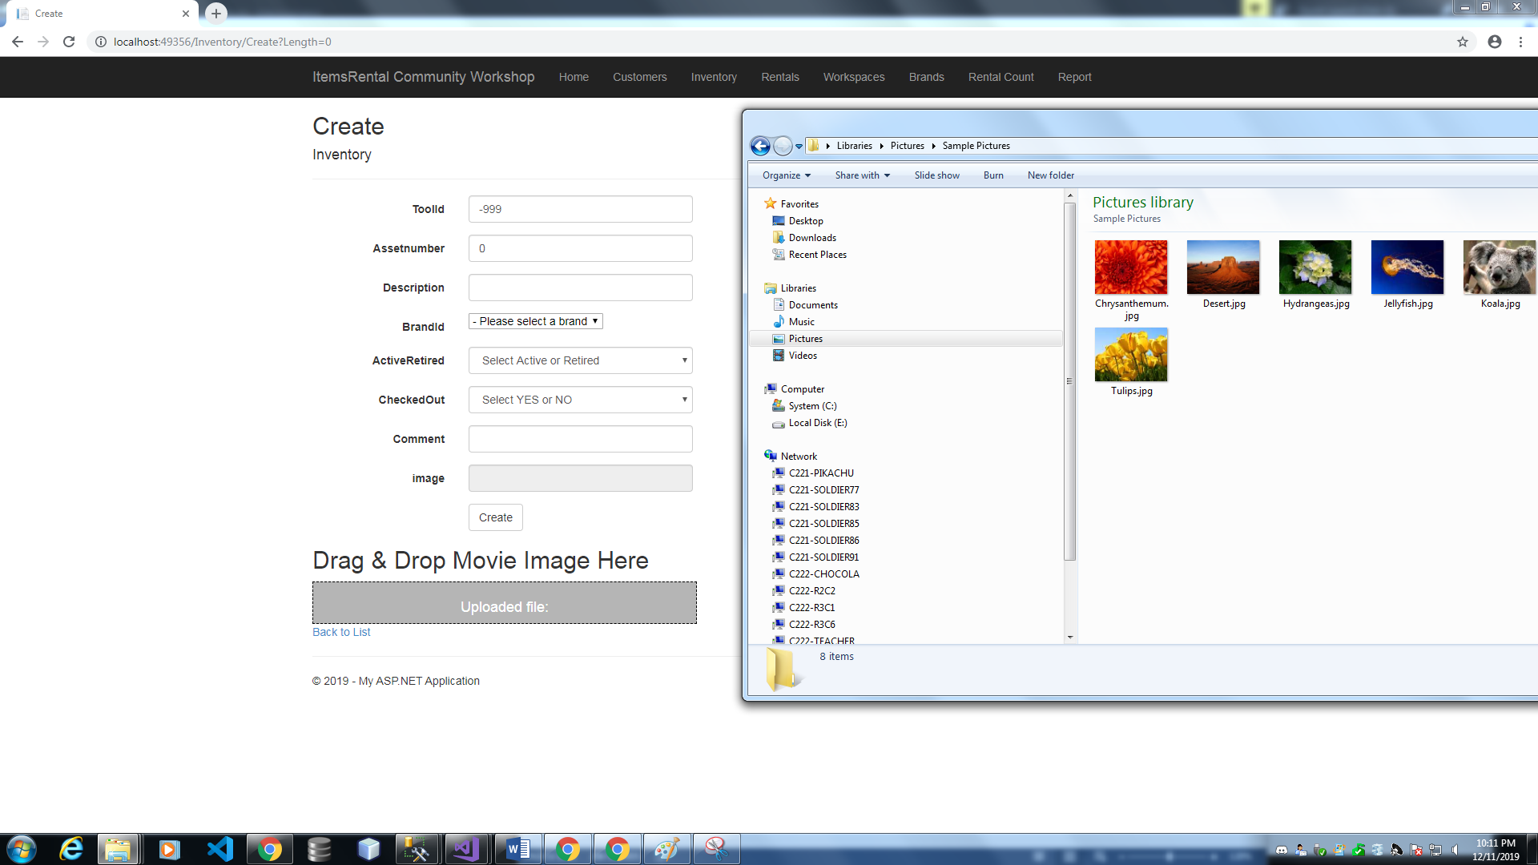

* Drag it and drop it into the grey box

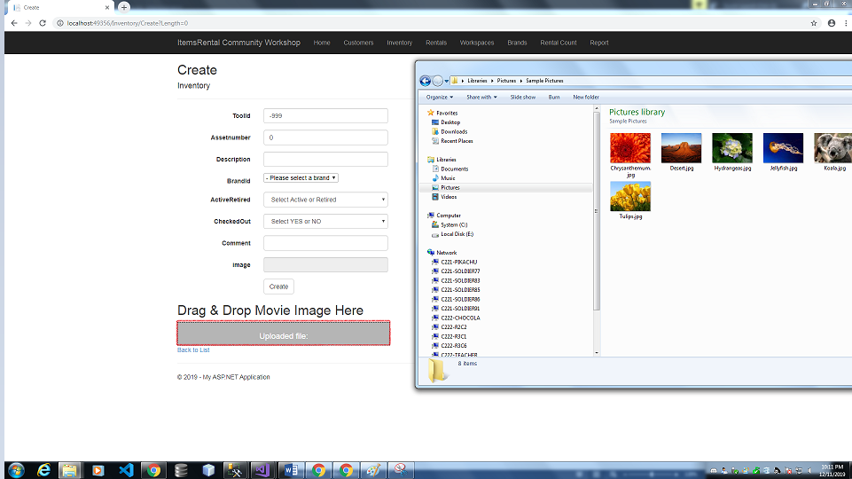

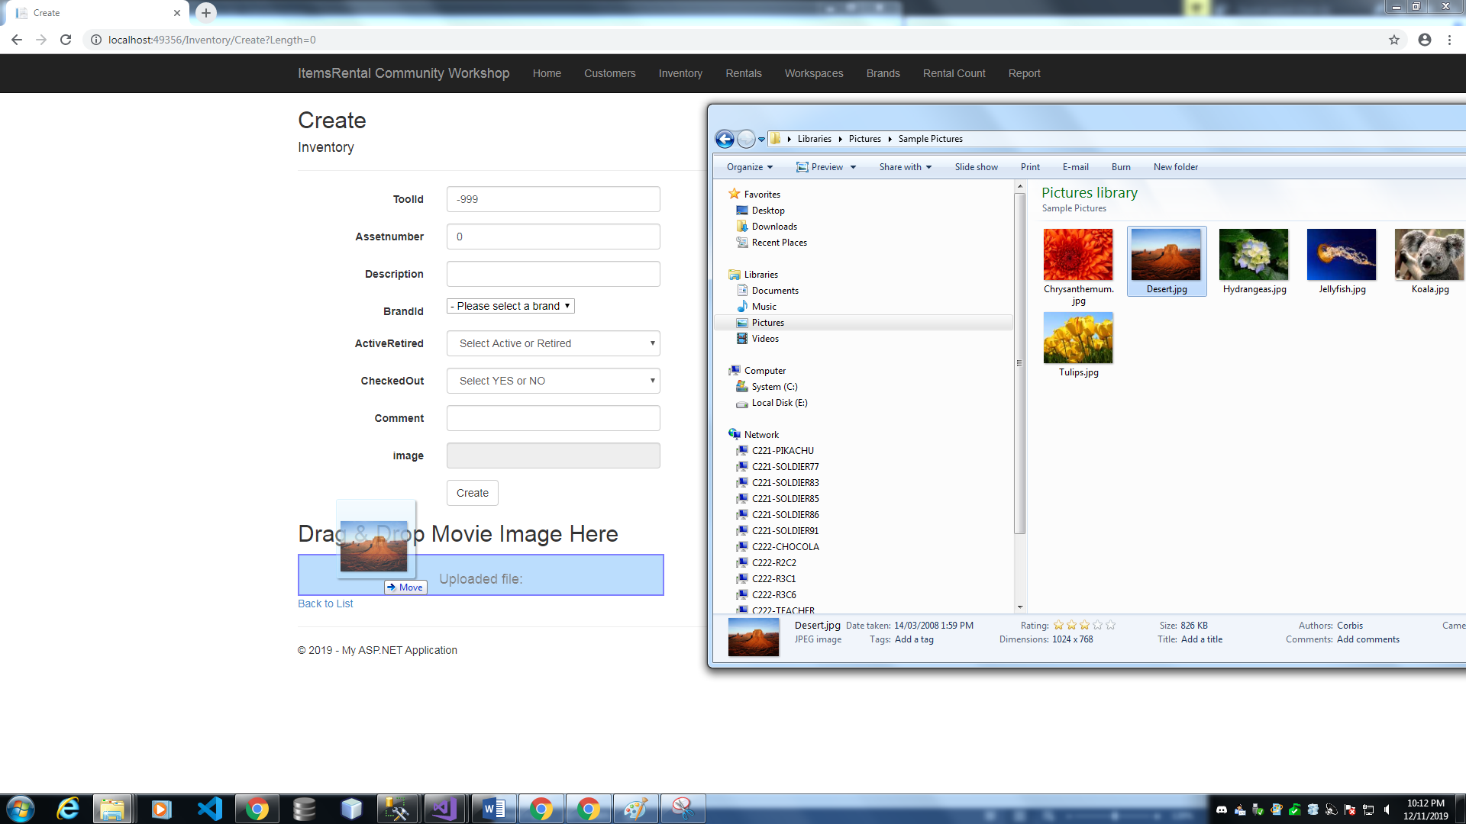

* Then click Save/Create

1. Get report

* From the main tab, click “Report”

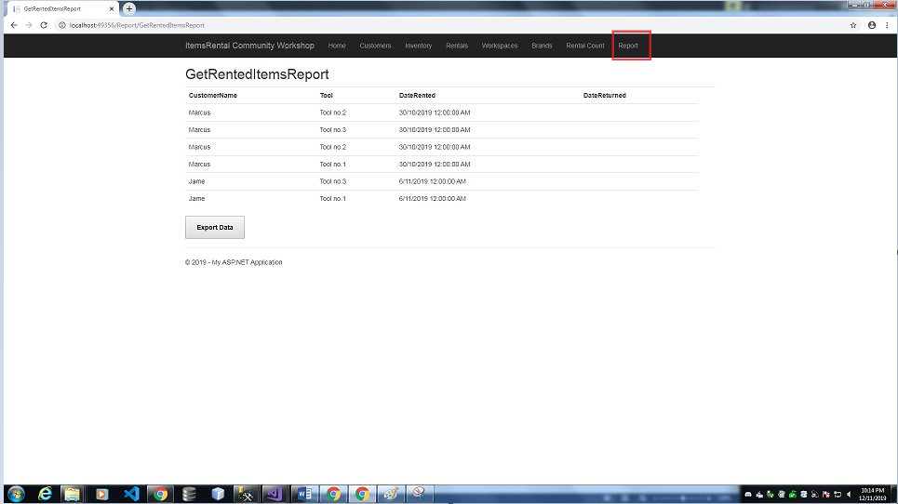

* Then click “Export Data”

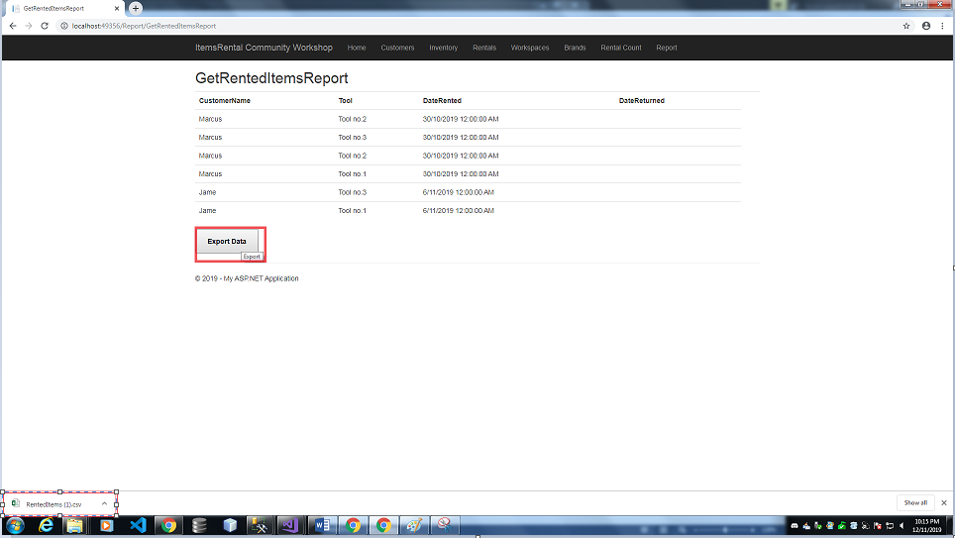

The csv file will be download