**The BPM Game**

**Manual**

**version 1.0.1**

Remco M. Dijkman

Eindhoven University of Technology

**Contents**

1 Introduction 3

2 Department Description 4

3 Preparation 5

4 How to Proceed 6

5 Creating your Process 7

6 Uploading you Process 9

7 Monitoring your Process 10

8 Hints 11

Appendix A Tasks, Events and Data Items 12

A.1 Tasks 12

A.2 Events 13

A.3 Data 13

A.4 Resources 14

# Introduction

During the BPM Game, you will act as the process manager of a loan application department.

Your department is responsible for determining whether the loan applications of customers should be accepted or rejected. Various tasks can be performed to make that decision. The tasks that you can use are specified in the appendix of this document. Each of these tasks has particular properties, such as service time, and particular requirements for its execution, such as the data and the skills that are needed to perform the task.

You can manage your process by deciding on:

* the tasks that must be performed to process a loan application;
* the order in which these tasks should be performed for a loan application with particular properties; and
* the employees that you will hire and which employees should be authorized to perform which tasks.

You can do so by developing a process model in Signavio and implementing that process model in your organization.

You should create the best possible process to help your employees structure their work. If you create a sub-optimal process, your employees will still complete their work, but will likely do so in a sub-optimal manner. They might not even be able to complete their work on time, which will lead to low customer satisfaction and ultimately lost customers.

You are in competition with other managers, who are also trying to create the best possible process. The performance of your process will be measured in terms of service time, waiting time, cost, and customer satisfaction. The process that scores best on these performance indicators, wins the game.

May the best manager win!

# Department Description

In broad stokes, the department that you are managing sells loans. Of course, you only want to sell loans to clients that can pay them back. Therefore, you first need to do a number of checks on the creditworthiness of the client. Note that there are various alternative ways in which you can perform these tests, but in the end you need data about the BKR assessment, the EVA assessment and the credibility assessment of the client. The credibility must be double checked. The checks lead to a decision to accept or reject the client. If you accept the client, you will need to call the client to ask for additional information. You will then send the client an offer to sign. After the client has returned the signed offer, you will activate the loan and finalize the administration.

# Preparation

To do the assignment, you will need:

1. Signavio
2. Disco
3. Access to the BPM game
4. A group
5. Signavio is an online modeling tool. Students and academics can get a free license. Please register at <http://academic.signavio.com/>.
6. Disco is a tool for process mining. Students and academics can get a free license. Please get Disco at <https://fluxicon.com/disco/>. When registering for the tool, use your university e-mail address. Disco uses your e-mail address to verify that you are indeed an academic and grant you the free license.
7. The BPM game is accessible at <http://www.bpmgame.org/>. You can register for the game here
8. You have to register for a group. Once you are registered for the game, you can create a group. Only one member of your group should create the group in the BPM game. He or she can then add the other members (see Figure 1).

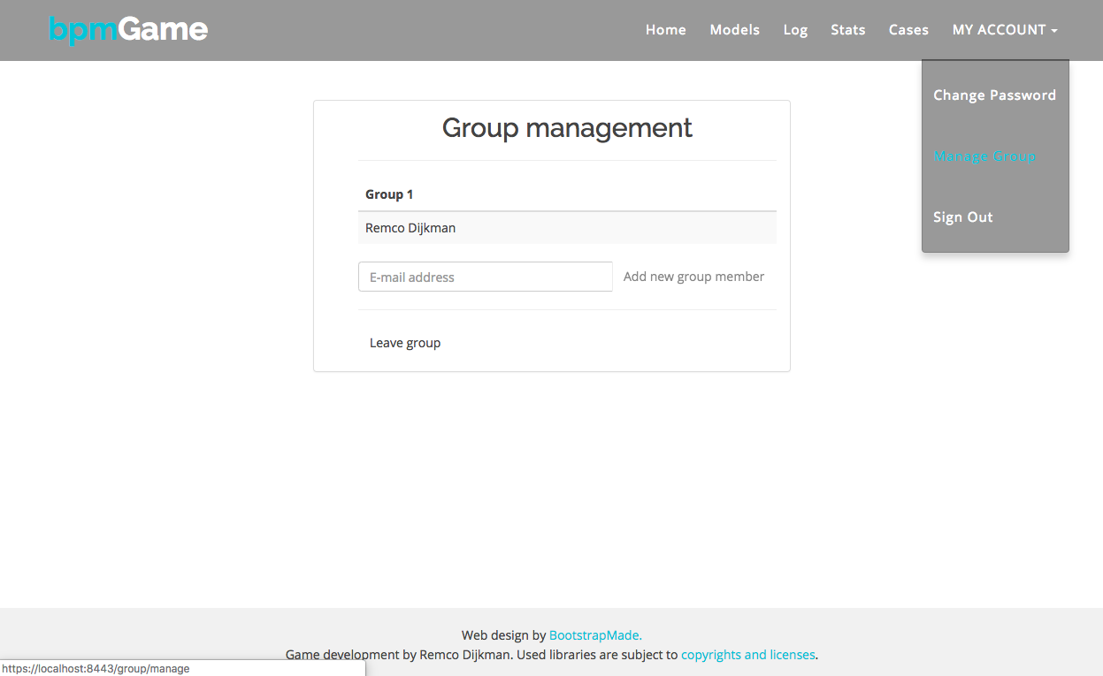

Figure 1. Group management.

# How to Proceed

Once you are all set up (see Chapter 3), we recommend that you proceed as follows.

1. Upload the ‘base model’ that you are provided with in the ‘Models’ section of your game. Note that if you upload a model, it will become the active model for your group as a whole (i.e. you manage the company as a group).
2. Wait until the end of the next day, such that your company has processed enough cases to generate an event log. Download the execution log of your group and analyze it in Disco as explained in Chapter 7.
3. Meanwhile, inspect the example model in Signavio. Keep an eye on your statistics as explained in Chapter 7, and check the tasks and events that you have at your disposal as they are described in Appendix A. Use that information and the theory on modeling, analyzing, (re-)designing, and monitoring business processes, to develop a strategy for improving your business process.
4. Improve your business process and create a new model and resource assignment. You can create a model by respecting the syntax rules that are presented in Chapter 5.

Repeat these steps until you are satisfied that your model is the best there is.

# Creating your Process

You can create your process in Signavio. You are also provided with an example process (‘base model’), which you can import into Signavio by clicking the ‘Import/Export’ menu and selecting ‘Import BPMN 2.0 XML’.

To create your process, you can only use the modeling elements that are shown in Figure 2. You can only model one company (also called a ‘pool’ or ‘lane set’ in BPMN), but within that company you can have multiple roles (also called ‘lanes’ in BPMN).

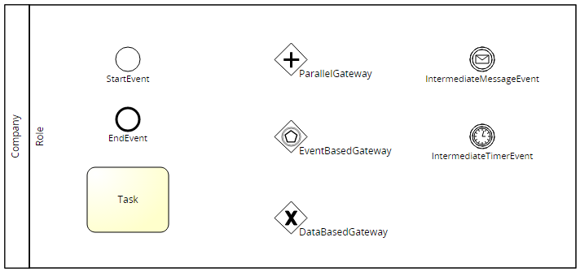

Figure 2. Allowed BPMN elements.

The tasks that can be performed in the company are listed in Appendix A, along with the events that can occur, the data items that are produced and used by tasks and events, and the resources that can execute the tasks. If you include a task in your model, then that task should have the name of one of the tasks from Appendix A. Note that all names are case-sensitive, i.e. if the task uses lowercase letters in its name, you should also use lowercase letters. Similarly, event names, data item names, and resource names should be taken from the Appendix A.

Each task and event can appear at most once in your model. Only the ‘end’ event can appear more than once.

You can place conditions on the arcs. This means that an arc can only be traversed in case the condition holds. For example, if you want an arc to only be traversed in case the BKR test is accepted, you can specify: BKRAssessment IN {accepted}. Note that conditions are also case-sensitive. Some example conditions are the following.

* For Numeric data items:  
  A > 1, means that the arc will only be traversed if A is greater than one.  
  A < 1, A = 1, A <= 1, and A >= 1 are defined analogously.
* For Nominal data items:  
  A IN {a, b}, means that the arc will only be traversed if A has the value ‘a’ or the value ‘b’. You can check Appendix A to see possible values of nominal data items.
* To combine conditions:  
  (A > 1) AND (B IN {b, c}) means that the arc will only be traversed if both (A > 1) and (B IN {b, c})  
  (A > 1) OR (B IN {b, c}) means that the arc will only be traversed if (A > 1) or (B IN {b, c}) or both  
  NOT (A > 1) means that the arc will only be traversed if not (A > 1)

You can arbitrarily combine conditions, e.g.: NOT (A > 1) OR ( (B IN {b, c}) AND (C < 5) ). Note that to test if a nominal data item is equal to a value, you must use the ‘IN {}’ notation, not the ‘=’ sign. For example, to test if ‘BKRAssessment’ is equal to ‘accepted’, use ‘BKRAssessment IN {accepted}’.

You can assign resources to tasks in Signavio by associating them with a role (or ‘lane’ in BPMN). All tasks in the lane will then be assigned to resources associated with the lane. Associate resources with a lane, by clicking on the desired lane and then opening the ‘Attributes’ to the right of the window. You can associate resources, by adding them by name to the ‘Documentation’ of the lane, separated by commas (see Figure 3). Note that the order in which you specify resources matters. Your management system will prefer to assign a task to the person in the lane that is specified first, then the one that is specified second, and so on.

The general manager will always be part of your company and is assigned to a task when nobody with the appropriate skills to perform a task works in the company.

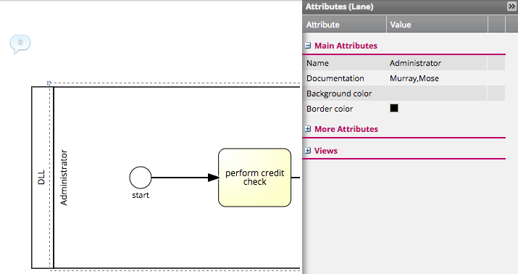

Figure 3. Assigning resources to roles.

# Uploading you Process

Once you have created your process, you can upload it.

First export your process from Signavio. Go to the Signavio Explorer. (This is the screen that you end up at when you log in.) Click on your process. In the ‘Import/Export’ menu click ‘Export BPMN 2.0 XML’. Now export your model to a file.

Log in to the BPM Game, using the username and password that were supplied and go to ‘Models’. You can upload your newly exported model here.

Note that your new model will not take effect immediately. A planning run is done daily after 17:00. If a model is uploaded before the daily planning run, that model will be taken into account the next day. However, the exact time of the planning run differs and may vary between 17:00 and 8:00 the next day. Consequently, models that are uploaded before 17:00 will certainly be used the next day. Models that are uploaded after 17:00 may or may not be used. Also, if you uploaded your model after 17:00, there is no way of knowing if that model was or was not used for the execution the next day.

# Monitoring your Process

Once you have activated your process, you will want to know how it performs. Go to your ‘Stats’ to see how your model performs and how you perform compared to other groups. You can also get real-time insight into what your employees and customers are doing in the ‘Cases’ section.

You can get detailed insight into how your model performs, by downloading the execution log page and importing it into Disco. You can download the log from the ‘Log’ section. Note that only finished cases will be exported to Disco, such that it may take some time before you actually have cases to export to Disco. Until then your log will be empty.

When importing your log in Disco, you have to provide the ‘types’ for the columns as shown in Figure 4. Make sure that you use the column named ‘Case ID’ as ‘Case’, the column ‘Resource’ as Resource, the column ‘Activity’ as Activity, and the columns named ‘Start Timestamp’ and ‘Complete Timestamp’ as Timestamp. If you want to do advanced analysis, you can import the other columns as Other. Note that more columns may become visible if you scroll to the right.

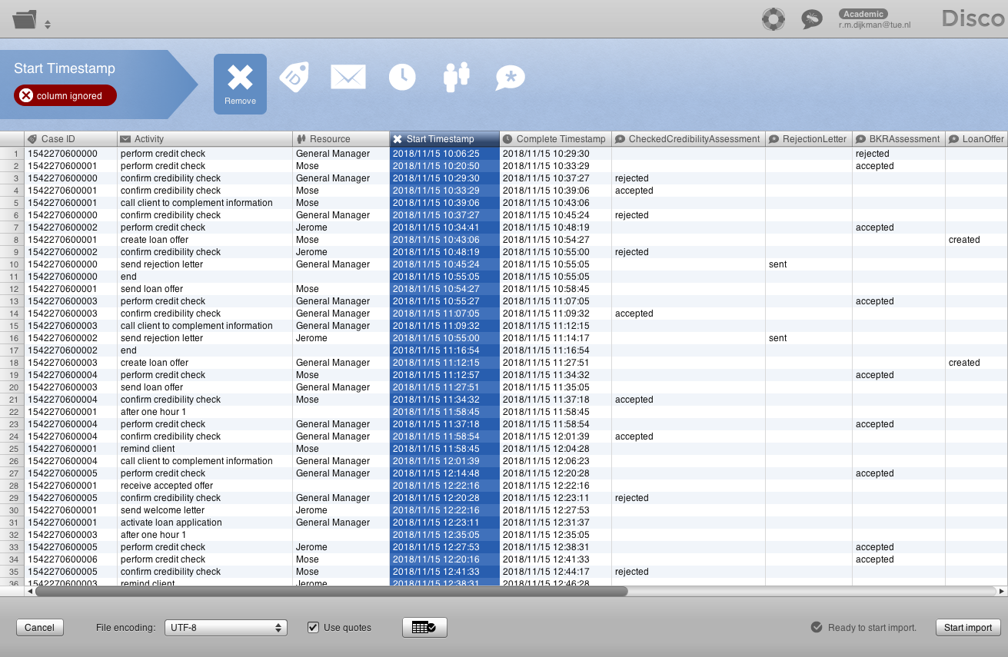

Figure 4. Importing in Disco.

# Hints

Costs are only determined by the employees that you have employed. Employees that are paid per hour will only cost you for the time they were actively working on a case.

Customer satisfaction is determined by improper handling of customer cases, or not handling customer cases within a reasonable time. The latter will cause your customer to leave and lead to a direct and strong decrease in customer satisfaction. Customer satisfaction is also affected by some of the tasks; some tasks may increase or decrease customer satisfaction.

You will probably find – when you download the execution log – that your employees did things that you did not model in your process model. There are two possible reasons for that.

1. Your employees made a mistake.
2. You made a mistake.

In both cases, these mistakes will usually cost you in terms of service time, waiting time, customer satisfaction and/or financial costs. However, you can fix your own mistakes, but not the ones of your employees. These are a fact of life.

You made a mistake if a customer cannot be handled in the way in which it is supposed to. In such cases, employees will take the appropriate action to make sure that the case is performed in the way in which it is supposed to. However, they will be less efficient about it, than when you told them how to handle the case (through the process model). For example:

* if you force a task to be performed for which the required input data is not available yet, the employees will first try to perform a task that makes that data available.
* if a task has no employees assigned to it that have the skills to perform that task, some other employee will be found who has the skills at a penalty.
* if a case has to be accepted, but cannot be accepted anymore, employees will find a way to get it accepted anyway.
* if a customer does not return requested information within a certain amount of time, employees may decide to give the customer a call.

Note that this is a non-exhaustive list of possible mistakes that you can make.

All groups will be given the same cases and the same employee mistakes, such that everyone will suffer equally from these mistakes. The challenge is to distinguish between mistakes that were made by employees and mistakes that were made by you, and to appropriately fix the mistakes that you made yourself.

You are ranked in the ranking list for service time, cost, and customer satisfaction. Your place in the leaderboard is determined by the sum of these rankings. E.g.: if you are ranked first in having the lowest service time, third in having the lowest cost, and fourth in having the highest customer satisfaction, your overall score is 1+3+4 = 8. This score determines your place in the leaderboard.

You may assume that customers will always return requested information eventually, if you remind them often enough.

Tasks, Events and Data Items

Tasks

**perform credit check**

Required data: LoanDetails

Produced data: CredibilityAssessment, BKRAssessment, EVAAssessment

Required skills: risk management

**perform BKR check**

Required data: LoanDetails

Produced data: BKRAssessment

Required skills: risk management

**perform EVA check**

Required data: LoanDetails

Produced data: EVAAssessment

Required skills: risk management

**perform credibility check**

Required data: BKRAssessment, EVAAssessment

Produced data: CredibilityAssessment

Required skills: risk management

**confirm credibility check**

Required data: CredibilityAssessment

Produced data: CheckedCredibilityAssessment

Required skills: senior risk management

**send rejection letter**

Required data: CheckedCredibilityAssessment IN {rejected}, LoanDetails

Produced data: RejectionLetter

Required skills: administration

**call client to complement information**

Required data: CheckedCredibilityAssessment IN {accepted}

Produced data: PickedUp

Required skills: customer contact

**create loan offer**

Produced data: LoanOffer

Required skills: customer contact

**check loan offer**

Required data: LoanOffer

Required skills: customer contact

**send loan offer**

Required data: LoanOffer

Required skills: customer contact

**remind client**

Required skills: customer contact

**send welcome letter**

Required data: AcceptedOffer

Required skills: administration

**activate loan application**

Required data: AcceptedOffer

Produced data: LoanActivation

Required skills: finance

**validate loan activation**

Required data: LoanActivation

Required skills: finance

**execute initial payment**

Required data: LoanActivation, LoanDetails

Produced data: InitialPayment

Required skills: finance

**return documents to client**

Required data: InitialPayment

Required skills: administration

Events

**start**

Type: Start event

Produced data: LoanDetails

**end**

Type: End event

**after one hour 1**

Type: Intermediate Timer Event

Trigger: Triggers after one hour has passed

**after one hour 2**

Type: Intermediate Timer Event

Trigger: Triggers after one hour has passed

**receive accepted offer**

Type: Intermediate Message Event

Produced data: AcceptedOffer

Trigger: Triggers upon reception of an accepted offer

Data

**LoanDetails**

Type: Nominal

Possible values: received

**BKRAssessment**

Type: Nominal

Possible values: accepted, rejected

**EVAAssessment**

Type: Nominal

Possible values: accepted, rejected

**CredibilityAssessment**

Type: Nominal

Possible values: accepted, rejected, undecided

**CheckedCredibilityAssessment**

Type: Nominal

Possible values: accepted, rejected

**RejectionLetter**

Type: Nominal

Possible values: sent

**PickedUp**

Type: Nominal

Possible values: pickedup, notpickedup

**LoanOffer**

Type: Nominal

Possible values: created

**AcceptedOffer**

Type: Nominal

Possible values: received

**LoanActivation**

Type: Nominal

Possible values: completed

**InitialPayment**

Type: Nominal

Possible values: completed

Resources

**Jerome**

Skills: administration

Cost: 120 per day

**Rafael**

Skills: administration

Cost: 120 per day

**Cecily**

Skills: risk management, senior risk management, finance

Cost: 176 per day

**Minh**

Skills: risk management, finance

Cost: 136 per day

**Frank**

Skills: risk management

Cost: 136 per day

**Madeline**

Skills: customer contact

Cost: 120 per day

**Murray**

Skills: risk management, senior risk management, customer contact, finance

Cost: 176 per day

**Ismael**

Skills: customer contact

Cost: 120 per day

**Mose**

Skills: risk management, senior risk management, administration, customer contact, finance

Cost: 200 per day

**Marisela**

Skills: administration

Cost: 40 per hour

**General Manager**

Skills: risk management, senior risk management, administration, customer contact, finance

Cost: 60 per hour