Fiber Audio Link TX/RX System Overview
Technical description of the analog audio optical link and the current revision of the full circuit schematic
This circuit takes analog audio from a 3.5 mm source, sums the left and right channels to mono, biases and amplifies the signal, uses a transistor to intensity-modulate an IF-E91A optical transmitter, detects the received light with a phototransistor, and then buffers the recovered signal for either microphone feedback to a PC or playback through an LM386 speaker driver. The design is intentionally adjustable at the most sensitive operating points: TX bias, TX gain, RX gain, mic level, and speaker level.
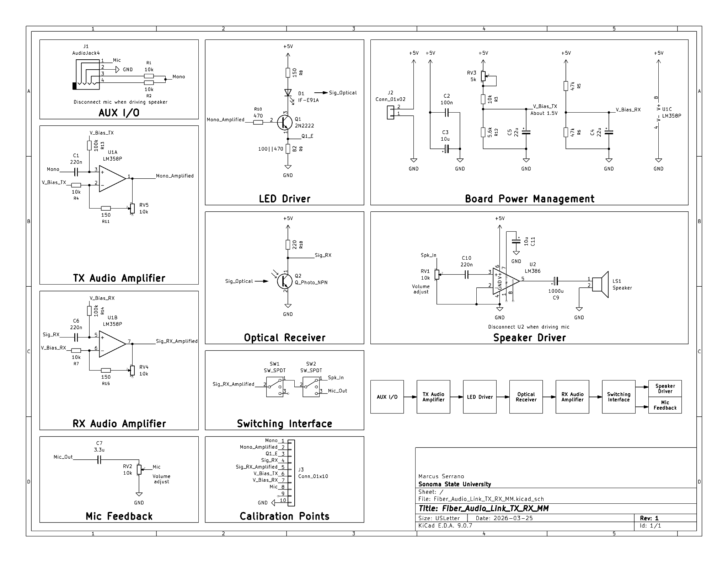
Figure 1. Current single-supply fiber-audio TX/RX schematic.
1. System-level signal flow
The signal path is: AUX I/O -> TX audio amplifier -> LED driver -> optical link -> optical receiver -> RX audio amplifier -> switching interface -> either microphone feedback or speaker driver. The schematic groups the design into these functional blocks so the optical path, audio conditioning, and final outputs can be debugged independently.
2. Block-by-block explanation
Block | Main parts / values | Purpose and behavior
AUX I/O | J1, R1 = 10 kΩ, R2 = 10 kΩ | Left and right audio are summed to the Mono net through equal 10 kΩ resistors. This prevents one channel from shorting into the other and gives a defined mono source for the transmitter.
TX bias and U1A | C1 = 220 nF, 100 kΩ input bias resistor, 10 kΩ to V_Bias_TX, 150 Ω + RV5 = 10 kΩ feedback | The TX op-amp is a single-supply non-inverting stage referenced to V_Bias_TX. It AC-couples the source audio, restores the correct DC operating point, and provides a trim range from approximately unity gain to about 2 V/V.
V_Bias_TX network | 10 kΩ fixed + RV3 = 5 kΩ over 5.6 kΩ to ground, C5 = 22 µF | This node sets the quiescent operating point of the transmitter. It is intentionally adjustable so the LED current can be re-centered for different transistors, LEDs, and source amplitudes.
LED driver | Q1 = 2N2222, R10 = 470 Ω base resistor, R8 = 150 Ω collector/LED path, emitter resistor = 100 Ω || 470 Ω ≈ 82 Ω | Q1 acts as a low-side current sink for the IF-E91A. The audio from U1A modulates LED current around a DC bias instead of switching the LED fully on and off, which improves linearity.
Power management | J2, C2 = 100 nF, C3 = 10 µF, RX bias divider = 47 kΩ / 47 kΩ, C4 = 22 µF | The main 5 V connector feeds the board. C2 and C3 provide local rail decoupling. V_Bias_RX is set near mid-supply to give the receiver op-amp symmetrical headroom.
Optical receiver | Q2 phototransistor, collector resistor R18 = 220 Ω | The phototransistor converts received optical power back into electrical current. The collector resistor turns that current into the Sig_RX voltage. This resistor was tuned low enough to prevent low-frequency clipping at full modulation.
RX amplifier U1B | C6 = 220 nF, 100 kΩ input bias resistor, 10 kΩ to V_Bias_RX, 150 Ω + RV4 = 10 kΩ feedback | U1B is the recovery/buffer stage for the detected signal. Like U1A, it is biased for single-supply operation and provides an adjustable gain range near 1 to 2 V/V.
Mic feedback | C7 = 3.3 µF, RV2 = 10 kΩ | The recovered signal is AC-coupled to the Mic_Out branch and then sent through a passive volume control. The wiper of RV2 drives the Mic node so the PC input can be trimmed without changing the RX amplifier.
Switching interface | SW1 and SW2 SPDT | The switch pair routes Sig_RX_Amplified to either the microphone path or the speaker path while keeping the inactive branch disconnected. This avoids unnecessary loading and crosstalk.
Speaker driver | RV1 = 10 kΩ, C10 = 220 nF, U2 = LM386, C11 = 10 µF bypass, C9 = 1000 µF output coupling | The LM386 branch is a separate low-power audio output stage for the local 4 Ω speaker. The input pot trims the drive into the LM386 to prevent clipping, and the 1000 µF output capacitor AC-couples the speaker load.
3. How the transmitter works
- The AUX input is summed to Mono through R1 and R2. C1 removes any source DC and applies only the AC audio content to the non-inverting input of U1A.
- V_Bias_TX establishes a deliberate quiescent operating point instead of letting the signal swing around ground. This is important because the LED cannot reproduce negative current. By biasing the stage above ground, the optical output can vary approximately linearly around a fixed optical carrier level.
- RV5 trims the TX gain. The fixed 150 Ω resistor in series with the pot prevents the feedback path from collapsing to an ideal short and makes calibration safer on a PCB. The practical gain range is about 1.015 to 2.015 V/V with the current values.
- Mono_Amplified then drives Q1 through R10. Q1 sinks current through the IF-E91A and R8. The emitter resistor network linearizes the transistor and makes the LED current more predictable from board to board.
- The most useful electrical proxy for optical modulation is Q1_E. Measuring the emitter voltage here allows LED current to be estimated directly by I_E ≈ V_E / 82 Ω.
4. How the receiver works
- The IF-D92-style phototransistor stage generates Sig_RX by converting received light into collector current. R18 was intentionally reduced during tuning because larger values created low-frequency clipping even when high-frequency test tones looked clean.
- C6 AC-couples Sig_RX into U1B and rejects the detector DC level. V_Bias_RX then recenters the recovered waveform for the LM358 so the stage can operate from a single +5 V rail.
- RV4 adjusts the RX gain without changing the detector operating point. This separation is useful because clipping at Sig_RX and clipping at Sig_RX_Amplified are not the same failure mode.
- Sig_RX_Amplified is the main post-recovery node. From here, the design branches either to Mic_Out for PC feedback or to the LM386 speaker path.
5. Microphone and speaker output paths
The board has two mutually exclusive output modes. For PC feedback, C7 and RV2 form a passive, AC-coupled microphone send. For local playback, RV1 controls the LM386 input level, C10 AC-couples the signal into pin 3, C11 bypasses the LM386 for lower noise, and C9 AC-couples the speaker.
The outputs should not normally be used simultaneously. The mic and speaker branches are separated on the schematic and intended to be selected through the switching interface to avoid unnecessary loading of the RX amplifier.
6. Calibration and test strategy
The J3 header exposes the full set of useful bring-up nodes: Mono, Mono_Amplified, Q1_C, Q1_E, Sig_RX, Sig_RX_Amplified, V_Bias_TX, V_Bias_RX, Mic, and U2_Out. This is enough to test every major stage of the system without probing component leads directly.
Calibration point | What it tells you
Mono | Confirms that the audio source is present and correctly summed to mono.
Mono_Amplified | Shows the output of U1A and confirms TX bias and TX gain settings.
Q1_C | Shows collector headroom in the LED driver and helps identify transistor saturation.
Q1_E | Best point for estimating LED current and confirming the transmitter stays out of cutoff.
Sig_RX | Shows the raw recovered optical signal and whether the phototransistor load is too large or too small.
Sig_RX_Amplified | Shows the post-recovery waveform that feeds both output branches.
V_Bias_TX / V_Bias_RX | Allow quick verification of the DC operating points that center the two LM358 stages.
Mic | Confirms the final level sent back to the PC microphone input.
U2_Out | Shows the LM386 output before the speaker load for speaker-branch debugging.
7. Practical operating notes
- The charger on the source laptop was found to be a major noise contributor. Running on battery significantly reduced buzz because it removed a ground-reference and switching-noise path between the source and the feedback input.
- The receiver load resistor had to be reduced aggressively during tuning. This is a reminder that phototransistor circuits may appear clean at high test frequencies while still clipping on low-frequency content if the detector gain is set too high.
- The LM386 branch should be treated as a separate load. If speaker distortion appears, check U2_Out independently before assuming the optical chain has failed.
- For PCB work, the most valuable trim points are the TX bias network, TX gain, and RX gain. The current revision already provides all three.
8. Summary
This design is a complete analog fiber-audio link built around a single +5 V supply. The transmitter uses a biased LM358 stage and a 2N2222 current sink to intensity-modulate the optical source. The receiver uses a phototransistor detector and a second LM358 stage to recover the signal. The recovered audio is then routed either to a microphone-feedback output or to an LM386 speaker stage. The current revision is intentionally calibration-friendly and includes the test access needed for scope-based tuning, verification, and future PCB bring-up.

