Student’s name : Marcus Thum
ID : 14734258
14 / 11 / 2025  9.00am – 12.00PM (Re-learning and doing the practical & Journaling) | Week 9: Sass  Didn’t really Use Sass, but we used bootstrap, Which has Sass  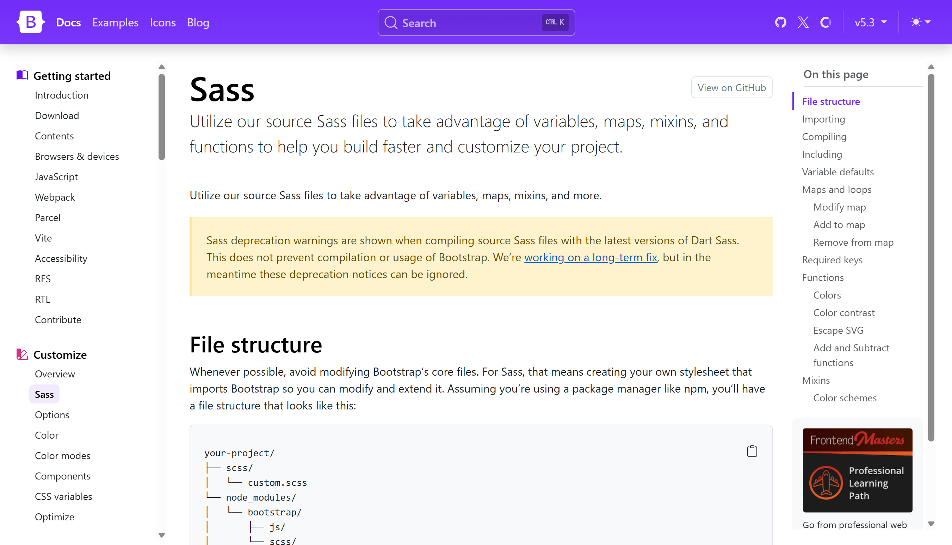  your-project/  ├── scss/  │ └── custom.scss  └── node_modules/  │ └── bootstrap/  │ ├── js/  │ └── scss/  └── index.html  How to import Saas  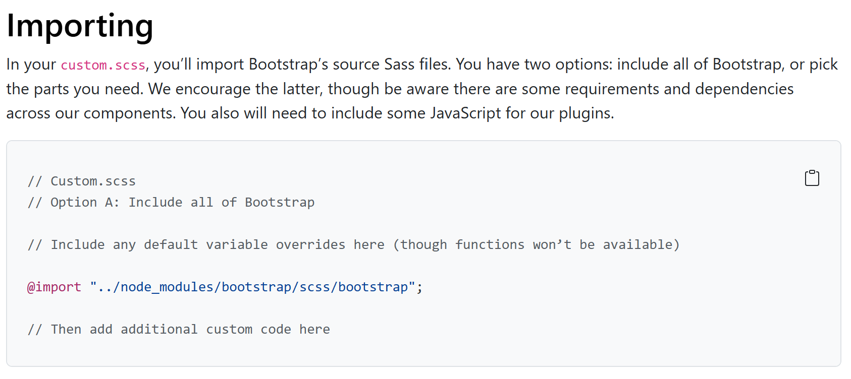  How to Compile Saas  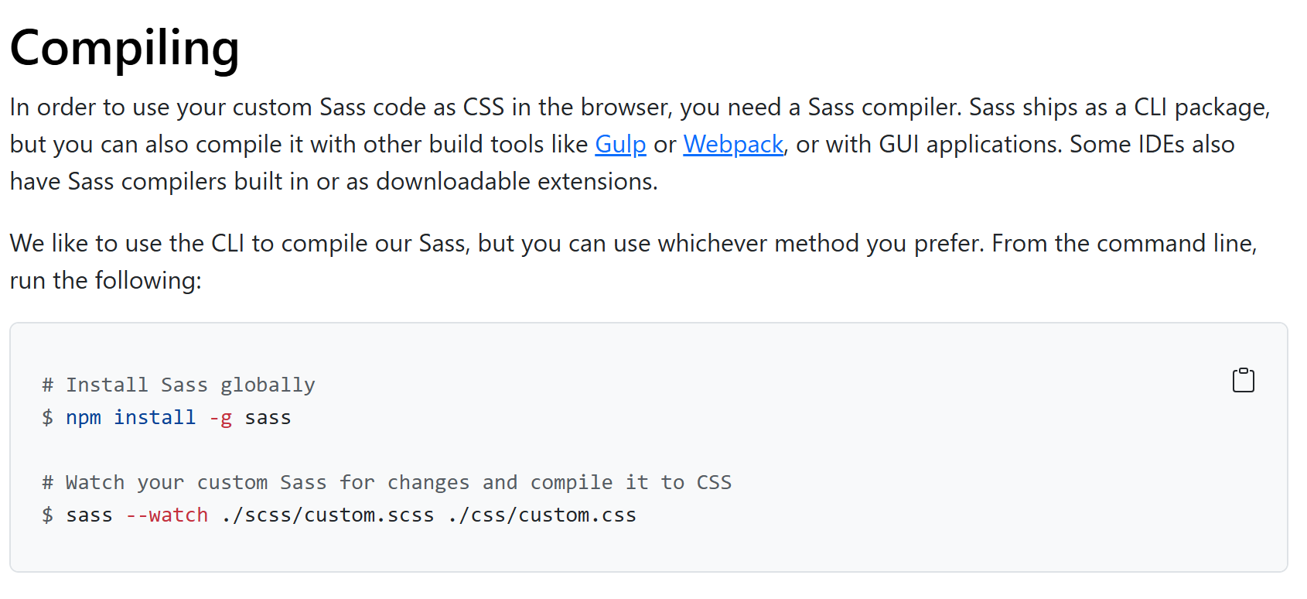  Learning Activities & Resources – CSS Files:  Using Bootstrap CSS files for our learning centre website provides a fast, reliable way to build a clean, responsive design without starting from scratch. Bootstrap’s built-in grid system helps us structure pages consistently across desktop, tablet, and mobile devices. Its pre-styled components—such as navigation bars, buttons, cards, forms, and alerts—allow us to develop features quickly while maintaining a professional look. Using Bootstrap also ensures visual consistency across all pages and simplifies future updates. Because it is widely used and well-documented, students and staff can easily learn, customize, and integrate Bootstrap into ongoing development and maintenance activities.  Practical:  Doing practical work with Bootstrap lets us learn by experimenting directly with the framework. By editing Bootstrap CSS classes, adjusting layouts, and testing different components, we quickly see how small changes affect the look and behaviour of our learning centre website. Messing with Bootstrap teaches us how the grid system works, how utilities simplify spacing and colours, and how components can be customized to fit our style. This hands-on approach builds confidence and helps us understand real-world web design practices. Through trial and error, we develop problem-solving skills and gain a deeper understanding of responsive design and modern front-end development.  Resources / Links:  Website Production: https://baizonn-learning-center.shop/ (Spaceship)  Website Testing: https://amazon.baizonn-learning-center.shop/ (Amazon)  Custom Theme: mytheme.zip  Trello Link: Link  Group A - Github Link: Link  Slack: Link  Presentation & Individual Report: Link  Marcus Weekly Journal Github: https://github.com/MarcusThum/CP3402-Marcus-Thum-Guru  Estimated Hours:  Spent 3 hours working on Presentation Video  Content Insights:  Using Bootstrap offers several valuable insights for anyone learning front-end development. First, it shows how a structured CSS framework can speed up design by providing ready-made components and a consistent grid system. You quickly learn the importance of responsive design, as Bootstrap automatically adapts layouts across different screen sizes. Experimenting with utility classes teaches efficiency—simple class names can handle spacing, colours, alignment, and more without writing custom CSS. Bootstrap demonstrates modern web development practices while giving you the flexibility to build polished interfaces with minimal effort.  Career Employability & Learning Insights  - Shows how a CSS framework speeds up web development.  - Teaches the value of reusable classes for styling consistency.  - Demonstrates how responsive design works through the grid system.  - Helps you understand breakpoints and mobile-first layouts.  - Encourages efficient styling using utility classes instead of custom CSS.  - Provides hands-on experience with common UI components like navbars, cards, and buttons.  - Builds practical front-end development skills widely used in industry.  - Demonstrates ability to work with established frameworks—valuable for employability.  - Strengthens understanding of responsive design, a core requirement in modern web jobs.  - Shows employers you can follow structured, professional coding practices.

Add more rows if necessary

=========================

