Student’s name : Marcus Thum
ID : 14734258
14 / 11 / 2025  9.00am – 12.00PM (Re-learning and doing the practical & Journaling) | Week 8: WordPress Custom Theme  Custom Header & Footer – Custom WordPress Theme  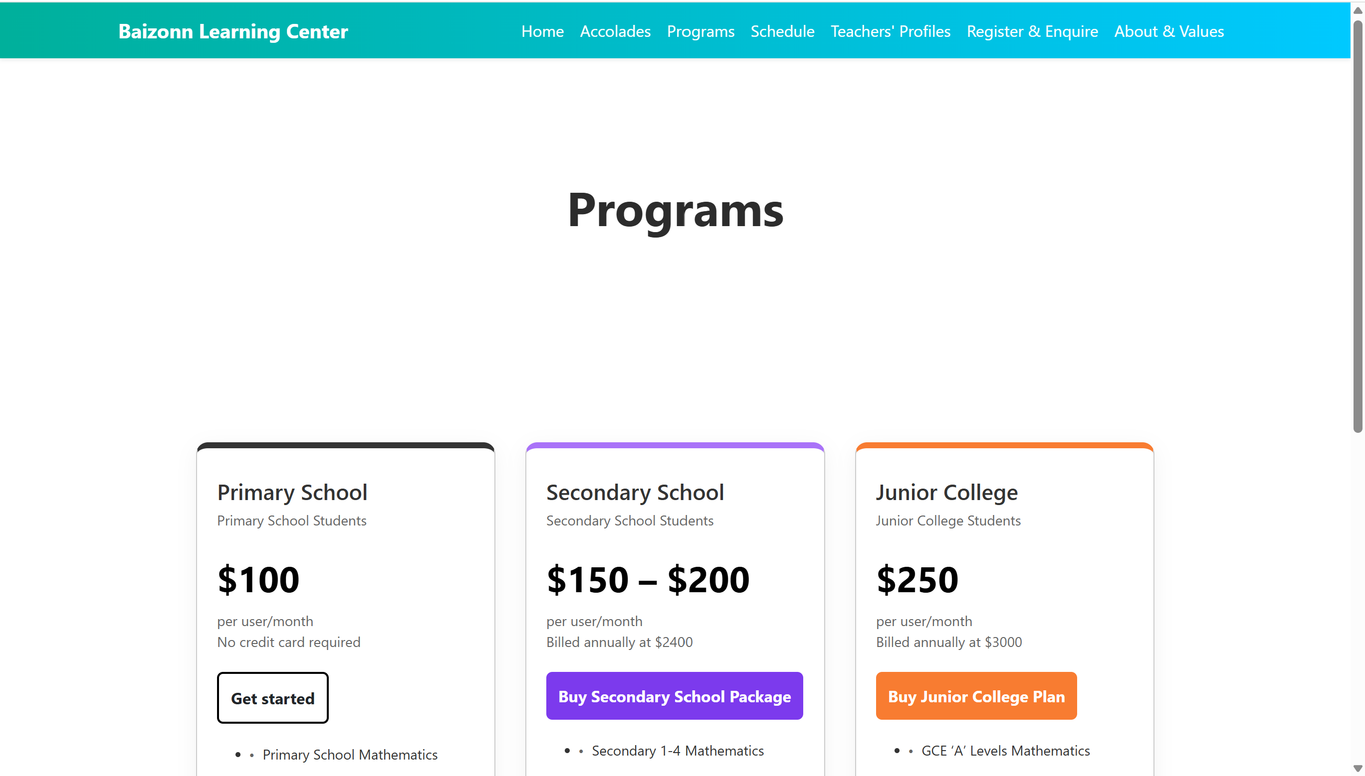  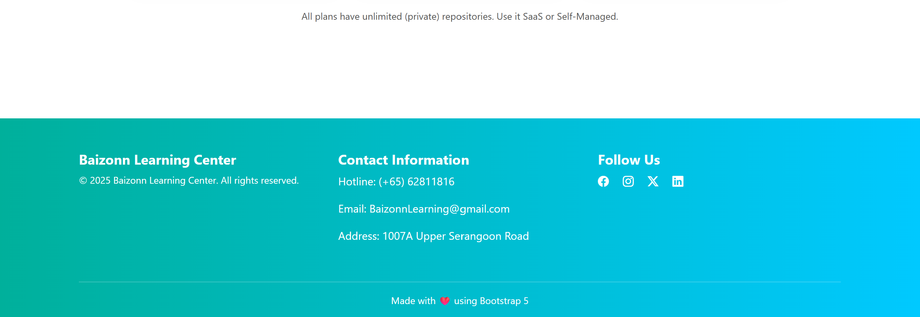  mytheme/  ├── footer.php  ├── functions.php  ├── header.php  ├── index.php  ├── style.css  ├── templateDetails.xml  Learning Activities & Resources – Custom Theme:  My Baizon Learning Center custom theme includes editable header.php and footer.php files, providing full control over the website’s top and bottom sections. The header can be tailored to showcase the logo, main navigation (such as Programs, Schedule, About, Values). The footer allows for consistent display of contact details, social links, and quick links across all pages. Customizing these files ensures brand consistency and improves user experience without relying on page builders.  Practical:  My Baizon Learning Center custom WordPress theme offers practical tools for building a functional, informative website. By using core files like header.php, footer.php, index.php, and style.css, administrators can easily manage layout and design without complex plugins. Key sections such as Programs, Schedule, About, and Values can be created using standard WordPress pages, ensuring simplicity and compatibility. The theme supports responsive design, making it user-friendly across all devices. With this practical setup, Baizon staff can update content, add new resources, and maintain a clean, professional site—ideal for informing families and promoting the center’s educational services effectively.  Resources / Links:  Website: https://baizonn-learning-center.shop/  Custom Theme: mytheme.zip  Trello Link: Link  Github Link: Link  Slack: Link  Presentation & Individual Report: Link  Estimated Hours:  Spent 3 hours working on Project, Assignment 2, creating Header & Footer for Custom Theme  Content Insights:  My Baizon Learning Center theme is structured to highlight content that informs, engages, and reflects the center’s core values. Key pages like Programs, Schedule, About, and Values are strategically positioned to guide visitors through the educational offering. The theme’s clean layout and editable templates ensure that content remains focused and easy to digest. By using custom post types and template parts, administrators can organize staff profiles, curriculum details, and news updates efficiently. This structure not only enhances readability but also improves SEO and accessibility, making the site a reliable source of information for both families and the community.  Learning Insights  - Designed to support lifelong learning and personal development.  - Clear presentation of programs helps users identify relevant career pathways.  - “Schedule” page allows learners to plan around structured classes or events.  - “About” and “Values” sections communicate the center’s mission and learning philosophy.  - Custom post types can highlight instructor experience, success stories, and certifications.  - Responsive design ensures accessibility across devices for job seekers and learners.  - Easy content updates allow the center to post workshops, job fairs, or internships.  - Encourages self-directed learning through downloadable resources and clear navigation.  - Strengthens learner confidence by showcasing real-world outcomes.

Add more rows if necessary

=========================

