Student’s name : Marcus Thum
ID : 14734258
17 / 10 / 2025  9.00am – 12.00PM (Re-learning and doing the practical & Journaling) | Week 5: Child Themes  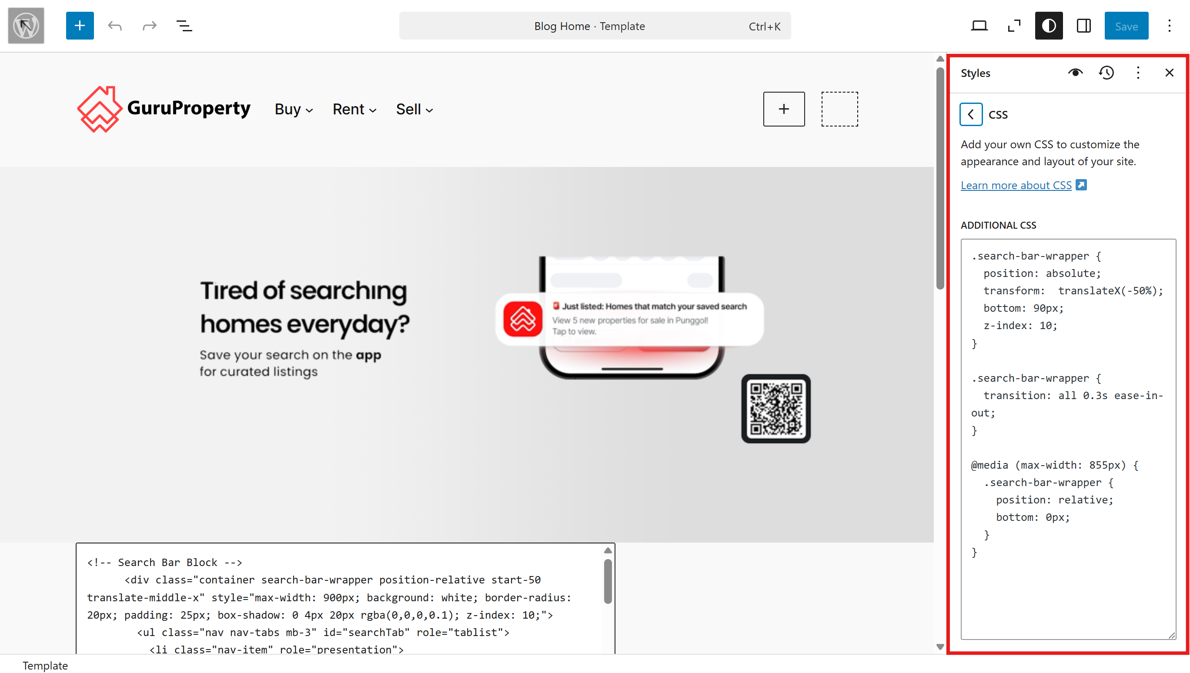  Additional CSS – Wordpress  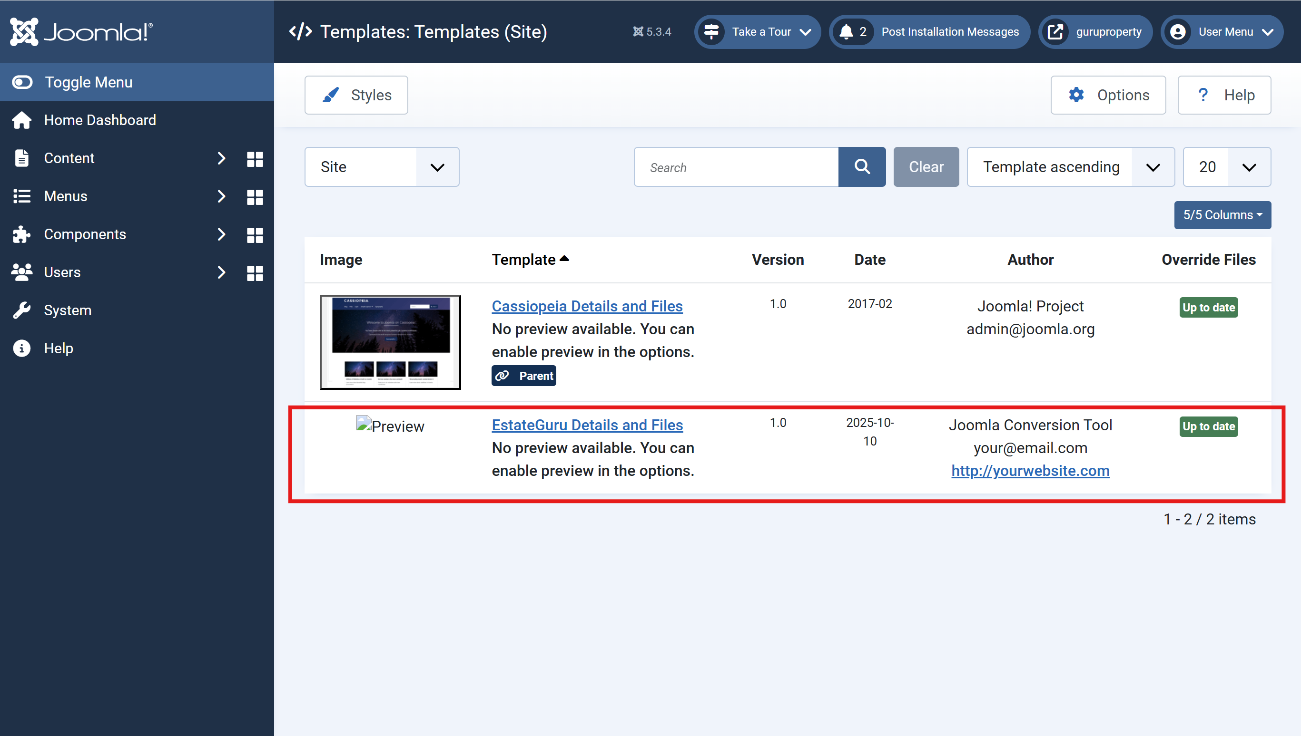  Custom Template – Joomla  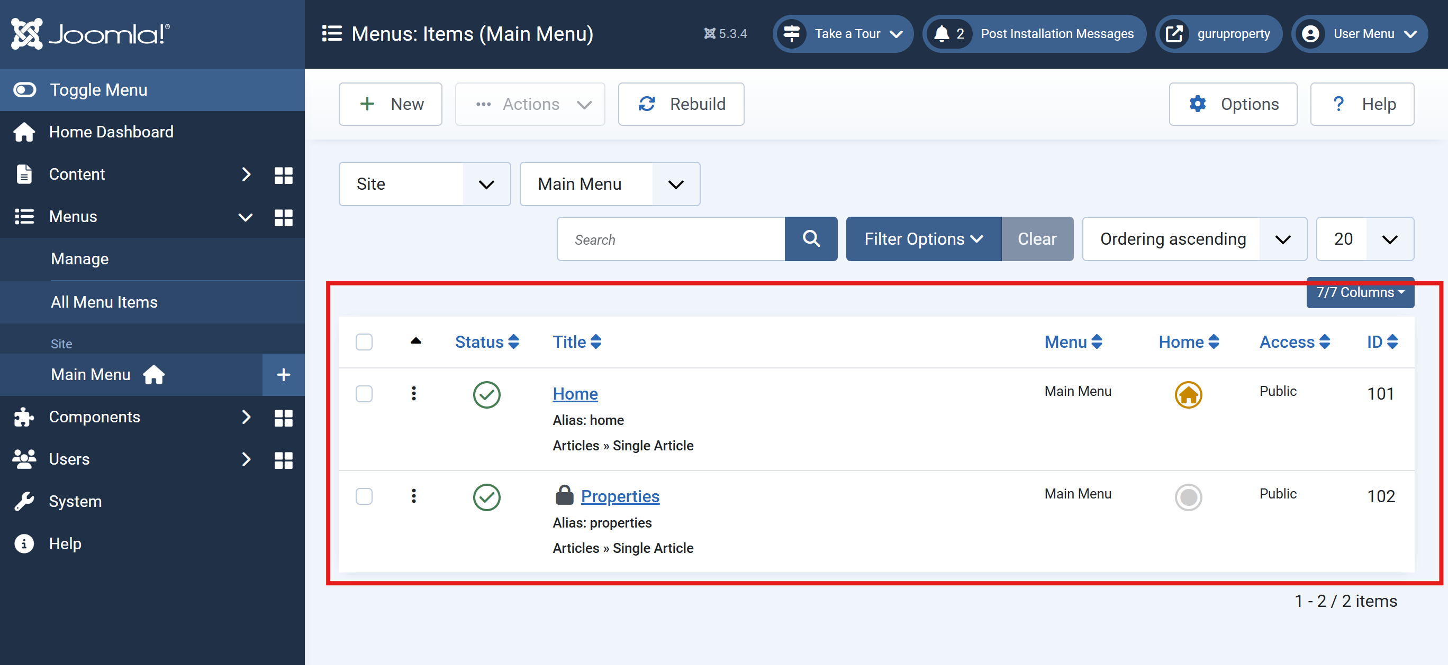  Menu  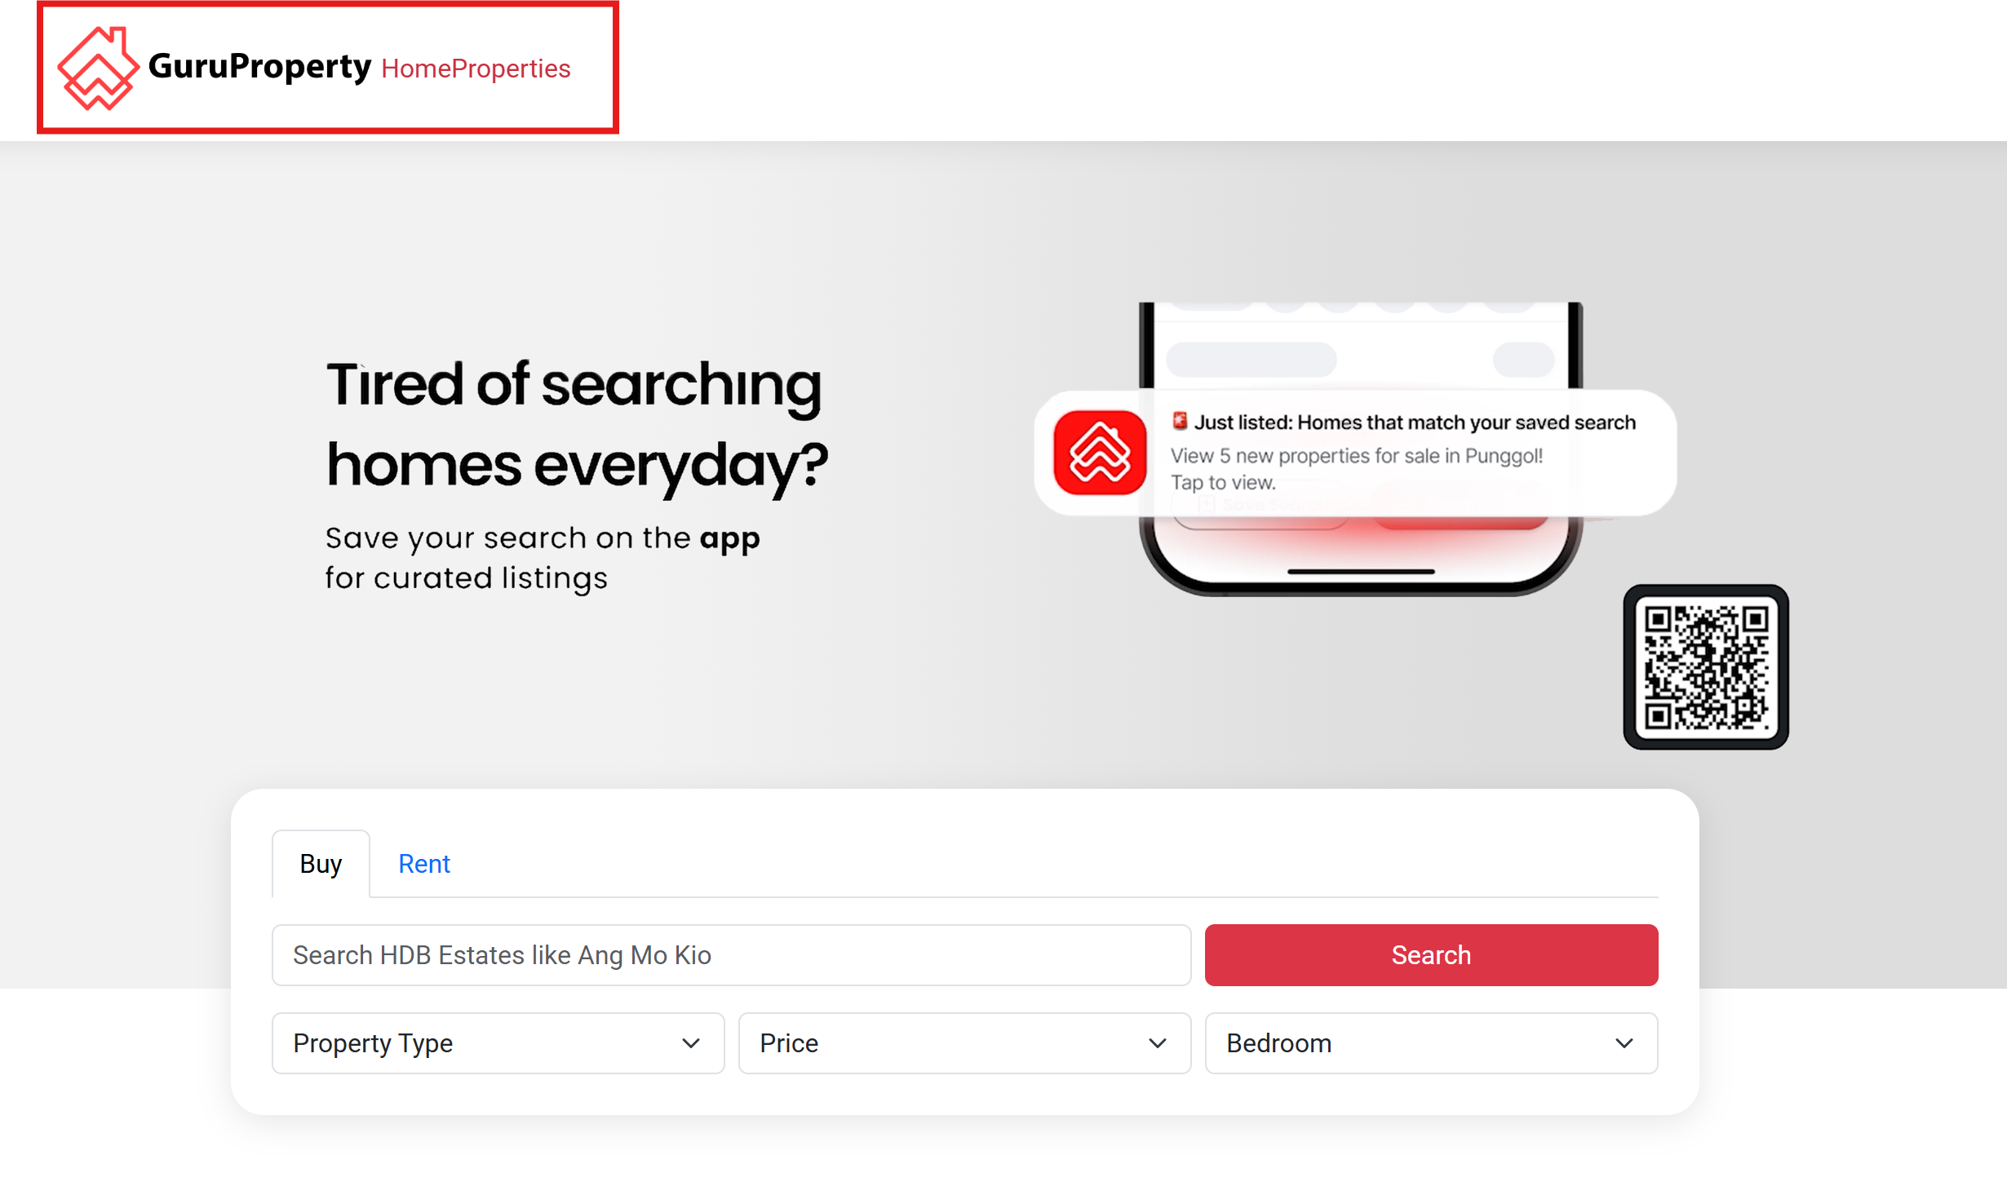  Adding Menus  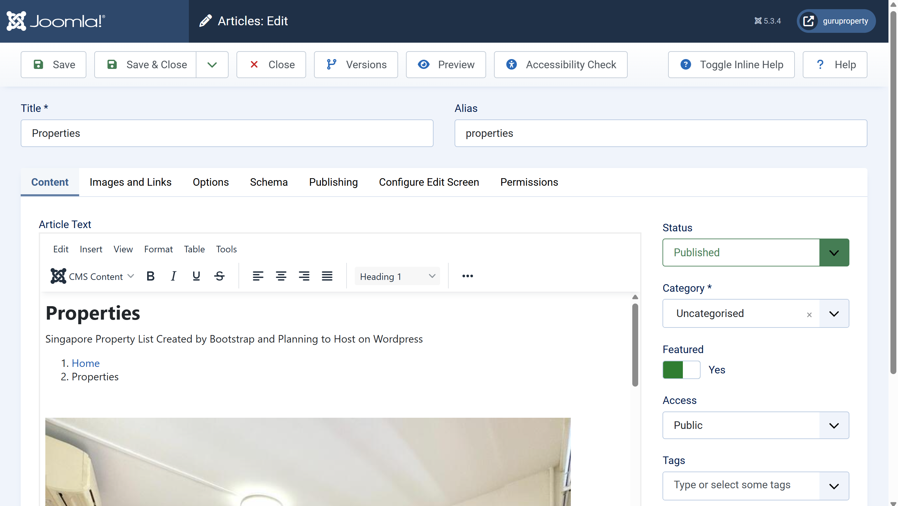  Publishing Pages - Articles  Learning Activities & Resources – Deployment of Joomla & Wordpress:  Using custom templates in Joomla and custom CSS in WordPress greatly enhanced my understanding of theme customization and flexibility in content management systems. In Joomla, importing custom templates allowed me to experiment with layout overrides and module styling without affecting the core template, making updates safer. In WordPress, applying custom CSS enabled precise design adjustments without altering parent themes, promoting cleaner and more maintainable code. Both approaches reinforced the importance of separating customization from core files, allowing future scalability and professional web design practices. These tools empowered me to tailor site aesthetics effectively while preserving system stability and upgrade compatibility.  Practical:  Learning how to use Joomla. Engaging in practical work with Joomla gave me hands-on experience in using a powerful content management system. I learned how to navigate the backend interface, create and publish articles, and organize content effectively. Managing menu items taught me how to structure a website logically, ensuring users can easily find information. The process of linking articles to menu items helped reinforce the importance of navigation and user experience.  Resources / Links:  - Weekly Journal: https://github.com/MarcusThum/CP3402-Marcus-Thum-Guru.git  - Website Wordpress: https://guruproperty.xyz/  - Website Joomla: https://myclean.it.com/ (*NEW)  - Hosting Platform: https://www.spaceship.com/  Estimated Hours:  Spent 3 hours Deploying Joomla and Learning how to use Articles, Menu Items and Custom Themes. (For Assignment 1)  Content Insights:  Joomla  - Open-source CMS used for building dynamic websites and web applications  - Separates content from design for easier management and updates  - Supports article creation, categorization, and tagging  - Allows custom layout through templates and modules  - Strong menu management system for site navigation  Career/Employability/Learning Insights  - Industry-Relevant Skills: Learning Joomla and child themes enhances web development skills highly valued in digital media, marketing, and IT sectors.  - CMS Proficiency: Demonstrates ability to work with industry-standard CMS platforms, a key requirement for many web design/development roles.  - Customization & Problem-Solving: Working with child themes shows understanding of non-destructive customization, an essential best practice.  - Portfolio Development: Projects involving Joomla and custom themes provide strong additions to a professional portfolio.  - Learning Agility: Shows ability to adapt to different platforms (Joomla, WordPress), boosting versatility and employability.  - Foundation for Freelance/Agency Work: Builds practical knowledge to offer web services or join creative agencies.

Add more rows if necessary

=========================

