Student’s name : Marcus Thum
ID : 14734258
10 / 10 / 2025  9.00am – 12.00PM (Re-learning and doing the practical & Journaling) | Week 4: Deployment  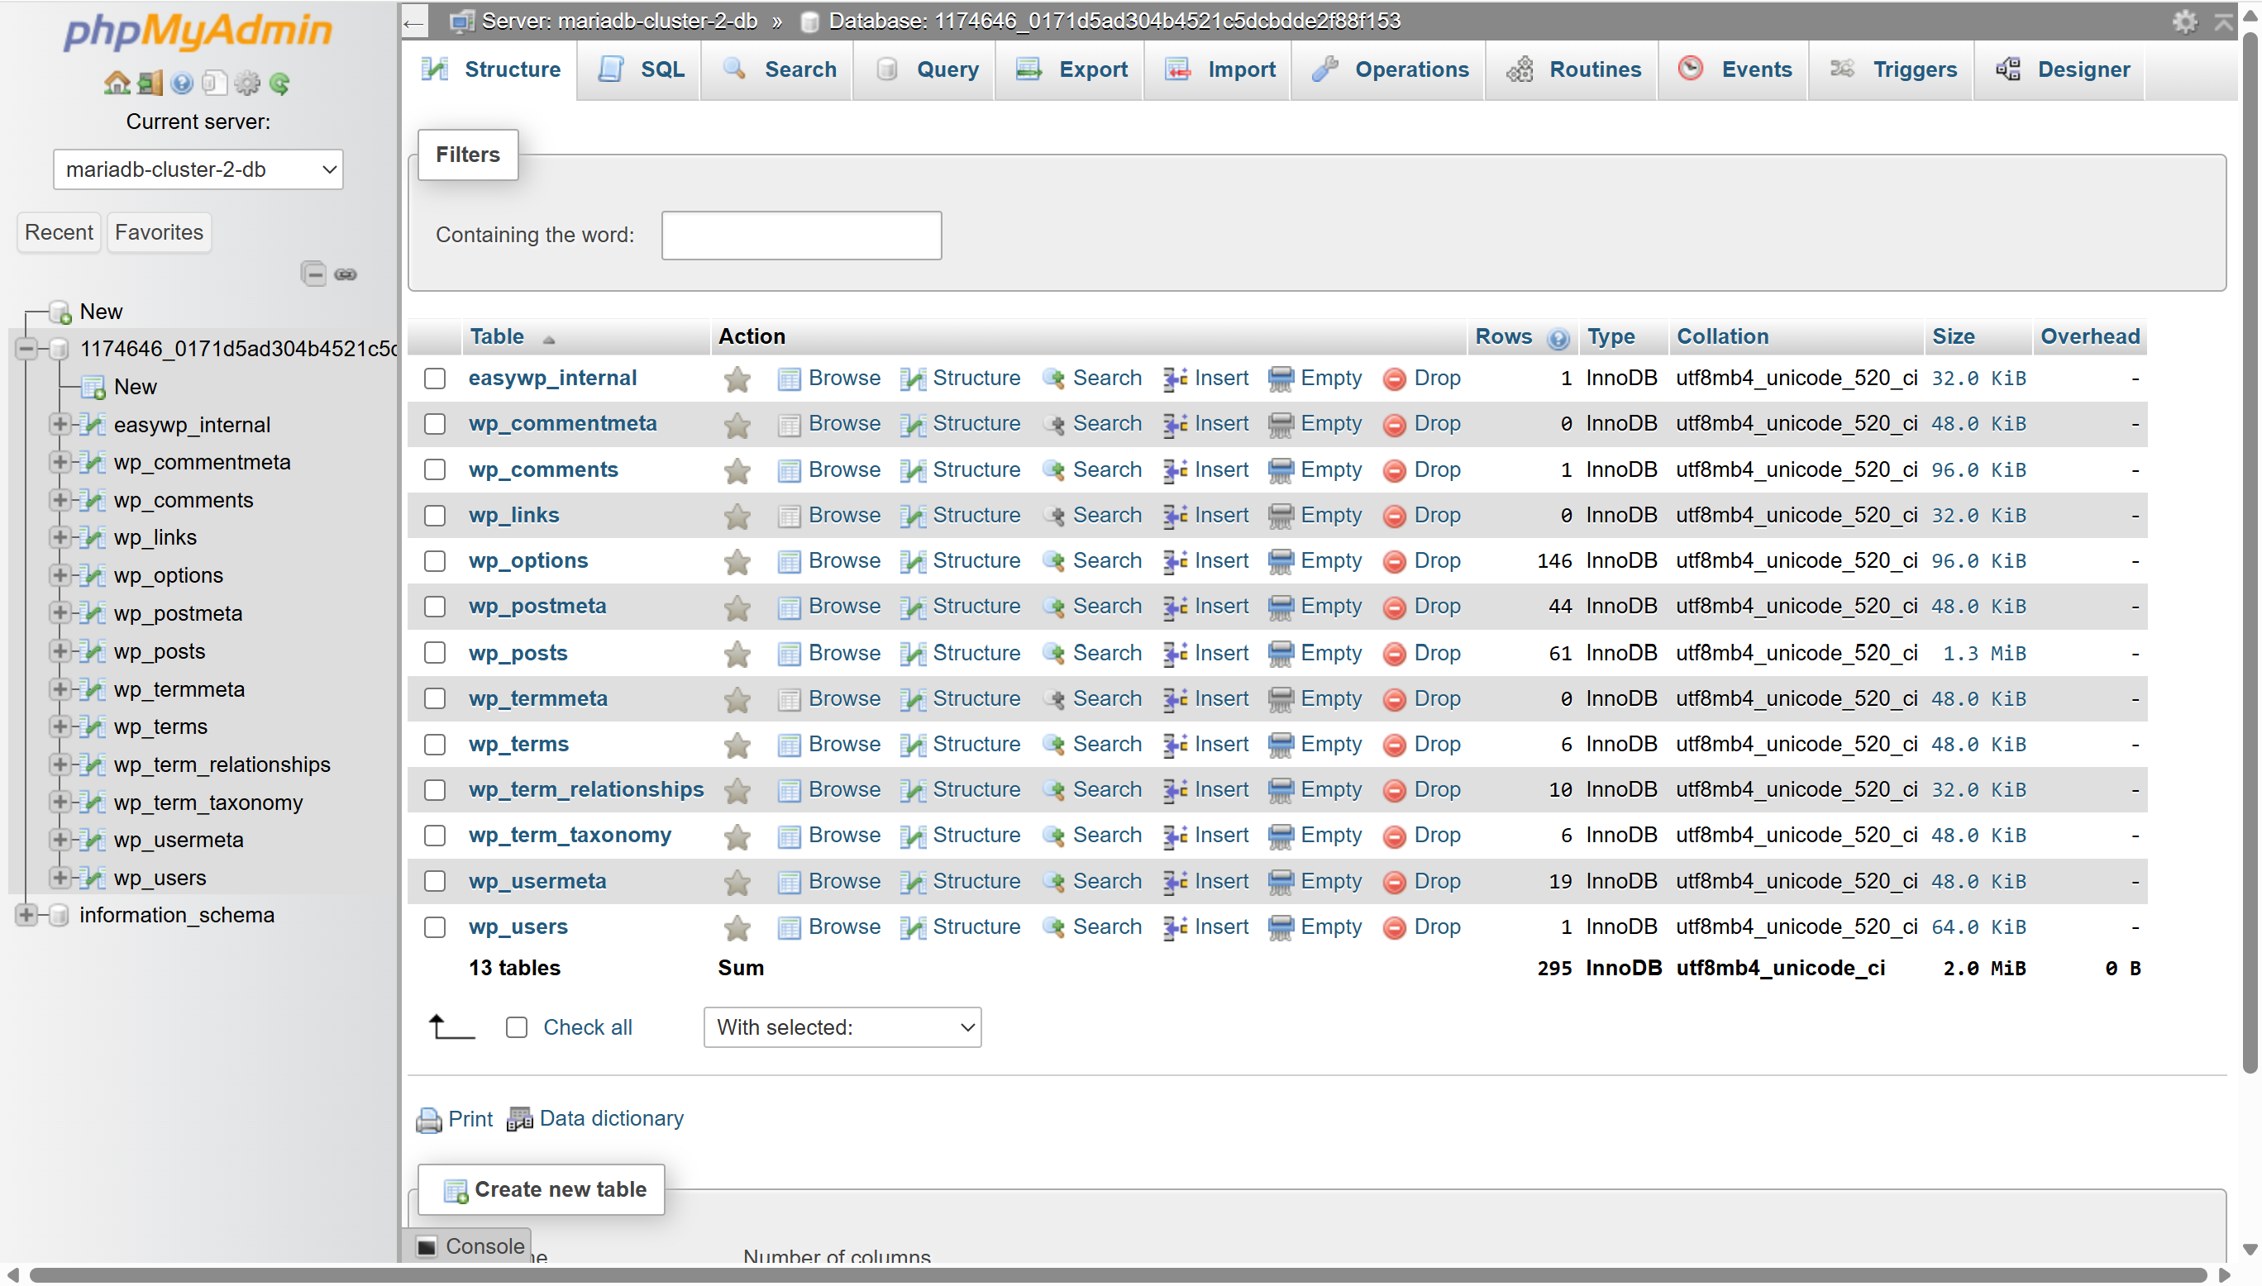  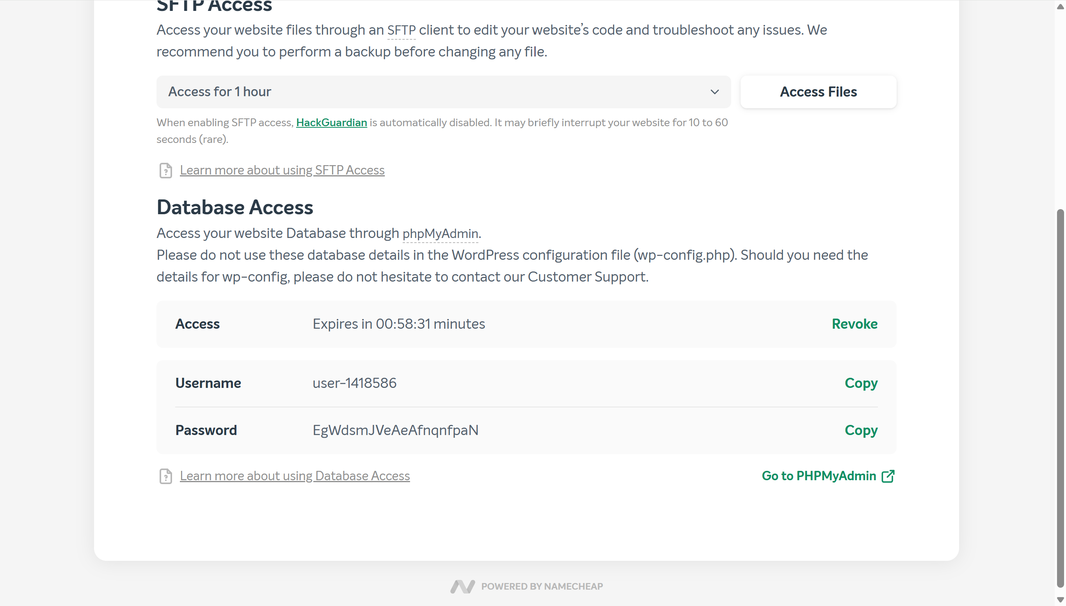  Database – Deployment  SFTP – File Access  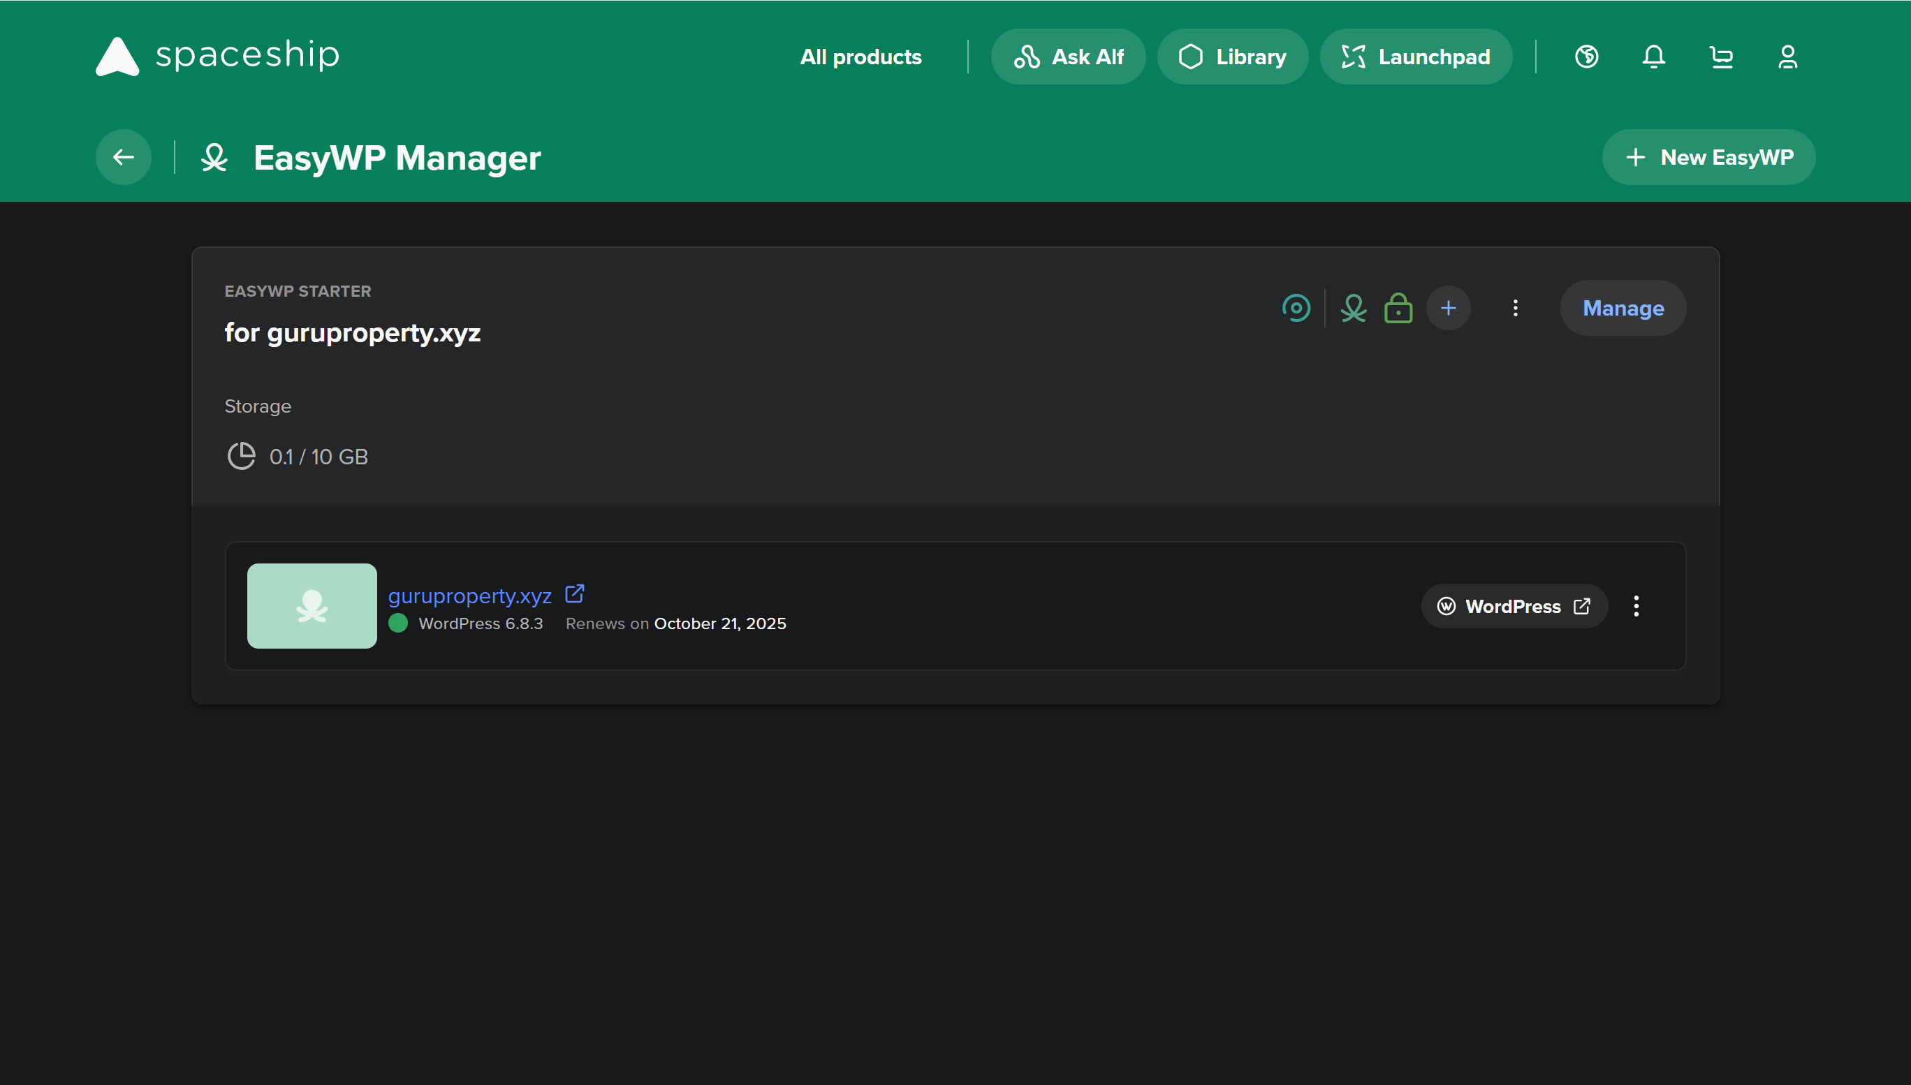  Wordpress - Deployment  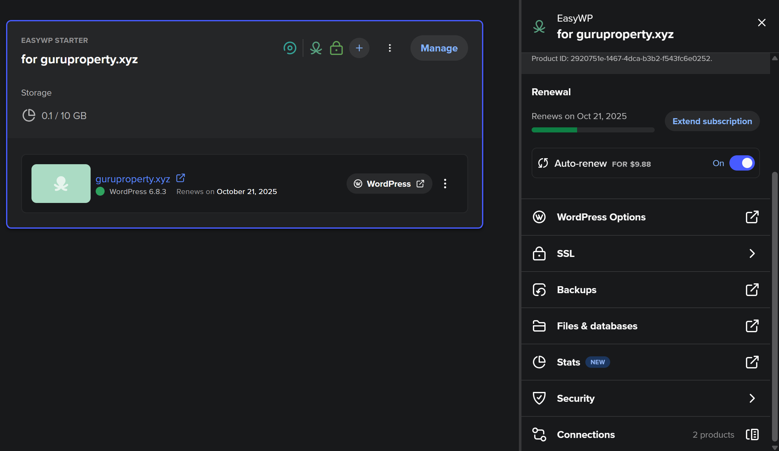  Management Deployment – SSL, Files, Database & Security  Learning Activities & Resources – Deployment of Wordpress:  Deploying WordPress via Spaceship (EasyWP) provides a user-friendly and efficient way to manage websites. The platform simplifies the process of deploying WordPress, making it easy even for beginners. Accessing the database through phpMyAdmin allows users to manage tables, users, posts, and configurations directly, offering greater control over the backend. File management through the web portal is intuitive, enabling quick updates and backups without needing FTP or cPanel. This integration streamlines website administration by combining hosting, database, and file access in a single interface, promoting ease of use, security, and fast website performance for WordPress-based projects.  Practical:  Using the Spaceship panel, managing a WordPress website becomes straightforward and user-friendly. It provides easy access to essential components such as the database, files, and domain settings, all from a single dashboard. The built-in phpMyAdmin tool allows efficient database management, where tables like posts, users, and comments can be edited or reviewed. File access is also streamlined, making it easy to upload, update, or back up website data without the need for external tools. Domain management, including DNS settings and SSL, is simple to configure. Overall, the Spaceship panel simplifies web hosting tasks, making WordPress site administration efficient and accessible.  Resources / Links:  - Weekly Journal: https://github.com/MarcusThum/CP3402-Marcus-Thum-Guru.git  - Website: https://guruproperty.xyz/  - Hosting Platform: https://www.spaceship.com/ (*NEW)  Estimated Hours:  Spent 3 hours doing the practical and journaling.  Content Insights:  - HackGuardian  HackGuardian scans your WordPress site for malware, vulnerabilities, and suspicious changes, helping keep your site secure.  - Web Application Firewall (WAF)  A WAF blocks common attacks like SQL injection, XSS, and brute-force attempts by filtering traffic before it reaches your site.  - SFTP File Access  SFTP offers encrypted file transfer to securely manage your website files, especially when combined with SSH keys for enhanced protection.  - Database Access via phpMyAdmin  phpMyAdmin provides an easy web interface to manage and troubleshoot your WordPress database safely.  - Domain and SSL  Managing your domain and SSL certificates through the panel ensures your site is accessible, trusted, and secure with HTTPS encryption.  Career/Employability/Learning Insights  Working with tools like Spaceship’s EasyWP hosting, HackGuardian, WAFs, phpMyAdmin, and SFTP builds valuable skills for a career in web development and IT security. Understanding WordPress deployment, database management, secure file access, and domain/SSL configuration demonstrates proficiency in website administration and cybersecurity basics. Employers value experience with security scanners and firewalls to protect sites from attacks, alongside hands-on ability to manage files and databases safely.

Add more rows if necessary

=========================

