Student’s name : Marcus Thum
ID : 14734258
31 / 10 / 2025  9.00am – 12.00PM (Re-learning and doing the practical & Journaling) | Week 6: Project Management  Trello Filled Project Management – Goals & Agreements  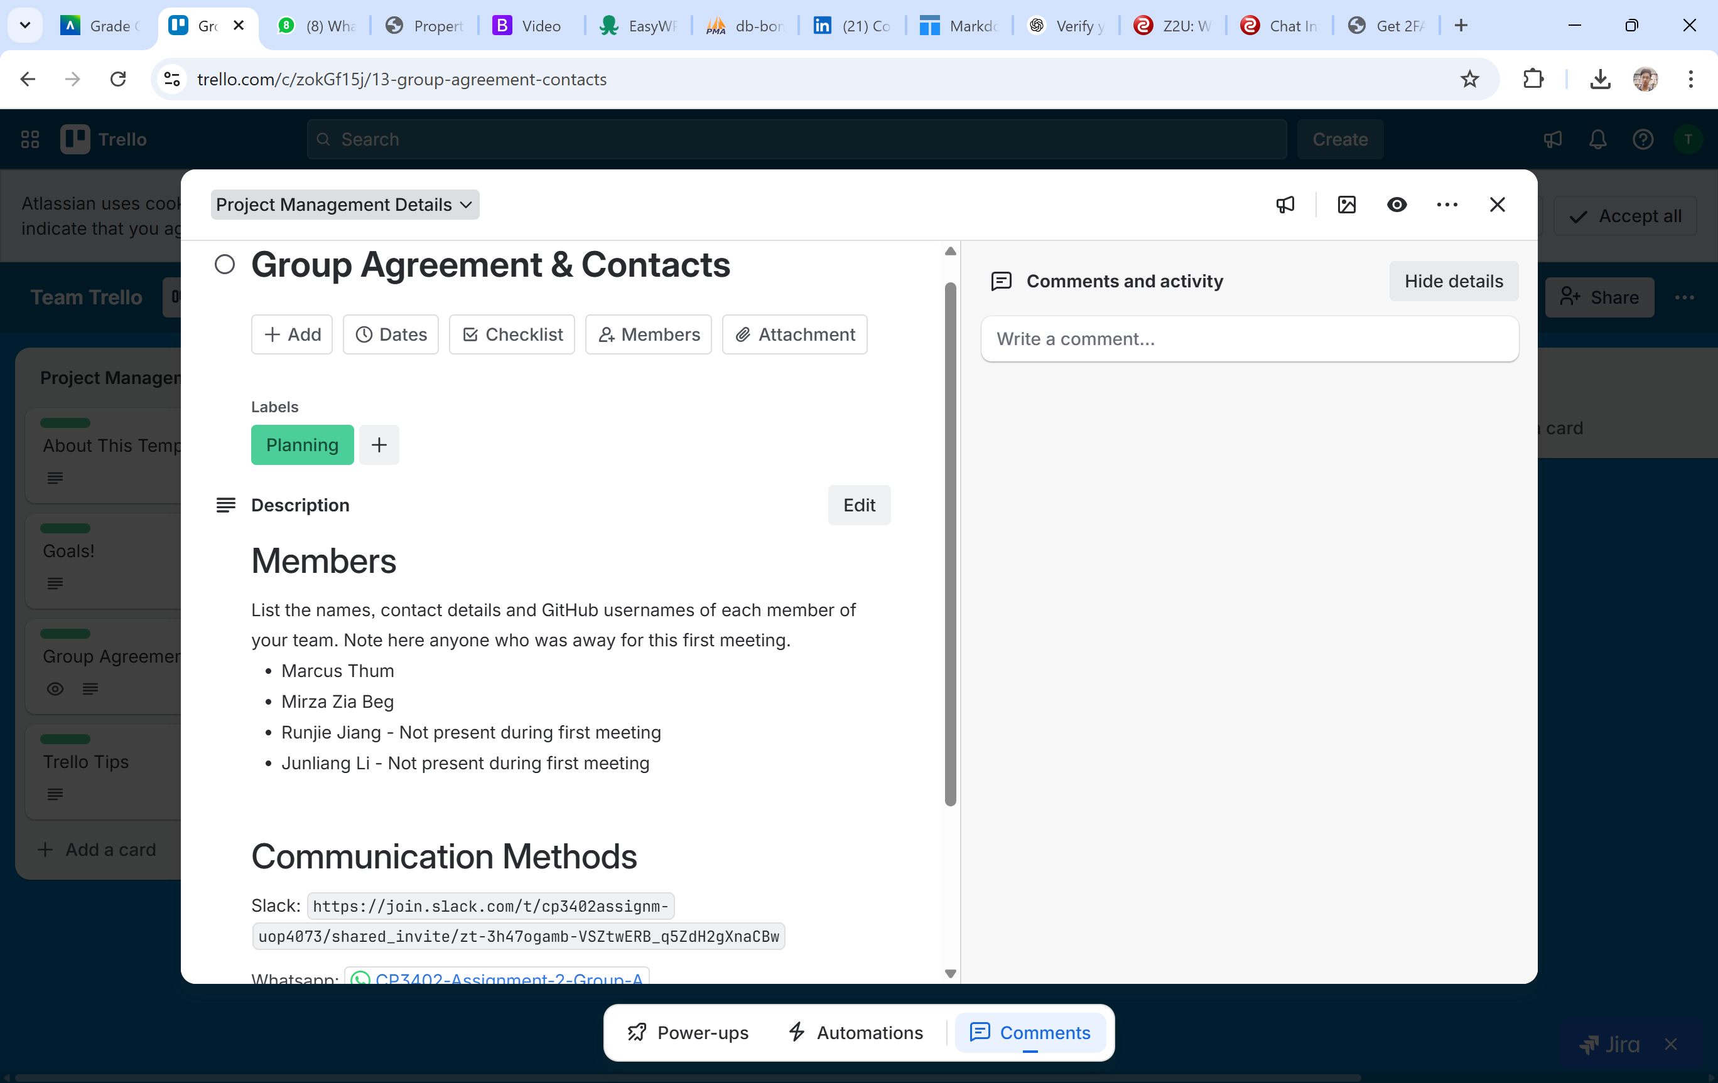  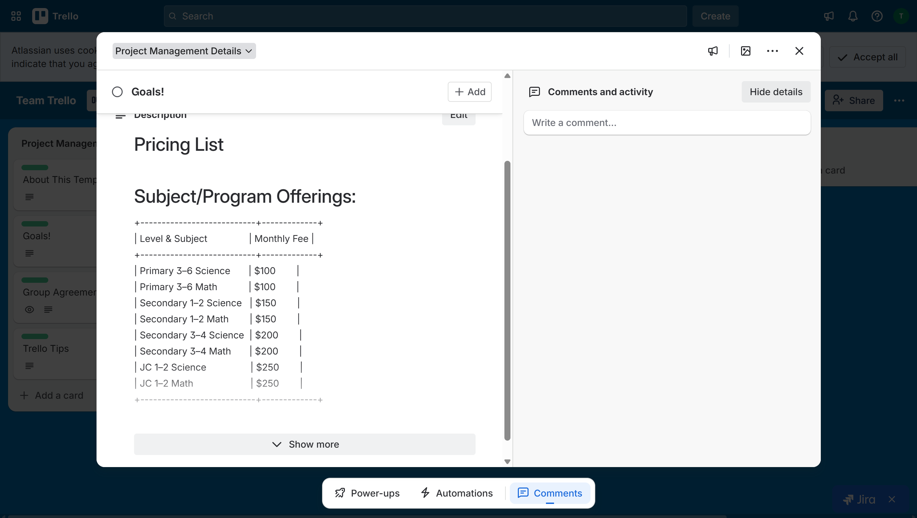  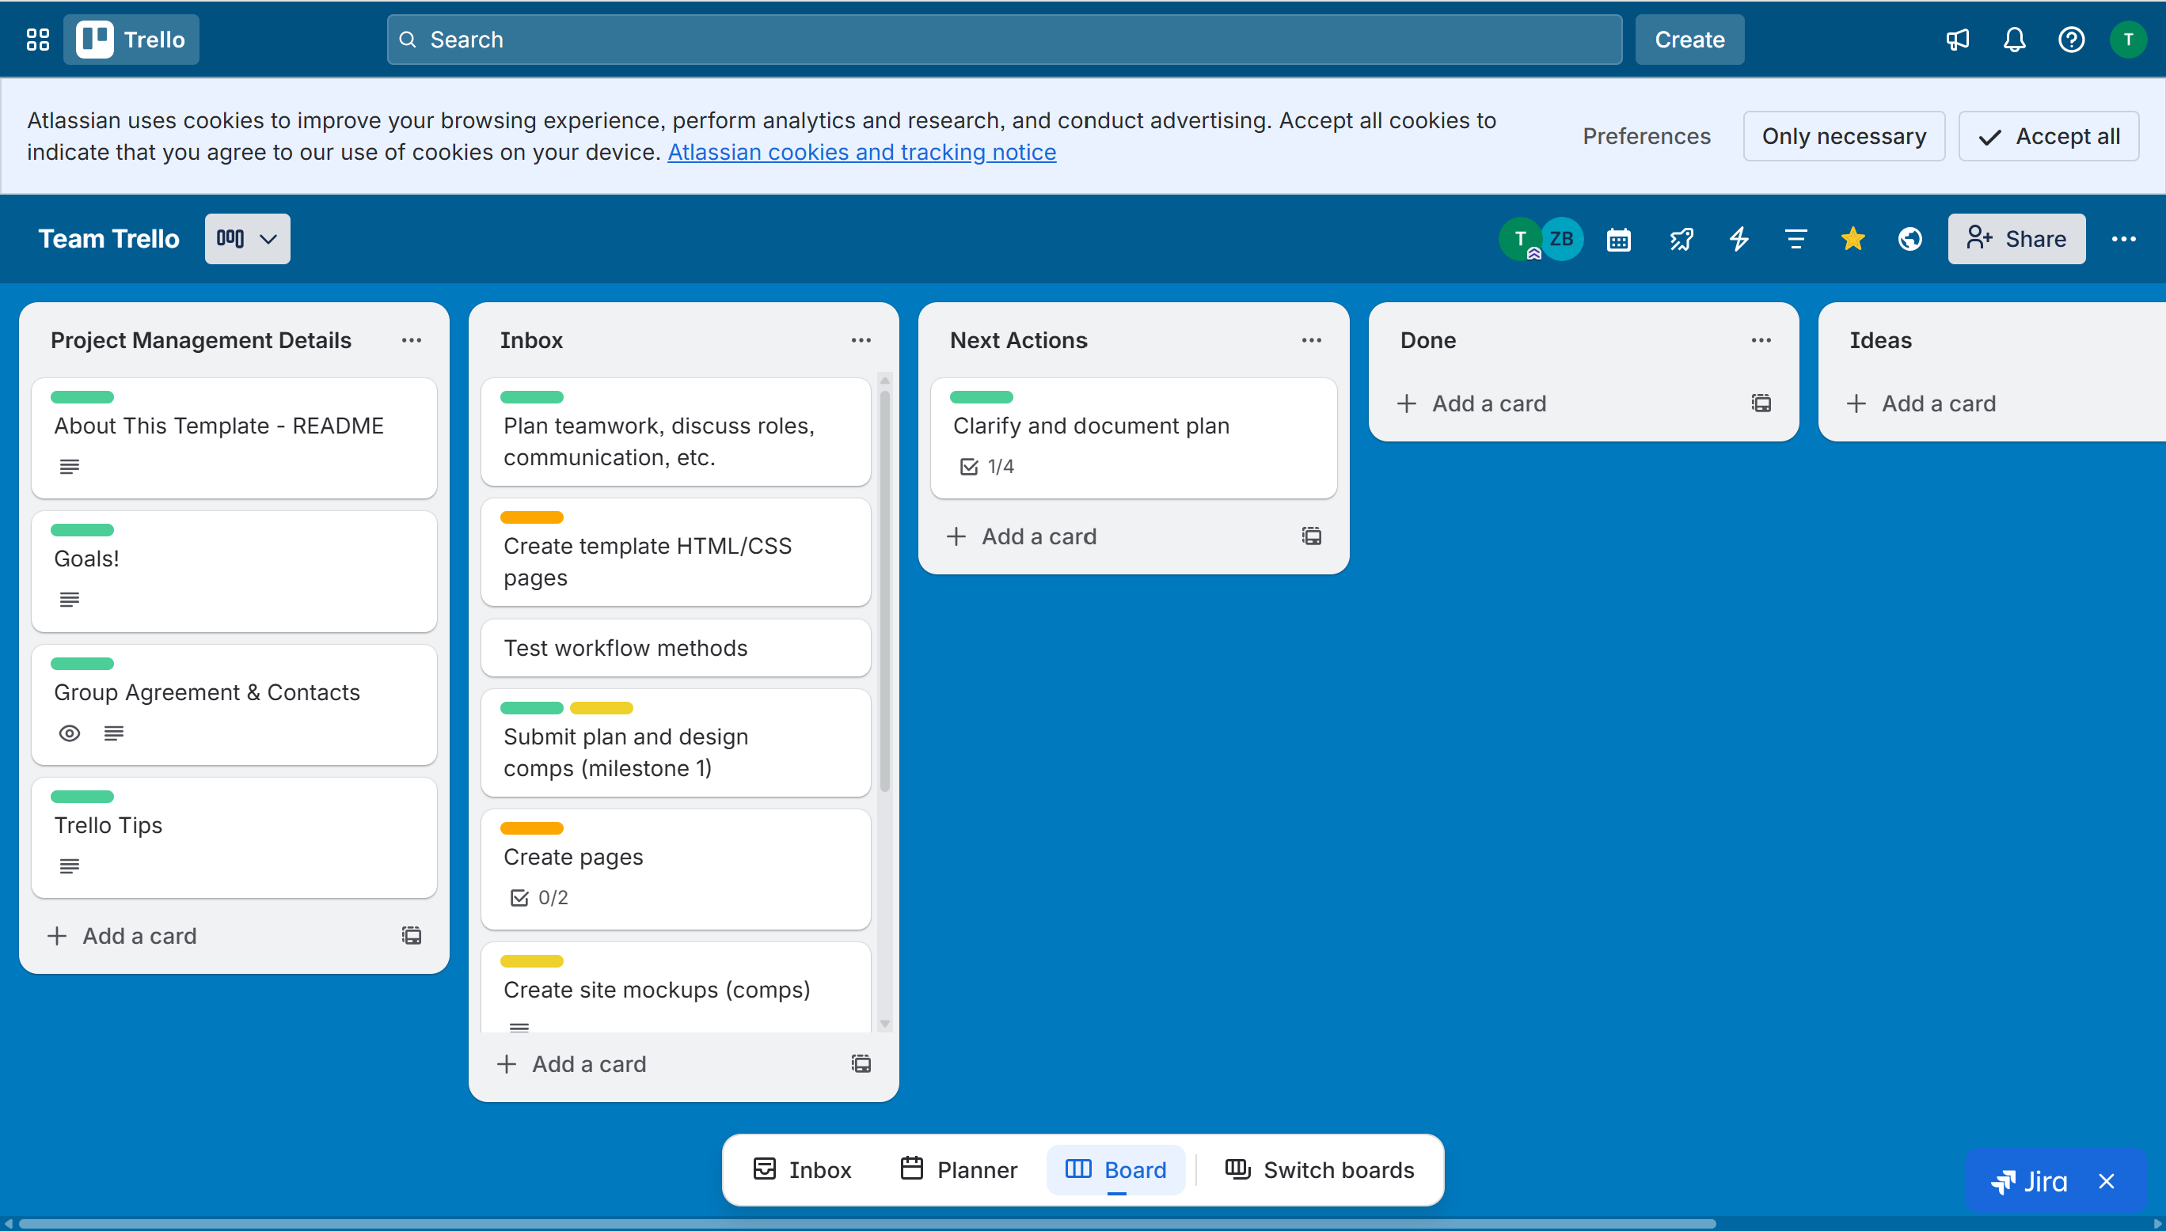  Created Github – Group A  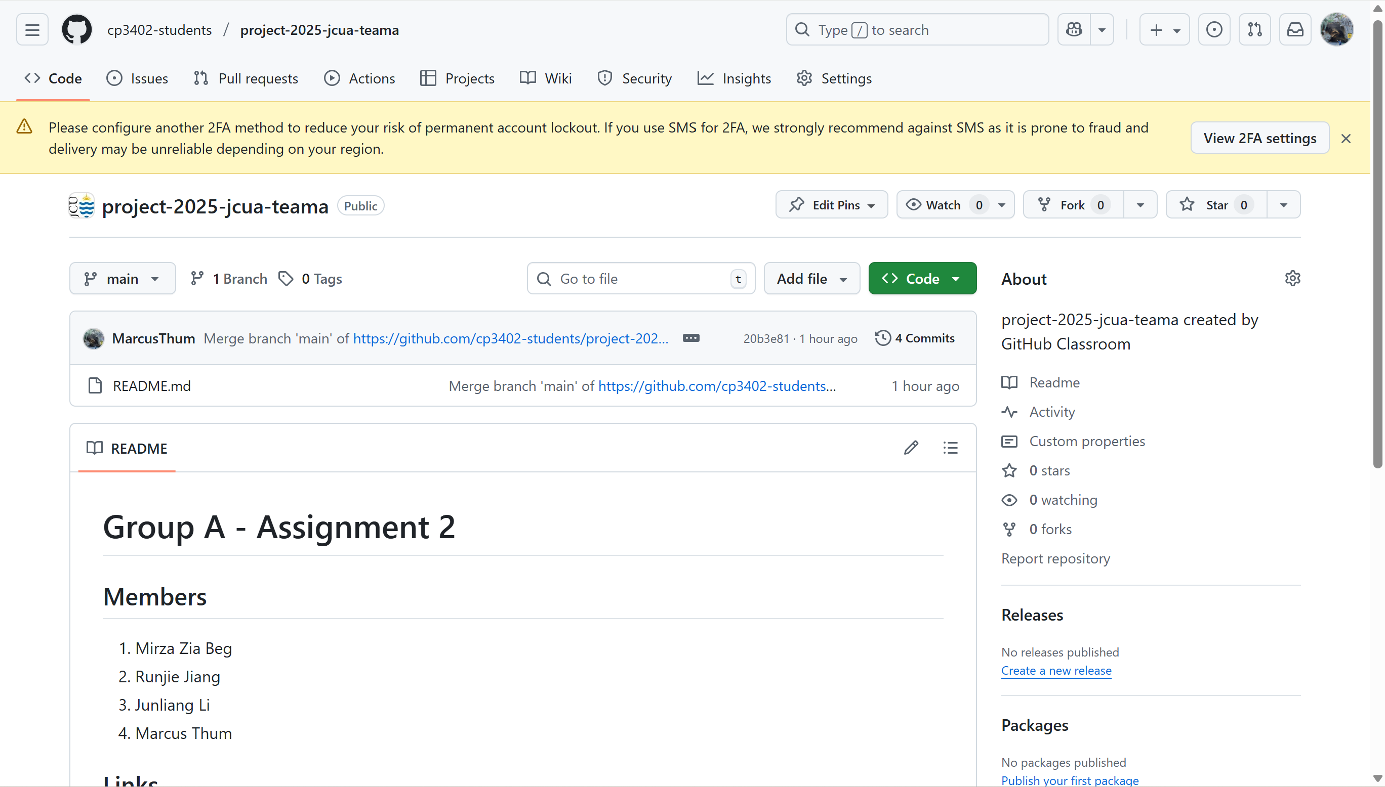  Integrated Github and Trello into Slack  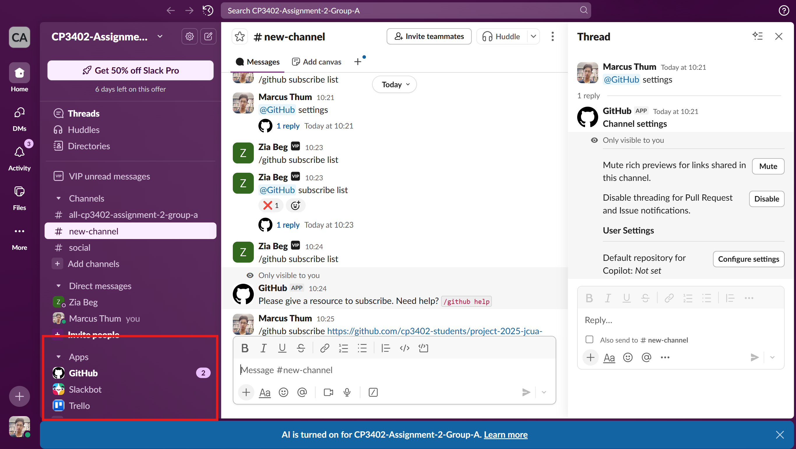  Added Whatsapp Group  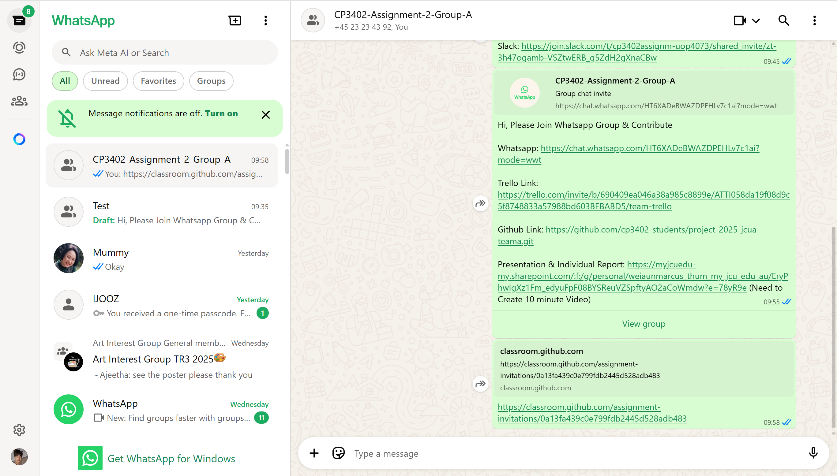  Learning Activities & Resources – Deployment of Trello, Github, Slack & Whatsapp:  Using Trello, GitHub, Slack, and WhatsApp has greatly enhanced my project management and communication abilities. Trello helped me organize tasks, set timelines, and visualize progress, while GitHub improved collaboration through version control and code sharing. Integrating GitHub and Trello into Slack streamlined our workflow by centralizing notifications, task updates, and commits in one place. This integration made communication more efficient and ensured that everyone stayed informed in real time. WhatsApp provided a quick and convenient channel for informal discussions. Overall, deploying these tools together strengthened teamwork, improved coordination, and helped me manage projects more effectively and professionally.  Practical:  The practical experience of using Trello, GitHub, Slack, and WhatsApp was highly valuable in developing my real-world project management and communication skills. Applying these tools in a hands-on environment allowed me to understand how technology supports teamwork and productivity. Trello provided a clear structure for organizing and monitoring tasks, while GitHub offered practical exposure to version control and collaborative coding.  Resources / Links:  Trello Link: Link  Github Link: Link  Slack: Link  Presentation & Individual Report: Link  Estimated Hours:  Spent 3 hours filling up Project Management for Trello. Creating and Integrating Github, Trello into Slack.  Created Presentation & Individual Report  Content Insights:  Using Trello, GitHub, Slack, and WhatsApp provided meaningful insights into effective collaboration and project management. These tools improved organization, communication, and accountability within the team.  Career/Employability/Learning Insights  ⚡ Project Management Skills – Developed strong project management and organizational abilities through Trello task tracking.  ⚡ Technical Proficiency – Gained hands-on experience with GitHub, enhancing technical expertise and version control proficiency.  ⚡ Communication & Teamwork – Strengthened professional communication and collaboration using Slack for team coordination.  ⚡ Workflow Integration – Integrated GitHub and Trello within Slack to improve workflow efficiency and real-time updates.  ⚡ Adaptability & Problem-Solving – Improved flexibility and critical thinking in managing digital projects.  ⚡ Leadership & Accountability – Enhanced leadership through effective task delegation and progress monitoring.  ⚡ Confidence with Tools – Built confidence in using industry-standard collaboration platforms for real-world applications.  ⚡ Time Management – Strengthened prioritization and scheduling skills essential for professional growth.  ⚡ Employability Growth – Increased overall career readiness through practical, technology-driven learning experiences.

Add more rows if necessary

=========================

