Student’s name : Marcus Thum
ID : 14734258
7 / 11 / 2025  9.00am – 12.00PM (Re-learning and doing the practical & Journaling) | Week 7: PHP Programming  Used PHP Code for Assignment 1  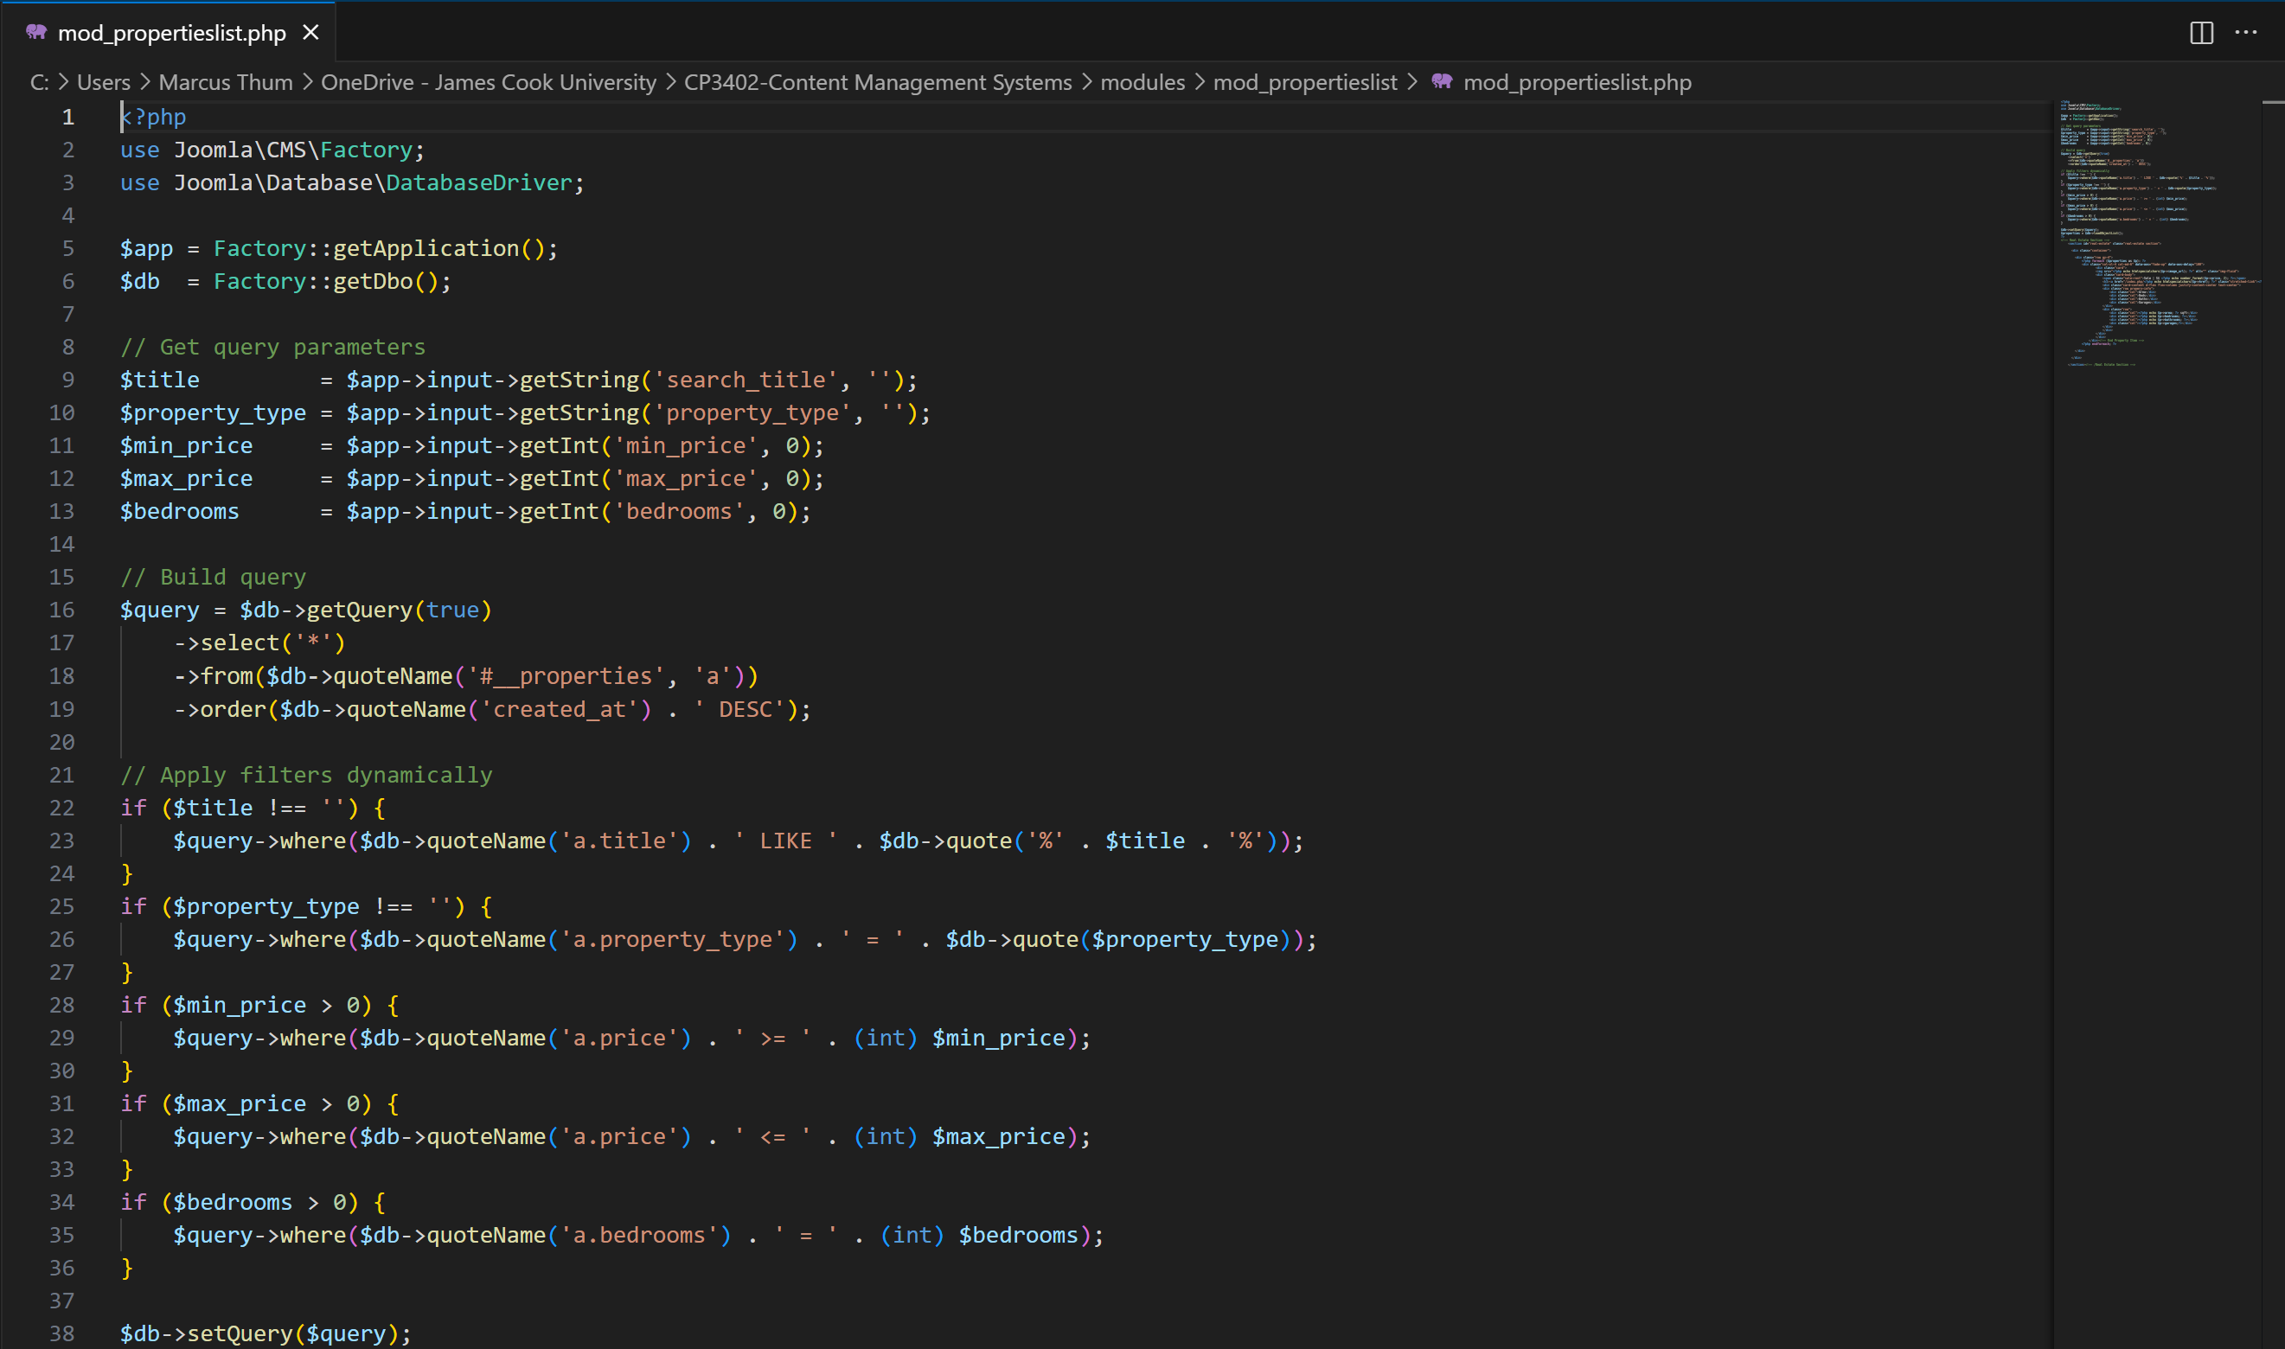  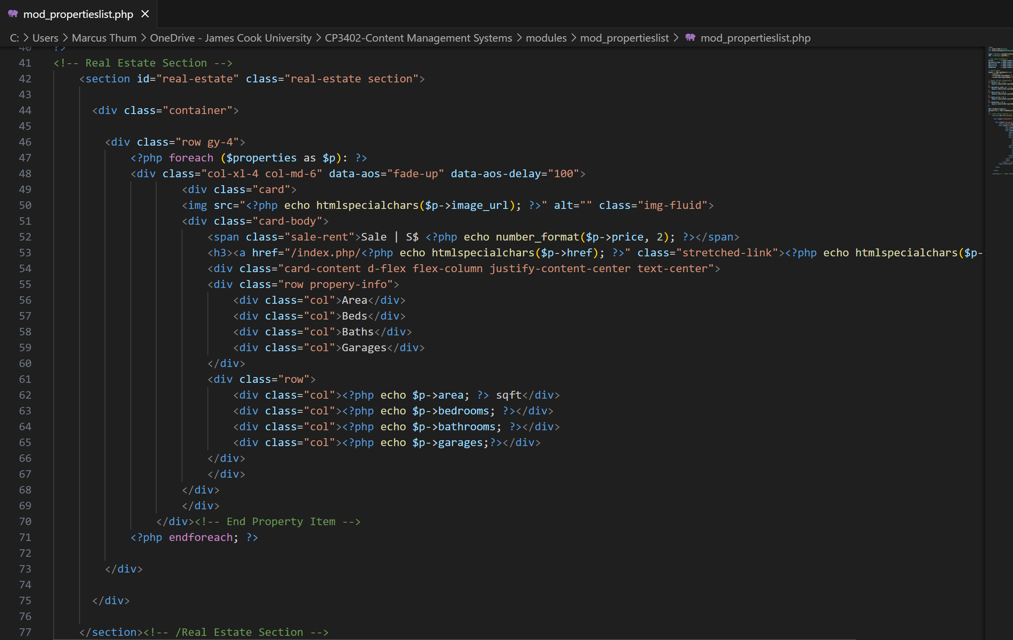  Used as extension & theme  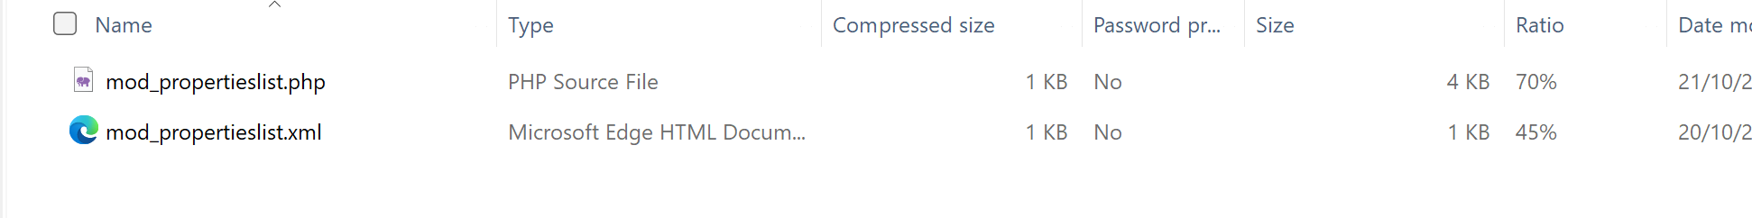  Assignment 2 – Project (Learning Centre)  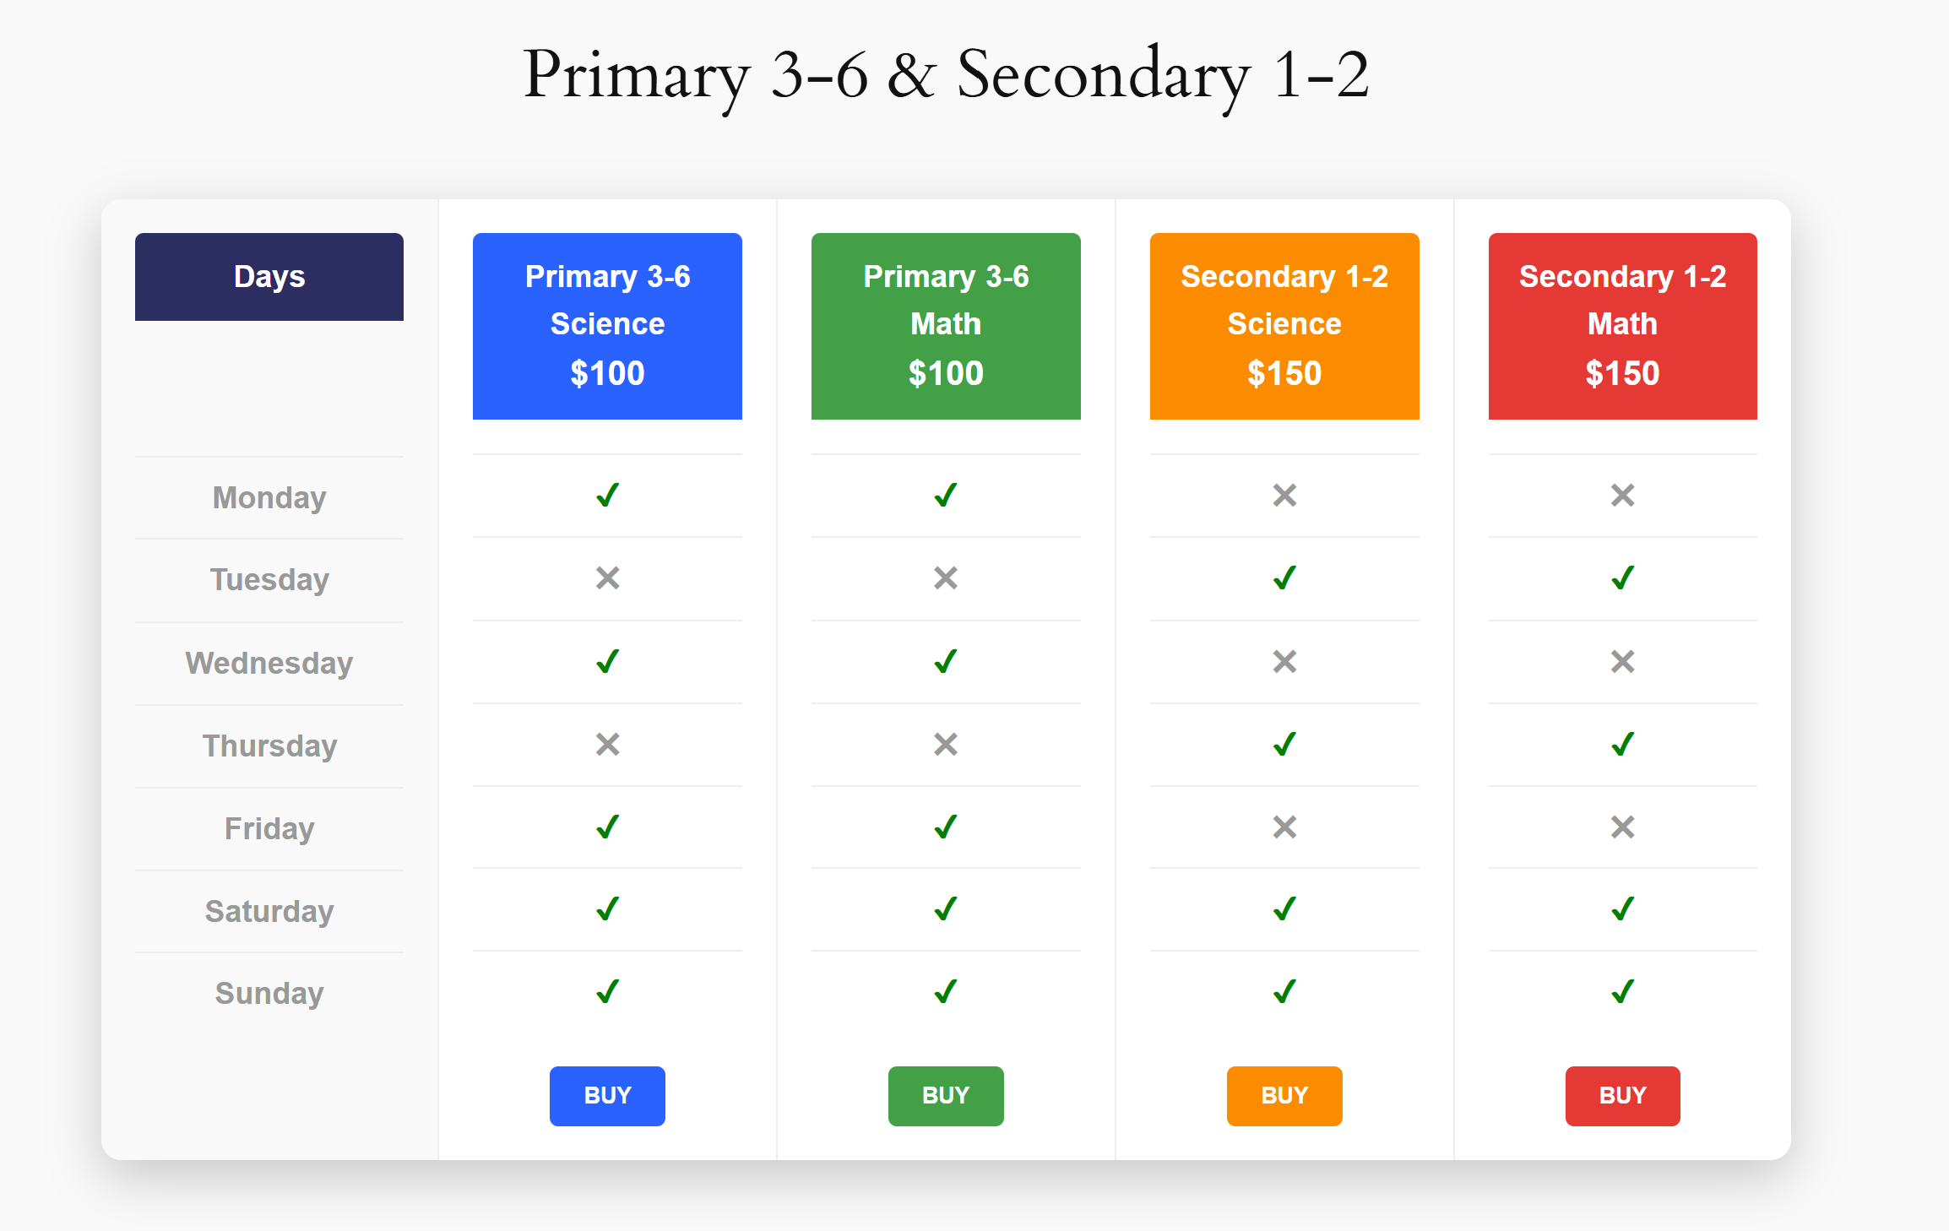  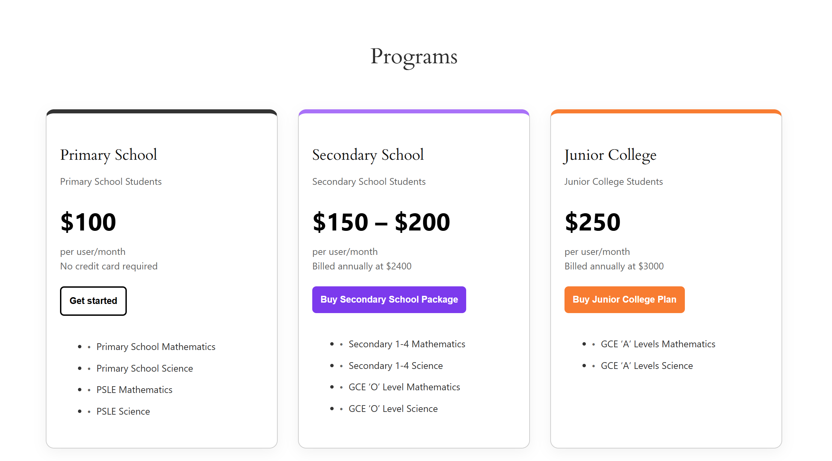  Learning Activities & Resources – PHP Code:  Using a PHP extension theme to display estate properties allows developers to dynamically generate and manage real estate listings with customizable layouts and data integration. PHP enables the theme to pull property data from databases—such as price, location, images, and amenities—and display them in responsive grids or maps. Developers can create reusable templates for property pages and filter systems for search by type, budget, or area. With custom PHP functions and short-codes, property listings can be automatically updated and easily embedded across pages. This approach provides flexibility, scalability, and automation for professional real estate websites or property management systems.  Practical:  In practical work, creating a ZIP file to upload in WordPress is essential when developing custom plugins or themes. After writing and organizing your PHP, CSS, and JS files into a structured folder, you compress it into a ZIP format using tools like WinRAR, 7-Zip, or your operating system’s built-in option. The ZIP file is then uploaded through the WordPress dashboard under Plugins → Add New → Upload Plugin or Appearance → Themes → Add New → Upload Theme. This method ensures proper installation and compatibility. Packaging your project as a ZIP also simplifies sharing, backup, and deployment across different WordPress sites.  Uploading PHP code as a file extension in WordPress allows developers to extend site functionality through custom plugins or theme functions. Typically, a PHP file is uploaded via FTP or the WordPress theme editor, placed in the /wp-content/plugins/ or /wp-content/themes/ directory. Once uploaded, it can add new features such as custom post types, shortcodes, or API integrations. However, uploading PHP files directly through the WordPress media uploader is not allowed for security reasons. It’s recommended to use proper plugin packaging or a child theme structure. Always verify and test PHP code to prevent syntax errors or security vulnerabilities.  Resources / Links:  Assignment 1 PHP Code: Assignment-1-PHP-Code  Project (Assignment 2):  Trello Link: Link  Github Link: Link  Slack: Link  Presentation & Individual Report: Link  Estimated Hours:  Spent 3 hours working on Project, Assignment 2, Creating Pricing & Schedule Page for Tuition Centre.  Content Insights:  Using WordPress for collaboration allows multiple users to work together on shared projects through roles, permissions, and content management tools. It provides an ideal environment for teamwork, version control, and structured workflows. For Assignment 2, the group might use PHP code to extend functionality—such as adding custom post types, automating tasks, or integrating external APIs  Career/Employability/Learning Insights  - Gained hands-on experience using WordPress as a real-world content management system for collaborative development.  - Learned how PHP code can extend functionality and customize web applications beyond default themes or plugins.  - Developed problem-solving skills through debugging, testing, and improving code performance.  - Strengthened team collaboration by sharing roles, managing tasks, and integrating individual work into one project.  - Improved technical communication, explaining design choices and code functionality to peers.  - Built a stronger understanding of web development workflows, including file management, version control, and deployment.  - Enhanced overall employability through practical, project-based experience in WordPress and PHP development.

Add more rows if necessary

=========================

