Truck Stop Token
Official Whitepaper



https://github.com/MarcusWentz/TruckStopTokenICO

Table of Contents

What is Truck Stop Token?………..…………....3

Why does TST exist?…………………………….4

How do I get TST?………………………………5

Where will it be deployed to?…………………...6

Who gets what token ownership?………………7

TST Tokenomics…………………………………8

Roadmap…………………………………………9

Truck Stop Token Team…..……………………10

What is Truck Stop Token?

Truck Stop Token (TST) is an ERC20 token “disrupting” the blockchain industry. Why? “Because it’s the future, bro.” Plus, we have transparent and fair tokenomics.



Why does TST exist?

Singularity 2045 was inspired to make this token after Strong Man Personal Finance said that bad investments will “have you down at the truck stop for retirement”. TST is a token made for entertainment purposes. If we get a strong following, we can create a DAO for video requests from Strong Man Personal Finance and
J Naugy. For example: Strong Man Personal Finance or J Naugy must make videos on Meet Kevin or Jeremy Lefebvre for 1 week straight.

How do I get TST?

We are planning to launch on Uniswap.
Uniswap is a AMM DEX (automated market maker decentralized exchange). AMM DEXs are built on smart contract blockchains (like Ethereum and Polygon) for financial security and transparency.

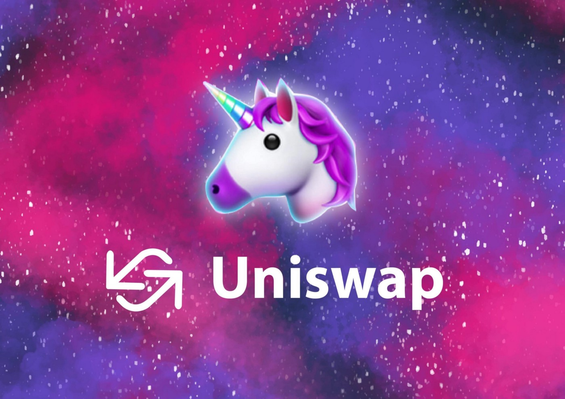

Where will it be deployed to?

We plan to launch TST on Polygon.
We are doing this due to the cheap gas fee prices on Polygon for deploying and interacting with smart contracts.

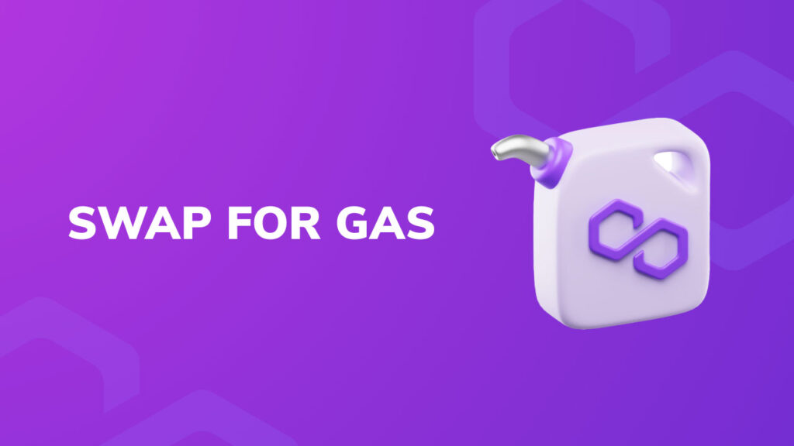

Who gets what token ownership?

Messari’s research suggests that fair token launches have ~80% public token sale.
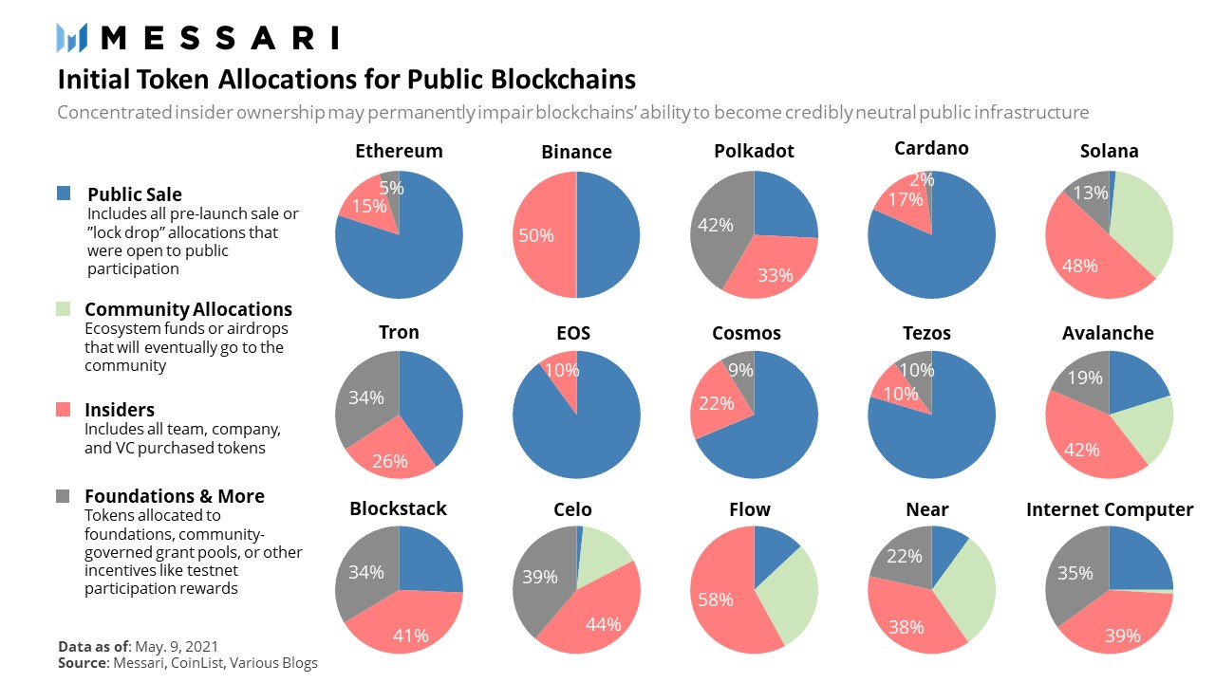

TST Tokenomics

1 Sextillion (10^21) TST tokens will exist.
Out of good faith, we have over 82% TST tokens
open to the public. The remaining TST tokens are held by all 3 co-founders evenly. The co-founders are all long term index fund investors. We like holding long term to prevent capital gains tax events.

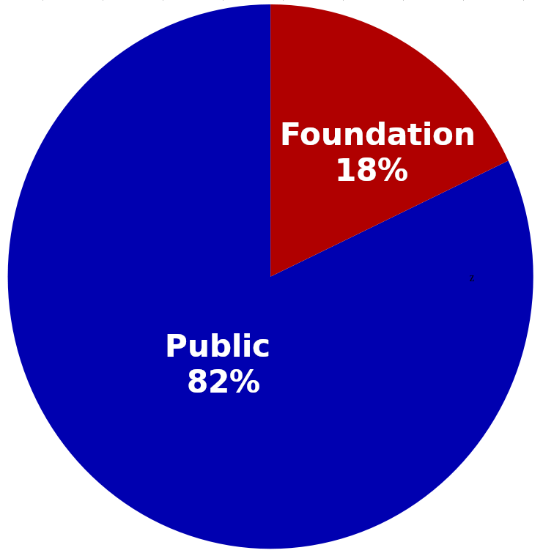
Roadmap


Trading

We plan to list on Uniswap. You will need to switch networks from Ethereum to Polygon on Uniswap and import TST for trading with MATIC.

Video Request DAO

A video request DAO can be made if TST community members would like one.

Truck Stop Token Team

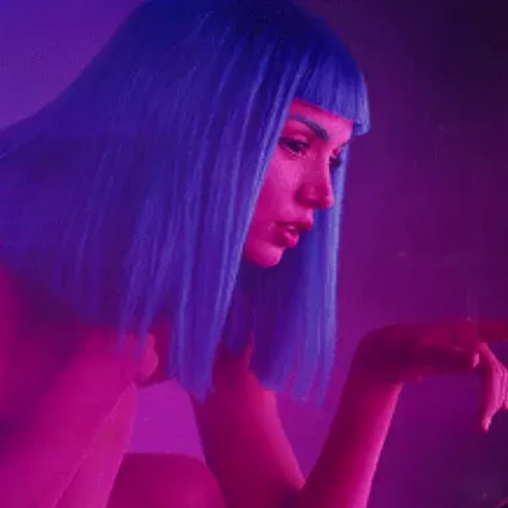

Singularity 2045
Developer and Co-Founder

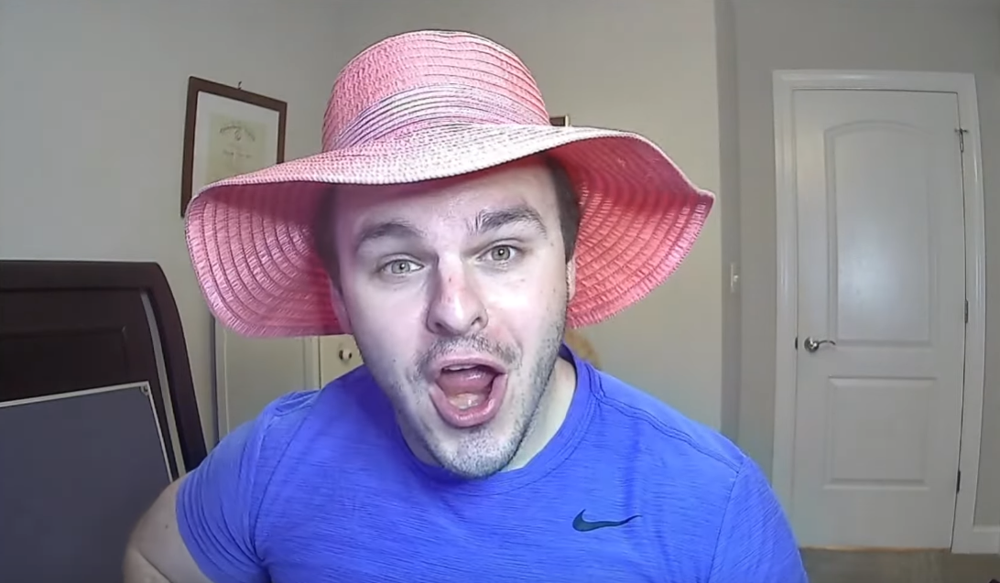

Strong Man Personal Finance
Co-Founder
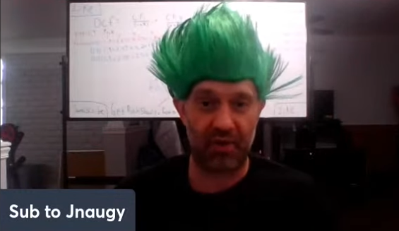

J Naugy
Co-Founder

