Please start by saving this file with the name: GUID_Surname_ENG5059P_Prelim_year

Please tick appropriate project:

ENG5059P (MSc) | √

Student Name | Haoshi Huang
Student GUID Number | 2635088H
Degree programme | Computer Systems Engineering
Working Title of Project | LIPTOR - AI and Machine Vision-based Litter Picking Autonomous Robot
Name of Supervisor(s) | Wasim Ahmad, Prashant Saxena
Academic year | 2022-2023

Introduction (max 1 page)
A remote control web application based on LIPTOR

With the rapid global socio-economic development and the rising standard of living, the amount of waste in the outdoor environment has increased in the great cycle of consumption and production. Therefore, it is necessary to propose an efficient resolution for collecting and sorting litter which can preserve our cities' cleanliness. Generally speaking, traditional waste removal is done manually, which is a time-consuming and laborious task After collecting waste, it still needs to be reclassified. To replace manual work, a road sweeper is proposed by Donati, L. et al.(2020). However, the sweeper still requires human control. Additionally, due to its size not enough small, there are many constraints on the working area.

As we know, robotics automation technology has developed rapidly over decades of years. Meanwhile, machine vision technology in the artificial intelligence field has gradually matured as well. As Satav, A.G. et al. (2023) showed, it is practicable to use deep learning technology to detect the location and type of waste through real-time camera photography and then to pick up the waste and put it into the correct wastebasket with a robotic arm. Based on the above-mentioned content, this project will design a robotic system with the help of machine vision technique, which can move, detect, pick up and sort litter automatically. Moreover, a web application will be developed. When using the application, the Jackal robot can be operated manually remotely and its cameras can also be used to monitor the surrounding area. Overall, four parts need to be developed: autonomous navigation, litter location, litter picking and sorting, and remote control manually.

This paper will focus primarily on designing a Java web application based on the LIPTOR system. The website contains three main functions. The first function is that with network programme technique, corresponding video streaming network protocols are adopted to connect 360-degree cameras and 3D cameras in real-time. By using the 360-degree camera we can observe Jackal's surroundings. By connecting the 3D camera, we can focus more on the current working state of the robot in the waste picking and sorting tasks. The second function is using the joystick or keyboard to manipulate the Jackal, such as its forward, backward, or left and right turns. The third function is the remote manual control of the robot arm.

References:
Donati, L. et al. (2020) ‘An energy saving road sweeper using deep vision for Garbage Detection’, Applied Sciences, 10(22), p. 8146. doi:10.3390/app10228146.

Satav, A.G. et al. (2023) ‘A state-of-the-art review on Robotics in Waste Sorting: Scope and challenges’, International Journal on Interactive Design and Manufacturing (IJIDeM) [Preprint]. doi:10.1007/s12008-023-01320-w.

Aims/Objectives of project
The remote control system based on LIPTOR is designed as a Java Web Application to provide real-time monitoringvideo from a 360-degree panoramic camera and a 3D camera used for garbage sorting. It can also remotely send commands to ROS (Robot Operating System) to control the movement of Jackal (a robotic car) and the actions of robotic arm.
So three functions that will be needed to implement in this Java Web Application:
1.By network programming, we can use network protocols corresponding to the camera (3D camera and 360 degree camera) implement remote connection with cameras to observe the situation around Jackal.
2.Using the joysick or keyboard to control the action of Jackal, such as forward, backward or turn.
3.Sending command to operate robotic arm.
Resources required
Hardware:
An unmanned ground vehicle, Jackal;
A 3D camera, Intel RealSense D455 connected to Jackal;
A 360 degree camera, Ladybug5+/Ladybug6 connected to Jackal;
A DURO GPS locator from SwiftNav connected to Jackal
A robot arm connected to Jackal;

Software:
ROS2 system to control Jackal and its accessories’ action;
Java SDK, Servlet(Core of Java Web Application), Spring frame, VUE(Front frame), git(Version management);

GANTT chart
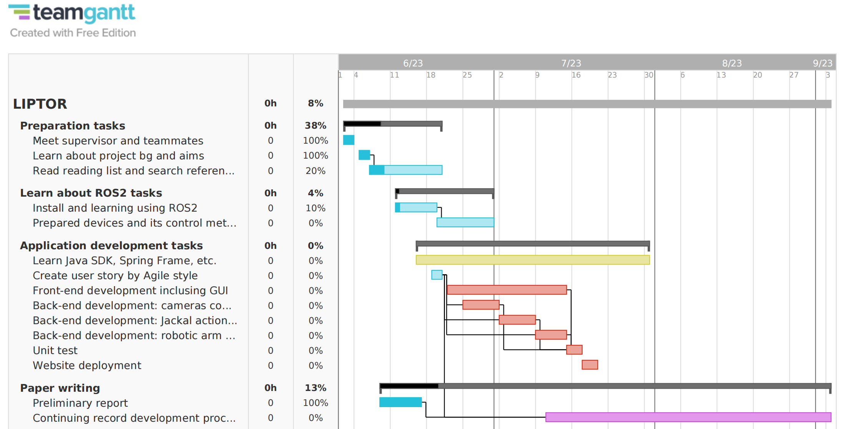

Risk assessment
