Article Title

Abstract
Paper aims:
Originality:
Research method:
Main findings:
Implications for theory and practice:

Keywords: Must be in sentence case. Separated by dot. With a dot in the end.

1. Introduction
Production journal only accepts manuscripts in English. Manuscripts shall have from 4,000 to 8,000 words, including references.
The paper must be in MS Word® format, typed with Times New Roman, size 12 and 1.5 cm of line spacing. Margins superior and inferior with 2.5 cm. Files must not exceed 3 MB.

2. Cover Letter
Submissions must be accompanied by a Cover letter, which must highlight its adherence to the Editorial scope of the journal, theoretical and practical relevance, aims, methods, main results and its original theoretical, empirical and/or methodological contribution.

3. Units, notes, abbreviations, and other such considerations
Units of measurement should always follow the standard defined by the International System (IS). Abbreviations used in the tables, figures, and other objects must be defined below such objects, even if they have previously been defined in the text.
The names of products and equipment must include the trademark symbol (®) and information on the manufacturer name, city and country.
Footnotes are not accepted in this periodical and should always be directly incorporated in the text body.
Please note: In English manuscripts, the decimals must be separated by points/dots (not commas).

4. Tables and equations
Tables should be compiled using the table resources in MS Word®. Tables inserted as images cannot be accepted and will result in delayed evaluation and publication. They shall be numbered sequentially, presenting caption and sources in the manuscript. We will not accept items that are not properly cited in the text and vice versa. Tables for which no sources are cited are understood as originally produced by the authors, and under their responsibility.

Table 1. Table title example.
 | Virtual Cell Layout | Traditional Cell  Layout | Job shop layout
Final Time (h)* | 0 | -23% | +1.5%
Throughput (parts/h) | 0 | -12% | +3%
WIP (parts) | 0 | -27% | +10%
Resource Utilization (%) | 0 | -20% | Equal
Waiting Total Time (h) | 0 | -50% | -10%
Lead Time (h) | 0 | -50% | -7%
*Table footnote example, describing all symbols used in the table.
Equations should always be carefully revised and sequentially numbered whenever necessary. Example:
$A=πr^{2}$ (1)

5. Figures and Illustrations
Images, figures and photographs should always be produced in 300 dpi resolution or higher. Figures should be inserted only in JPEG format. Data displayed must be in English and the smallest font must be legible after insertion in the file text. Figures and illustrations must display a caption and source as well as be referenced in the text. We will not accept figures that are not properly cited in the text and vice versa.
Figures for which no sources are cited are understood as originally produced by the authors, and under their responsibility.
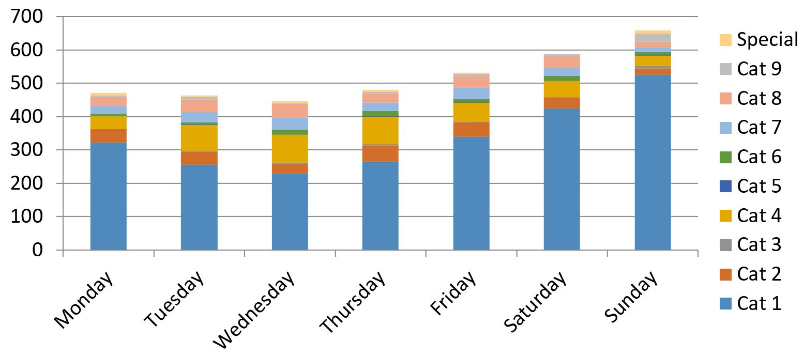
Figure 1. Figure caption example. Source: Lima (2019).

6. Citations
Production journal adopts the citation and reference style of the American Psychological Association - APA. The complete policy and tutorials can be found at http://www.apastyle.org.
Citations in the text body should follow the author-date citation system, that is, notes in the text should only indicate the author’s surname and year of publication.
Direct citations (verbatim transcript of the consulted paper) should be within the body text in double quotation marks. In these cases, the page(s) of the source consulted must be specified. In indirect citations, the indication of the page(s) consulted is optional.
Some examples of citations:
• One author: Sayers (1970); (Sayers, 1970).
• Two authors: Moraes & Furuie (2010); (Moraes & Furuie, 2010).
• More than two authors: Ferreira et al. (1984); (Ferreira et al., 1984).
• Citing articles of the same author: Santos (2003a, b; 2007); (Santos, 2003a, b; 2007).

6.1. Reference List
The reference list should be elaborated first alphabetically and then by chronological order, if necessary. Multiple references of the same author in the same year must be identified by letters ('a', 'b' and 'c', etc.) placed after the year of publication, according to the citations in the body text. All the bibliography/literature used and cited in the text must be in the list of references, as well as each reference in the list must be cited in the text.
When preparing your list of references, please note the following:
• Do not use "et al." in references.
• Always use full titles to identify journals.
• Citations from recent literature are preferred.
• Whenever possible, avoid difficult-to-access citations, such as out-of-print or rare books and unpublished materials.
• Avoid using theses, dissertations and other unpublished or under-preparation articles.
Examples:

Journal articles
Herbst-Damm, K. L., & Kulik, J. A. (2005). Volunteer support, marital status, and the survival times of terminally ill patients. Health Psychology, 24, 225-229. http://dx.doi.org/10.1037/0278-6133.24.2.225
Sillick, T. J., & Schutte, N. S. (2006). Emotional intelligence and self-esteem mediate between perceived early parental love and adult happiness. E-Journal of Applied Psychology, 2(2), 38-48. Retrieved from http://ojs.lib.swin.edu.au/index.php/ejap
Ganster, D. C., Schaubroeck, J., Sime, W. E., & Mayes, B. T. (1991). The nomological validity of the Type A personality among employed adults. Journal of Applied Psychology, 76, 143-168. http://dx.doi.org/10.1037/0021-9010.76.1.143

Books
Light, I. (2006). Deflecting immigration: Networks, markets, and regulation in Los Angeles. New York: Russell Sage Foundation.
Shotton, M. A. (1989). Computer addiction? A study of computer dependency [DX Reader version]. Retrieved from http://www.ebookstore.tandf.co.uk/html/index.asp
American Psychological Association, Task Force on the Sexualization of Girls. (2007). Report of the APA Task Force on the Sexualization of Girls. Retrieved from http://www.apa.org/pi/wpo/sexualization.html

Chapter in book
Haybron, D. M. (2008). Philosophy and the science of subjective well-being. In M. Eid & R. J. Larsen (Eds.), The science of subjective well-being (pp. 17-43). New York: Guilford Press.

Events
Muellbauer, J. (2007, September). Housing, credit, and consumer expenditure. In S. C. Ludvigson (Chair), Housing and consumer behavior. Symposium conducted at the meeting of the Federal Reserve Bank of Kansas City, Jackson Hole, WY.

