Org mode example

Marc van der Sluys

Table of Contents
1. Key strokes
2. TODO To do [1/3]
2.1. DONE What to use Org mode for [8/8]
2.2. PROGRESS Add file with simple examples [5/6]
2.2.1. DONE Text style
2.2.2. DONE Task lists and headings [33%]
2.2.3. DONE Links
2.2.4. DONE Table/spreadsheet
2.3. PROGRESS More advanced examples
2.3.1. DONE Equations
2.3.2. ACTIVE Code

Key strokes
- I use lower-case letter a for the A-key.
- I use upper-case letter C- for the Ctrl key, M- for the Alt (meta) key and S- for the Shift key.
  - hence C-c is Ctrl-C, C-c C-c is twice that and C-M-a means simultaneously press Ctrl, Alt and A.
  - note that you can type e.g. C-c C-x C-l without releasing the Ctrl key (i.e., keep Ctrl pressed while typing c x l).
- ENTER, TAB and ESC are the keys you'd expect.
- Got confused? Press ESC ESC ESC and you should be good to start typing again.
- See also http://pub.vandersluys.nl/download/GettingStartedWithEmacs.pdf (in particular section 1.2 and the start of 1.3)

TODO To do [1/3]

DONE What to use Org mode for [8/8]
- [✓] note taking, personal wiki, writing documentation
- [✓] the brainstorm phase of a project, paper:
  - Overview in Org mode
  - then export to LaTeX to finish
- [✓] clock tasks, projects
- [✓] agenda, planning, task lists (TODO/PROGRESS/DONE), issues (OPEN/ASSIGNED/CLOSED), idea lists, …
- [✓] (internal) links
- [✓] tables, simple spreadsheets
- [✓] export, publish: plain text (ASCII, UTF-8), html, md, LaTeX/PDF (+Beamer!), odt, reST, …
- [✓] equations, code

PROGRESS Add file with simple examples [5/6]

DONE Text style
- bold
- italics
- underlined
- strike through
- code or verbatim

DONE Task lists and headings [33%]
- [✓] see 2
- [✓] indent:
  - put the cursor on an item (e.g. in this list) and press Alt-arrow right/left
  - same for headers
- [ ] drag:
  - put the cursor on an item and press Alt-arrow up/down
  - up/down swaps items (with the same indentation and if possible)
  - the same for headers (of the same level)
- [ ] change list symbols:
  - put the cursor on an item and press Shift right/left
  - symbols change between +/-/*/1./1) (* if possible)
- [✓] (de)select item (radio button):
  - put the cursor on the item and press C-c C-c
  - the number or percentage in the parent header (created by typing [/] or [%]) changes as well
- [ ] change TODO:
  - put the cursor on a header and press Shift right/left
  - if all subheaders are DONE, the parent header changes from TODO to DONE as well
- [ ] new item in a list:
  - Alt-ENTER
- [ ] new header in a document:
  - Ctrl-ENTER
- [ ] Create new list
  - Enumerated:
    - type 1. or 1) followed by a space and the description
    - press Alt-ENTER for the next item (counts automatically)
  - Bullets (unnumbered):
    - type a +, - or (if subitem) * followed by a space and the description
    - press Alt-ENTER for the next item with the same symbol
  - Definition:
Definition
a definition is an unnumbered item with a keyword, followed by a double colon (::) and the definition.
(no term)
Alt-ENTER asks for the next definition with the same symbol
  - Check box/Radio button:
    - type an item symbol or number, followed by a space, [ ], another space and the description
    - the [ ] lights up to show that the check box is active
    - Alt-ENTER produces a new item, but no empty check box (bug?)
    - C-c C-c on the line toggles between [ ] and [X]

DONE Links
- Internal link: see 2
- External link: https://github.com/MarcvdSluys/
- External link with description: My GitHub page

DONE Table/spreadsheet
- type |- TAB for a horizontal line
- type x|x^2|x^3 TAB in the new line for the header
- type - right against the | for another line
- in the left column, type 1 ENTER 2 ENTER etc.
- under x2, type =$1**2 TAB. $1 represents column 1.
- under x3, type =$1**3 TAB
- go to the line with TBLFM (table formula) under the table and press C-c C-c
x | x2 | x3
1 | 1 | 1
2 | 4 | 8
3 | 9 | 27
4 | 16 | 64
5 | 25 | 125

PROGRESS More advanced examples

DONE Equations
LaTeX must be installed to display formatted equations in emacs.
- Lazy symbols outside equations using inline \LaTeX, like ∫, ∞ and ∇ɸ will show up nicely in \LaTeX.
- inline: type $\int_0^\infty \frac{\sin x}{x} dx$ and press C-c C-x C-l to display in emacs. This is a nice equation $\int_0^\infty \frac{\sin x}{x} dx$, but complicated.
- between the lines: type \[\int_0^\infty \frac{\sin x}{x} dx\] and press C-c C-x C-l to display in emacs. \[\int_0^\infty \frac{\sin x}{x} dx\]

ACTIVE Code
- Elisp always works?
- Elisp (emacs lisp script)
  - press C-c C-, s for a #+begin/end_src-block and add elisp yourself
  - type some code and return a value (see example below)
  - in the code block, press C-c C-c and answer the question in the minibuffer below with yes ENTER
  - the result appears in a RESULTS block under the code, a bit like in a Jupyter notebook.
(concat (emacs-version)
"\nOrgmode " (org-version))
GNU Emacs 27.2 (build 1, x86_64-pc-linux-gnu, GTK+ Version 3.24.29, cairo version 1.16.0)
of 2021-10-01
Orgmode N/A
- Bash
Bash must be installed and Babel must be activated for Bash…
echo "My home directory is $HOME"
My home directory is /home/sluys
- Python
Python must be installed and Babel must be activated for Python…
  - press C-c C-, s for a #+begin/end_src-block and type python yourself
  - type some code and return a value
  - In the code block, press C-c C-c and answer the question in the minibuffer below with yes ENTER
  - the return value appears below the code in a RESULTS block
Listing 2.3.1:
x=3
y=5
z=x*y
return z
15
import numpy as np
import matplotlib.pyplot as plt
x = np.linspace(-15,15)
plt.plot(x, np.sin(x)/x)
plt.savefig('Orgmode_example.png')
return 'Orgmode_example.png' # Return filename to Org mode
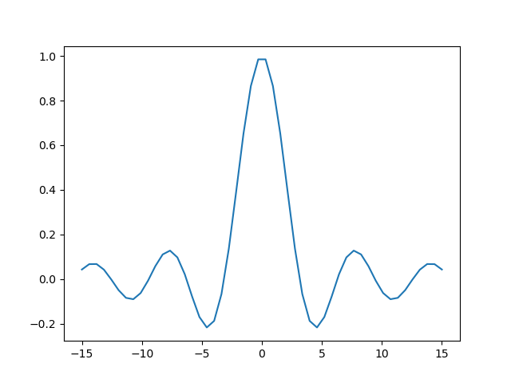
- Python + Bash
  - Nicked from https://jherrlin.github.io/posts/emacs-orgmode-source-code-blocks/
Print a list with a selection of files in the current directory in bash. I will export both (both) the code and the result (to e.g. .md or .pdf). Also, I will give the code a name (ls) so that the output can be used later:
Listing 2.3.2:
ls -lb Orgmode_example.*
-rw-r--r-- 1 sluys sluys 9465 Dec 16 20:49 Orgmode_example.md
-rw-r--r-- 1 sluys sluys 37346 Dec 16 20:40 Orgmode_example.odt
-rw-r--r-- 1 sluys sluys 7945 Dec 16 20:48 Orgmode_example.org
-rw-r--r-- 1 sluys sluys 321341 Dec 16 20:49 Orgmode_example.pdf
-rw-r--r-- 1 sluys sluys 23293 Dec 16 20:50 Orgmode_example.png
-rw-r--r-- 1 sluys sluys 9647 Dec 16 20:41 Orgmode_example.rst
-rw-r--r-- 1 sluys sluys 12381 Dec 16 20:49 Orgmode_example.tex
-rw-r--r-- 1 sluys sluys 9178 Dec 16 20:41 Orgmode_example.txt
Use awk to take the file names and sizes from ls and create a table:
Listing 2.3.3:
BEGIN { OFS="|" }; { print $5, $9}
9465 | Orgmodeexample.md
37346 | Orgmodeexample.odt
7945 | Orgmodeexample.org
321341 | Orgmodeexample.pdf
23293 | Orgmodeexample.png
9647 | Orgmodeexample.rst
12381 | Orgmodeexample.tex
9178 | Orgmodeexample.txt
Use Python to o.a. find the smallest and largest file in the table from awk:
print(table[0]) # First row of the table as read
print("Number of files: %i" % len(table))
print("Smallest file: (%i b) %s" % tuple(min(table)))
print("Largest file: (%i b) %s" % tuple(max(table)))
print("Total size: %0.3f kb" % (sum([x for x,y in table]) / 1000))
[9465, 'Orgmode_example.md']
Number of files: 8
Smallest file: (7945 b) Orgmode_example.org
Largest file: (321341 b) Orgmode_example.pdf
Total size: 430.596 kb

