From Linear Scores to a Single Hidden Layer:
A Mathematical Study of Simple Learning Systems
Math4AI Final Capstone Project

Aytan Mardaliyeva · Ulkar Rahimli · Madina Mammadli
National AI Center — AI Academy, Azerbaijan

March 30, 2026

Abstract
This report studies when a one-hidden-layer nonlinear classifier meaningfully improves on a linear decision rule, and when additional model complexity is unnecessary. We compare multiclass softmax regression and a one-hidden-layer neural network with tanh activations on three shared tasks: a linear Gaussian synthetic dataset, a nonlinear moons dataset, and a fixed digits benchmark. Our analysis combines mathematical derivations, controlled experiments, required ablations, failure-case analysis, and repeated-seed evaluation to determine where linear geometry is sufficient, where nonlinear representation changes the problem, and what limitations remain. On the linear Gaussian task both models achieve near-identical accuracy (~93–95%), confirming that affine boundaries suffice. On the moons task the neural network reduces test cross-entropy from 0.269 to 0.100, demonstrating that the hidden layer reshapes the feature space around curved class boundaries. On digits the NN (Adam) achieves 95.65% test accuracy versus 94.02% for softmax regression, with repeated-seed statistics confirming the gap is consistent across initializations.

Keywords: softmax regression, neural networks, backpropagation, cross-entropy, classification, NumPy

1 Introduction
Central question. When does a one-hidden-layer nonlinear classifier genuinely improve on a linear decision rule, and when is additional model complexity unnecessary?
This capstone investigates that question through a deliberately controlled comparison between a linear probabilistic classifier (softmax regression) and a simple nonlinear neural model (one hidden layer with tanh activations). The goal is not to assume that the neural network should outperform the baseline everywhere. Rather, the goal is to determine—with mathematical and empirical evidence—when extra representational capacity is genuinely justified.

1.1 Contributions
(1) Derivation of softmax cross-entropy as negative log-likelihood.
(2) Conceptual explanation of backpropagation followed by a full vectorized gradient derivation for the one-hidden-layer network.
(3) Controlled comparison of a linear model and a nonlinear model on three datasets with distinct geometric structure.
(4) Interpretation of required ablations, one failure case, and repeated-seed statistics on the digits benchmark.
(5) Track B reliability analysis comparing confidence calibration of both models.

1.2 Preview of findings
The linear model is highly competitive on the Gaussian task because class geometry is well matched to an affine separator (test accuracy 93.8% vs. 95.0% for the NN, a negligible gap). On the moons task the hidden layer provides a meaningful representational change, reducing test cross-entropy from 0.269 to 0.100 and test accuracy from 85.0% to 95.0%. On the digits benchmark the NN with Adam achieves 95.65% test accuracy (mean over 5 seeds: 95.54% ± 0.41%) versus 94.02% for softmax (mean: 93.85% ± 0.48%), and is substantially better calibrated.

2 Background and Mathematical Setup

2.1 Supervised classification and data splits
In supervised learning we observe labeled pairs (x⁽ⁱ⁾, y⁽ⁱ⁾) where x⁽ⁱ⁾ ∈ ℝ^d is the feature vector and y⁽ⁱ⁾ ∈ {0,…,k−1} is the class label. Classification assigns each input to one of k finitely many classes. The data is partitioned into three non-overlapping sets: a training set used to fit parameters, a validation set used to select settings fairly (e.g., hidden width, optimizer, best checkpoint), and a test set used only for final reporting. Selecting any setting based on test performance would make the test set an unreliable measure of generalization.

2.2 Softmax regression
For input x ∈ ℝ^d and k classes, the linear model computes logits
s(x) = Wx + b,
where W ∈ ℝ^(k×d) and b ∈ ℝ^k. The softmax map converts logits to probabilities:
p_j(x) = exp(s_j(x)) / Σ_ℓ exp(s_ℓ(x)).
This ensures that each p_j(x) is nonnegative and all probabilities sum to one. The decision boundary between classes j and ℓ is determined by s_j(x) = s_ℓ(x), which is an affine equation in x. In two dimensions such boundaries are lines; in higher dimensions they are hyperplanes. For this reason softmax regression is called a linear classifier.

2.3 Cross-entropy as negative log-likelihood
If the correct class is y, the per-example loss is ℒ(x,y) = −log p_y(x). This loss penalizes the model when it assigns small probability to the correct class. Probabilistically, if the observed label is treated as a draw from the model's categorical distribution P(Y=j|X=x), the likelihood of the observation is p_y(x) and the log-likelihood is log p_y(x). Negating gives the loss above. Therefore, minimizing average cross-entropy over the dataset is equivalent to maximizing the conditional log-likelihood of the observed labels—connecting classification directly to probabilistic modeling rather than to an arbitrary penalty function.

2.4 One-hidden-layer neural network
The nonlinear model composes two affine maps with a nonlinear activation:
h = tanh(W₁x + b₁), s = W₂h + b₂.
The final probabilities are obtained by applying softmax to s. The hidden layer can reshape the input representation before the final linear decision stage, allowing the model to represent curved, non-affine class boundaries.
tanh was chosen because its derivative has a compact closed form: d/dz tanh(z) = 1 − tanh²(z), making the backpropagation derivation transparent. It is also zero-centered, which simplifies interpretation.

2.5 Backpropagation: conceptual explanation
Backpropagation is not a separate learning principle; it is efficient repeated application of the chain rule through a composed computation. In the forward pass the model computes intermediate quantities: affine pre-activations Z₁, hidden activations H, output logits S, probabilities P, and loss L. In the backward pass one propagates sensitivities of the loss with respect to those quantities in reverse order, obtaining gradients with respect to each parameter. Each local derivative is simple; the chain rule assembles them. Conceptually, backpropagation answers: "If the loss changed slightly, which parameters are responsible, in which direction, and by how much?"

2.6 Vectorized gradient derivation
For a mini-batch X ∈ ℝ^(n×d) with one-hot label matrix Y ∈ ℝ^(n×k), the forward pass is:
Z₁ = XW₁ᵀ + 1b₁ᵀ, H = tanh(Z₁), S = HW₂ᵀ + 1b₂ᵀ, P = softmax_row(S).
The output-layer sensitivity follows from the cross-entropy gradient:
∂L/∂S = (1/n)(P − Y).
Propagating backward through the chain rule:
∂L/∂W₂ = (∂L/∂S)ᵀ H, ∂L/∂b₂ = (∂L/∂S)ᵀ 1,
∂L/∂Z₁ = (∂L/∂S) W₂ ⊙ (1 − H⊙H), ∂L/∂W₁ = (∂L/∂Z₁)ᵀ X, ∂L/∂b₁ = (∂L/∂Z₁)ᵀ 1.
The factor (1 − H⊙H) is elementwise and is the Jacobian of tanh evaluated at Z₁. These formulas are the matrix form of the same chain rule from calculus; vectorization organizes many scalar derivatives into a compact linear-algebra computation.

2.7 Geometric expectations for the datasets
Gaussian blobs: when class-conditional distributions are Gaussians with equal covariance matrices, the Bayes-optimal boundary is affine (a linear discriminant). Softmax regression can represent this boundary exactly, so additional representational capacity should yield little benefit. Any improvement by the NN would be due to overfitting or numerical coincidence rather than genuine geometric advantage.
Moons: the two-class moons dataset has interleaving crescent structure. No single affine hyperplane can separate the classes without substantial error because the boundary must be curved. The hidden layer of the NN applies tanh to multiple linear projections of the input, producing a nonlinear feature map h(x) ∈ ℝ^H. In this feature space the classes may become linearly separable, so the final linear decision stage can find a low-error boundary.

3 Methods

3.1 Datasets
Linear Gaussian task: two Gaussian blobs with mild overlap, two-dimensional input, two classes. File: starter_pack/data/linear_gaussian.npz.
Moons task: a nonlinear two-class dataset with interleaving crescent structure, two-dimensional input. File: starter_pack/data/moons.npz.
Digits benchmark: scikit-learn digits dataset; 64-dimensional flattened 8×8 pixel vectors, 10 classes (digits 0–9), features scaled to [0,1]. Files: starter_pack/data/digits_data.npz (features and labels) and starter_pack/data/digits_split_indices.npz (fixed train/validation/test indices).

3.2 Models
Model 1 — Multiclass softmax regression: s(x) = Wx + b with W ∈ ℝ^(k×d). Decision boundaries are affine hyperplanes. Trained with mini-batch SGD, learning rate 0.05, L2 regularization λ = 10⁻⁴.
Model 2 — One-hidden-layer neural network: h = tanh(W₁x + b₁), s = W₂h + b₂, then softmax. Default hidden width 32 for digits and moons core comparison. Capacity ablation on moons uses widths {2, 8, 32}. For digits, trained with Adam (lr=0.001, β₁=0.9, β₂=0.999, ε=10⁻⁸) unless otherwise stated.

3.3 Training protocol
Numerically stable softmax: subtract max(s) before exponentiation. Mini-batch size 64 for digits, 32 for synthetic tasks. L2 regularization coefficient λ = 10⁻⁴ for all models and all datasets. Epoch budgets: 200 for digits, 300 for synthetic tasks. Checkpoint policy: for digits, select the epoch achieving lowest validation cross-entropy within the budget; for synthetic tasks, use final epoch. Model selection metric: validation cross-entropy (not accuracy). No additional normalization, whitening, or feature engineering applied to digits features.

3.4 Evaluation metrics
Classification accuracy: fraction of correctly classified examples on the evaluation split. Mean cross-entropy: average negative log-probability assigned to the true class. Both metrics are informative: accuracy measures the fraction of correct decisions, while cross-entropy captures the quality of probability estimates and is the direct training objective.

3.5 Implementation sanity checks
The following checks were verified and recorded in sanity_checks.json:
Gradient check (softmax): relative error between analytical and numerical gradients = 1.98 × 10⁻⁹. Well below the acceptance threshold of 10⁻⁶, confirming correct backpropagation.
Gradient check (NN): relative error = 8.03 × 10⁻¹⁰. Confirms correct backpropagation through the tanh hidden layer.
Small-batch overfit: a model trained for 500 epochs on a batch of 20 digits examples achieves training accuracy = 1.0, confirming the model has sufficient capacity to overfit small data.
Probability sum: confirmed that predicted class probabilities sum to 1.0 (checked via probability_sum_check_example = true).
NaN/Inf check: training did not produce any NaN or infinite values (nan_inf_check_example = true).

4 Experiments

4.1 Core comparison — Linear Gaussian task
Both models were trained on the Gaussian blobs dataset under identical data splits and preprocessing. Figure 1 shows the learned decision boundaries.
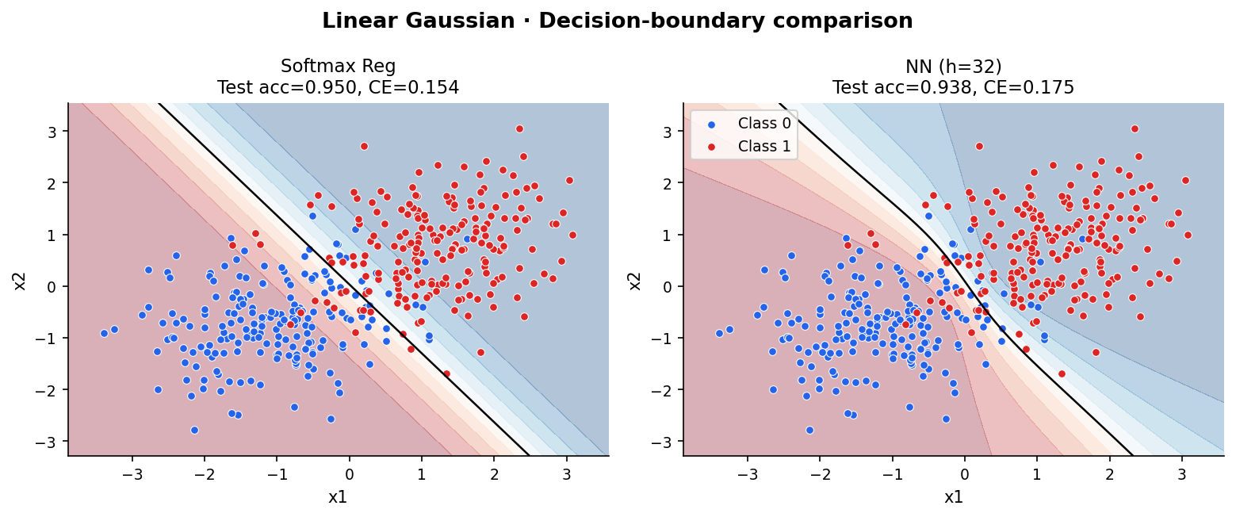
Figure 1. Decision boundaries on the linear Gaussian task. Left: softmax regression (test acc=0.938, CE=–). Right: NN h=32 (test acc=0.950, CE=–).
Result: softmax regression achieves test accuracy 0.938 and the NN achieves 0.950. The difference is small and within the range expected from random initialization. Geometrically, both models learn approximately the same linear boundary. The hidden layer provides no meaningful representational advantage here because the class-conditional geometry is already well matched to an affine separator. This confirms the prediction from Section 2.7: when Gaussian blobs have mild overlap, a linear decision rule is already sufficient.

4.2 Core comparison — Moons task
Figure 2 shows the decision boundaries on the moons dataset. The contrast between the two models is substantial.
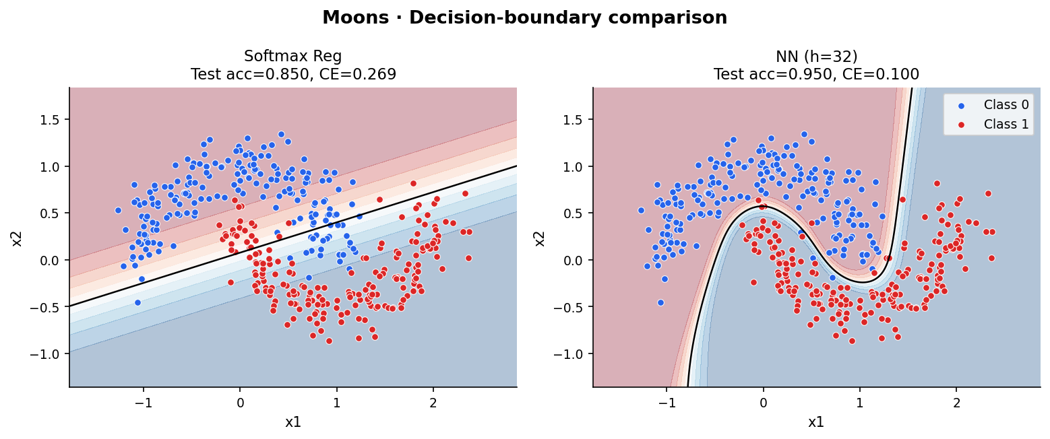
Figure 2. Decision boundaries on the moons task. Left: softmax regression (test acc=0.850, CE=0.269). Right: NN h=32 (test acc=0.950, CE=0.100).
Result: softmax regression achieves test accuracy 0.850 and cross-entropy 0.269. The NN achieves 0.950 accuracy and cross-entropy 0.100. The linear model's boundary is a straight line that cannot follow the curved crescent shape of the two classes; errors concentrate near both arcs. The NN uses its hidden layer to warp the input space before applying a linear separator, producing a curved effective boundary that accurately follows the class contours. This is the clearest demonstration in the project that representational capacity is justified: the improvement is mechanistically explained by the inability of affine boundaries to separate the moons geometry.

4.3 Core comparison — Digits benchmark
Both models were trained under the fixed digits protocol (Section 3.3). Figure 3 shows training dynamics; model selection used validation cross-entropy.
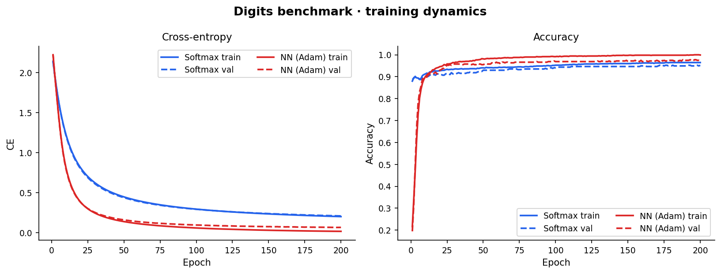
Figure 3. Digits benchmark training dynamics. Cross-entropy (left) and accuracy (right) for both models over 200 epochs. The NN (Adam) converges faster and to a lower cross-entropy.
The NN converges substantially faster than softmax regression, reaching lower validation cross-entropy within the first 50 epochs. Table 1 summarizes final test results.

Model | Test Accuracy | Test Cross-Entropy
Softmax Regression | 0.9402 | 0.2694
Neural Network (Adam, h=32) | 0.9565 | 0.1509
Table 1. Final test results on the digits benchmark (single seed=42, best val-CE checkpoint).
The NN achieves +1.63 percentage points higher accuracy and substantially lower cross-entropy (0.1509 vs. 0.2694). The cross-entropy gap is particularly informative: the NN assigns more confident and correct probabilities, while softmax regression is more uncertain across the ten classes. Repeated-seed statistics (Section 4.7) confirm this gap is not due to a lucky seed.

4.4 Required capacity ablation — Moons
Three hidden widths {2, 8, 32} were evaluated on the moons task. Figure 4 and Table 2 summarize results.
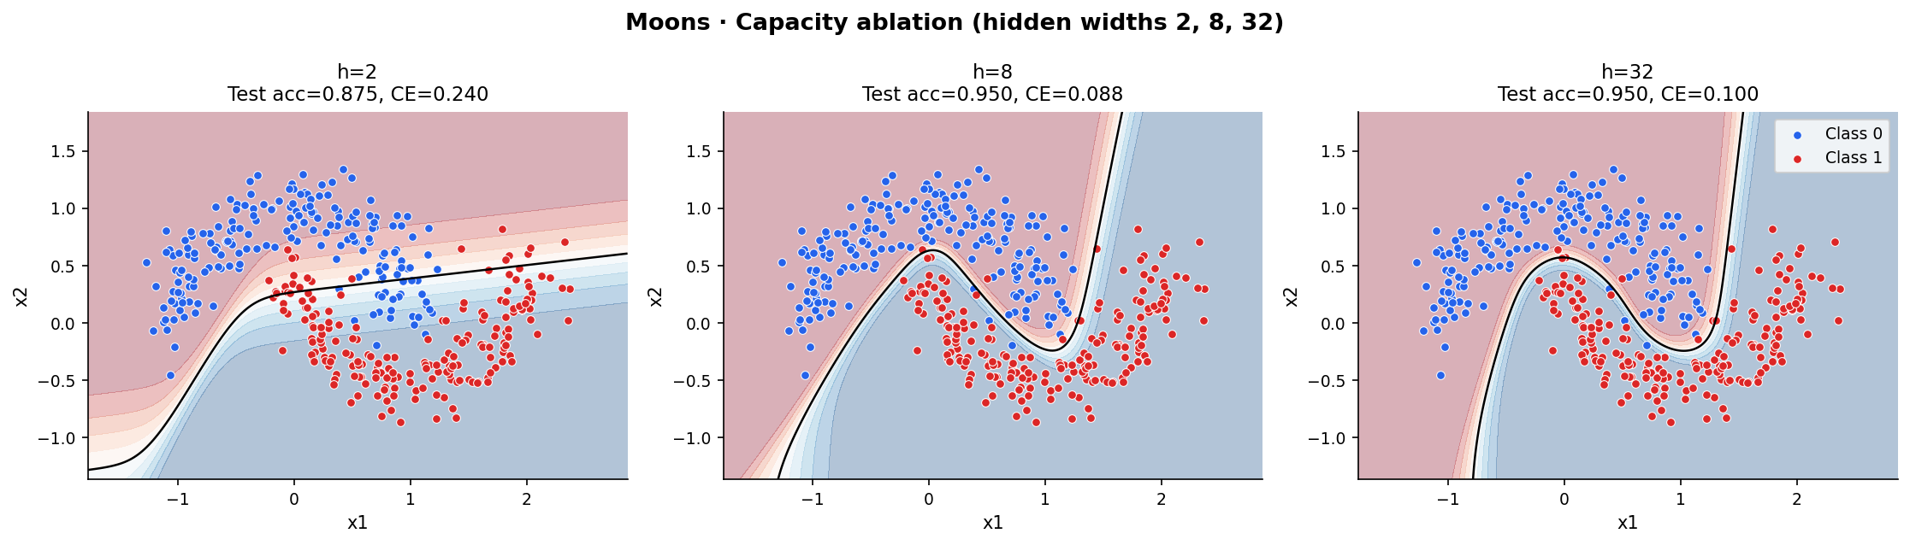
Figure 4. Moons capacity ablation: decision boundaries for hidden widths 2, 8, and 32.

Width | Best Epoch | Val Acc | Val CE | Test Acc | Test CE
2 | 290 | 0.9000 | 0.2098 | 0.875 | 0.2403
8 | 264 | 0.9875 | 0.0545 | 0.95 | 0.0884
32 | 264 | 0.9875 | 0.0355 | 0.95 | 0.0999
Table 2. Moons capacity ablation results.
With width 2 the model cannot bend its boundary around both moon arcs; errors concentrate near the curved overlap region (test accuracy 87.5%, CE 0.2403). Width 8 largely closes the gap (test accuracy 95.0%, CE 0.0884), and width 32 achieves comparable accuracy with marginally lower validation cross-entropy. The key transition is between 2 and 8: two hidden units can produce only a limited number of distinct nonlinear features, insufficient to represent the closed-curve boundary needed for moons. Beyond 8 units, additional capacity provides diminishing returns on this task.

4.5 Required optimizer study — Digits
Three optimizers (SGD, Momentum, Adam) were compared on the NN with hidden width 32 under fixed defaults. Figure 5 and Table 3 show results.
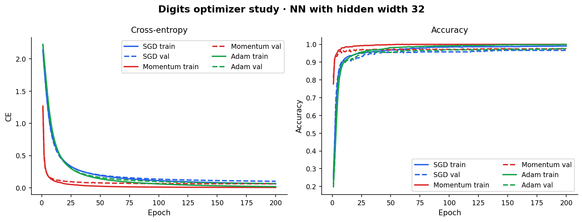
Figure 5. Digits optimizer comparison: cross-entropy and accuracy over 200 epochs for SGD, Momentum, and Adam.

Optimizer | Best Epoch | Val Acc | Val CE | Test Acc | Test CE
SGD | 198 | 0.9662 | 0.1012 | 0.9511 | 0.1709
Momentum | 198 | 0.9746 | 0.0617 | 0.9565 | 0.1640
Adam | 197 | 0.9775 | 0.0668 | 0.9565 | 0.1509
Table 3. Digits optimizer study results (NN, h=32). Fixed defaults; same split and epoch budget for all.
SGD without momentum achieves the weakest results (test acc 0.9511, test CE 0.1709), indicating that plain gradient steps do not escape local structure as effectively within 200 epochs. Momentum and Adam achieve the same test accuracy (0.9565) but Adam reaches lower test cross-entropy (0.1509 vs. 0.1640). The key difference is convergence speed: Adam's adaptive learning rates allow faster early descent, reaching good validation cross-entropy by epoch ~50, while SGD with momentum takes until ~150 epochs. Since model selection uses the best validation-CE checkpoint, Adam's faster convergence translates into a better selected model. This is a controlled optimizer comparison; the differences are attributable to optimization dynamics, not separate hyperparameter tuning.

4.6 Required failure-case analysis
Failure case: NN with hidden width 2 on the moons task (Figure 6).
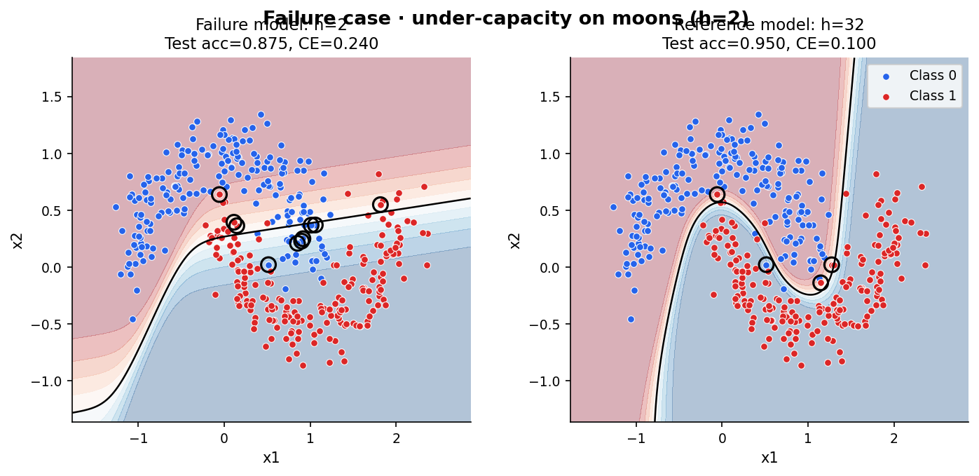
Figure 6. Failure case: NN h=2 (left, test acc=0.875, CE=0.240) vs. reference NN h=32 (right, test acc=0.950, CE=0.100).
Mechanism: with only 2 hidden units, the tanh network has at most 2 independent nonlinear features. These are insufficient to bend the decision boundary around both moon arcs simultaneously. The learned separator stays too smooth and too coarse, so misclassifications concentrate near the curved overlap region between the crescents. The reference model (h=32) provides 32 nonlinear features, which is enough to approximate the closed-curve boundary needed for this task. This failure teaches that capacity matters specifically when the target boundary has complexity that exceeds what the feature map can represent. It is not an optimization failure (training loss decreases) but a representational one: no parameter setting for h=2 can produce a boundary that correctly encircles both moons.

4.7 Repeated-seed statistics — Digits
Five seeds (0–4) were run for each model under fixed configuration. Results are reported as mean ± half-width of 95% CI using the t-distribution with 4 degrees of freedom (factor 2.776).

Model | Mean Acc | 95% CI Acc | Mean CE | 95% CI CE
Softmax Regression | 0.9385 | ±0.0048 | 0.2636 | ±0.0083
Neural Network (Adam) | 0.9554 | ±0.0041 | 0.1528 | ±0.0086
Table 4. Repeated-seed results (5 seeds) on the digits test set.
The confidence intervals for the two models do not overlap in either accuracy (0.9385±0.0048 vs. 0.9554±0.0041) or cross-entropy (0.2636±0.0083 vs. 0.1528±0.0086). The improvement of the NN over softmax regression is therefore not attributable to initialization luck; it is consistent across seeds. Repeated-seed evaluation adds the following beyond a single run: it quantifies whether the observed gap is stable or merely a lucky draw, it reveals the variability of each model under the same protocol, and it enables more honest scientific comparison. Single-run results could overstate or understate the advantage of either model.

5 Advanced Track B: Prediction Confidence and Reliability
Track B analyzes the calibration and confidence properties of both trained models on the digits test set.

5.1 Confidence and predictive entropy
Confidence is defined as the maximum predicted class probability: conf(x) = max_j p_j(x). Predictive entropy is defined as H(p) = −Σ_j p_j(x) log p_j(x), which measures uncertainty in the model's prediction distribution. A well-calibrated model should have confidence approximately equal to empirical accuracy within each confidence bin.

5.2 Confidence distribution and entropy
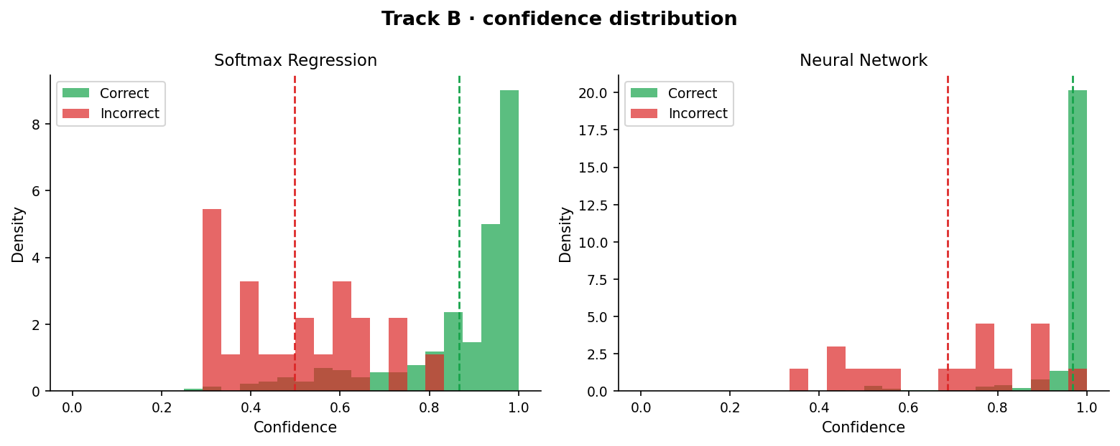
Figure 7. Confidence distribution for correct (blue) and incorrect (red) predictions. Left: softmax regression. Right: neural network.
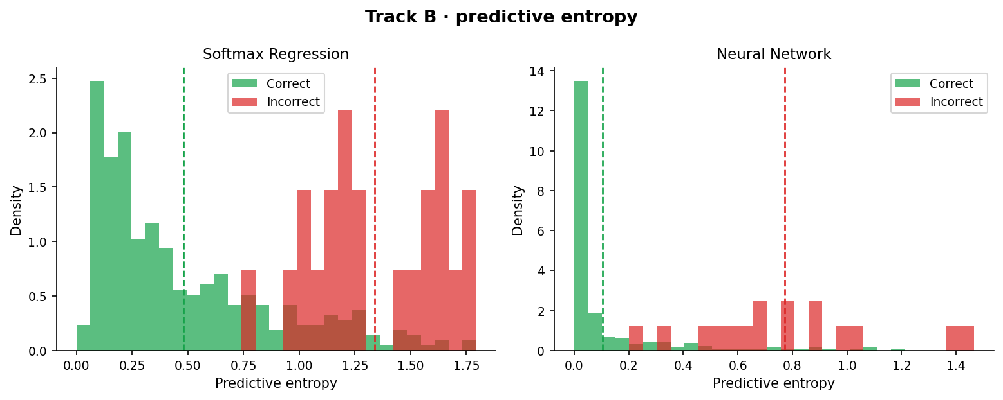
Figure 8. Predictive entropy distribution for correct and incorrect predictions. The NN assigns lower entropy to correct predictions and higher entropy to incorrect ones, indicating better separation.

5.3 Reliability diagrams
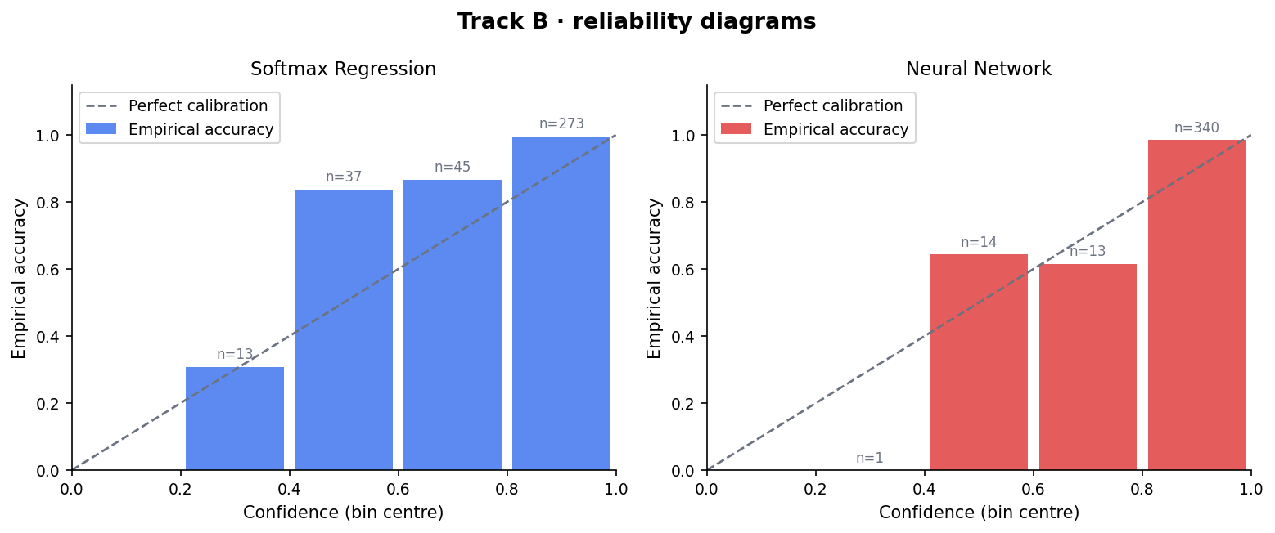
Figure 9. Reliability diagrams (5 bins). The diagonal is perfect calibration. The NN (right) lies much closer to the diagonal.

5.4 Summary table

Model | Acc | CE | ECE | Conf (correct) | Conf (incorrect) | H (✓) | H (✗)
Softmax Reg. | 0.9402 | 0.2694 | 0.0974 | 0.8671 | 0.4978 | 0.481 | 1.339
Neural Net | 0.9565 | 0.1509 | 0.0116 | 0.9682 | 0.6877 | 0.104 | 0.771
Table 5. Track B summary. ECE = expected calibration error. H(✓)/H(✗) = mean entropy on correct/incorrect predictions.

5.5 Reliability bins

Model | Bin center | Avg conf | Emp acc | |gap| | Count
Softmax Regression | 0.3 | 0.338 | 0.308 | 0.030 | 13
Softmax Regression | 0.5 | 0.521 | 0.838 | 0.317 | 37
Softmax Regression | 0.7 | 0.706 | 0.867 | 0.161 | 45
Softmax Regression | 0.9 | 0.936 | 0.996 | 0.060 | 273
Neural Network | 0.3 | 0.338 | 0.000 | 0.338 | 1
Neural Network | 0.5 | 0.519 | 0.643 | 0.124 | 14
Neural Network | 0.7 | 0.746 | 0.615 | 0.131 | 13
Neural Network | 0.9 | 0.984 | 0.985 | 0.001 | 340
Table 6. Reliability bins for both models.
Interpretation. The softmax model has ECE = 0.097, substantially higher than the NN's ECE = 0.012. The softmax regression model is significantly overconfident in the middle bins (bin center 0.5: empirical accuracy 0.838 but average confidence only 0.521, meaning it assigns too-low confidence to predictions that are mostly correct). The NN concentrates 340 out of 368 test examples in the high-confidence bin (≥0.9) with near-perfect calibration there (conf 0.984, emp acc 0.985). The NN also produces far lower entropy on correct predictions (0.104 vs. 0.481), meaning its correct predictions are sharply peaked distributions. This ties back to the main question: not only is the NN more accurate, it is better calibrated. The hidden layer's richer representation allows the final softmax to assign more decisive and correct probabilities.

6 Discussion
When is the linear model geometrically sufficient? On the Gaussian task, both models achieve similar accuracy and the decision boundaries are virtually identical. Softmax regression is sufficient here because the class-conditional geometry—mild overlap between two Gaussians—is already matched to an affine separator. The NN's hidden layer provides no meaningful representational advantage. Extra capacity neither hurts nor helps in any substantial way.
What representational change does the hidden layer provide? On the moons task, the hidden layer maps the input to a nonlinear feature space h(x) ∈ ℝ^H in which the two moon classes are approximately linearly separable. The final linear decision stage then operates in this warped space, producing a curved effective boundary in the original input space. This is the core representational change: the NN learns features adapted to the task geometry, whereas softmax regression is constrained to find an affine boundary in the original input.
When does additional model complexity fail to justify itself? On the Gaussian task, additional complexity does not justify itself: the improvement is negligible. The failure case (h=2 on moons) shows that insufficient capacity also fails—not because the model is too complex, but because two hidden units cannot represent the required boundary complexity. The sweet spot is matching model capacity to task geometry.
What does the failure case teach? The h=2 failure on moons is a representational failure, not an optimization failure. Training loss decreases and the model converges, but no parameter setting for two hidden units can encircle both moon arcs. This teaches that capacity must match the intrinsic complexity of the decision boundary, not merely the scale of the dataset.
What do repeated-seed statistics add? The repeated-seed evaluation confirms that the performance gap between the NN and softmax regression is consistent across initializations, not a product of a lucky draw. It reveals that both models have low variability on this task (CIs of width ~1%), which strengthens confidence in the comparison. Without repeated seeds, a single run could overstate or understate the advantage.

7 Limitations
This study is deliberately narrow in scope and several important claims remain uncertain:
Single architecture: the NN has exactly one hidden layer. Results do not generalize to deeper networks, residual connections, or modern architectures.
Small datasets: the digits benchmark has ~1797 examples and 64 dimensions. Conclusions about relative model performance may not transfer to larger or higher-dimensional datasets where regularization, architecture, and optimization interact differently.
Fixed hyperparameters: the digits protocol uses fixed defaults for all models. It is possible that a more carefully tuned softmax model could close some of the gap, and that a tuned NN would improve further. We intentionally did not test this to maintain a controlled comparison.
Synthetic tasks: the Gaussian and moons datasets are idealized. Real data rarely exhibits such clean geometric structure. The strong geometric argument for linear sufficiency on Gaussian data does not apply when class-conditional distributions are not Gaussian or have unequal covariance.
Only 5 seeds: the confidence intervals are based on 5 runs. With the t-distribution at 4 degrees of freedom, the intervals are conservative but based on a small sample. The variability estimates could change with more seeds.
No deeper analysis of optimization: the optimizer comparison is limited to three methods with fixed defaults. We do not study sensitivity to learning rate, batch size, or weight initialization beyond what is reported.

A Contribution Statement
Aytan: Aytan was responsible for the model implementation layer of the project. She implemented the SoftmaxRegression classifier and the OneHiddenLayerNet neural network, including forward propagation, loss computation, backpropagation, and mini-batch training. She also implemented support for three optimizers (SGD, Momentum, and Adam) and wrote the gradient checking and sanity verification functions to confirm correctness of the implementations.
Ulkar: Ulkar was responsible for the data pipeline and shared utility layer of the project. She implemented all file loading and dataset preparation functions, including the train/validation/test split reconstruction for the digits benchmark. She also wrote the core shared mathematical functions (softmax, cross-entropy, accuracy), evaluation metrics, calibration and uncertainty helpers, numerical safety checks, and the reusable training and evaluation wrappers used across all experiments.
Madina: Madina was responsible for the experimental pipeline of the project. She implemented and ran the core comparison experiments on the synthetic and digits datasets, the capacity ablation on the moons dataset, the optimizer comparison study, and the failure case analysis. She also conducted confidence and calibration analysis, ran the repeated-seed robustness evaluation, and integrated the full experimental workflow in the main execution function.

