COMP 431 Internet Protocols & Services

Fall 2018  
Kevin Jeffay

Worksheet 4, September 19

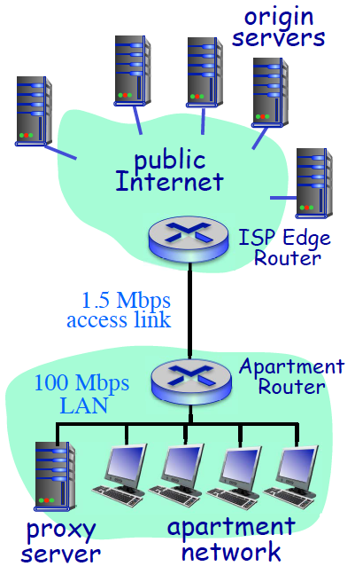1) Consider the network configuration for an apartment illustrated in the figure at the right. Assume the only traffic on the network is generated by web browsers trying to access objects stored on origin servers on the public Internet. The apartment network is connected to the Internet via a 1.5 Mbps DSL link.

Measurements on this network indicate that in aggregate, the browsers generate 22.75 HTTP requests per second on average with the mean size of HTTP requests being 500 bytes and the mean size of responses being 7,500 bytes. Assume that once a request arrives at the ISP’s router from a browser, that the mean round-trip time for a request/response exchange between the ISP router and an origin server is 1.2 seconds. Assume further that the propagation time on the apartment LAN is 1 *ms* and 5 *ms* on the access link. For these questions you can ignore the overhead of TCP connection establishment (the TCP “handshaking”).

*a*) What is the traffic intensity on the 1.5 Mbps access link? (You should compute this measure separately for each direction of the access link. That is, you should compute the traffic intensity in the direction between the apartment router to the ISP router and in the direction between the ISP router to the apartment router.)

Outbound Traffic Intensity = 22.75 reqs/sec \* 4000 bits / 1.5 Mbps = .061

Inbound Traffic Intensity = 22.75 reqs/sec \* 60000 bits / 1.5 Mbps = .91

*b*) Given the traffic intensity you computed, compute the average queuing delay at each of the apartment and ISP routers that a packet waiting to be transmitted on the access link will experience. Hint: A very general result from queuing theory relates traffic intensity (*I*) on a link to the average number of packets in the queue when a new packet arrives (*q*) by the expression:

*q* = 

average queue length at the ISP router = .91/(1-.91) = 10.1 responses

average queue length at the apartment router = .06/(1-.06) = .06 requests

The unit is requests because that’s what we did with the intensity formulas. We also could’ve done it with packets.

*c*) Given the queuing delays you computed, the link speeds, roundtrip times, and object sizes specified in the problem, compute the average response time for a browser on the apartment network to request and download an average sized object from the web.

Transmission + propagation: 4000 bits / 100000000 bits + 1 ms = 1.04 ms

Queuing Delay: 500 bytes x 8 bits/byte / 1500000 bits/sec x .06 reqs = .16 ms

Transmission + Propagation Time on the access link = 2.67 + 5 = 7.67 ms

RTT = 1200 ms

Queuing Delay at ISP Router = queue length x transmission time = 40000 bits / 1.5m bits \* 10.1 = 404 ms

Transmission + Propagation time for the response on the access link = 40 + 5 = 45 ms

Tramission + Propagation time for the response on apartment network = 40000 / 100m + 1 = 1.6 ms

Response time for the whole thing is 1.04 + .16 + 7.67 + 1200 + 404 + 45 + 1.6 ms = 1659.5 ms

*d*) Now assume the apartment tenants install a proxy server on their network with a terabyte disk. If the proxy server has a 15 *ms* access time, and a 45% hit ratio, by what fraction does the average response time increase or decrease?

Taverage = hit ratio x Tproxy cache + (1-hit ratio) x t origin server

T is the request / response latency

T proxy cache = transmission + prop delay on the apartment LAN for the request to arrive at the proxy = 1.04 + 15 + 1.6 = 17.64 ms

Proxy server think time

Transmission + propagation delay on the apartment LAN for the response to be returned to the client

Way smaller, huge win

We now have to redo the Torigin server because the queuing delay is smaller because some fraction fo the requests never leave the apartment LAN and never get to the origin servers, meaning the traffic intensity on the origin servers is lower, and therefore the queuing has changed

Traffic intensity is now 10.1 \* .55 = 5.55 on way back, .45 \* .033 on way there

= 1.04 + .16 \* .55 + 7.67 + 1200 + 404 \* .55 + 45 + 1.6 + 17.64 = 1495.2 ms

Average response time = .45 \* 17.64 + .55 \* 1495.2 = 830.3 ms, which is a 50% improvement.