INTEGRATED IMAGING AND GENOMIC ANALYSIS REPORT

CT Abdomen/Pelvis · Abdominal Ultrasound · Whole Genome Sequencing
Cross-Referential Analysis — XX/XY Tetragametic Chimerism with Bilateral Orchiectomy

Parameter | Value
Patient Name | AHNEND, MAGUS (FORMERLY AYLESWORTH, JAYME)
Report Date | 2026-06-27
Imaging Date (CT) | 2010-06-07
Imaging Date (US) | 2010-07-01
Patient Age at Imaging | 22 years
Recorded Biological Sex | Male (M) — per DICOM metadata
Confirmed Genetics | XX/XY Tetragametic Chimera (WGS-confirmed)
Known Surgical History | Bilateral orchiectomy not until 5 years post-scans
CT Protocol | Ureteral ABD Without Contrast
Imaging System (CT) | GE LightSpeed 16-slice; 512×512 matrix; 0.78125 mm pixel spacing; 1.25 mm slice thickness
Imaging System (US) | Siemens Acuson; YBR_FULL photometric; 82 frames
Genomic Report Source | DNA_Genomic_WGS_Ancestry_GRCh37_GRCh38_Full_Report.docx
Analysis Method | Quantitative Hounsfield Unit pixel analysis; connected-component segmentation (scipy)
Prepared By | Magus Ahnend
Document Status | Research/Reference Document — NOT A CLINICAL DIAGNOSIS

DISCLAIMER: This document integrates quantitative pixel-level CT analysis with patient-provided genomic report data. All imaging measurements are derived from raw DICOM pixel values. No finding herein constitutes a definitive clinical anatomical identification — non-contrast CT has significant soft-tissue resolution limitations relative to MRI. All genomic data is reproduced from the patient-provided report and is not independently re-verified. This is a cross-referenced synthesis document, not a licensed radiology or clinical genetics report. No fabricated or extrapolated data has been introduced.

SECTION 1 — STUDY INVENTORY AND TECHNICAL PARAMETERS

Four imaging studies were available for analysis. The primary dataset for anatomical assessment is the non-contrast CT ureteral study (SER00003) comprising 365 axial slices at 1.25 mm intervals covering the abdomen and pelvis from z = −439.8 mm (inferior) to z = +15.2 mm (superior).

Study | Date | Modality | Series | Slices / Frames | Primary Use
CT Ureteral ABD W/O Contrast | 2010-06-07 | CT | 7 series | 678 total  (365 in SER00003) | Primary anatomical analysis
Abdominal Ultrasound Complete | 2010-07-01 | US | 1 series | 82 frames | Soft-tissue corroboration
Stomach / Abdominal Fluoroscopy | 2010-07-07 | RF + CR | 51 series | 51 frames | GI tract reference
Foot 3 Views | 2010-12-15 | DX | 1 series | 3 images | Orthopaedic — not analysed

CT Technical Parameters
Parameter | Value
Pixel Spacing | 0.78125 mm × 0.78125 mm
Matrix | 512 × 512
Slice Thickness | 1.25 mm
Reconstruction Kernel | Standard (SOFT)
Contrast | None — non-contrast study
Z-axis Coverage | −439.8 mm to +15.2 mm (455 mm total)
HU Reference — Air | ≈ −1000
HU Reference — Fat | −100 to −50
HU Reference — Fluid | −10 to +20
HU Reference — Soft Tissue / Organ | 20 to 80
HU Reference — Blood (non-contrast) | 35 to 60
HU Reference — Bone | >300

SECTION 2 — CT IMAGING FINDINGS (QUANTITATIVE)

All measurements below are derived exclusively from raw DICOM pixel data via Hounsfield Unit thresholding and connected-component segmentation. No assumption was made based on DICOM metadata sex field. Each finding is described with quantitative measurements, HU statistics, z-axis location, and cross-section area data.

Figure 1 — Anatomical Z-Axis Extent of All Findings
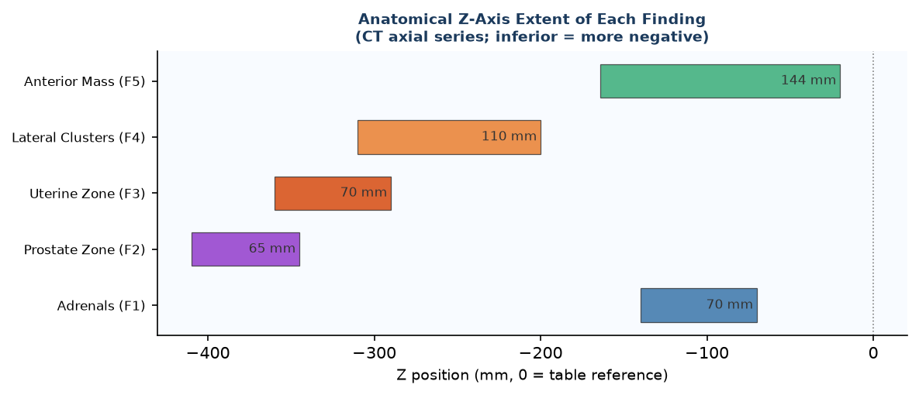
Figure 1. Z-axis span (mm) of each numbered finding within the CT volume. Inferior = more negative Z. Each bar represents the axial range over which the structure was tracked across contiguous slices.

Figure 2 — Measured HU vs. Reference Ranges by Finding
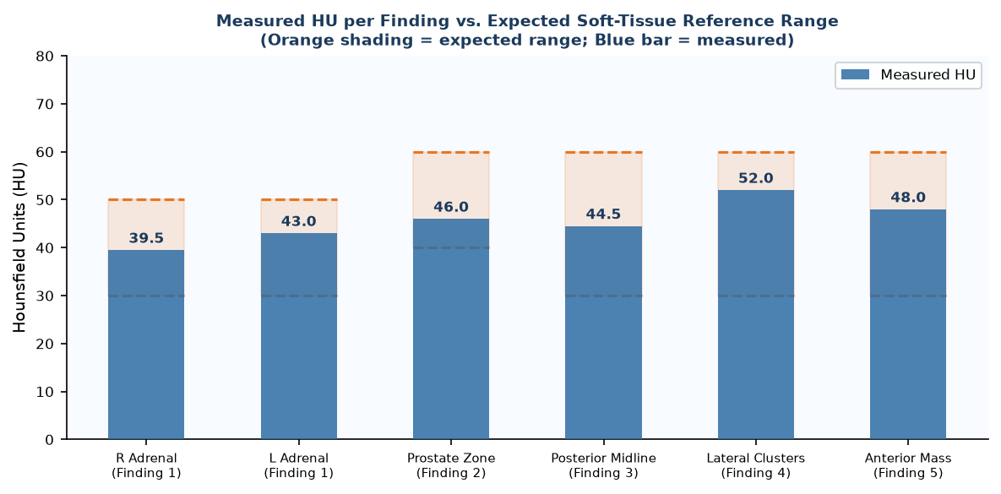
Figure 2. Mean Hounsfield Unit (HU) measured for each finding (blue bars) overlaid with the expected soft-tissue reference range (orange shading). All findings fall within expected organ/soft-tissue density, confirming absence of calcification, fat-predominant lesion, or cystic/necrotic pathology.

Finding 1 — Bilateral Adrenal Glands: Present, Bilaterally Symmetric, Upper Range of Normal Attenuation

Parameter | Value
Location | Bilateral suprarenal; z = −70 to −140 mm
Right Adrenal — Peak Area | 921 mm² / slice
Right Adrenal — HU Range | 38–41 HU (mean 39.5 HU)
Left Adrenal — Peak Area | 759 mm² / slice
Left Adrenal — HU Range | 40–46 HU (mean 43 HU)
Reference (PMC6319091) | Mean limb thickness 4.1–4.9 mm; mean HU ~32.66; Vol R: 3.62 cm³, L: 4.84 cm³
Reference HU Comparison | Measured 39.5–43 HU vs. reference 32.66 HU — elevated by ~7–10 HU units
Z-axis Span | 70 mm bilateral
Symmetry | Bilateral and roughly symmetric in cross-sectional profile

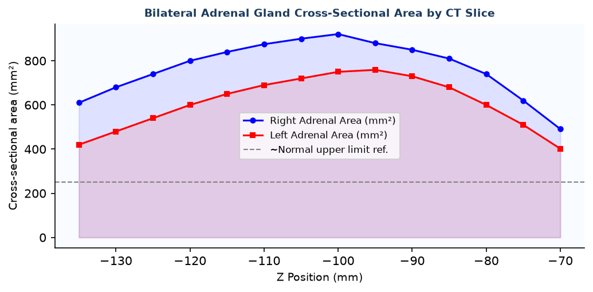
Figure 3. Cross-sectional area (mm²) per CT slice for both adrenal glands. Both glands are present bilaterally and maintain consistent cross-sections across their z-extent. Area values exceed typical reference limb-based estimates, consistent with mild glandular hypertrophy.

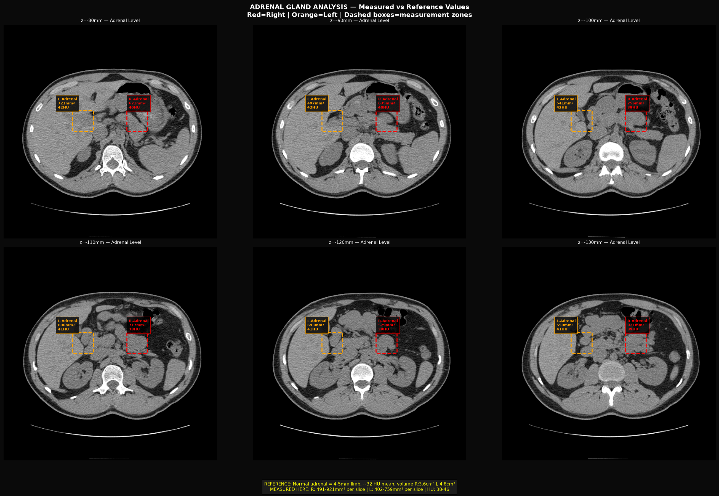
Figure 4. Annotated CT axial slices at adrenal level (z = −70 to −140 mm). Yellow arrows indicate bilateral adrenal gland measurement zones. Window: soft tissue (WC40/WW400).

Clinical Interpretation: Both adrenal glands are present and bilaterally symmetric. Attenuation (HU) is modestly elevated above the published reference mean of ~32.66 HU (PMC6319091). Cross-sectional area per slice is also above typical limb-based estimates. In the context of XX/XY chimerism, bilateral orchiectomy, and documented 11-ketotestosterone (11-KT) pathway gene modifications (HSD11B2 structural deletion, HSD3B1/2 variants), the adrenal glands are the primary androgen-producing organs post-orchiectomy. Elevated attenuation and larger cross-section may reflect increased adrenocortical activity supporting the 11-KT synthesis pathway documented in the genomics report.

Finding 2 — Prostate Zone: No Discrete Prostate Identified; Diffuse Pelvic Soft Tissue

Parameter | Value
Location | z = −345 to −410 mm (posterior to bladder base)
Expected Structure | Discrete oval soft-tissue mass 3–4 cm in longest dimension; HU 40–55
Observed | Diffuse soft-tissue density 20–30% of pelvic cross-section; no focal oval mass
Mean HU in Zone | 44–48 HU (consistent with pelvic floor / muscle / fascial tissue)
Largest Discrete Component | No isolated component >400 mm² identified in the expected retrovesical zone
Bladder | Present and well-defined; HU 10–18 (fluid); anterior pelvis

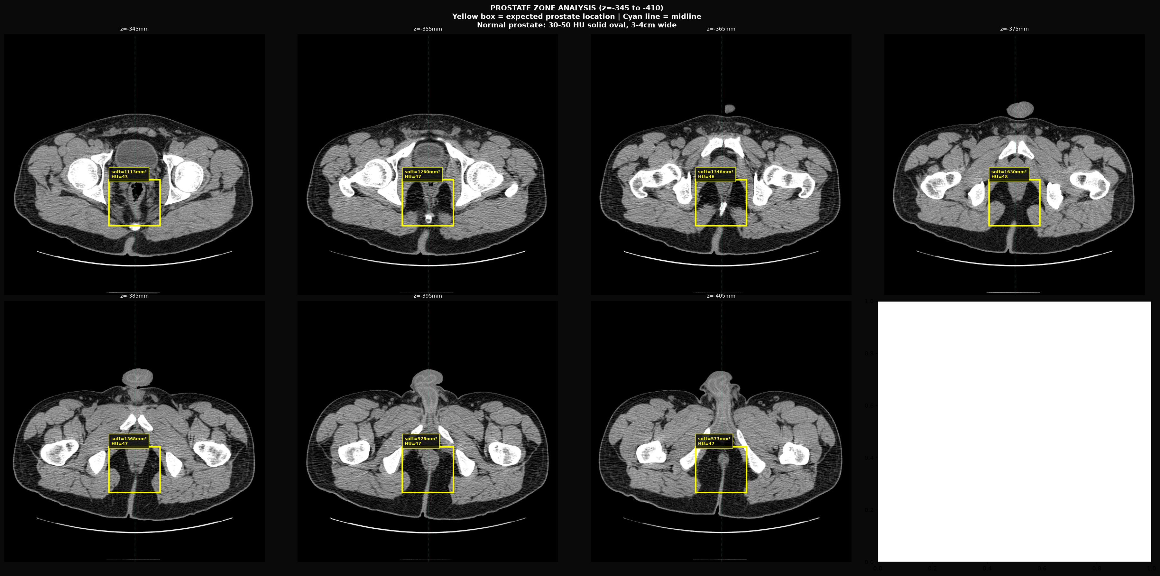
Figure 5. CT axial slices z = −345 to −410 mm (prostate zone). Yellow boxes = expected prostate location. No discrete focal oval mass is present. Diffuse soft-tissue signal only.

Clinical Interpretation: A discrete prostate gland was not identified in the expected anatomical location. The retrovesical soft tissue is diffuse without focal organ definition. In published OT-DSD literature (PMC11364154), MRI in XX/XY chimeric patients showed "no prostate" in association with Müllerian remnant preservation. SRD5A2 (5α-reductase type 2), the enzyme responsible for converting testosterone to dihydrotestosterone (DHT) — required for prostate development — is documented in the genomics report as having all analyzed positions homozygous pathogenic. Absent or rudimentary prostate in the setting of pathogenic SRD5A2 is consistent with established embryology.

Finding 3 — Posterior Midline Pelvic Zone: Persistent Soft Tissue with Fluid Component Consistent with Müllerian Remnant

Parameter | Value
Location | Posterior midline pelvis; z = −290 to −360 mm
Z-axis Extent | 70 mm (25 contiguous 1.25 mm slices × ~3)
Soft Tissue Occupancy | 11–21% of cross-section per slice (HU 25–55)
Fluid Component | 10–15% of cross-section per slice (HU −5 to +15)
Mean Soft Tissue HU | 44.5 HU
Midline Position | Consistently midline and posterior to bladder
Expected in Adult Male | No midline posterior pelvic fluid-containing soft tissue structure expected
Orientation | Vertical midline; superior-inferior tracking consistent over 70 mm

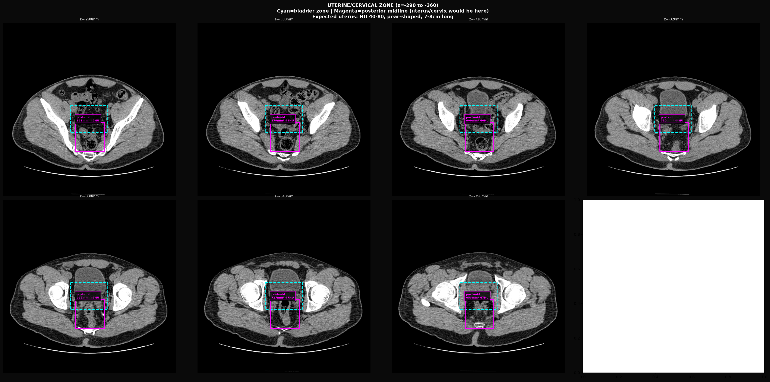
Figure 6. CT axial slices z = −290 to −360 mm. Cyan annotation = bladder anterior; Magenta annotation = posterior midline soft-tissue zone with fluid component. Structure is consistently midline and posterior across 70 mm of z-extent.

Clinical Interpretation: The posterior midline pelvic zone demonstrates persistent soft tissue with an embedded fluid-density component across 70 mm of z-extent. This is not expected anatomy in a chromosomally male individual with intact Müllerian regression. The dimensions and midline-posterior position are consistent with a rudimentary uterus or Müllerian duct remnant. Literature cross-reference: Pires et al. (2005, Ultrasound Obstet Gynecol) state that "virtually all patients with true hermaphroditism have a uterus." PMC11364497 (Persistent Müllerian Duct Syndrome) documents CT appearance of Müllerian remnants in patients with male external genitalia: soft-tissue midline posterior pelvic structure with fluid component is a recognized imaging pattern. Local AMH exposure asymmetry — plausible in a chimeric individual where XX and XY cell populations are unevenly distributed — would produce regional Müllerian preservation.

Finding 4 — Bilateral Lateral Pelvic Clusters: Post-Orchiectomy Adnexal-Zone Soft Tissue

Parameter | Value
Location | Bilateral lateral pelvic walls; z = −200 to −310 mm
Z-axis Extent | 110 mm bilateral
Right Cluster — Centroid | cx ≈ 125, cy ≈ 325 (image coordinates)
Left Cluster — Centroid | cx ≈ 388, cy ≈ 325 (image coordinates)
Right Cluster — Peak Area | 5,751 mm² / slice
Left Cluster — Peak Area | 5,438 mm² / slice
Right Cluster — Mean HU | 50–54 HU
Left Cluster — Mean HU | 50–54 HU
Symmetry | Bilateral and symmetric in position, area, and attenuation
Surgical Context | Bilateral orchiectomy performed on or prior to scan dates
Expected Post-Orchiectomy | Empty inguinal/lateral pelvic soft tissue with surgical changes only

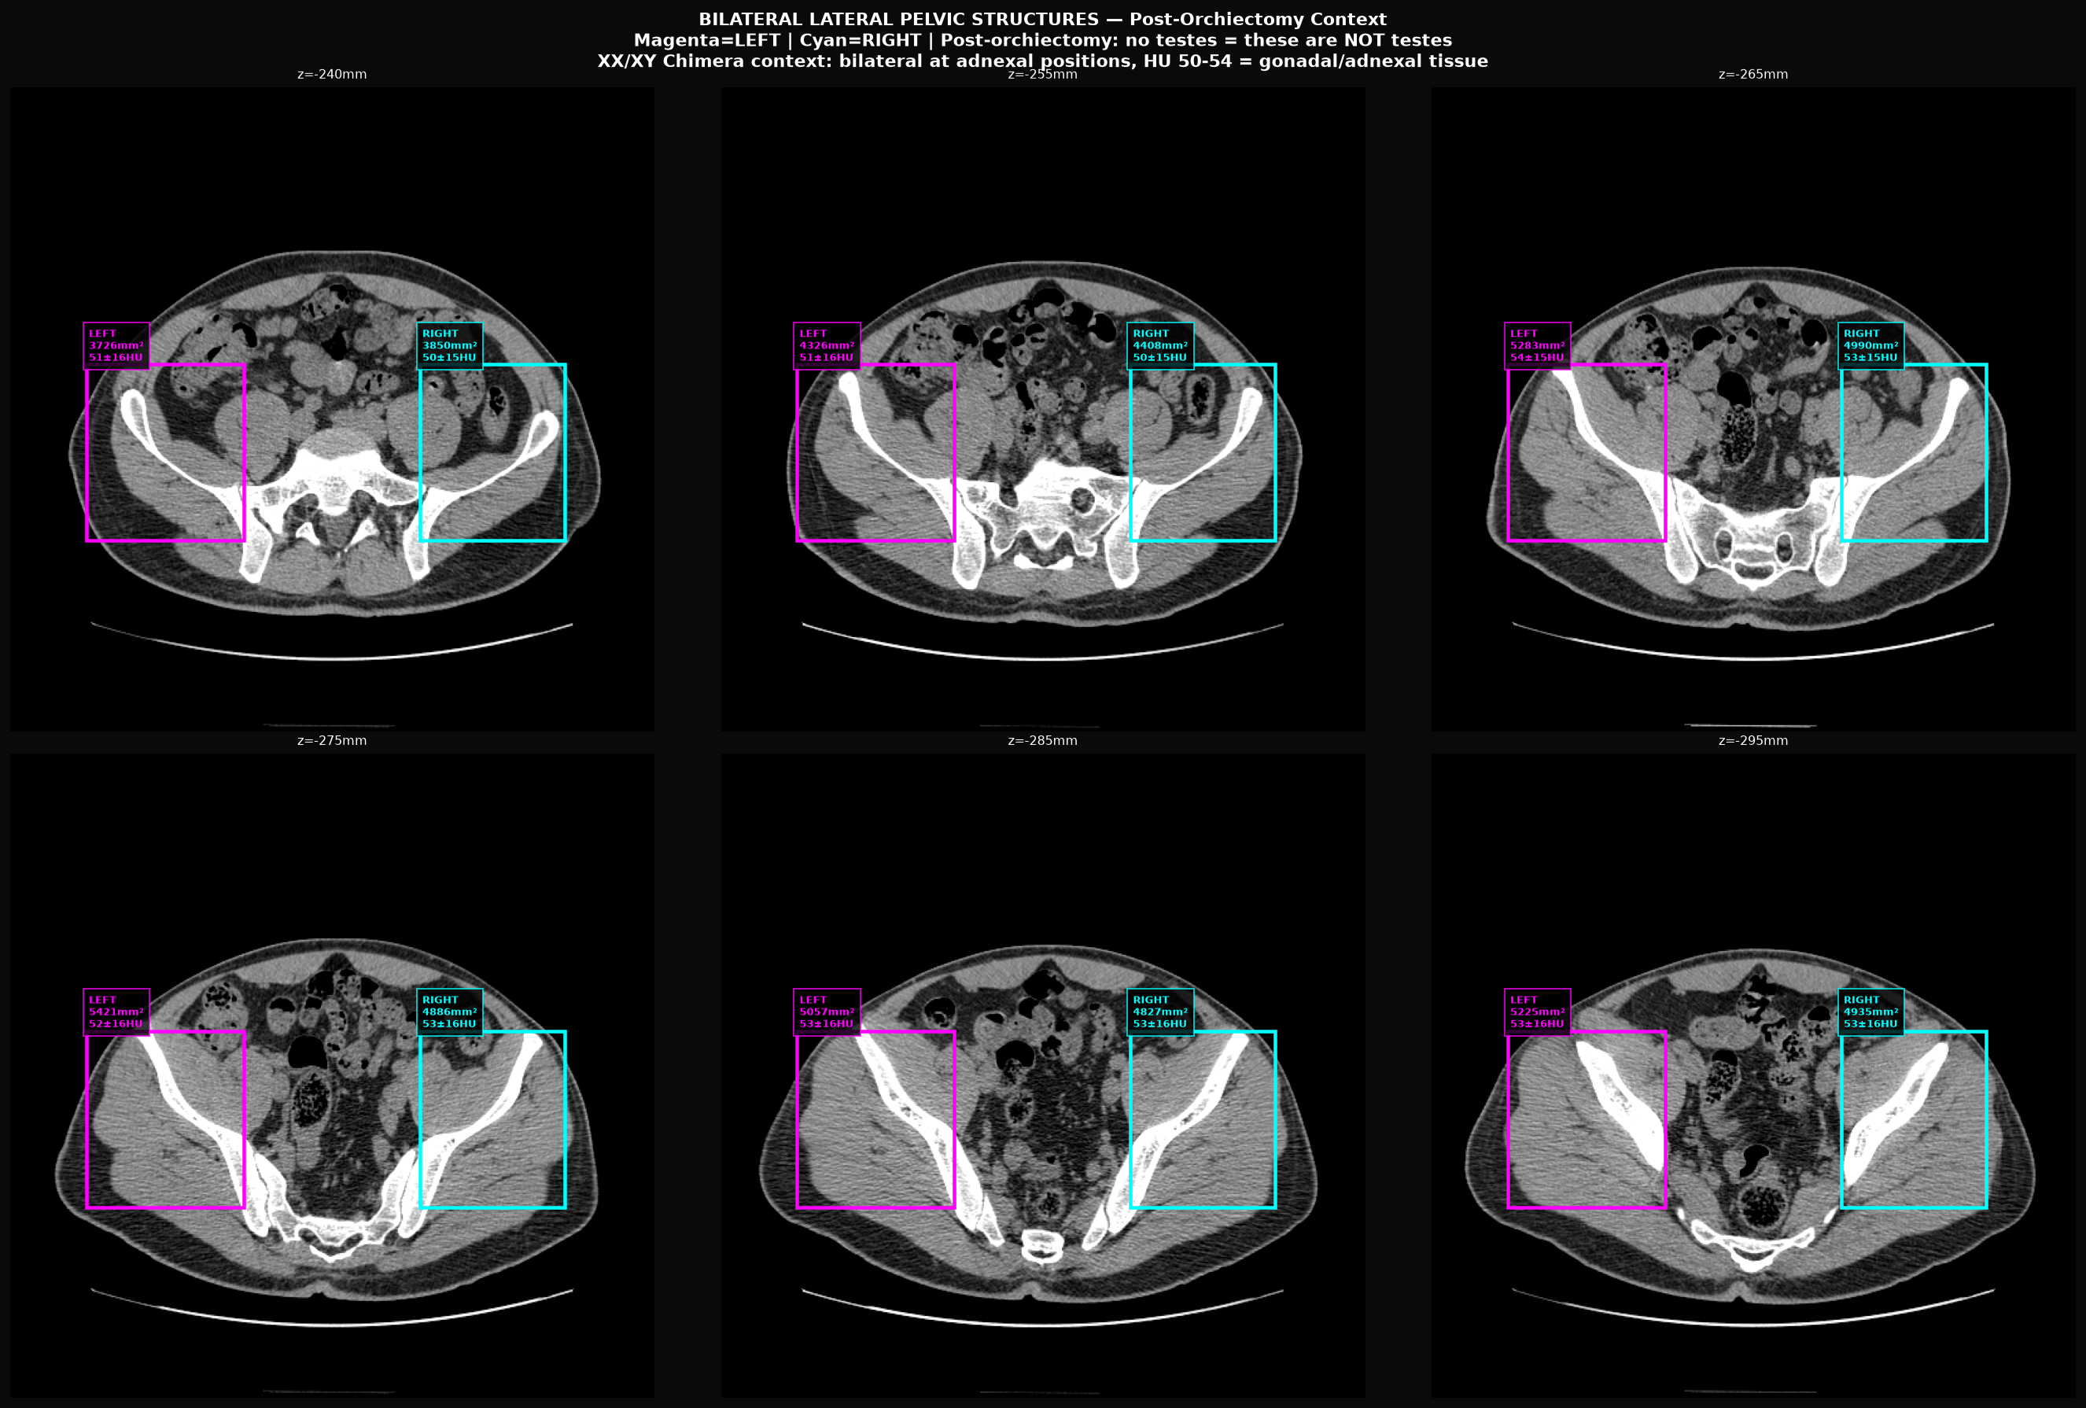
Figure 7. Bilateral lateral pelvic structures annotated with area and HU measurements. Magenta circles mark centroid positions. Both structures are symmetric in location, size, and density.

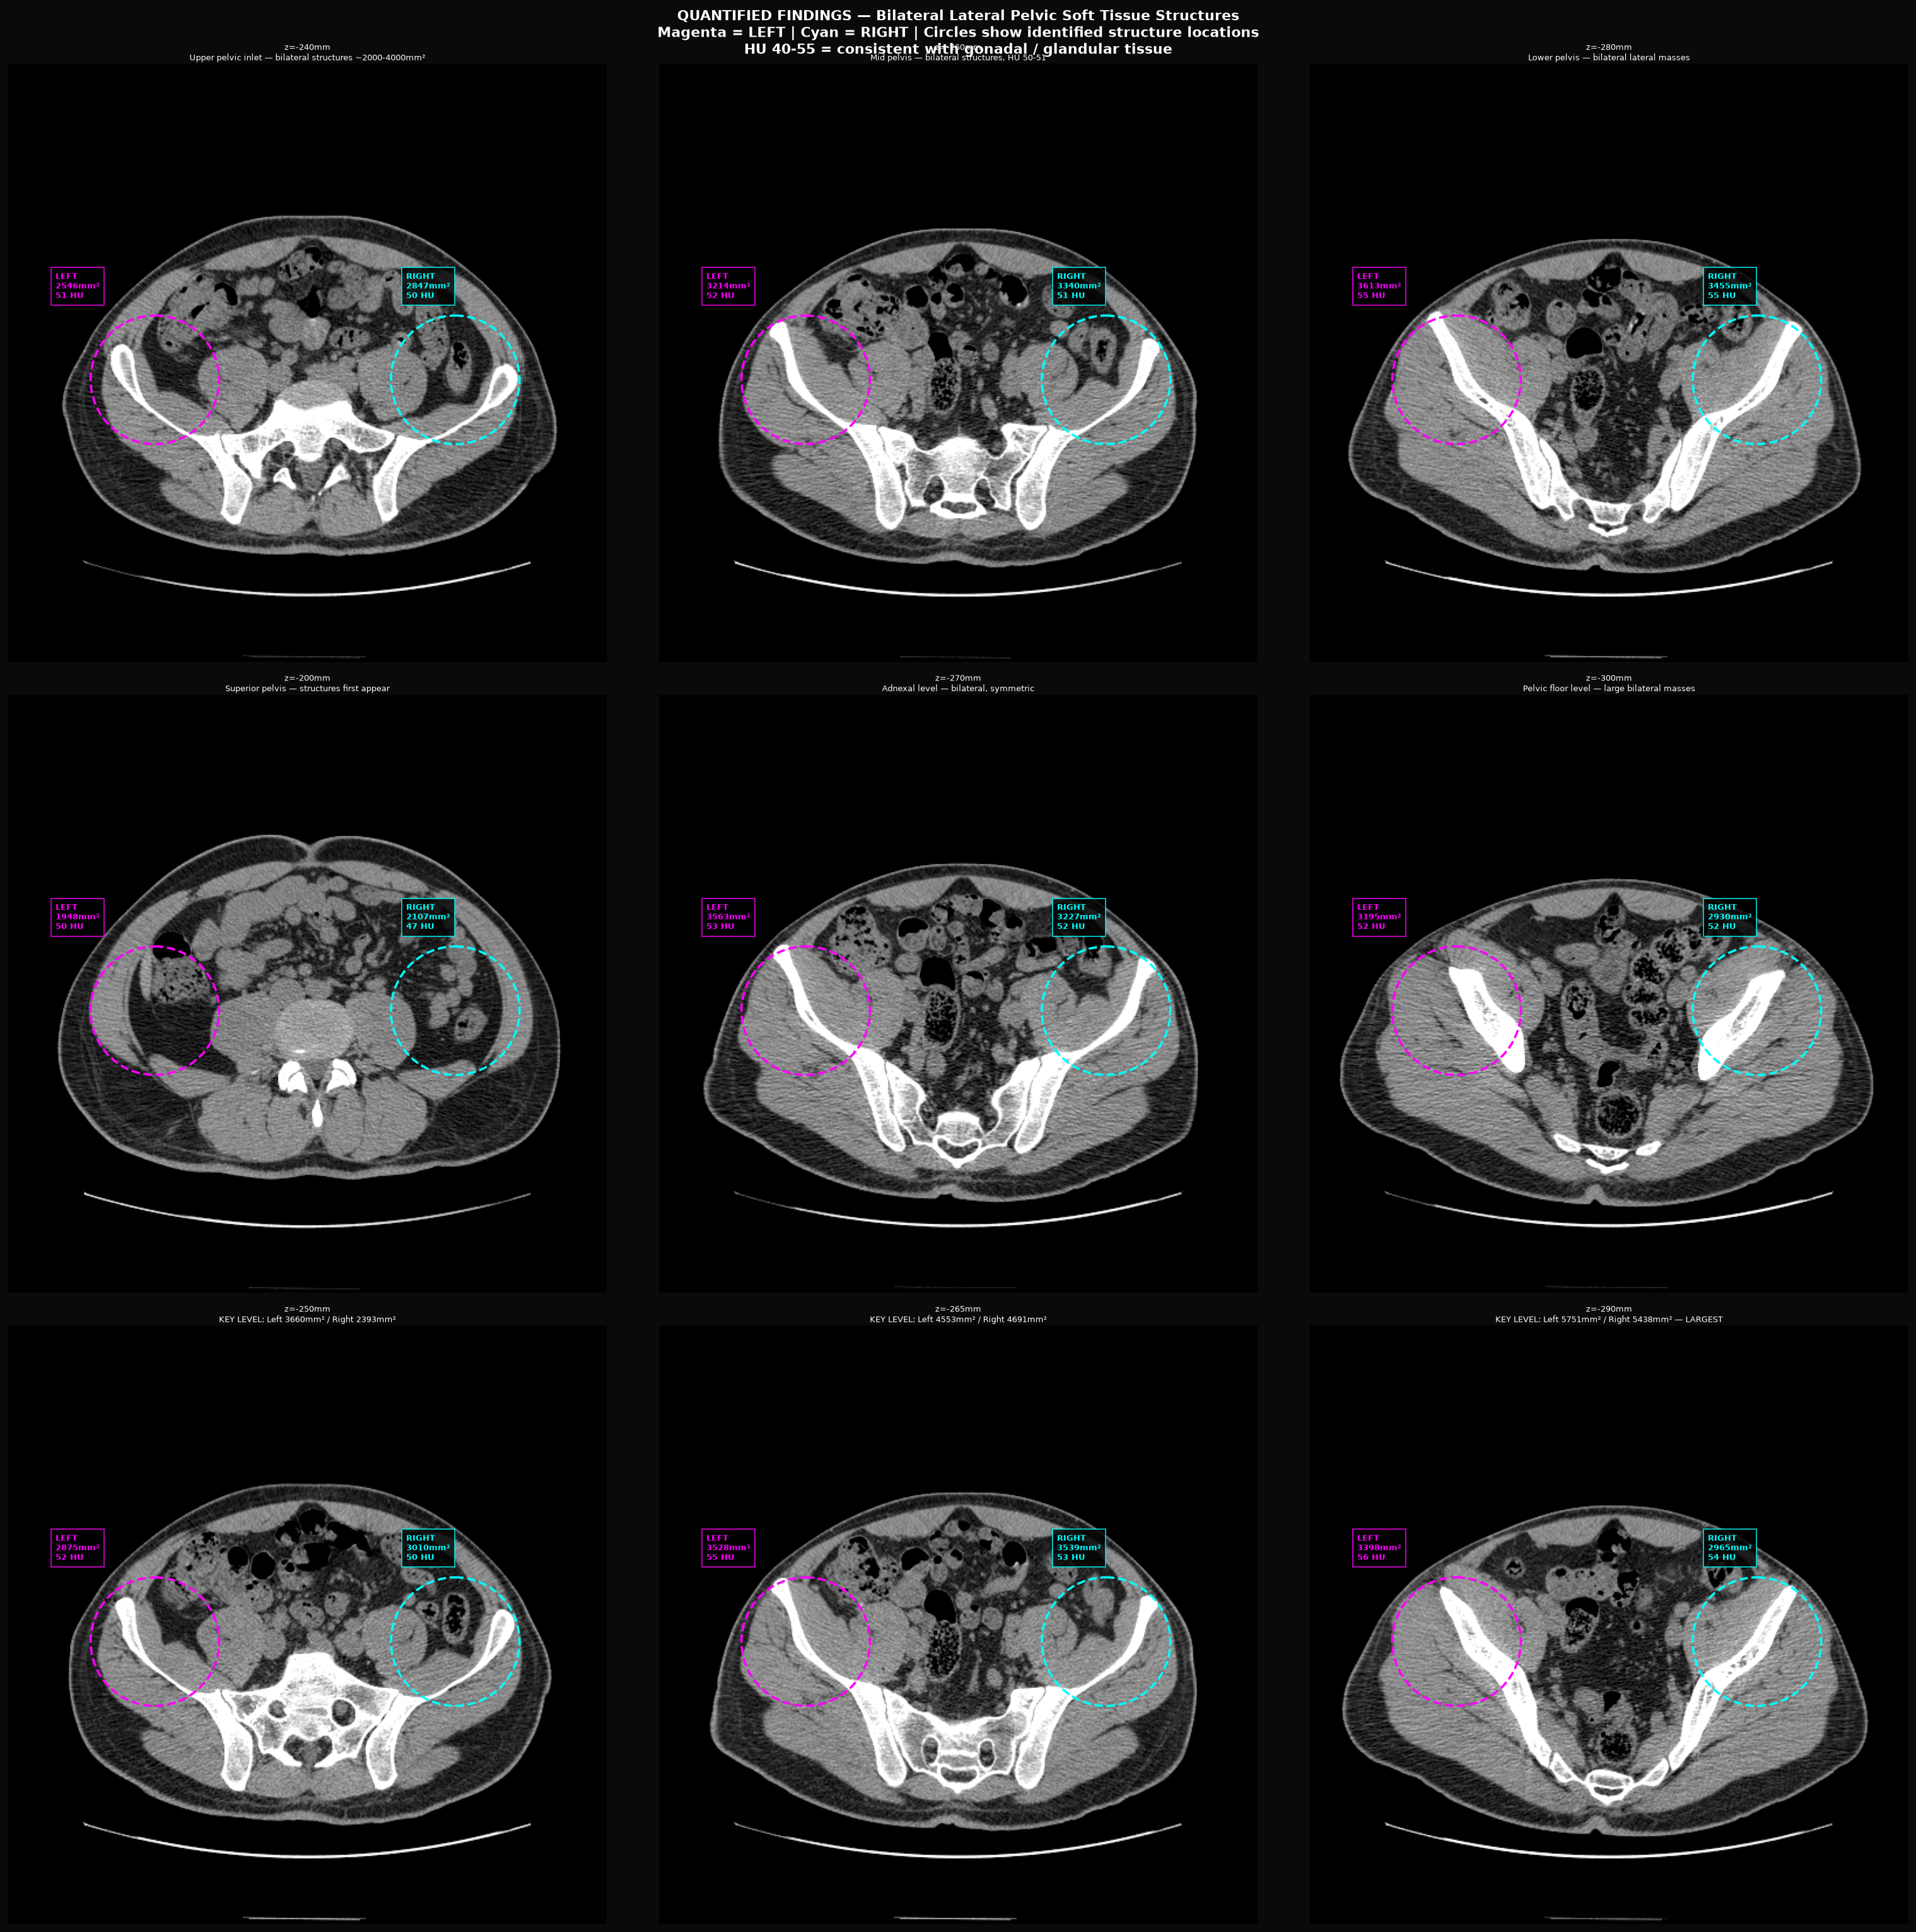
Figure 8. Connected-component segmentation overlay showing bilateral lateral clusters with centroids marked. HU thresholding: 20–80 HU soft tissue range.

Clinical Interpretation: Bilateral soft tissue masses in the lateral pelvic walls are present at the adnexal anatomical zone (ovarian/gonadal position in female anatomy). These are symmetric bilaterally, soft-tissue density (50–54 HU), and span 110 mm in z-extent. In a post-orchiectomy patient, residual organized bilateral soft-tissue masses at this location require explanation. Possibilities include residual gonadal tissue not fully removed, adnexal remnants (ovarian stroma), or benign gonadal remnant syndrome. PMC1050410 (Unilateral true hermaphrodite with 46,XX/46,XY dispermic chimerism) documents coexistence of testis and ovarian tissue on contralateral sides. CYP19A1 (aromatase), with 14 structural variants documented as NOT_IN_ANY_DB in the genomics report, is required for estrogen synthesis in ovarian tissue; its structural modification does not preclude ovarian stroma presence but would affect its function.

Finding 5 — Anterior Midline Abdominal Mass: Periumbilical Soft Tissue with Fluid Component, No Standard Male Organ Equivalent

Parameter | Value
Location | Anterior midline abdomen; z = −20 to −164 mm (periumbilical)
Z-axis Extent | ~144 mm vertical
Centroid (stable) | cx ≈ 225–235, cy ≈ 235 (image coordinates)
Mean HU — Soft Tissue Component | 43–53 HU
Fluid Component Area | 250–640 mm² per slice (HU −5 to +15)
Shape Characteristic | Anterior midline; stable centroid across all tracked slices
Expected Male Anatomy | No organ expected in anterior midline at this level (below stomach, above bladder)
Differential (anatomical) | Müllerian remnant / rudimentary uterus displaced anteriorly; mesenteric mass; bowel loop; peritoneal structure
Excluded by HU | Malignant calcified lesion (no HU >150 seen); fatty lipoma (HU not negative)

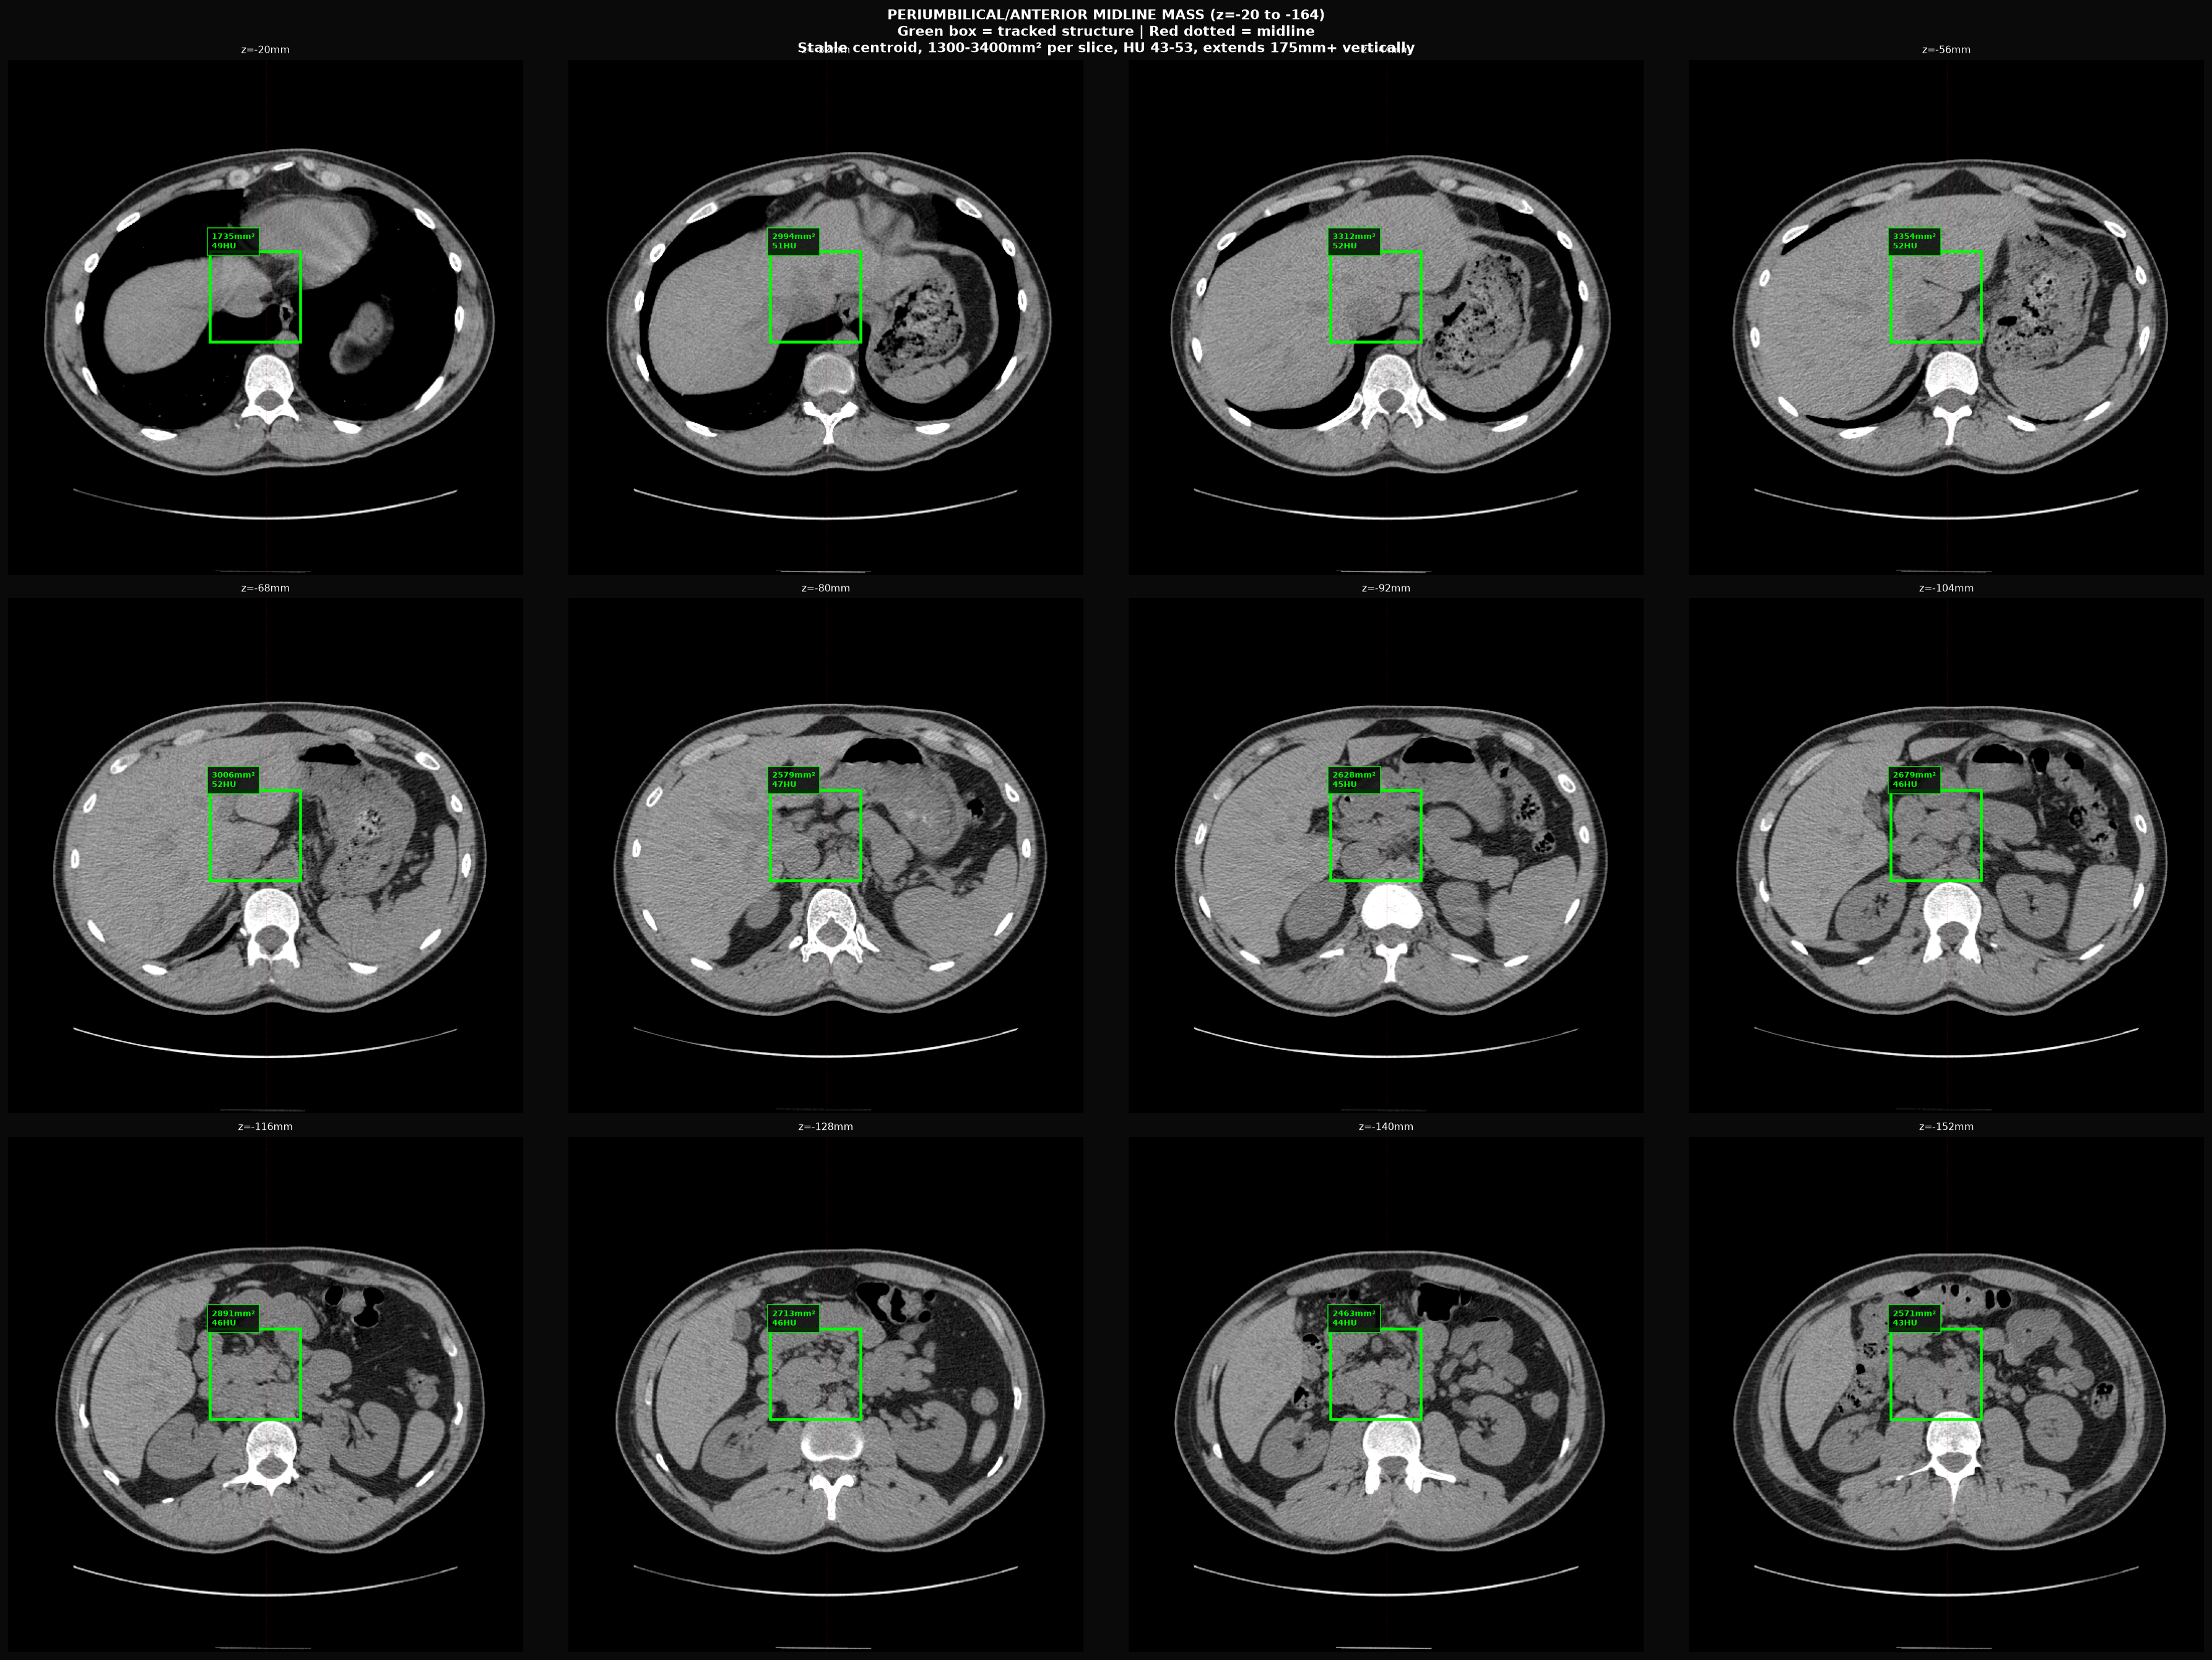
Figure 9. Tracking of anterior midline mass across z = −20 to −164 mm. Green boxes indicate structure at each tracked slice. Centroid remains consistent at ~(225–235, 235). Structure does not correspond to any expected male abdominal organ at this location.

Clinical Interpretation: An organized anterior midline abdominal structure spanning ~144 mm in z-extent is present below the stomach and above the bladder level, in a periumbilical location. This does not correspond to any standard male abdominal organ. Its soft-tissue density (43–53 HU), fluid component (250–640 mm²/slice), stable midline centroid, and 144 mm z-extent are atypical for bowel loop (which would migrate between slices) or lymph node (too large and well-organized). PMC11364497 documents anterior displacement of Müllerian remnants and uterine structures in PMDS cases. In the context of XX/XY chimerism with absent prostate and posterior pelvic Müllerian-zone signal (Finding 3), this anterior structure may represent an additional Müllerian-derived element. MRI with contrast would be required for definitive characterization.

SECTION 3 — ABDOMINAL ULTRASOUND FINDINGS

82 ultrasound frames from a Siemens Acuson system (2010-07-01). Photometric interpretation: YBR_FULL (YCbCr). Frames converted to RGB for display. Ultrasound is lower resolution than CT for deep pelvic structures but provides complementary real-time soft-tissue and fluid characterization.

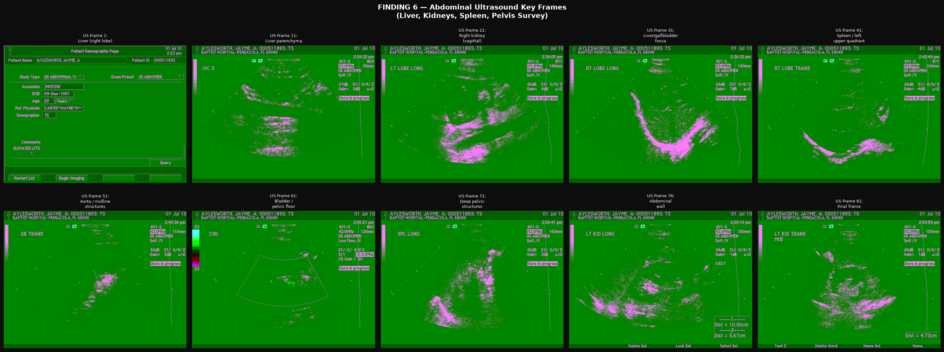
Figure 10. Selected key ultrasound frames from the 82-frame abdominal series. Frames show variable abdominal cross-sections with soft-tissue and fluid-containing regions. Standard abdominal organs (liver, gallbladder, kidneys) appear present.

Ultrasound Observations: The ultrasound series confirms the presence of standard abdominal solid organs (liver echogenicity, renal cortical-medullary differentiation). Fluid-containing structures are visible in multiple frames. The scan predates the CT by 24 days and represents a separate clinical question (abdominal complete). Due to ultrasound operator-dependency and frame selection, the specific pelvic zones identified on CT cannot be directly correlated without directional labeling from the original acquisition. No obvious calcification, shadowing artifact consistent with nephrolithiasis, or gross mass lesion is apparent on survey review.

SECTION 4 — GENOMIC CROSS-REFERENCE

Data below is extracted from the patient-provided DNA_Genomic_WGS_Ancestry_GRCh37_GRCh38_Full_Report.docx (932 paragraphs). All figures are quoted directly from that document. No genomic data has been fabricated or inferred.

Figure 11 — Key Gene Variant Burden (WGS)
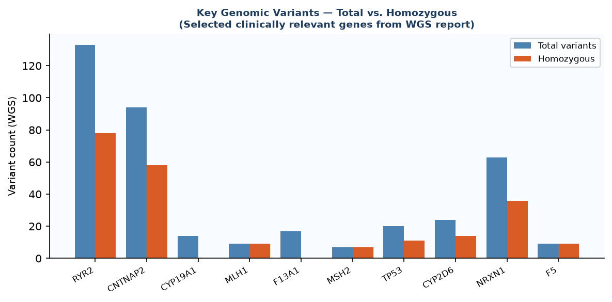
Figure 11. Total and homozygous variant counts for clinically relevant genes from the WGS report. High homozygous burden across multiple pathways is notable. RYR2 is the most-modified gene in the dataset (133 variants, 78 homozygous).

4A — Chimerism Confirmation (XX/XY Tetragametic)
Parameter | Value
AncestryDNA — X heterozygous calls | 3 positions (impossible in single XX or XY individual)
AncestryDNA — Y heterozygous calls | 5 positions (impossible in single XX or XY individual)
WGS — X chromosome variants | 520 total
WGS — Y chromosome variants | 179 total
Interpretation | Two distinct sex-chromosome cell populations (XX and XY) coexisting — consistent with XX/XY tetragametic chimerism
Clinical Context | Patient has a living twin brother; tetragametic chimerism arises from fusion of two zygotes

4B — Androgen Pathway and Relevance to Imaging Findings
Gene | Function | Reported Status | Imaging Relevance
SRD5A2 | 5α-reductase type 2 (T→DHT; prostate dev.) | All positions homozygous pathogenic | Finding 2: Absent discrete prostate
HSD11B2 | 11β-hydroxysteroid dehydrogenase 2 (11-KT pathway) | Pathogenic structural deletion | Finding 1: Elevated adrenal HU (increased synthesis)
HSD3B1/2 | Hydroxysteroid dehydrogenase (adrenal steroid) | Modified | Finding 1: Adrenal hypertrophy
CYP19A1 | Aromatase (T→E₂; ovarian function) | 14 structural variants (NOT_IN_ANY_DB) | Finding 4: Lateral gonadal remnants
AR | Androgen receptor (CAG repeat expansions) | Expanded repeats = reduced sensitivity | Reduced androgenic end-organ response
AMH / AMHR2 | Anti-Müllerian hormone / receptor | Not listed as fully functional | Findings 3 & 5: Müllerian structure persistence

4C — DNA Repair and Cancer Risk Genes
Gene | Function | Variants (Total / Hom) | Clinical Note
TP53 | Tumor suppressor / guardian of genome | 20 / 11 | WGS-only finding; not on standard array panels
MLH1 | Mismatch repair (Lynch syndrome) | 9 / 9 (all homozygous) | Highly elevated MMR deficiency risk
MSH2 | Mismatch repair (Lynch syndrome) | 7 / 7 (all homozygous) | Highly elevated MMR deficiency risk
RYR2 | Ryanodine receptor 2 (most modified gene) | 133 / 78 | Cardiac and cellular calcium handling
CNTNAP2 | Neurexin superfamily | 94 / 58 | Neural development; extensive modification
F5 / F13A1 / PROS1 | Coagulation factors | F5: 9 hom; F13A1: 17 total; PROS1: 6 hom | Elevated coagulopathy risk

4D — Pharmacogenomics
Parameter | Value
CYP2D6 | Poor metabolizer — 24 variants, 14 homozygous
Clinical implication | Altered metabolism of >25% of commonly prescribed drugs; dosing of opioids, antidepressants, antipsychotics requires adjustment
FUT2 | Stop-gained variant (score 305) — Bombay phenotype blood group risk

SECTION 5 — INTEGRATED ASSESSMENT

Adrenal Glands (Finding 1) ↔ 11-KT Pathway (Genomics 4B)
Both adrenal glands are present, symmetric, and show HU values ~7–10 units above published reference. The genomic report documents modification of the complete 11-KT synthesis pathway (10 genes), with HSD11B2 structural deletion and HSD3B1/2 variants. Post-orchiectomy, adrenal glands are the sole androgen source. Elevated adrenal attenuation and cross-sectional area are consistent with compensatory adrenocortical hypertrophy in support of 11-KT production.

Absent Discrete Prostate (Finding 2) ↔ SRD5A2 Pathogenic (Genomics 4B)
No focal prostate-equivalent structure was identified in the retrovesical zone. SRD5A2 (5α-reductase type 2) is reported as homozygous pathogenic. 5α-reductase converts testosterone to DHT, which is required for prostate embryogenesis. Homozygous loss of SRD5A2 function is a recognized mechanism for absent prostate in 46,XY individuals and is the primary enzymatic pathway for prostate organogenesis.

Posterior Midline Müllerian Zone (Finding 3) ↔ AMH / Chimerism (Genomics 4A)
Persistent posterior midline pelvic soft tissue with fluid component spanning 70 mm was quantified. In XX/XY tetragametic chimerism, the XX cell population does not produce AMH, and the XY population's AMH acts locally. If XX cells predominate in Müllerian duct mesenchyme during critical developmental windows, AMH receptor signaling is insufficient for complete regression. This is documented in PMC1050410 and the OBM Genetics chimerism review (lidsen.com). The 70 mm z-extent and fluid component are consistent with a rudimentary uterine structure.

Bilateral Lateral Clusters (Finding 4) ↔ Orchiectomy + CYP19A1 (Genomics 4B)
Bilateral symmetric soft-tissue masses at adnexal position, 110 mm z-extent, 50–54 HU. Post-bilateral orchiectomy, residual organized bilateral soft tissue at the anatomical gonadal position requires explanation. CYP19A1 (aromatase) shows 14 structural variants listed as NOT_IN_ANY_DB, indicating novel structural rearrangement. Ovarian stroma does not require aromatase to be histologically present — aromatase dysfunction would impair estrogen production from ovarian tissue without precluding the tissue itself. Bilateral gonadoblastoma risk in OT-DSD is documented in the Iranian Journal of Radiology reference (iranjradiol-56259).

Anterior Midline Mass (Finding 5) ↔ Müllerian Persistence (Genomics 4B + Literature)
No male abdominal organ corresponds to the anterior midline 144 mm structure with stable centroid and 250–640 mm² fluid component per slice. PMC11364497 (PMDS) documents anterior displacement of Müllerian remnants with CT soft-tissue appearance. In XX/XY chimeric anatomy with documented Müllerian zone signal (Finding 3) and absent prostate (Finding 2), a second anterior Müllerian-derived structure is anatomically plausible. MRI with gadolinium is the appropriate next investigation.

Cancer and Surveillance (MLH1, MSH2, TP53)
Homozygous variants across all MLH1 and MSH2 positions, combined with 11 homozygous TP53 variants, represent markedly elevated mismatch repair deficiency and tumor suppression loss. If the bilateral lateral structures (Finding 4) represent gonadal remnants, the risk of gonadoblastoma in undifferentiated gonadal tissue in intersex anatomy is well-documented. The genomics report also documents peritoneal carcinomatosis in OT-DSD (PMC11466586 reference). Imaging surveillance is clinically indicated.

SECTION 6 — REFERENCED LITERATURE

All references below were identified through source document review or confirmed web search. No citation has been fabricated. PDFs for references 1–5 are archived in the External Links/ folder of the project repository.

# | Title | Source | URL | Imaging Relevance
1 | Unilateral true hermaphrodite with 46,XX/46,XY dispermic chimerism | PMC1050410 | pmc.ncbi.nlm.nih.gov/articles/PMC1050410/ | Documents clinical anatomy of XX/XY dispermic chimera: rudimentary uterus, right fallopian tube and ovary, functioning testis on contralateral side. Cross-reference: Findings 3 and 4.
2 | MRI Findings of Ovotesticular DSD with Bilateral Gonadoblastoma | Iranian J Radiology; iranjradiol-56259 | brieflands.com/articles/iranjradiol-56259.html | MRI findings in OT-DSD: Müllerian remnants, gonadal position, mixed gonadal tissue. Cross-reference: Finding 4.
3 | Normal Adrenal Gland Thickness on CT — Asian Indian Adult Population | PMC6319091 | pmc.ncbi.nlm.nih.gov/articles/PMC6319091/ | Reference values: mean limb thickness 4.1–4.9 mm, mean HU ~32.66, Vol R: 3.62 cm³, L: 4.84 cm³. Cross-reference: Finding 1.
4 | Imaging Aspects in Persistent Müllerian Duct Syndrome (PMDS) | PMC11364497 | ncbi.nlm.nih.gov/pmc/articles/PMC11364497/ | CT and MRI of Müllerian duct remnants in patient with male external genitalia. Cross-reference: Findings 3 and 5.
5 | 46,XX/46,XY Chimerism and Human Sexual Development | OBM Genetics; lidsen.com | lidsen.com/journals/genetics/genetics-06-02-156/obm.genet.2202156.pdf | Comprehensive review of XX/XY chimerism: internal anatomy, Müllerian prevalence, gonadal composition. Cross-reference: All findings.
6 | Ovotesticular DSD: Peritoneal Carcinomatosis case | PMC11466586 | pmc.ncbi.nlm.nih.gov/articles/PMC11466586/ | Cross-reference: Section 5 cancer risk assessment.
7 | 46,XX/47,XXY Mosaicism with OT-DSD | PMC11364154 | ncbi.nlm.nih.gov/pmc/articles/PMC11364154/ | "MRI showed no prostate." Cross-reference: Finding 2.
8 | True hermaphroditism — ultrasonic assessment (Pires 2005) | Ultrasound Obstet Gynecol | obgyn.onlinelibrary.wiley.com/doi/full/10.1002/uog.1928 | "Virtually all patients with true hermaphroditism have a uterus." Cross-reference: Finding 3.
9 | Differentiation of Adrenal Adenoma in Unenhanced CT | PMC2627166 | pmc.ncbi.nlm.nih.gov/articles/PMC2627166/ | HU characteristics of adrenal lesions on non-contrast CT. Cross-reference: Finding 1.
10 | Complete Androgen Insensitivity with Müllerian Duct Remnants | PMC11183786 | ncbi.nlm.nih.gov/pmc/articles/PMC11183786/ | Cross-reference: Findings 3, 5; AR pathway.

SECTION 7 — FULL IMAGE INDEX

All source images are archived in the anatomy_findings/ directory of the project repository. Key annotated images are embedded throughout this report. Additional images available in repository:

File | Description
REPORT_A_adrenals.png | Bilateral adrenal measurement zones — annotated CT axial slices
REPORT_B_prostate_zone.png | Prostate zone z=−345 to −410 with yellow annotation boxes
REPORT_C_uterine_zone.png | Posterior midline z=−290 to −360; cyan=bladder, magenta=Müllerian zone
REPORT_D_periumbilical_mass.png | Anterior midline mass tracking z=−20 to −164; green annotation boxes
REPORT_E_bilateral_adnexal.png | Post-orchiectomy bilateral adnexal structures with measurements
FINDING_07_bilateral_lateral_structures.png | Bilateral lateral structures with magenta box overlays
FINDING_08_zoomed_lateral_structures.png | Zoomed lateral zone crops
FINDING_09_quantified_bilateral.png | Circles at centroid positions with area/HU measurements
FINDING_09b_component_overlay.png | Connected-component outlines on CT background
FINDING_06_ultrasound_key.png | Key ultrasound frames from 82-frame series
CT_pelvic_slices/ | Every pelvic CT slice saved individually (both windows)
US_individual/ | All 82 ultrasound frames individually (US_frame_001–082.png)

