
DEPARTMENT OF MECHANICAL AND MECHATRONICS ENGINEERING
CPUT STEM CLUB EXPO COMPETITION
HUMAN SUPERCAPACITOR ELECTRIC VOLTAGE CHARGER

PROJECT DESIGN CONCEPT REPORT
By
Shongwe Prince Njabulo: 231258291
Sindane Mandlenkosi: 240771761
Cape Peninsula University of Technology

SYNOPSIS
This report presents the design concept for a Human Supercapacitor Electric Voltage Charger developed for the CPUT STEM Club Expo Competition. The project responds to the limitations identified in conventional battery-based energy storage, including long charging periods, environmental concerns associated with battery disposal, and limited ability to deliver power immediately when required. The proposed concept converts human mechanical energy from pedalling into electrical energy and stores that energy in a supercapacitor bank.
The design combines a stationary bicycle frame, driver and driven gears, a chain transmission, a shaft, an AC generator, a rectifier, a current sensor, an Arduino controller, an LCD display and supercapacitors. Human pedalling rotates the gear and shaft system, which drives the generator. The generated alternating current is converted into direct current before being stored, while the sensor, controller and display provide monitoring and control functions.
The presentation compares the proposed charger with e-bikes, solar power and wind power. Its intended applications include emergency scenarios, hospitals, gyms, fitness areas and off-grid communities. The concept is presented as portable and available on demand because it relies on human motion rather than sunlight, wind or pre-charged batteries.
The supplied design calculations use an energy requirement of 12 Wh and a stated input power of 2 kW, producing a theoretical charging time of 21.6 seconds and a proposed practical charging range of 30 seconds to 3 minutes. A 3000 F, 15 V supercapacitor bank with a 20 A discharge current is also presented, with an estimated discharge duration of 25 minutes. These are design-stage estimates that require prototype testing and verification.
The final concept integrates the mechanical conversion system and the AC-to-DC electrical control system into one human-powered charging unit. The report concludes that the concept offers a promising basis for fast, reusable and human-powered energy storage, while recommending detailed engineering design, safety assessment, component sizing and experimental validation before manufacturing and deployment.
ACKNOWLEDGEMENT
The project team acknowledges the Department of Mechanical and Mechatronics Engineering at the Cape Peninsula University of Technology and the CPUT STEM Club for providing the platform to develop and present this concept. Appreciation is also extended to the lecturers, mentors, classmates and supporting contributors who encouraged the development of the prototype design and presentation material.

CONTENTS PAGE
SYNOPSIS 2
ACKNOWLEDGEMENT 2
LIST OF ILLUSTRATIONS 4
LIST OF TABLES 4
1. INTRODUCTION 5
1.1 Background 5
1.2 Aim and Objectives 6
1.3 Research Questions and Hypothesis 6
2. PROBLEM DEFINITION 7
2.1 Problem Statement 7
2.2 Requirements 7
2.3 Constraints 7
2.4 Criteria 7
3. SOLUTION SPECIFICATION 9
3.1 Performance Characteristics 9
3.2 Overall Dimensions and Prototype Frame 9
3.3 Functional Components 10
3.4 Efficiency, Durability and Maintenance 11
4. CONCEPT FORMATION 12
4.1 Existing Solutions and Inspiration 12
4.2 Concept One: Mechanical Energy to Electrical Energy 13
4.3 Concept Two: Converting AC to DC 14
4.4 Final Concept 15
5. DISCUSSION OF SOLUTION 17
5.1 Operating Sequence 17
5.2 Comparison with Existing Bikes 17
5.3 Comparison with Solar and Wind Power 17
5.4 Target Audience 18
6. DESIGN CALCULATIONS 19
7. CONCLUSION 20
8. RECOMMENDATIONS 21
9. REFERENCES 22
APPENDIX A: STUDENT ENGAGEMENT 23
APPENDIX B: PRODUCTION AND MANUFACTURING DETAILS 24
APPENDIX C: CALCULATIONS 25
APPENDIX D: REGULATIONS AND STANDARDS 26

LIST OF ILLUSTRATIONS
Figure 1: Mechanical energy to electrical energy conversion 5
Figure 2: Supercapacitor and battery charging comparison 9
Figure 3: Existing gym-bike and e-bike inspiration 12
Figure 4: AutoCAD prototype frame concept 10
Figure 5: Concept One - mechanical energy conversion system 13
Figure 6: Driver and driven gear system 14
Figure 7: Concept Two - AC-to-DC conversion and monitoring system 15
Figure 8: Final integrated concept 16

LIST OF TABLES
Table 1: Project requirements, constraints and criteria 8
Table 2: Solution specification 10
Table 3: Main components and functions 11
Table 4: Existing e-bike compared with the proposed charger 17
Table 5: Proposed charger compared with solar and wind power 17
Table 6: Design calculation summary 19

1. INTRODUCTION
1.1 Background
The global demand for electricity continues to increase while conventional energy systems remain strongly dependent on finite fossil-fuel resources and battery-based storage. The supplied presentation identifies slow charging, pollution and limitations in instant power delivery as the key reasons for investigating an alternative storage method. For decades, batteries have been widely used to store electrical energy, but the project argues that they can take hours to charge and may not provide the rapid burst of power required in urgent situations.
A supercapacitor is presented as an electrical device that stores and releases energy almost instantly. The project therefore explores whether mechanical energy produced by a person can be converted into electrical energy and stored in a supercapacitor bank. The proposed system uses a pedal-driven mechanism inspired by gym bicycles and e-bikes. This is based on the First Law of Thermodynamics: energy is not created or destroyed, but can be transferred and converted from one form to another.
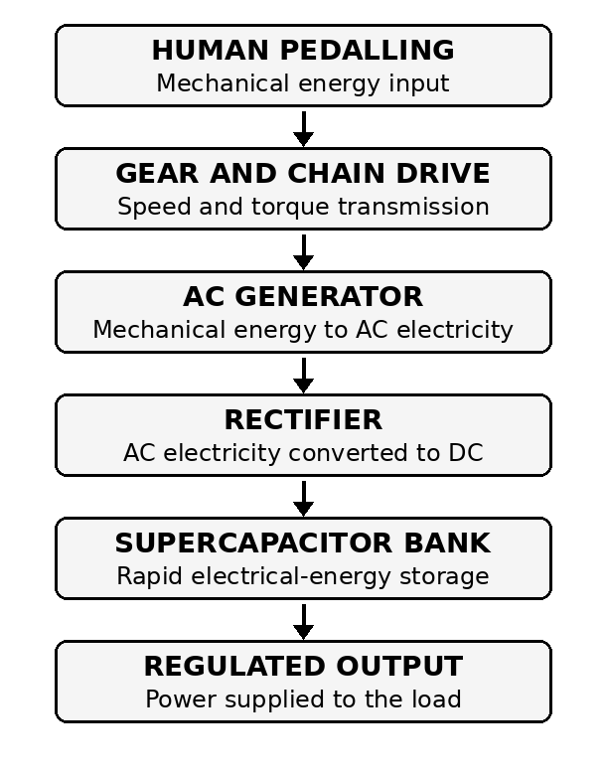
Figure 1: Mechanical energy to electrical energy conversion
In the proposed charger, the user supplies mechanical energy by pedalling. The bicycle crank and gear system transfer rotational motion to a shaft connected to an AC generator. The generator converts the rotational mechanical energy into electrical energy. A rectifier then changes the alternating current to direct current so that the energy can be stored in the supercapacitor bank and used for charging or emergency power applications.
1.2 Aim and Objectives
The overall aim is to design a human-powered charger that uses supercapacitors to store energy rapidly and make electrical power available without depending on a conventional plug-in charging period, sunlight or wind.
1.2.1 To develop a charger concept that converts human pedalling into electrical energy.
1.2.2 To use supercapacitors as the principal energy-storage system.
1.2.3 To reduce charging waiting time from minutes or hours to seconds or a short practical charging period.
1.2.4 To provide immediate power for portable devices and emergency applications.
1.2.5 To integrate voltage and current monitoring through a sensor, Arduino and LCD display.
1.2.6 To maintain portability and a low environmental impact compared with conventional battery-based systems.
1.3 Research Questions and Hypothesis
Primary research question: Can a human-powered supercapacitor charger provide faster and more efficient energy storage and delivery compared with traditional battery-based systems such as e-bikes or solar chargers?
Secondary research question: How does the charge and discharge speed of supercapacitors compare with lithium-ion batteries in human-powered systems?
Hypothesis: A human-powered supercapacitor charger will recharge devices faster and provide greater cycle durability than conventional battery-based systems while maintaining portability and low environmental impact.

2. PROBLEM DEFINITION
2.1 Problem Statement
Traditional energy-storage solutions such as lithium-ion batteries are described in the presentation as slow to charge, environmentally harmful at disposal, and inefficient for instant power delivery. This creates a design need for a sustainable, on-demand electricity-generation and storage system that can be powered by human motion and that can make energy available rapidly.
2.2 Requirements
2.2.1 The design must convert human mechanical energy from pedalling into electrical energy.
2.2.2 The mechanism must include a bicycle frame, pedal drive, gears or chain transmission, shaft and generator.
2.2.3 The electrical system must convert generator AC output into DC for storage.
2.2.4 The design must use a supercapacitor bank as the energy-storage element.
2.2.5 The system must measure current and voltage and display real-time operating information.
2.2.6 The system must include a controller to read sensor information and assist with preventing overcharging.
2.2.7 The charger must be suitable for emergency power, gym, bicycle and off-grid applications.
2.2.8 The concept must remain portable and operable on demand using human effort.
2.3 Constraints
2.3.1 The available output depends on the amount and duration of human pedalling.
2.3.2 The system requires safe AC-to-DC conversion and controlled charging of the supercapacitor bank.
2.3.3 The mass, overall dimensions, production cost, gear ratio, generator rating and component capacities are not fully specified in the supplied presentation and must be confirmed during detailed design.
2.3.4 The presentation provides design-stage charging and discharge estimates that require experimental verification on the completed prototype.
2.3.5 The system must protect the user from moving chains, gears, shafts and electrical connections.
2.4 Criteria
2.4.1 Rapid charging and immediate energy availability.
2.4.2 Reliable conversion from pedalling motion to generator rotation.
2.4.3 Stable supercapacitor charging without overcharging.
2.4.4 Clear display of voltage, current and stored-energy information.
2.4.5 Portability and practical use in locations where grid electricity, sunlight or wind is unavailable.
2.4.6 Durability over repeated charge and discharge cycles.
Table 1: Project requirements, constraints and criteria
Category | Design item | Project interpretation
Requirement | Energy conversion | Human pedalling must drive a generator through a mechanical transmission.
Requirement | Energy storage | Electrical energy must be stored in a supercapacitor bank.
Requirement | Monitoring | Voltage and current must be measured and displayed.
Constraint | Human power | Output depends on user effort and pedalling duration.
Constraint | Incomplete sizing data | Dimensions, mass, cost and exact component ratings were not specified in the presentation.
Criterion | Charging speed | The concept aims for rapid charging and immediate power availability.
Criterion | Portability | The unit should be usable in gyms, emergency settings and off-grid areas.
Criterion | Safety | Moving and electrical components require guarding and controlled operation.

3. SOLUTION SPECIFICATION
This section translates the information in the supplied presentation into a design specification for the overall mechanism. Values not provided by the presentation are identified as items to be determined during detailed design and prototype testing.
3.1 Performance Characteristics
The charger must allow a user to pedal a stationary bicycle and convert that motion into electrical energy. The transmission must rotate the generator, the rectifier must provide DC output, and the supercapacitor bank must receive and store the energy. The current sensor and voltage inputs must provide real-time data to the Arduino, and the LCD must display operating values such as voltage, current and stored energy.
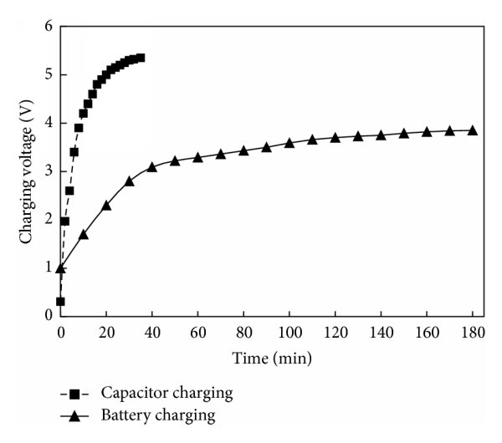
Figure 2: Supercapacitor and battery charging comparison
The graph included in the presentation illustrates the project argument that capacitor charging reaches its operating voltage substantially faster than battery charging. The graph is used as conceptual support for selecting supercapacitor storage; it is not presented as measured data from the proposed prototype.
3.2 Overall Dimensions and Prototype Frame
The supplied presentation includes an AutoCAD concept for the stationary-bicycle frame but does not provide numeric overall dimensions. The design shows a base frame, seat, handle/display support, crank and gear arrangement. Final dimensions must be obtained from the CAD model and checked for user ergonomics, stability and component clearances before fabrication.

Figure 4: AutoCAD prototype frame concept
3.3 Functional Components
Table 2: Solution specification
Specification item | Proposed value or description
Energy source | Human mechanical energy supplied by pedalling.
Mechanical transmission | Driver gear, driven gear, chain, shaft and chain guard.
Generator | AC generator; exact power and speed rating to be confirmed.
Power conversion | Rectifier converts generator AC output to DC.
Storage device | Supercapacitor bank.
Monitoring | Current sensor, voltage input, Arduino and LCD display.
Concept display output | The diagram shows 12.0 V and 1.5 A as example real-time readings.
Calculation input power | 2 kW or 2000 W, as stated in the presentation calculation.
Energy target | 12 V, 1000 mAh, equivalent to 12 Wh.
Supercapacitor data | 3000 F, maximum voltage 15 V and discharge current 20 A.
Charging estimate | 21.6 seconds theoretical; presentation gives 30 seconds to 3 minutes as the practical range.
Discharge estimate | 25 minutes as stated in the presentation.
Overall dimensions | Not provided in the supplied presentation.
Total mass | Not provided in the supplied presentation.
Production cost | Not provided in the supplied presentation.

Table 3: Main components and functions
Component | Function
Pedal and crank | Receive human effort and create rotational mechanical motion.
Driver gear | Transfers motion from the pedal shaft to the chain transmission.
Chain and driven gear | Transmit rotation and adjust generator speed according to the selected gear ratio.
Chain guard | Provides a physical barrier around moving transmission components.
Shaft | Connects the driven mechanical system to the generator.
AC generator | Converts rotational mechanical energy into alternating-current electrical energy.
Rectifier | Converts AC from the generator into DC for storage.
Current sensor | Measures current flowing from the generator toward the supercapacitor system.
Supercapacitor bank | Stores electrical energy electrostatically.
Arduino | Reads voltage and current data, controls energy flow and supports overcharge prevention.
LCD display | Shows real-time values such as voltage, current and stored energy.

3.4 Efficiency, Durability and Maintenance
The supplied presentation describes the concept as faster, durable and environmentally preferable to conventional battery systems, but it does not provide a measured overall efficiency. Prototype efficiency must therefore be determined by comparing human mechanical input with electrical energy delivered to the supercapacitor and to the connected load. Transmission losses, generator losses, rectifier losses, wiring losses and supercapacitor equivalent-series resistance should be included in the test plan.
Durability depends on repeated operation of the frame, bearings, chain, gears, shaft, generator and supercapacitor bank. Maintenance should include chain inspection and lubrication, fastener checks, bearing inspection, electrical-connection inspection, cleaning of the display and controller enclosure, and verification of the supercapacitor balancing and protection system.

4. CONCEPT FORMATION
4.1 Existing Solutions and Inspiration
The concept is inspired by gym bicycles and e-bikes. A gym bicycle already converts human leg movement into continuous rotational motion, while an e-bike demonstrates the integration of electrical components with a bicycle platform. The project adapts these familiar systems for stationary electricity generation and supercapacitor charging rather than transport.

Figure 3: Existing gym-bike and e-bike inspiration
In accordance with the First Law of Thermodynamics, the user does not create energy; instead, chemical energy in the body is converted into mechanical pedalling energy, then into rotational shaft energy and finally into electrical energy. This conversion chain forms the basis of the design.
4.2 Concept One: Mechanical Energy to Electrical Energy
Concept One focuses on the mechanical conversion stage. The user pedals the bicycle, rotating the driver gear. The chain transfers this rotation to the driven gear, and the shaft transmits torque to the AC generator. The chain guard covers the moving transmission. The LCD display is positioned near the user so that system information can be observed during operation.
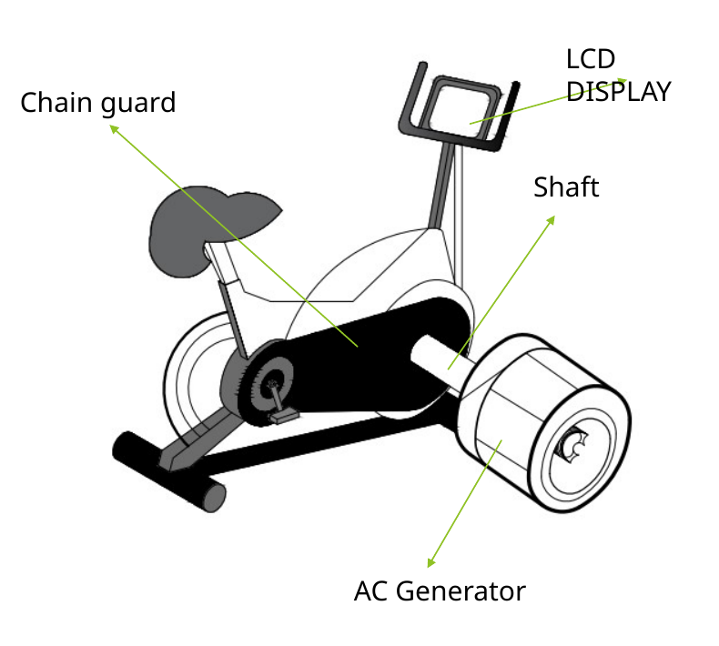
Figure 5: Concept One - mechanical energy conversion system
The driver and driven gears form the principal speed-transfer mechanism. Their tooth numbers and selected ratio determine the generator rotational speed for a given pedalling speed. The presentation labels the two gears but does not specify their tooth counts, pitch or ratio; these details must be selected to match the generator operating range.
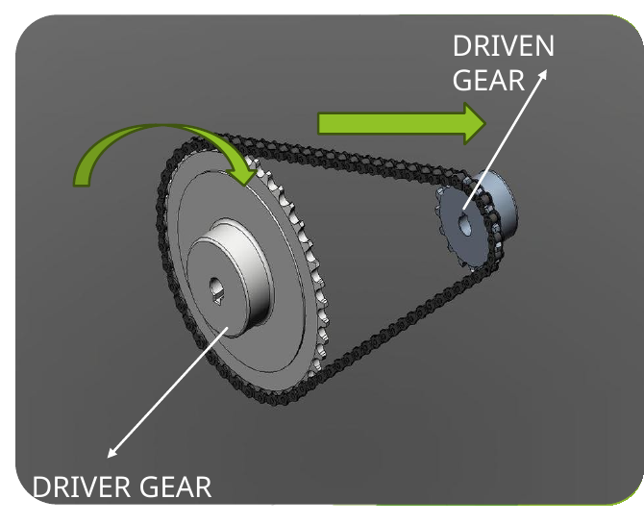
Figure 6: Driver and driven gear system
4.3 Concept Two: Converting AC to DC
Concept Two focuses on electrical conversion, storage, measurement and control. The AC generator produces alternating current. The rectifier converts this output to direct current, allowing the supercapacitor bank to be charged. A current sensor measures the electrical current, while voltage lines provide voltage information. The Arduino reads the sensor data, supports control of the charging process and updates the LCD display.
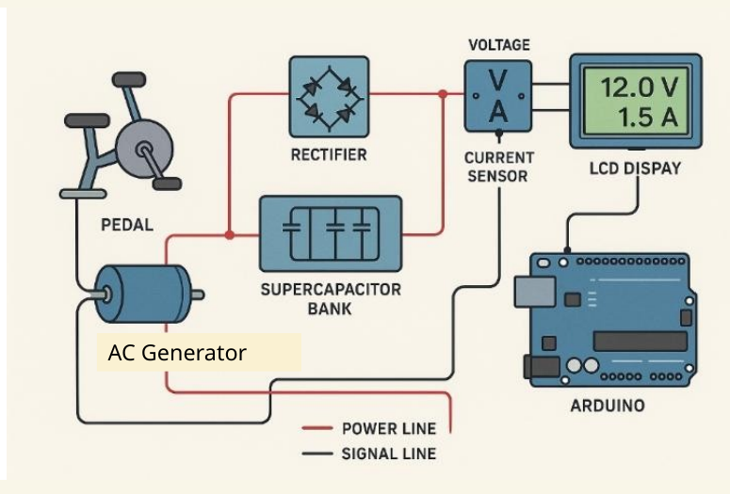
Figure 7: Concept Two - AC-to-DC conversion and monitoring system
The diagram distinguishes the power line from the signal line. The power path carries energy from the pedal-driven generator through the rectifier to the storage system, while the signal path connects the sensors, Arduino and display. The exact protection circuit, voltage-regulation method and supercapacitor balancing arrangement are not shown in the supplied presentation and must be developed in the detailed electrical design.
4.4 Final Concept
The final concept combines Concept One and Concept Two. The stationary bicycle provides the frame and human-power input. The chain-and-gear transmission drives the generator. The generator output is rectified and directed to a monitored supercapacitor storage and output unit. The integrated arrangement is intended to provide immediate, reusable electrical power for charging and emergency applications.
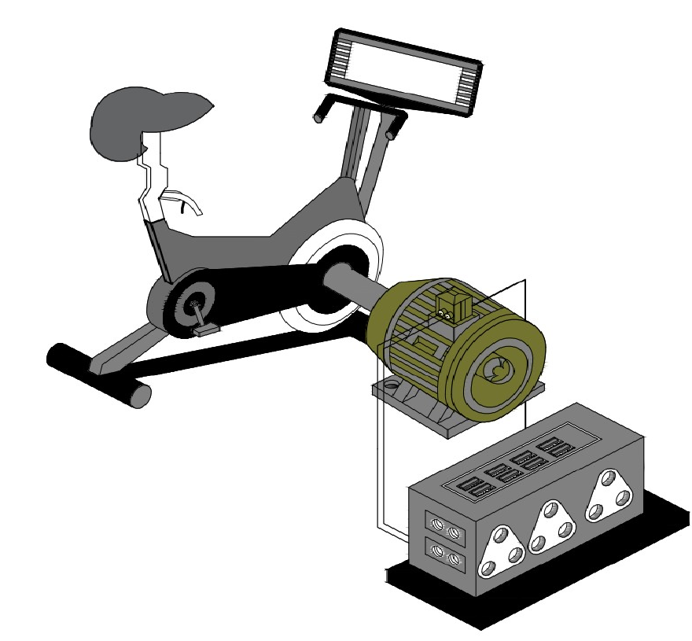
Figure 8: Final integrated concept

5. DISCUSSION OF SOLUTION
5.1 Operating Sequence
5.1.1 The user sits on the stationary bicycle and begins pedalling.
5.1.2 The crank rotates the driver gear and transfers motion through the chain to the driven gear.
5.1.3 The driven gear rotates the shaft connected to the AC generator.
5.1.4 The generator converts rotational mechanical energy into AC electrical energy.
5.1.5 The rectifier converts AC into DC suitable for the supercapacitor bank.
5.1.6 The supercapacitor bank stores the electrical energy electrostatically.
5.1.7 The current sensor and voltage inputs provide measurements to the Arduino.
5.1.8 The Arduino updates the LCD display and supports control of the energy flow to prevent overcharging.
5.1.9 Stored energy is supplied to the intended charging or emergency load through an appropriately regulated output stage.
5.2 Comparison with Existing Bikes
Table 4: Existing e-bike compared with the proposed charger
Feature | E-bike | Human supercapacitor charger
Power source | Pre-charged lithium-ion battery | Human pedalling plus supercapacitors
Charging method | Plug-in charging that takes hours | Charging through motion, described as seconds
Energy recovery | Some models use regenerative braking | Direct energy capture from pedalling
Weight and portability | Heavy due to a large battery | Presented as lighter because supercapacitors are more compact
Best use case | Commuting and fixed-range trips | Emergency power, gyms and off-grid charging

The proposed charger differs from an e-bike because its purpose is electricity generation and storage rather than vehicle propulsion. The user remains stationary and intentionally supplies energy to the generator. The presentation describes this as direct energy capture without waste and identifies emergency power, gyms and off-grid charging as the most suitable applications.
5.3 Comparison with Solar and Wind Power
Table 5: Proposed charger compared with solar and wind power
Feature | Human supercapacitor charger | Solar power | Wind turbine
Energy source | Mechanical energy from human pedalling | Sunlight | Wind
Energy conversion | Pedalling to gears to generator to supercapacitor | Photovoltaic cells to battery | Turbine rotation to generator to battery
Charging speed | Presented as instant | Presented as slow because batteries take hours | Presented as slow because batteries take hours
Power output | Moderate and dependent on human effort | Variable and dependent on sunlight | Variable and dependent on wind
Portability | Highly portable and usable wherever motion is available | Requires sunlight exposure | Requires consistent wind
Low-condition performance | Works on demand | Unavailable at night and reduced in cloudy conditions | Unavailable in low-wind conditions
Best use case | Gyms, bicycles and emergency power | Homes and off-grid systems | Large-scale energy farms

The key advantage claimed for the human-powered concept is availability on demand. Unlike solar and wind systems, it does not require a specific environmental condition. Its limitation is that the electrical output is moderate and depends directly on the user effort that can be sustained.
5.4 Target Audience
Hospitals and emergency scenarios: The presentation proposes hand-crank or pedal-powered charging for emergency lights, phones, radios and selected portable medical equipment when normal electricity is unavailable.
Gyms and fitness areas: Energy produced during exercise could be used in real time for phone-charging stations, lighting or fans.
Off-grid and remote areas: The unit is intended to charge phones, LED lights and small devices without relying on grid electricity, sunlight or wind.
Any use with medical equipment must be subject to appropriate electrical safety, output regulation, equipment compatibility and clinical approval. The supplied presentation identifies the application area but does not provide a medical-device compliance design.

6. DESIGN CALCULATIONS
6.1 Energy Requirement and Charging Time
The presentation specifies a 12 V, 1000 mAh energy requirement. Since 1000 mAh is equal to 1 Ah, the required energy is calculated as follows:
Energy = Voltage x Capacity
Energy = 12 V x 1 Ah = 12 Wh
Using the presentation input-power value of 2 kW or 2000 W, the ideal charging time is:
Charging time = Energy / Power
Charging time = 12 Wh / 2000 W = 0.006 h
Charging time = 0.006 x 3600 = 21.6 seconds
The presentation therefore states a proposed practical charging interval of approximately 30 seconds to 3 minutes. The difference between the ideal result and the proposed practical range allows for losses and operating conditions, although those losses are not quantified in the supplied material.
6.2 Supercapacitor Discharge Estimate
The supercapacitor design data shown in the presentation are:
6.2.1 Capacitance: 3000 F.
6.2.2 Maximum voltage: 15 V.
6.2.3 Discharge current: 20 A.
6.2.4 Estimated discharge duration stated in the presentation: 25 minutes.
The exact discharge equation, usable voltage range, conversion losses and load-voltage requirement are not fully shown in the supplied presentation. The 25-minute value must therefore be treated as a design estimate and verified using the actual supercapacitor configuration, regulated output and prototype load.
6.3 Calculation Summary
Table 6: Design calculation summary
Parameter | Value in presentation | Comment
Load voltage | 12 V | Target charging voltage.
Load capacity | 1000 mAh or 1 Ah | Used to calculate 12 Wh.
Energy required | 12 Wh | 12 V x 1 Ah.
Input power | 2 kW or 2000 W | Presentation design input.
Ideal charging time | 21.6 seconds | 12 Wh divided by 2000 W.
Proposed practical charging range | 30 seconds to 3 minutes | Stated in the presentation.
Supercapacitor capacitance | 3000 F | Storage parameter.
Maximum supercapacitor voltage | 15 V | Storage voltage limit.
Discharge current | 20 A | Presentation discharge-current value.
Estimated discharge duration | 25 minutes | Requires prototype verification.

7. CONCLUSION
This project demonstrates a design concept in which human-powered mechanical energy is combined with supercapacitor technology to provide an alternative to conventional battery-based charging systems. The concept uses a stationary bicycle, gear and chain transmission, shaft and AC generator to convert pedalling into electricity. A rectifier, current sensor, Arduino, LCD display and supercapacitor bank form the electrical conversion, control, monitoring and storage system.
The presentation supports the hypothesis that supercapacitors can provide rapid energy storage and delivery, with potential advantages in charging speed, cycle durability, portability and on-demand operation. The design is particularly intended for emergency power, gym and off-grid applications where the user can produce energy independently of sunlight, wind or an existing charged battery.
The final concept successfully combines the two main design stages: mechanical-to-electrical conversion and AC-to-DC storage and control. However, the supplied presentation remains at concept level. Overall dimensions, mass, cost, gear ratio, generator rating, protection components, measured efficiency, output regulation and verified performance must still be developed and tested before the design can be considered complete.

8. RECOMMENDATIONS
8.1 Complete the detailed AutoCAD model and specify all frame dimensions, shaft sizes, bearings, gear geometry, chain size and component mounting positions.
8.2 Select a realistic human-power input range and match the gear ratio and generator rating to the expected pedalling speed and torque.
8.3 Design a complete electrical protection circuit including voltage regulation, current limiting, fusing, reverse-polarity protection and supercapacitor balancing.
8.4 Confirm the supercapacitor series-parallel arrangement needed to achieve the required voltage, capacitance and energy capacity.
8.5 Provide guards around the chain, gears, shaft couplings and generator drive, and ensure that no sharp or rotating parts are accessible to the user.
8.6 Measure mechanical input power, generator output, rectifier output, stored energy, charging time, discharge time and overall efficiency during prototype testing.
8.7 Verify the stated charging and discharge estimates under realistic human pedalling and electrical-load conditions.
8.8 Develop a regulated and isolated output interface suitable for the specific devices to be charged.
8.9 Prepare a bill of materials, mass calculation, production-cost estimate and manufacturing plan before fabrication.
8.10 Conduct user testing in gym, emergency and off-grid scenarios and document comfort, usability, reliability and safety findings.
8.11 Do not connect the prototype to medical equipment until all relevant electrical safety, compatibility and approval requirements have been met.

9. REFERENCES
1. Prototypes Promise Lower Cost, Faster Charging, and Greater Safety. IEEE Power Electronics Magazine, 2020, 7, 16-19.
2. Gonzalez, A., Smith, B., & Lee, C. (2016). Advanced Energy Storage Systems: Supercapacitors and Batteries (2nd ed.). Springer.
3. Forse, A. C., Merlet, C., Griffin, J. M., & Grey, C. P. (2016). New perspectives on the charging mechanisms of supercapacitors. Journal of the American Chemical Society, 138(22), 6514-6517.
4. MIT Media Lab. (2023). Human-Powered Energy Harvesting in Gym Environments (Technical Report MIT-ML-2023-017).
5. Simon, P., & Gogotsi, Y. (2008). Materials for electrochemical capacitors. Nature Materials, 7(11), 845-854.
6. Review of Energy Storage System Technologies in Microgrid Applications: Issues and Challenges. IEEE Access, 2018, 6, 35143-35164.
7. Katsanevakis, M., Stewart, R. A., & Lu, J. (2017). Aggregated applications and benefits of energy storage systems with application-specific control methods: A review. Renewable and Sustainable Energy Reviews, 75, 719-741.
8. Salaheldeen, M., Abu-Dief, A. M., & El-Dabea, T. (2025). Functionalization of Nanomaterials for Energy Storage and Hydrogen Production Applications. Materials, 18, 768.
9. Gortz, J., Aouad, M., Wieprecht, S., & Terheiden, K. (2022). Assessment of pumped hydropower energy storage potential along rivers and shorelines. Renewable and Sustainable Energy Reviews, 165, 112027.
10. Hamidah, I., Ramdhani, R., Wiyono, A., Mulyanti, B., Pawinanto, R., Hasanah, L., Diantoro, M., Yuliarto, B., Yunas, J., & Rusydi, A. (2023). Biomass-Based Supercapacitor Electrodes for Electrical Energy Storage Systems Activated Using Chemical Activation Method: A Literature Review and Bibliometric Analysis. Indonesian Journal of Science and Technology, 8, 439-468.
11. Scrosati, B., & Garche, J. (2010). Lithium batteries: Status, prospects and future. Journal of Power Sources.
12. International Renewable Energy Agency (IRENA). (2020). Renewable Power Generation Costs.
13. Electrical Double Layer Capacitors: Comparison with PANI Pseudocapacitors. ChemSusChem, 2023, 16, e202202057.

APPENDIX A: STUDENT ENGAGEMENT
The project was developed for the CPUT STEM Club Expo Competition by Shongwe Prince Njabulo (231258291) and Sindane Mandlenkosi (240771761). The project activities represented in the supplied presentation include problem identification, background research, comparison of energy-storage technologies, research-question development, AutoCAD prototype-frame design, mechanical concept formation, AC-to-DC electrical concept formation, design calculations, target-audience analysis and preparation of the final integrated concept.
Further engagement should include allocation of responsibilities for detailed mechanical design, electrical design, procurement, fabrication, programming, testing, safety assessment, data analysis and final presentation. Test results should be recorded so that the final report distinguishes measured prototype performance from initial design estimates.

APPENDIX B: PRODUCTION AND MANUFACTURING DETAILS
The supplied presentation provides a conceptual AutoCAD frame and component arrangement but does not provide a manufacturing drawing set, bill of materials, tolerances, material grades, welding requirements, machining processes, production cost or assembly sequence. These items must be developed before fabrication.
B.1 Prepare detailed drawings for the base frame, seat support, handle/display support, generator mount, shaft supports and electrical enclosure.
B.2 Specify materials and manufacturing processes for every structural and rotating component.
B.3 Specify bearings, shafts, keys, couplings, gears, chain, sprockets, guards and fasteners using calculated loads and speeds.
B.4 Prepare an electrical schematic and enclosure layout for the rectifier, sensor, Arduino, LCD, protection circuit and supercapacitor bank.
B.5 Develop an assembly sequence, inspection checklist and prototype test procedure.

APPENDIX C: CALCULATIONS
C.1 Energy required for the stated 12 V, 1000 mAh load:
Capacity = 1000 mAh = 1 Ah
Energy = 12 V x 1 Ah = 12 Wh
C.2 Ideal charging time using the stated 2000 W input:
Time = 12 Wh / 2000 W = 0.006 h
Time = 0.006 x 3600 = 21.6 seconds
C.3 Supercapacitor information from the presentation:
Capacitance = 3000 F; maximum voltage = 15 V; discharge current = 20 A; stated discharge duration = 25 minutes.
The presentation does not fully show the assumptions, usable voltage range, efficiency losses or complete equation used for the 25-minute discharge estimate. This value must be verified during detailed electrical design and prototype testing.

APPENDIX D: REGULATIONS AND STANDARDS
The supplied presentation does not identify specific regulations or standards. Before prototype fabrication and public demonstration, the project team should identify the standards applicable to stationary exercise equipment, rotating machinery guarding, low-voltage electrical systems, battery or capacitor energy-storage assemblies, electromagnetic compatibility, wiring, enclosures and product safety. Any intended medical application requires a separate compliance assessment and must not be assumed from the concept presentation.
A documented risk assessment should be completed for mechanical entanglement, pinch points, unstable mounting, electrical shock, short circuit, excessive current, overvoltage, component overheating, stored-energy release and emergency stopping. The selected standards and mitigation measures should be listed in the final detailed-design report.

