Polygenic risk score analysis with PRSice
To perform polygenic risk score analysis we suggest to use PRSice (http://prsice.info). In this tutorial we provide a step-by-step guide to perform a simple polygenic risk score analysis using PRSice and explain how to interpret the results. For additional information we refer to the PRSice user manual.

Installation of PRSice
PRSice is an R program that can be run in Unix, Linux and Mac OS from the command line. The code used in this tutorial used PRSice version 1.23 and was tested on R version 3.2.2. An installation of PRSice requires
First download and unpack the PRSice software with the following code on the command line.
wget http://prsice.info/PRSice_v1.23.zip
unzip PRSice_v1.23.zip
If you enter the newly created PRSice_v1.23 directory you see the PRSice R script (PRSice_v1.23.R), binary files (for linux and mac) of plink1.9 (also known als plink2), user documentation, and toy datasets to perform a polygenic risk analysis.
cd PRSice_v1.23
ls
In addition, PRSice requires the following R packages to be preinstalled:
- ggplot2
- plyr
- batch
- fmsb
- gtx
Make sure you have writing permissions to install R packages in the default location. In that case the following code should suffice to install all required dependencies. You will be prompted to choose a site from where to download the packages.
Rscript -e 'install.packages(c("ggplot2","plyr","batch","fmsb","gtx"))'
If the installation does not succeed, you can try to install the dependencies in a subfolder of PRSice with the following code.
mkdir Rdependencies
Rscript -e 'install.packages(c("ggplot2","plyr","batch","fmsb","gtx"), lib="./Rdependencies")'

Running a polygenic risk score with PRSice
To run a polygenic risk score analysis on the toy data provided with PRSice run the following code.
Rscript PRSice_v1.23.R -q --args \
plink ./plink_1.9_linux_160914 \
base TOY_BASE_GWAS.assoc \
target TOY_TARGET_DATA \
slower 0 \
sinc 0.01 \
supper 0.5
The plink parameter specifies where PRSice can find the correct plink executable with which to perform the analysis. Change this to the Mac executable if appropriate. The base parameter refers to the file with summary statistics from the base sample (also known as discovery or training samples). These summary statistics contain for each genetic variant at least an effect size and p-value. The target parameter refers to the prefix of the files (without file extension) that contain the genotype data in binary plink format (i.e., .bed,.bim,.fam file extensions) (also known as validation or test samples). This target sample should be completely independent from the base sample that was used to compute the summary statistics. Sample overlap across the discovery and target sample will greatly inflate the association between the polygenic risk score and the disease trait. The last three parameters indicate that several polygenic risk score analyses are performed with p-value thresholds from 0 to 0.5 with steps of 0.1. That is, in each risk score analysis only SNPs with a below a particular threshold in the base sample are used in the prediction model.
For the purposes of this tutorial we run the polygenic risk score analysis in PRSice folder where the toy data resides. In more realistic settings the data is likely to be in a separate folder and you can add another line of code with the parameter 'wd data-directory' to change the working directory of PRSice to data-directory. This will also be the directory where PRSice saves its results. Note that `\` characters are used to break up the code in different lines. If you add parameters do not forget to add `\` to all lines except the last one.
By default, PRSice assumes a dichotomous trait within plink target files. In addition, if no covariates are added, PRSice automatically computes ancestry informative principal dimensions (using he MDS approach) from the target data and uses the first two dimensions as covariates. Principal dimensions are somewhat different from ancestry informative principal components, but similar in spirit.
Instead of performing a polygenic risk score analysis on all genetic variants it is customary to clump first. In clumping, within each block of correlated SNPs the SNP with the lowest p-value in the discovery set is selected and all other SNPs are ignored in downstream analyses. This clumping procedure is performed by PRSice automatically, but can be adjusted with several clumping parameters. Although many other options exist, we refer to the PRSice user manual for more detailed information about the program.

Interpreting the results
By default, PRSice saves two plots and and several text files. The first plot is PRSice_BARPLOT_<date>.png (Figure S1). This plot shows the predictive value (Nagelkerke's ) in the target sample of models based on SNPs with p-values below specific thresholds in the base sample. In addition, for each model, a p-value is provided for the null hypothesis that the respective . As Figure S1 shows, a model using SNPs with a p-value up to 0.45 achieves the highest predictive value in the target sample with a p-value of . However as is often the case in polygenic risk scores analysis with relatively small samples, the predictive value is relatively low (Nagelkerke around 5%). The text files include the exact values for each p-value threshold. Figure S2 shows for many different p-value thresholds the p-value of the predictive effect () in black together with an aggregated trend line in green.
Both figures show that many SNPs that affect the trait in the base sample can be used to predict the trait in the target sample. Note that the two traits can be either the same or different. If the same trait is used the predictive value is related to the heritability of the trait (as well as the sample size of the base sample). If different traits are analyzed, the predictive value is also related to the genetic overlap between the two traits. Either way, polygenic risk score analysis typically shows that models with lenient p-value thresholds often predict better than models with more stringent thresholds, suggesting that many statistically insignificant SNPs still have predictive value in polygenic traits.
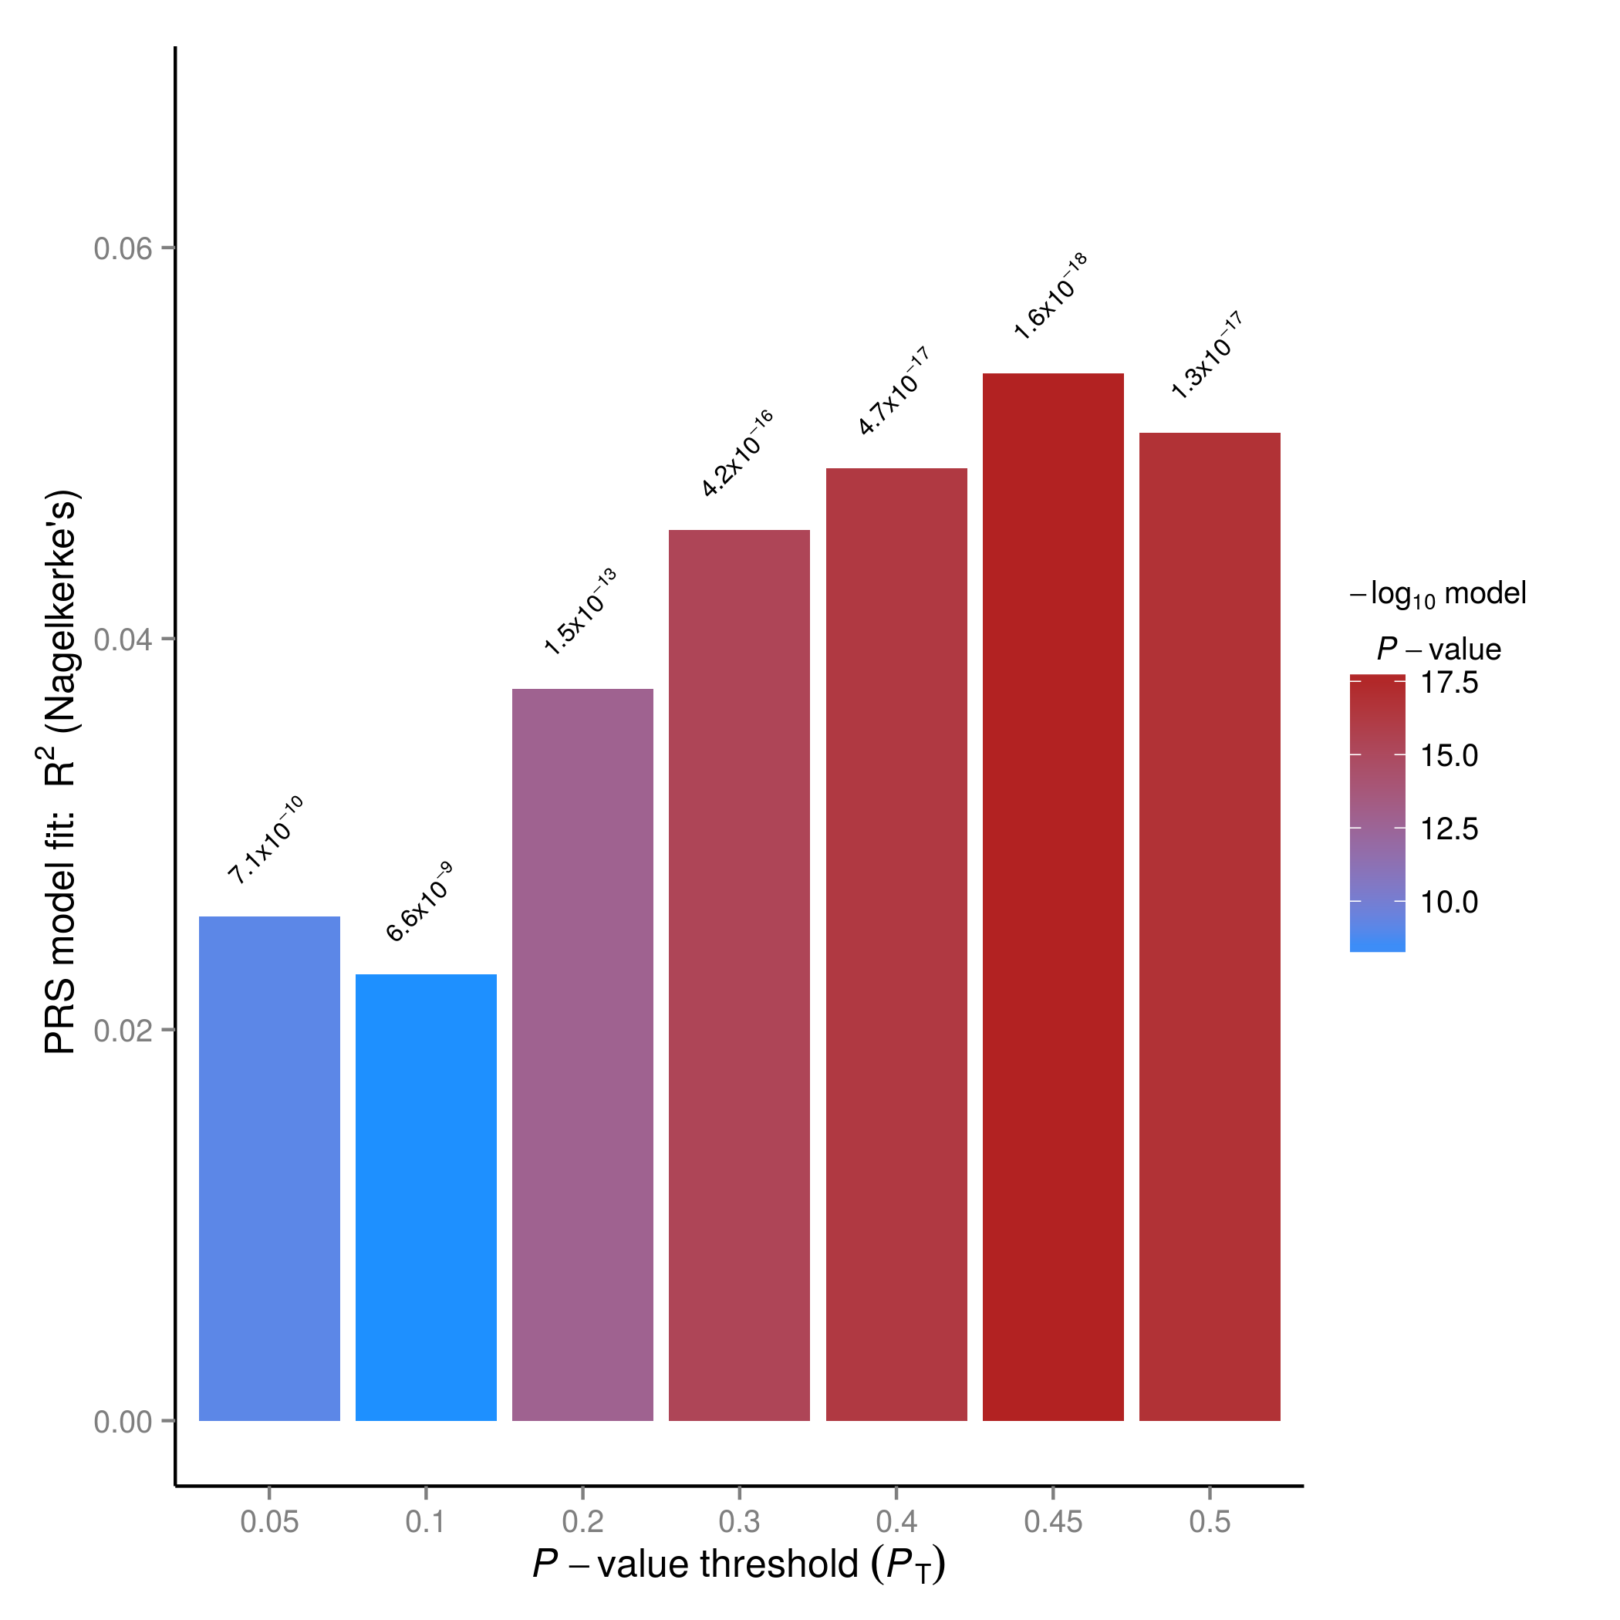
Figure S1. Default PRSice barplot. Nagelkerke R2 and p-value as a function p-value threshold in discovery sample.
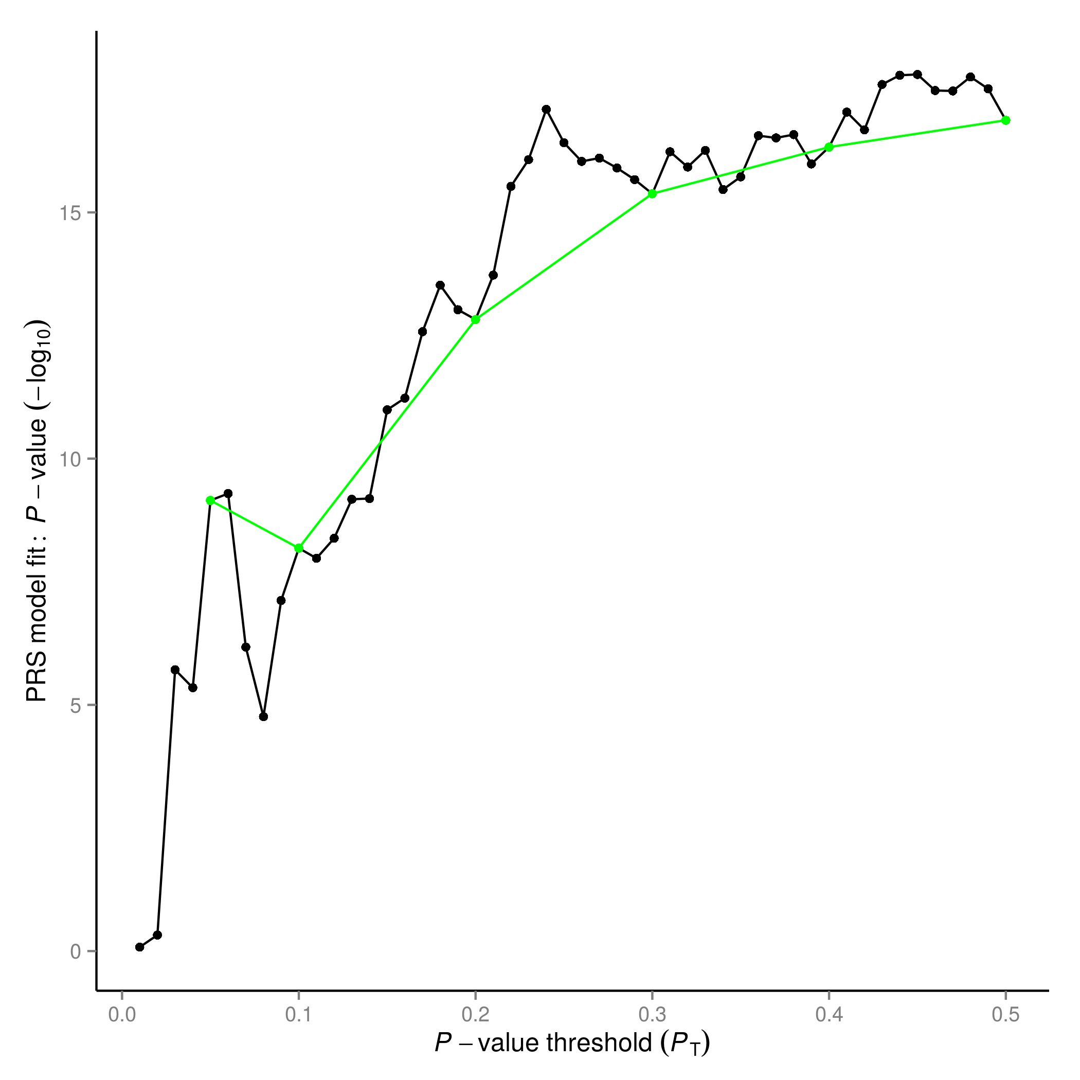
Figure S2. Default PRSice high resolution plot. P-value as a function of predictive p-value (black) together with a trend line (green).

Conclusion
In this tutorial we discussed how to perform a simple polygenic risk score analysis using the PRSice script and how to interpret its results. When PLINK genotype target files are available, PRSice provides a relatively easy way of performing polygenic risk score analysis. As mentioned before, PRSice offers many additional options to adjust the risk score analysis, including adding covariates and additional principal components and adjusting clumping parameters. We therefore recommend reading the user manual of PRSice to perform a polygenic risk score analysis optimal to the research question at hand.

