**Retrieve and Upload Hardware Hash during OOBE**

Steps to retrieve and upload Hardware Hash during OOBE:

1. Make sure that the device has an internet connection – make sure the cable is plugged in
2. Start the computer and wait for it to go into OOBE stage (region settings etc.).
3. 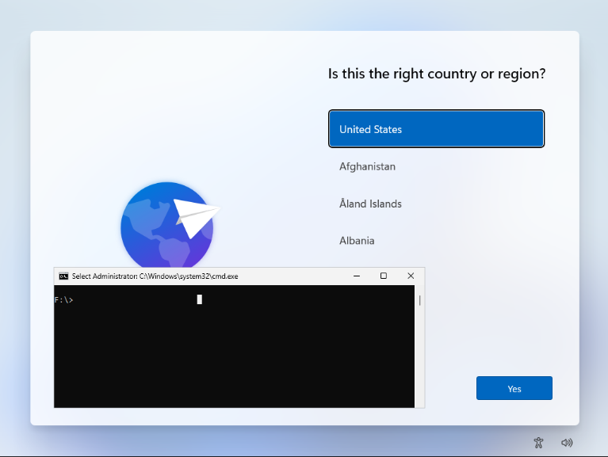Press **SHIFT + F10** in order to open CMD.
4. Execute commands below, when prompted type a letter **Y** and hit **Enter** to continue

***PowerShell.exe -ExecutionPolicy Bypass***

***Install-Script -name Get-WindowsAutopilotInfo -Force***

***Set-ExecutionPolicy -Scope Process -ExecutionPolicy RemoteSigned***

***Get-WindowsAutopilotInfo -Online***

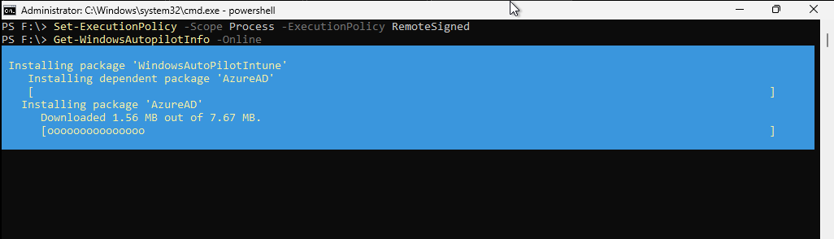

1. 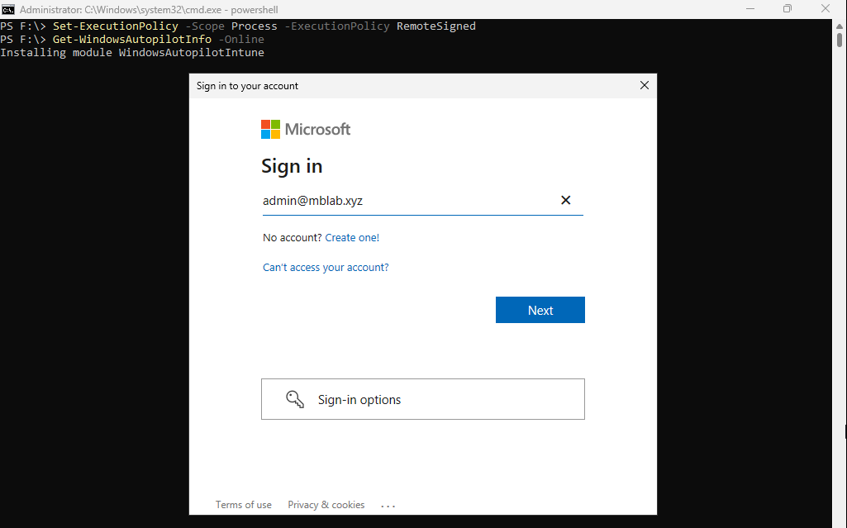During the script a prompt will show up, make sure you sign in with the account dedicated for device registrations
2. 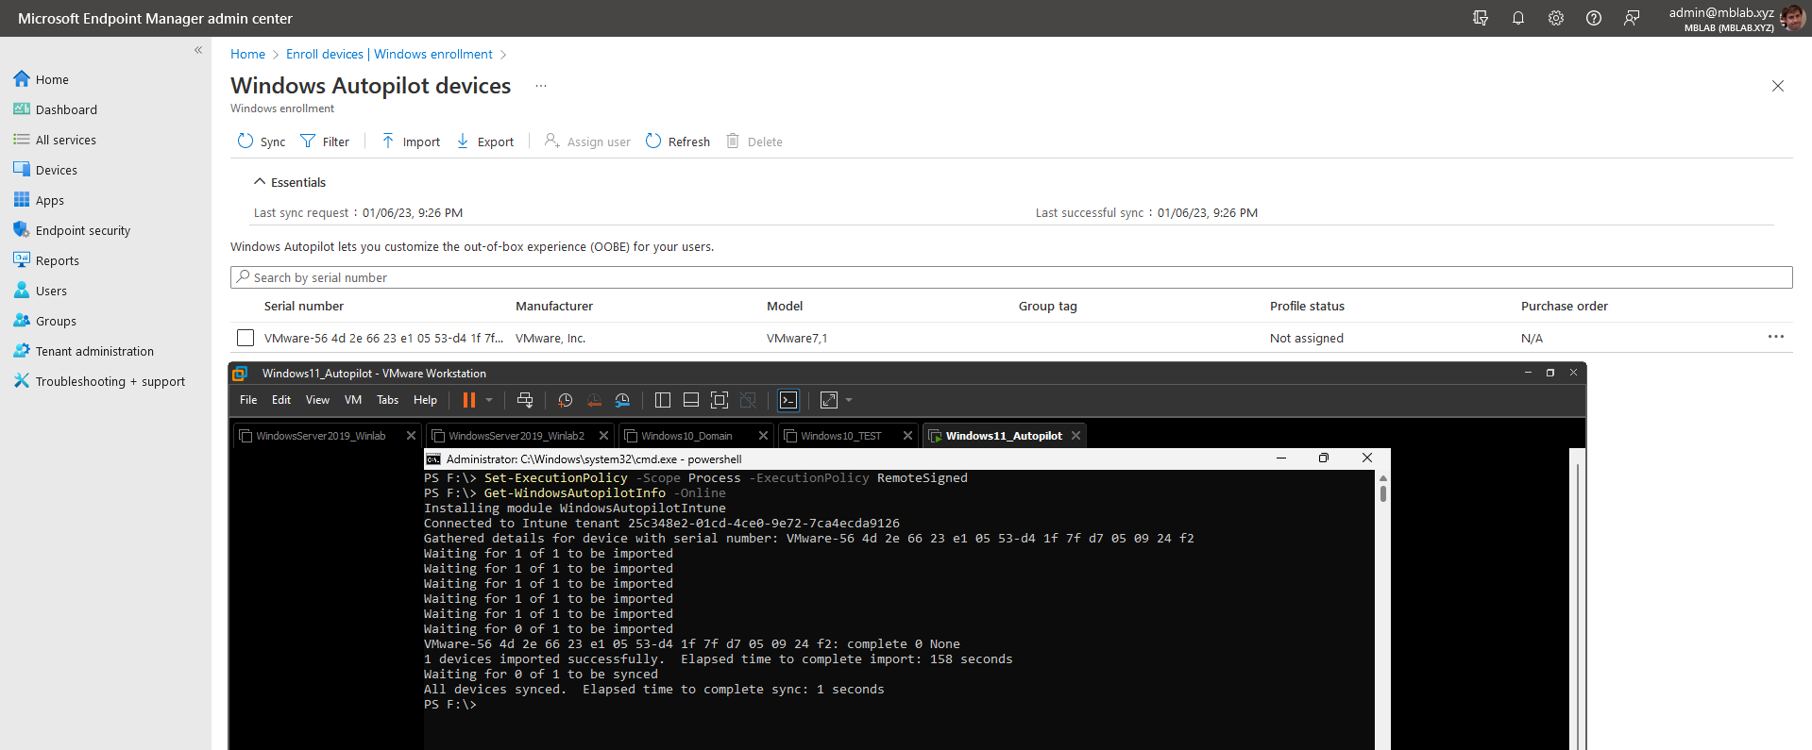After sign in, the script will upload hardware hash of the device to Autopilot, you can confirm that by checking Windows Enrolment section in MEM admin console
3. After a confirmation, restart the device and start the OOBE.