STATIVE & DYNAMIC VERBS

PRACTICE

EXERCISE 1. Put the verbs in brackets into the present simple or present continuous. 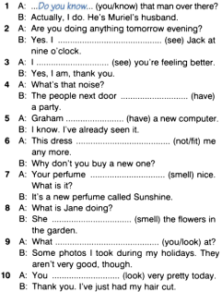 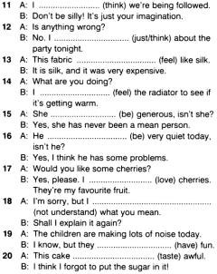EXERCISE 2. Choose the correct alternative.

