**Time expressions - In, At, On**

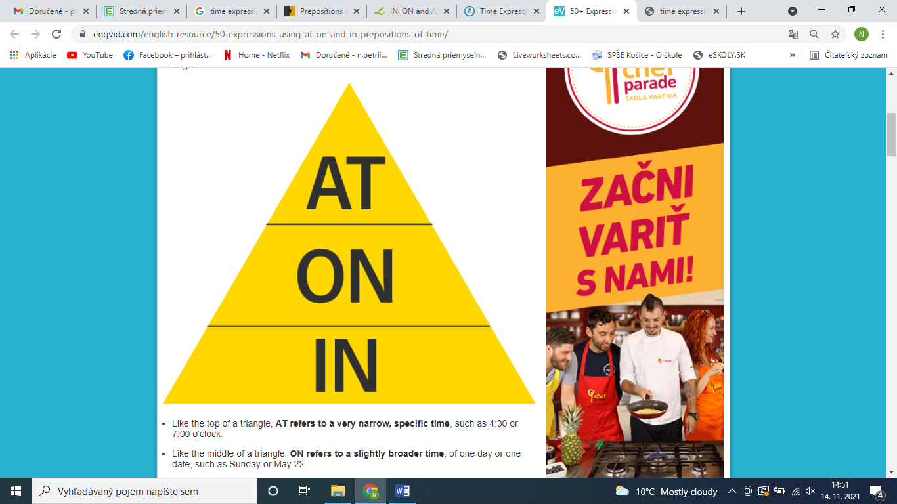

**AT**

At 10 o’clock

At midday

At noon

At dusk

At dawn

At night

At the weekend

At Christmas

At Easter

At the moment

At that time

At the beginning

At the end

At breakfast

At dinnertime

**ON**

On Monday

On January 3rd

On the 10th

On the first day

On the last day

On my birthday

On Christmas day

On East day

On holiday

On my wedding day

On that day

on Saturday night

On a Summer evening

**IN**

In the morning

In the afternoon

In the evening

In January

In December

In the Summer

In 1970

In the 1990’s

In the seventies

In the 20st century

In the past

In the future

In 15 year’s time

In the Christmas holiday

In two hours

• The train leaves ___ five minutes, hurry up.  
at     in     on

• I'm going to America ___ April.  
at     in     on

• He doesn't work ___ Sundays or Mondays.  
at     in     on

• In England the shops shut ___ 5:30.  
at     in     on

• She never feels very good ___ the morning.  
at     in     on

• She is starting work ___ June 4th.  
at     in     on

• What do you do ___ the evenings?  
 at      in      on

• I can't sleep ___ night these days.  
 at      in      on

• Where are you going ___ the summer?  
 at      in      on

• He was born ___ 1966.  
 at      in      on

• The school is closed _______ Sunday.  
 at      in      on

• I wake up ____ 6 am everyday.  
 at      in      on

• Kim was born ____ 1981.  
 at      in      on

• I go to sleep ____ night.  
 at      in      on

• She will go to her friend's house ____ Tuesday.  
 at      in      on

• Jack and Jill play ___ the same time.  
 at      in      on

• Christopher will come back ___ a week.  
 at      in      on

• My birthday comes ___ December.  
 at      in      on

• Sheila will give a nice greeting card to her mother ____ Mother's Day.  
 at      in      on

• The school prayer starts ____ 8 a.m.  
 at      in      on

• We wear warm clothes ____ winter.  
at     in     on

• Mary is celebrating her birthday ____ May 3.  
at     in     on

• I will see you ____ the morning.  
at     in     on

• I will come and visits you ____ the Christmas holidays.  
at     in     on

• I completed my work ____ two hours.  
at     in     on