Future Tenses

Will
We use will:
- when we express beliefs about the future:
It will be a nice day tomorrow.
I think Brazil will win the World Cup.
I'm sure you will enjoy the film.
- to mean want to or be willing to:
I hope you will come to my party.
George says he will help us.
- to make offers and promises :
I'll see you tomorrow.
We'll send you an email.
- We use the Future Simple tense when there is no plan or decision to do something before we speak. We make the decision spontaneously at the time of speaking. The decision is made at the time of speaking.
Hold on. I'll get a pen.
We will see what we can do to help you.

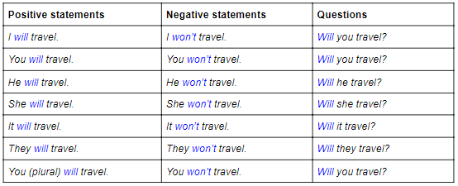

Shall
We can use shall instead of will for future time references with I and we. However, it is slightly more formal.
E.g. We shall never forget this beautiful day.
It is also common to use shall in questions to make offers, suggestions or ask for advice.
E.g. Shall I carry these bags for you?
Shall I open the window?
What shall I tell Mary about the broken vase?

Going to
We use be going to:
- to talk about plans or intentions:
I'm going to drive to work today.
They are going to move to Manchester.
- to make predictions based on evidence we can see:
Be careful! You are going to fall. (= I can see that you might fall.)
Look at those black clouds. I think it's going to rain. (= I can see that it will rain.)

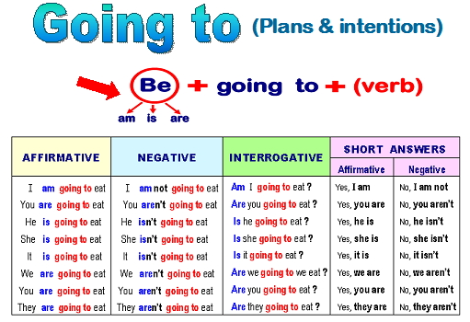
Present Continuous
We can use the present continuous for plans or arrangements:
I'm playing football tomorrow.
They are coming to see us tomorrow.
We're having a party at Christmas.

