Time expressions - In, At, On

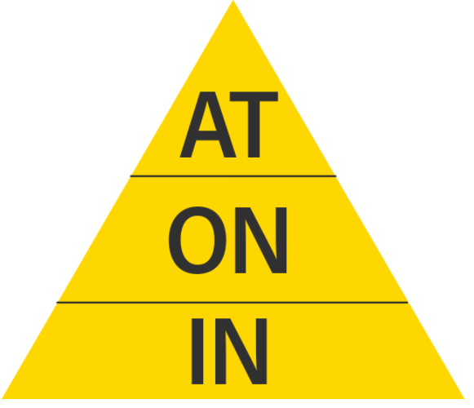
AT
At 10 o’clock
At midday
At noon
At dusk
At dawn
At night
At the weekend
At Christmas
At Easter
At the moment
At that time
At the beginning
At the end
At breakfast
At dinnertime

ON
On Monday
On January 3rd
On the 10th
On the first day
On the last day
On my birthday
On Christmas day
On East day
On holiday
On my wedding day
On that day
on Saturday night
On a Summer evening

IN
In the morning
In the afternoon
In the evening
In January
In December
In the Summer
In 1970
In the 1990’s
In the seventies
In the 20st century
In the past
In the future
In 15 year’s time
In the Christmas holiday
In two hours

• The train leaves ___ five minutes, hurry up.
at in on
• I'm going to America ___ April.
at in on
• He doesn't work ___ Sundays or Mondays.
at in on
• In England the shops shut ___ 5:30.
at in on
• She never feels very good ___ the morning.
at in on
• She is starting work ___ June 4th.
at in on
• What do you do ___ the evenings?
at in on
• I can't sleep ___ night these days.
at in on
• Where are you going ___ the summer?
at in on
• He was born ___ 1966.
at in on
• The school is closed _______ Sunday.
at in on
• I wake up ____ 6 am everyday.
at in on
• Kim was born ____ 1981.
at in on
• I go to sleep ____ night.
at in on
• She will go to her friend's house ____ Tuesday.
at in on
• Jack and Jill play ___ the same time.
at in on
• Christopher will come back ___ a week.
at in on
• My birthday comes ___ December.
at in on

• Sheila will give a nice greeting card to her mother ____ Mother's Day.
at in on
• The school prayer starts ____ 8 a.m.
at in on
• We wear warm clothes ____ winter.
at in on
• Mary is celebrating her birthday ____ May 3.
at in on
• I will see you ____ the morning.
at in on
• I will come and visits you ____ the Christmas holidays.
at in on
• I completed my work ____ two hours.
at in on

