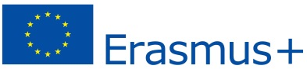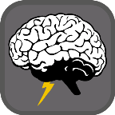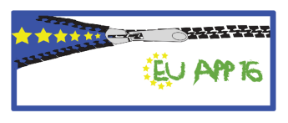**Documentation BRAIN STORM**

MEETING IN BRNO 6.11-10.11.2017

**Coordinator:**

Natalia Szczygieł

**Programers:**

Joseph Adam Saunders

Peter Novotný

Norbert Zapora

**Documentation:**

Ilyas Bal

Lucas Kössler

Rebecca Sambataro

**Monday**

We learned about databases, relational databases and SQL.

We also created a SQL file for our application.

We also went for task-based sightseeing in Brno city.

**Tuesday**

We learned how to use databases and used the Arduino to messure temperatures at the Macocha cave.

**Wednesday**

Visited Redhat and learned something about Unix/Linux.

We also evaluated the temperature data from the Arduino and created a Microsoft Exel file with the data.

**Thursday**

We learned about the difference between the Arduino and the Rasberry Pi.

Checked that our application runs(fixed some bugs) and started to implement the database.

Started to create a presentation and a documentation.

**Friday**

Finish our presentation and documentation and present our results.