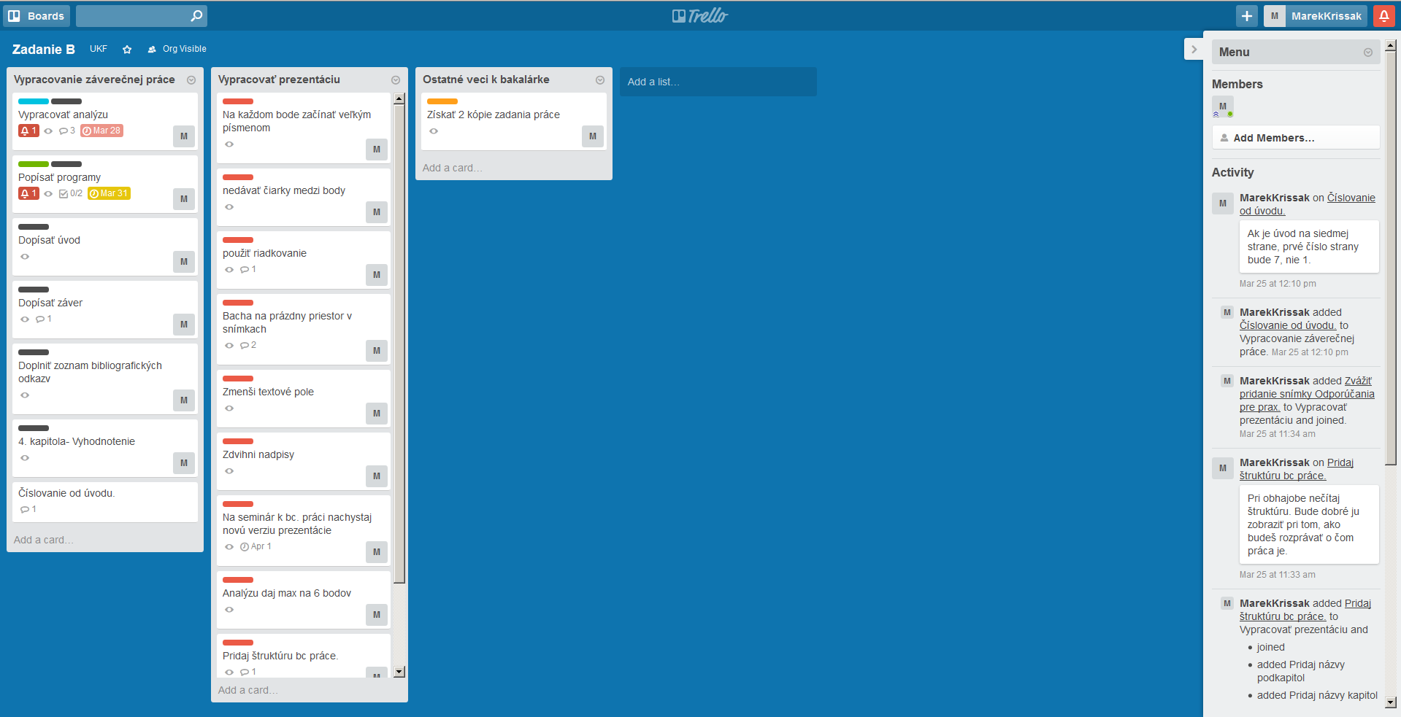

Obr. Zobrazenie nástenky

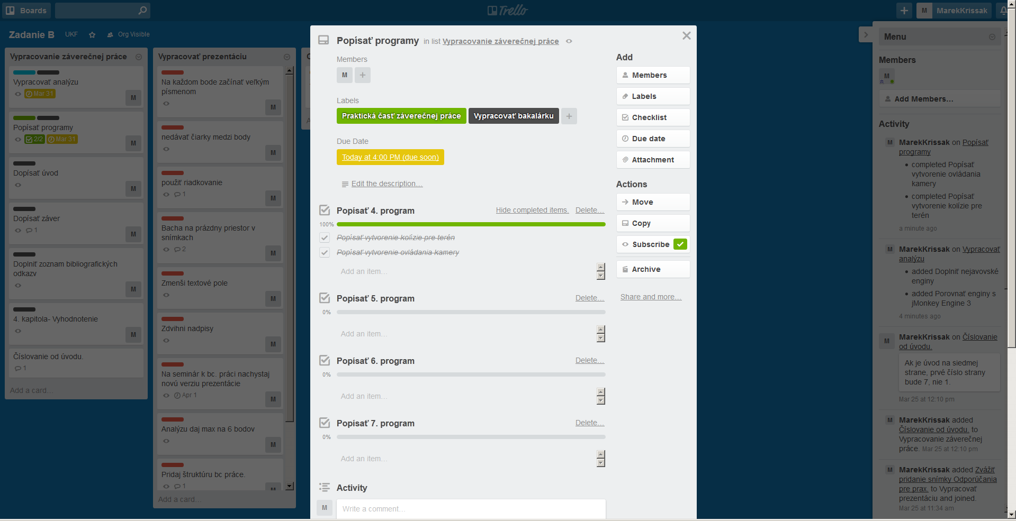

Obr. 2 Využitie checklistov, labels, members, due date

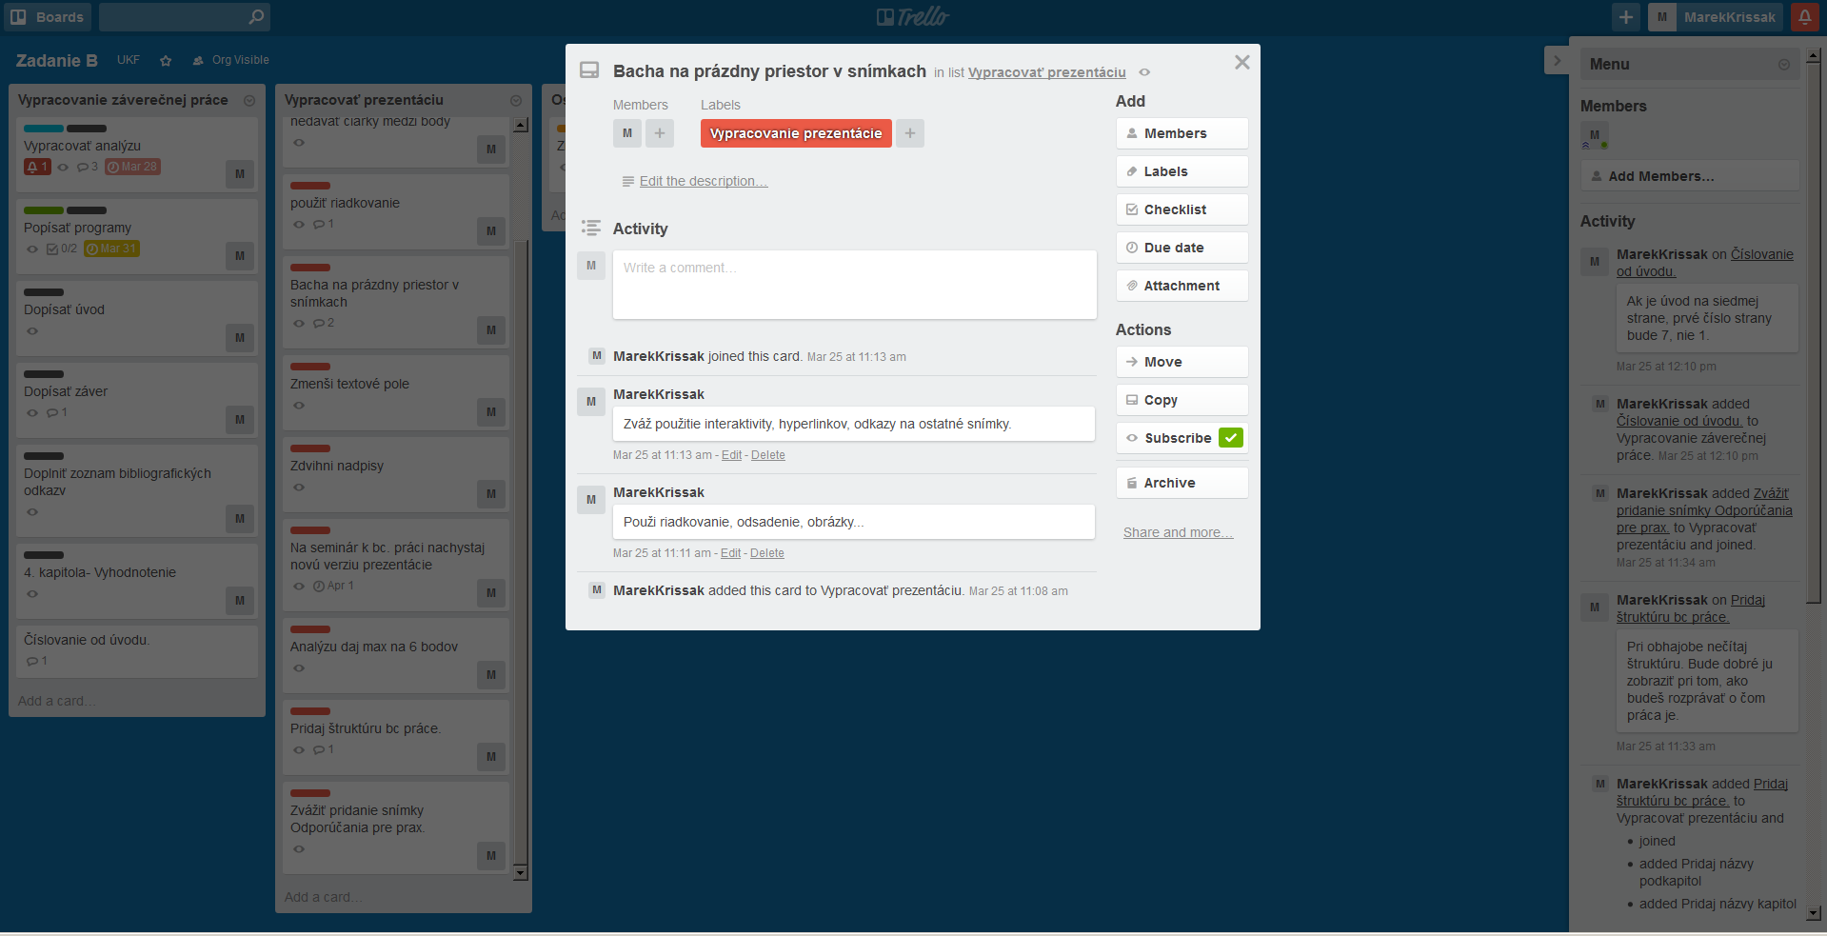

Obr. 3 Využitie Members, Labels, Activity

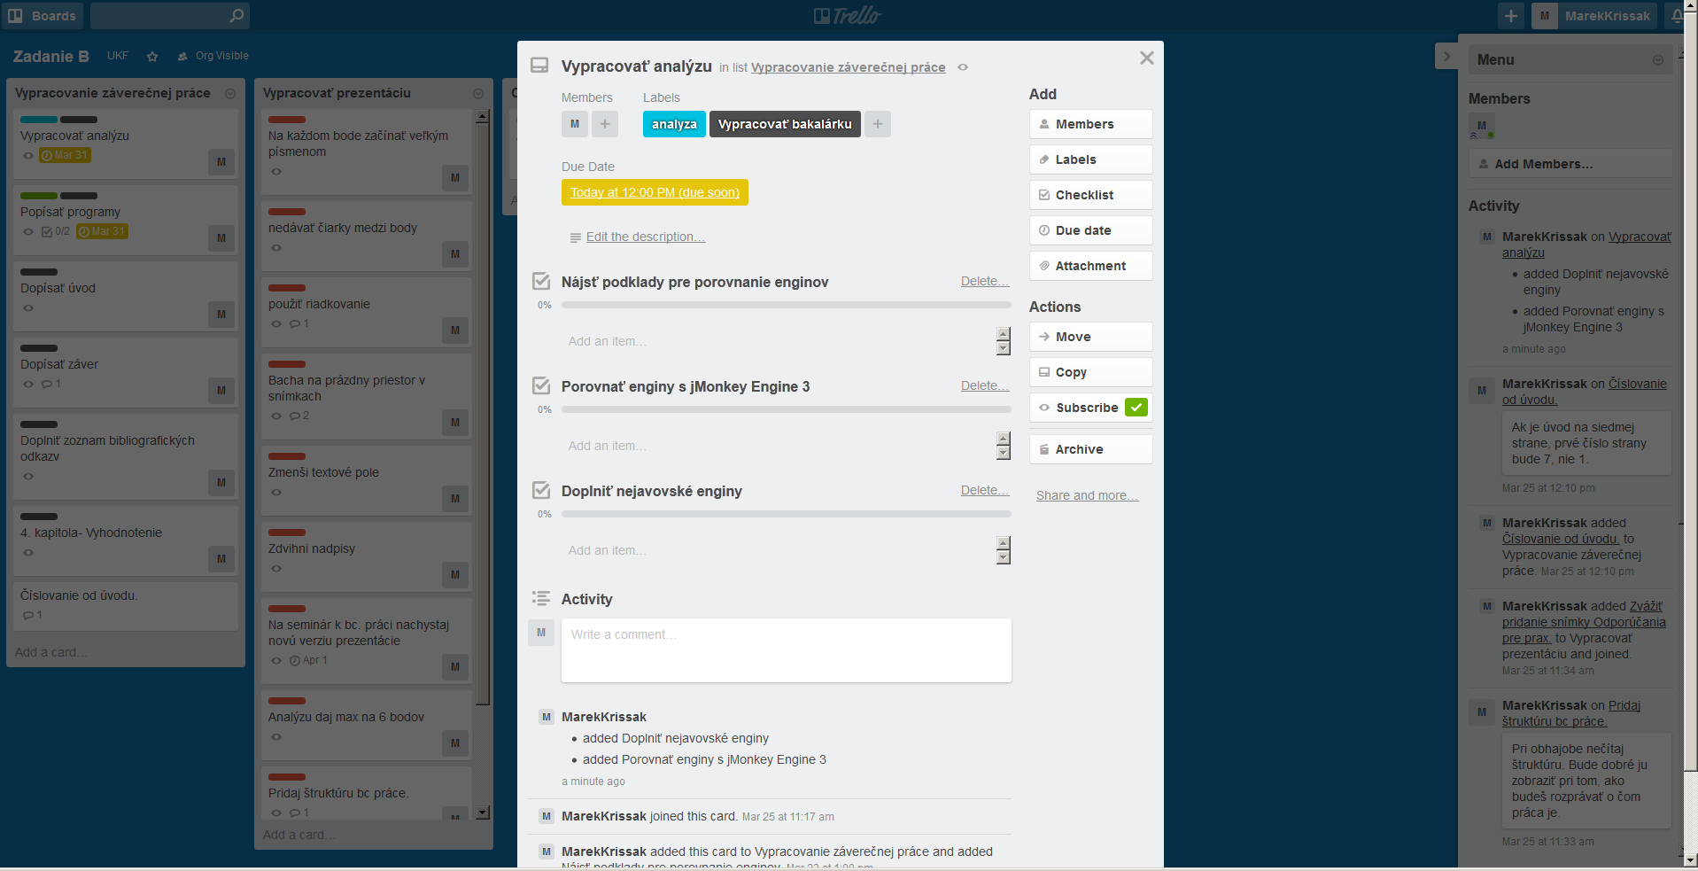

Obr. 4 Využitie Members, Labels, Due date, Checklist