Free Modelica Library of Chemical and Electrochemical Processes

Marek Mateják1, Martin Tribula1, Filip Ježek2, Jiří Kofránek1,2

11st Faculty of Medicine, Charles University, Czech Republic

2Faculty of Electrical Engineering, Czech Technical University, Czech Republic

[marek@matfyz.cz](mailto:marek@matfyz.cz)

A new, free Modelica library for electrochemical processes has been released - accessible as “Chemical” at <https://www.modelica.org/libraries>. It is based on equilibrating the electrochemical potentials of the substances involved, following the modern theories of physical chemistry. It dynamically solves the chemical equilibration of homogeneous chemical solutions with fully thermodynamic states, supported also through thermal, mechanical, electrical and fluid components of Modelica Standard Library 3.2.1.

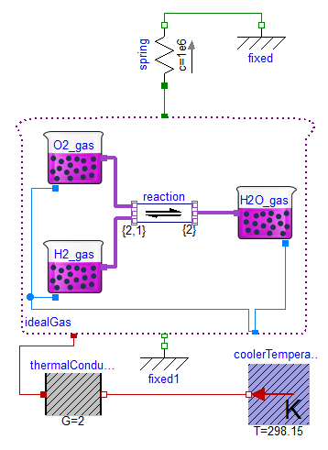 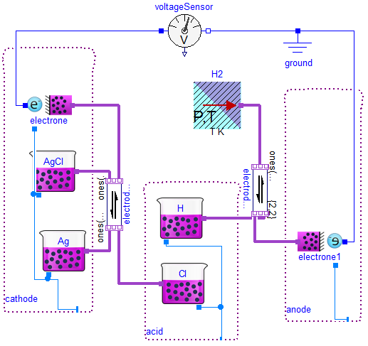

**Electrochemical cell**. The chemical reactions on the electrodes are connected to electrical circuit via electron transfers, where is the molar flow of electrons scaled to electric current.

Hydrogen burning. The chemical reaction H2 + O2 ↔ H2O in closed gaseous homogenous solution as piston with spring upside and with external cooling.

The properties such as activity coefficients, molar mass, formation energies or heat capacity of each chemical substance can be specified by user as functions of new “state of matter model” or selected as predefined ideal gas or predefined ideal incompressible solid or liquid.

**References**

1. J. Kofránek, M. Mateják, P. Privitzer: HumMod - large scale physiological model in Modelica. 8th. International Modelica Conference, Dresden, Germany, 2011.
2. M. Mateják, T. Kulhánek, J. Šilar, P. Privitzer, F. Ježek, J. Kofránek: Physiolibrary - Modelica library for Physiology, 10th. International Modelica Conference, Lund, Sweden 2014.