# Modelica Library of Chemical Processes

(Chemical 1.1.0)

Marek Matejak

## Basic definitions

There are two base components, which should be included in almost all chemical models. The chemical solution and the chemical substance. Chemical solution join together all substances inside and provide to each chemical substance the current state of temperature “T” and pressure “p”. These physical quantities are the characterization of the solution. They are the result of the fundamental relations of thermodynamics:

|  |  |
| --- | --- |
|  | 1. Pressure-Volume relationship |
|  | 1. Temperature relationship |

Where “U” is the free internal energy as the integration of heat energies added the solution “∂Q” and mechanical power of the solution “∂W” as equation (3); “G” is a free Gibbs energy defined as the sum of each electrochemical potential “μj” multiplied by amount of the j-th substance “nj” in the solution as equation (4); “H” is the enthalpy of the solution, which is also extensive property and can be calculated from molar enthalpies of the substances “Hm” as equation (5); “V” is a volume of the solution, which is also extensive property as the sum of all molar volumes “Vm” of the substances in the solution as equation (6); and amount of all substances “n” is the sum of amount of each substance in the solution as equation (7).

|  |  |
| --- | --- |
|  | 1. Free Internal energy |
|  | 1. Free Gibbs energy |
|  | 1. Free enthalpy |
|  | 1. Volume |
|  | 1. Amount of solution |

Some mechanical aspects must be added to make a work with the solution, for example as piston in the motor with a fixed area “A” equaled to πr2, where r is an internal radius of the cylinder. The solution pressure can be converted to force by equation (9) and the force can be accumulated by displacement of the piston to the work of the solution “W” using equation (8) and (10). Change of this mechanical energy becomes from internal energy of the solution, so derivation of the work “∂W” is part of the change of free internal energy of the solution as mentioned in equation (3).

|  |  |
| --- | --- |
|  | 1. Work of the chemical solution |
|  | 1. Pressure-Force relation |
|  | 1. Displacement-Volume relation |

Having these equations for solution it is defined through all solution’s substances the relation between added heat “∂Q” and temperature “T” and the relation between force “F” and the position “s”. It means that the solution has two standard additional connectors – the thermal connector of Modelica Standard Library 3.2 (MSL) as Modelica.Thermal.HeatTransfer.Interfaces.HeatPort and mechanical connector from MSL as Modelica.Mechanics.Translational.Interfaces.Flange_a. And Modelica compilers will handle the causality for each couple of these physical quantities.

The chemical solution can have also the electrical properties as electrical potential “ϕ” and electrical current “i”. The non-zero electric potential “ϕ” has a direct impact to each substance with non-zero charge number. And the change of the charges has the meaning of electric current as in equation (11) , where “nj” is the molar amount of j-th substance, “zj” is the number of charge of the j-th substance (e.g. -1 for electron, +2 for Ca2+), and “F” is the Faraday’s constant.

|  |  |
| --- | --- |
|  | 1. Electric current of the solution |

Having internal relation between electric potential “ϕ” and electric current “i” there is presented also standard electrical port for the solution as Modelica.Electrical.Analog.Interfaces.Pin. However typical electroneutral solution should have zero electric potential, so the typical usage of this port is to connect it in the electrical ground. Setting some non-zero voltage source can cause the electrochemical processes, which are dependent on electric potential of the solution.

Each extensive property of the chemical solution, which can be calculated from properties of the chemical substances inside, is connected to the substances of the solution via solutionPort. The solution port redefine the sums above into the Kirchhoff’s node relation for flow variables. In reality there are not physical flows. However the automatically generated sum to zero is an ideal candidate to calculate all these extensive properties of the solution. This mathematical trick is used only to simplify the usage to user, which can connect all substances into one port of the chemical solution. And in the side of the chemical solution is the total extensive property presented in connector as non-flow variable having the same value for each substance. The exception from this extension variable pattern make quantities of three additional solution ports – thermal, mechanical and electrical noted as first three rows in the next table.

|  |  |  |
| --- | --- | --- |
| **flow variables on side of the j-th substance** | **Kirchhoff's junction rule – on solution** | **non-flow variable of the solution** |
| ${dH}_{j}$– enthalpy ; heat energy flow ; heat change | $$dH=\sum{{dH}_{j}}$$ | $T$– temperature |
| ${dV}_{j}$– volumetric flow ; change of volume | $$dV=\sum{{dV}_{j}}$$ | $p$– pressure |
| $i_{j}$– electric current ; change of charge | $$i=\sum{i_{j}}$$ | $φ$- electric potential |
| $n_{j}$– amount of substance | $$n=\sum{n_{j}}$$ | $n$– amount of solution |
| $m_{j}$– mass of substance | $$m=\sum{m_{j}}$$ | $m$– mass |
| $V_{j}$– volume of substance | $$V=\sum{V_{j}}$$ | $V$– volume |
| $G_{j}$– free Gibbs energy of substance | $$G=\sum{G_{j}}$$ | $G$– free Gibbs energy |
| $Q_{j}$– electric charge of substance | $$Q=\sum{Q_{j}}$$ | $Q$– electric charge |
| $I_{j}$– mole-fraction based ionic strength of substance | $$I=\sum{I_{j}}$$ | $I$– mole fraction based ionic strength |

The properties of the substance as molar mass “MM”, charge number of ion “z”, molar volume “Vm” or molar enthalpy “Hm” can be expressed in the substance definition, which will be shown at the end of this article.

The model of substance is accumulating the molar flow of the substance “∂n­j” into the amount of substance “nj” using equation (12). Having the amount of substance “nj” and the amount of solution “n” there is possible to present the mole fraction of the substance in solution “xj” as equation (13), which is typically the same as activity of the substance “a­j” defined by equation (15). However there exist some special cases, when the activity is different. This can be corrected by activity coefficient “γj” different as 1.

|  |  |
| --- | --- |
|  | 1. Amount of the substance |
|  | 1. Mole fraction of the substance |
|  | 1. Concentration of the substance |
|  | 1. Activity of the substance |

The main equation of the substance is the definition of electrochemical potential as the fundamental equation of physical chemistry – equation (16), where “μo” is the chemical potential of the pure substance (aj=1), and R is gas constant. The chemical potential is independent on electric potential and it is equal to the electrochemical potential at zero electric potential (ϕ=0).

|  |  |
| --- | --- |
|  | 1. **Electrochemical potential** of the substance in the solution |
|  | 1. Chemical potential of the substance in the solution |
|  | 1. Chemical potential of the pure substance |

The chemical potential of the pure substance “μo“ is the main property of the substance. It is temperature and pressure dependent and its derivation for ideal gas substance and for incompressible substance is in the end of this article.

Using this electrochemical potential “μ” together with molar flow “q” of the substance it is defined the substance connector.

|  |  |
| --- | --- |
| flow variable | non-flow variable |
| $q$– molar flow of the substance | $μ$– electrochemical potential of the substance |

## Chemical processes

The most, if not all, chemical processes are equilibration of the electrochemical potentials. The chemical equilibrium is state, when the chemical process stops and it does not generate any molar changes of any substance. And at this time the sum electrochemical potentials of reactants is the same as the sum of electrochemical potentials of products. Each equilibrium of electrochemical potentials is described by the equation (19), where “vj” is stoichiometry coefficient negative for reactants and positive for products (e.g. transport of the substance Ain <-> Aout has stoichiometry vin=-1, vout=1; chemical reaction 3 A1 <-> 2 A2 + 4 A3 has stoichiometry v1=-3, v2=2, v3=4).

|  |  |
| --- | --- |
|  | 1. Chemical equilibrium |
|  | 1. Molar change of the substance |

Where at equilibrium each molar flow of the substance “∂n­j” and each molar flow of the process “∂np” is zero.

Each chemical reaction in solution without electric potential (ϕ=0) reaches the standard equilibrium coefficient “K” as equation (21), which is also the direct result of molar Gibbs energy of the reaction calculated using Hess’ law from chemical potentials of pure substances as usually calculated in physical chemistry. The equation (21) is mathematically expressed from (16) and (19) at zero electric potential (ϕ=0).

|  |  |
| --- | --- |
|  | 1. Equilibrium (dissociation) coefficient of the chemical reaction |

The equilibrium of the diffusion process of the substance ends with the same electrochemical potentials “μ“ of the substance in each place of the solution. The same “μ” means the same activity “a” of the substance and the same “a” means the same mole fraction “x” of the substance. So the ideal diffusion ends with homogenous mixture, where the concentration of the substance is the same at each place.

The osmosis is the diffusion of electroneutral (zj=0) substances through semipermeable membrane. It is a membrane, through which some substances can freely diffuse and other cannot. For example the cellular membrane in biology is very selective and even a water must have a membrane channel to be enabled the transport through it. The water cross the membrane to reach the same mole fraction on both sides if there are the same pressure on both side of the membrane. If not, and the pressures are different, then the pressure dependence at equilibrium is reaching osmotic pressure “Π” of the substance with molar volume “Vm” as in equation (22) derived from the equilibrium (19).

|  |  |
| --- | --- |
|  | 1. Osmotic pressure |

The other situation is on semipermeable membrane for electrolytes (zj≠0), the substances which has an electric charge. Because at steady state the Donnan’s equilibrium is reached as expected, the concentrations of the free diffusible ion can be different on both side of the membrane during this equilibrium. However the electrochemical potentials of this ion is the same on both side of the membrane. This phenomena generate the direct relation between Donnan’s coefficient as ration of ion concentration and membrane potential as difference of electric potentials of the solutions. This equation is known as Nernst potential of the permeable ion and it is the direct result of the equilibration equation (19), where the stoichiometry of the same ion is vin=-1, vout=1 and electrochemical potentials of the same ion are μin and μout with the same μo, temperature T and activity coefficient γ on both side of the membrane. And the membrane potential is the difference of the electric voltages of the solutions as in equation (23) derived from the equilibrium (19).

|  |  |
| --- | --- |
|  | 1. Membrane potential |

Gas dissolution in liquids equilibrates the electrochemical potentials between the gaseous and the dissolved substance. This process is called Henry’s law and the ratio between gaseous and dissolved concentration is called Henry’s coefficient “kH”. From the steady state equation (19) is derived the relation between the tabulated Henry’s coefficients as equation (24), μog as chemical potential of the pure gaseous substanceand μod as extrapolated chemical potential of the pure dissolved substance. The same principle is the vaporization of the solvent called Raoult’s law (25), where the fraction between liquid dissolved activity ad and gaseous form ag=pvap/pair is also determined by μod of pure liquid and μog of pure vapor of the substance. The last relation from gas dissolution series is dissolution in solid substances called as Sievert’s law (26), which is equilibrating a little longer, but the situation at equilibrium is similar.

|  |  |
| --- | --- |
|  | 1. Henry’s coefficient |
|  | 1. Raoult’s vapor pressure |
|  | 1. Sieverts’ coefficient |

As it is known the vaporization is highly dependent on pressure and temperature. The vaporization curve is known as the temperature relationship of vaporization pressure at pair = 100 kPa and ad­=1 as equation (25).

## Chemical substance

The most of previous processes are well described at standard temperature of 25°C and standard pressure of 100kPa. In all equations of equilibrium of the chemical processes as (21), (22), (23), (24), (25) and (26) the measurable coefficients have the meaning of differences between μo. This means, that only a relative values for μo is needed to know of equilibriums coefficients. Typically there are selected the substances in their typical phase as reference with μo=0 and the other phases and composite substances are relatively defined to these reference substances. These relative μo values are called free formation molar Gibbs energies of the substances “ΔfGo“ and they are typically tabulated at temperature T0=25°C and p0=100kPa. So it is reasonable for these standard conditions to define μo25C,1bar = ΔfGo and Hm,25C,1bar= ΔfHo, where “ΔfHo“ is the free formation molar enthalpy of the substance as the amount of heat consumed by one mole of the substance during whole formation process from the reference substances. Also the molar entropy ΔfSo at standard temperatures can be expressed from equation (27). This value is usually not tabulated for the substances and must be really calculated by equation (27). Man must not be confused with the standard molar entropy of the substance, which is an absolute quantity usually noted as “So”. However the Hess’ law calculation of process entropies should give the same entropy of the chemical process.

|  |  |  |
| --- | --- | --- |
|  |  | 1. Free molar entropy of formation at T0=298.15K and p0=100kPa |

The enthalpies and the entropies at different pressure and temperature conditions can be easily extended for idealized substances as ideal gas (molar volume Vm=R*T/p) or incompressible substance, for which the molar volume Vm is constant at each temperature and pressure.

|  |  |  |
| --- | --- | --- |
|  |  | 1. Molar enthalpy of the ideal gaseous substance |
|  |  | 1. Molar enthalpy of the incompressible substance |
|  |  | 1. Molar entropy of the ideal gas substance |
|  |  | 1. Molar entropy of the incompressible substance |
|  |  | 1. Chemical potential of the pure ideal gas substance |
|  |  | 1. Chemical potential of the pure incompressible substance |

Where cp is molar heat capacity of the substance at constant pressure. The meaning of this substance property is the ratio of heat change per change of temperature in one mole of the substance. If the solution does not exchange any other energy with environment then the heat flow from environment is the same as change of internal energy as equation (3). The change of Gibbs energy is equal to change of temperature multiplied by entropy during isobaric heating as equation (35), which is the direct result of fundamental equation (34) at isobaric heating.

|  |  |
| --- | --- |
|  | 1. Fundamental thermodynamic relation |
|  | 1. Change of Gibbs energy and change of enthalpy as a result of fundamental equation (34) |
|  | 1. Ideal gas isochoric heating   (Molar heat capacity of ideal gas at constant volume and amount of substance) |
|  | 1. Molar heat capacity of ideal gas at constant pressure |
|  | 1. Incompressible substance isochoric heating (Molar heat capacity of incompressible at constant volume) |
|  | 1. Molar heat capacity of incompressible at constant pressure |

So the temperature shift of ideal gas is the solution of differential equation ∂Hm=∂T*(cp) for free molar enthalpy and the differential equation T*∂Sm=∂T*(cp) for free molar entropy. In the case of incompressible substances are the equations ∂Hm=∂T*cp and T*∂Sm=∂T*cp. These relations give the temperature shifts as presented in (28), (29), (30) and (31) for fixed pressure condition.

If we look at the relation (22) of osmotic pressure of incompressible substance then we see the pressure shift of (p-p0)*Vm. By definition this pressure-volume energy is part of the internal energy, but not a part of enthalpy, so it must be included in entropy of the substance as in equation (31).

And if we imagine that the chemical processes of the ideal gas substance are driven only by partial pressure independently of ambient pressure of the whole gaseous solution we need to add a correction shift also to molar entropy of the pure gas, which change the mole fraction of gas to meaning of partial pressure in scale of different pressures of the solutions. Mathematically it is the total pressure of solution “p” is extracted from electrochemical potential defined by equation (32) at 25°C and 0V as following algebraic operation expressed by following equation.

|  |  |
| --- | --- |
|  | 1. Ideal gas at 25°C |

And because the other states of matter should be also consistent with previous theory, there is an option to define any “state of matter” with new calculation of the molar enthalpy, molar entropy, free molar Gibbs energy, molar volume and other base substance properties with any possible dependences on pressure, temperature, electric potential and ionic strength of the solution.

The other possible solution of equations (37) for non-constant heat capacity are Shomate equations (http://old.vscht.cz/fch/cz/pomucky/fchab/Shomate.html):

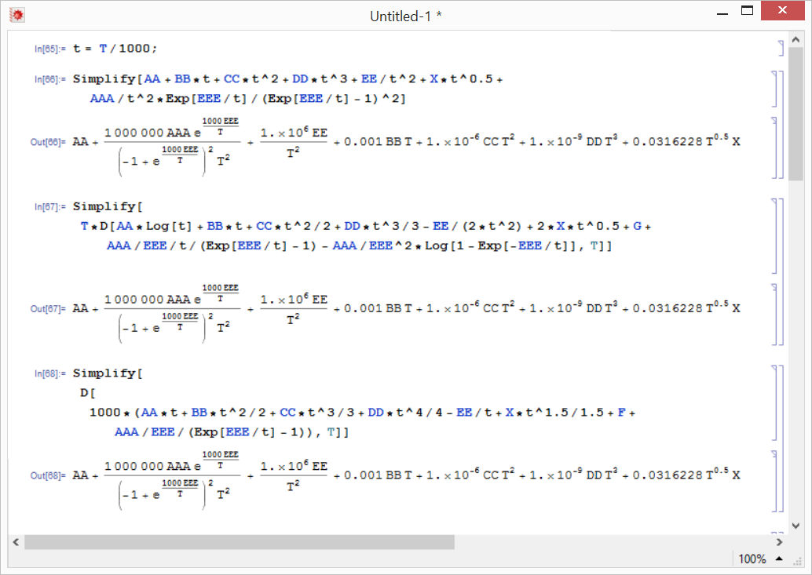

where AA,BB,CC,DD, EE, AAA, EEE, G and F are Shomate’s parameters of the substance and the solution for standard condition point as AA, G and F from cp_25degC, Hm_25degC and Sm_25degC can be calculated as follows:

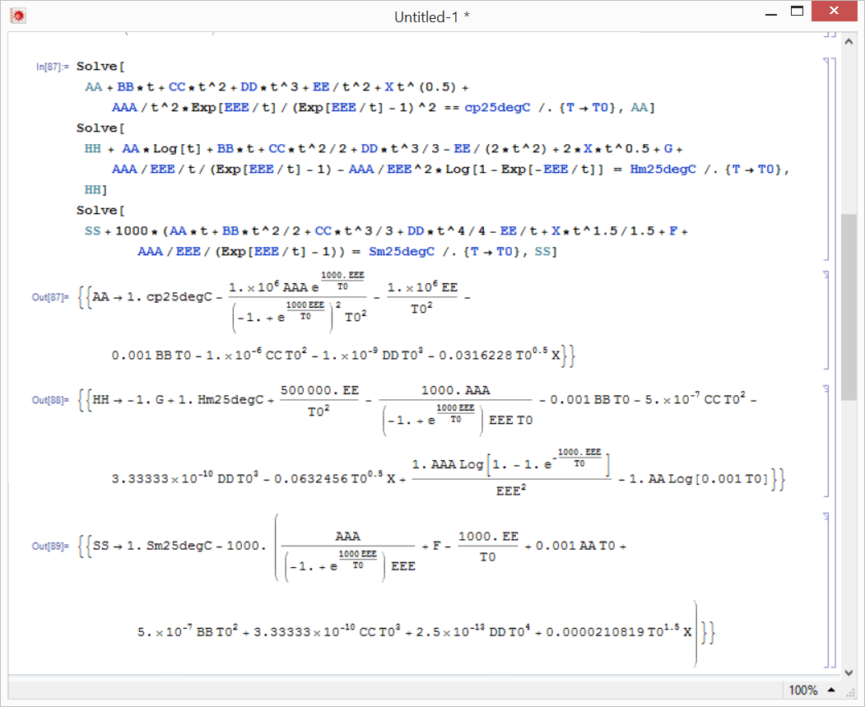

## Chemical kinetics

The rate of chemical process (41) is designed to reach chemical equilibrium (19) ( ${∂n}_{p}=0$ if and only if $\sum{(v_{j}∙μ_{j})}=0$) with possibility of speed turnover. For this purposes are proposed two parameters of kinetics: kC and kE. The parameter kC is describing the speed of the process near equilibrium. The parameter kE is describing the shape of dependence on energetic difference from equilibrium.

|  |  |
| --- | --- |
|  | 1. Chemical kinetics |

The example of parametrization is possible to see in scale of mathematical expression u*exp(-|u|) as Figure 1-3, where $u=\sum{(v_{j}∙μ_{j})}$ is the process energy difference, red line is “rate=u” and blue line is “rate= u*exp(-|u|) “.

Figure 1) Chemical process has maximal rate at energy difference = 1/kE.



Figure 2) Linear behavior is caused with zero kE or process energy difference << 1/kE.



Figure 3) If actual energy difference of the process increases above 1/kE then the rate rapidly slow down.

This allows to define chemical processes, which need the energy for begin of the process. Typical example is the combustion.