Contents

[1 Introduction 3](#_Toc399405482)

[1.1 Imagine 3](#_Toc399405483)

[2 Methods 3](#_Toc399405484)

[2.1 Physical principles 3](#_Toc399405485)

[International system of units 3](#_Toc399405486)

[Reciprocal quantities 4](#_Toc399405487)

[Conservation laws 5](#_Toc399405488)

[2.2 Modelica Principles 5](#_Toc399405489)

[Definition vs. Instance 5](#_Toc399405490)

[Connections 5](#_Toc399405491)

[Steady states 5](#_Toc399405492)

[3 Physiolibrary 6](#_Toc399405493)

[3.1 Chemical domain 6](#_Toc399405494)

[3.2 Osmotic domain 7](#_Toc399405495)

[3.3 Thermal domain 7](#_Toc399405496)

[3.4 Hydraulic domain 7](#_Toc399405497)

[3.5 Examples 8](#_Toc399405498)

[4 Physiomodel 9](#_Toc399405499)

[4.1 Cardiovascular system 9](#_Toc399405500)

[Heart 9](#_Toc399405501)

[Blood flow 9](#_Toc399405502)

[Vasoconstriction 9](#_Toc399405503)

[Vessels Compliance 10](#_Toc399405504)

[Muscle pump effect 10](#_Toc399405505)

[Sequestered volume 10](#_Toc399405506)

[Blood Volume regulations 10](#_Toc399405507)

[Autoregulation of circulation 10](#_Toc399405508)

[4.2 Osmolarity and Water distribution 10](#_Toc399405509)

[Extracellular proteins 12](#_Toc399405510)

[Gastro intestinal water absorption 13](#_Toc399405511)

[Upper/Middle/Lower torso water 14](#_Toc399405512)

[Kidney 15](#_Toc399405513)

[4.3 Hormones 17](#_Toc399405514)

[Vasopressin 17](#_Toc399405515)

[Renin 19](#_Toc399405516)

[Insulin 20](#_Toc399405517)

[4.4 Electrolytes 20](#_Toc399405518)

[4.5 Gases and Acid-Base 20](#_Toc399405519)

[Ventilation 21](#_Toc399405520)

[Oxygen 22](#_Toc399405521)

[Carbon dioxide 23](#_Toc399405522)

[Acid-base 23](#_Toc399405523)

[4.6 Nutrients and Metabolism 26](#_Toc399405524)

[4.7 Thermoregulation 26](#_Toc399405525)

[4.8 Neural Reflexes 26](#_Toc399405526)

[5 Discussion 26](#_Toc399405527)

[6 Conclusion 26](#_Toc399405528)

[7 References 26](#_Toc399405529)

# Introduction

## Imagine

Imagine the power to develop complex physical human health simulation just by dragging, dropping and connecting of small amount of components from prepared library to schemes. Schemes such as electrical circuits with connectors independent of direction of calculation. And each of this scheme can be used many times in many other schemes with different values of parameters for each usage as tissues, cells, organelles, receptors, macromolecules are understood.

# Methods

## Physical principles

Generalization of physical laws leads to similar principles between many physical domains. Motivation is not only to have similar mathematical expressions, but also to use prepared methodology from one domain to another. For example an electrical circuit diagrams can be generalized for chemical, osmotic, hydraulic or other non-electrical systems. To do this, it is necessary to find analogies in physical quantities and physical laws. With only two quantities can be described the state of subsystems at interfaces. One of this variable is flow in term of Kirchhoff law, i.e., the sum of connected flows is zero at each place in scheme. The second has to be non-flow in the meaning that it has the same value in each connected side. The flows are usually changes of some quantity in time such as volumetric flow, molar flow, heat flow, electric current, magnetic flux or mechanical force. The non-flows should be some effort such as pressure, concentration, temperature, electric potential, magnetic potential or space position. The most of physical laws from mentioned physical domains can be represented with equations with mentioned flow and non-flow physical quantities, for example the hydraulic resistance, diffusion, thermal conduction, Ohm’s law etc.

### International system of units

Energy in medicine and chemistry has a very long tradition. One must not be confused by its different units and definitions. The researcher must be aware of multiple definitions of calorie, such as the international calorie, the 15°C calorie, the thermal calorie or the Calorie with a capital "C". The origin of this unit is in the thermal energy needed to heat one gram of water by one degree Celsius. But because the measurement conditions may differ, these alternative definitions are necessary. In physiology it is recommended to use only international calorie as defined in Table 1. The flow of heat/energy is usually calculated in kcal/min, but in physics this is called power and is expressed in the SI unit watts.

Pressure units in medicine are also mainly based on historical measurements. For many years blood pressure was measured by the mercury sphygmomanometer, where the pressure is represented by the change of mercury hydrostatic column height. And because the scale of units on the column is in millimeters the pressure unit is called millimeter of mercury 'mmHg'. There also exists a very small difference between this unit and torrs. It is caused again by variance in measurement conditions.

Many physiological processes are based on electrical principles in the human body. The main cause of this is that each cell has a nonconductive membrane with molecular structures called channels, through which the fluxes of electrolytes can be precisely regulated. Even more, the cells use energy from metabolism to retain a small electric potential between inside and outside. This view leads to a unit called equivalents or “eq”. A charge of 1eq, for example, has 1mol of sodium cations (Na+). The fluxes of electrically charged ions can be in meq/min, but in physics the SI unit ampere is more generally used.

|  |  |  |  |  |
| --- | --- | --- | --- | --- |
| Unit conversion table | | | | |
|  | x kcal | = | 4186.8\*x | J |
|  | x kcal/min | = | 69.78\*x | W |
|  | x mmHg | = | 133.322387415\*x | Pa |
|  | x degC | = | 273.15 + x | K |
|  | x meq | = | 96.4853365\*x | C |
|  | x meq/min | = | 1.60808894\*x | A |
|  | x mosm | = | 0.001\*x | mol |
|  | x litreSTP | = | 0.044031617\*x | mol |
|  | x litreSATP | = | 0.040339548\*x | mol |
|  | x litreNIST | = | 0.041571200\*x | mol |
|  | pH = x | … | [H3O+] = 10-pH+3 | mol/m3 |
|  | x iu of Erythropoietin | = | ? | mol/m3 |

Table 1, Selected Non-SI units

Another strange unit describing the amount of substance is the osmol (“osm”), which has the same value as the mol, but which highlights the property that this substance cannot cross the membrane together with the flux of its solvent.

For gases, it is common to measure the amount as volume, which for specific measurement conditions is equivalent to the number of molecules. The International Union of Pure and Applied Chemistry (IUPAC) set this standard condition for temperature and pressure (STP) precisely at 0°C and 100kPa. But other standards exist. For example, SATP is measured at 25°C and 100kPa, or the standard measurement condition at the National Institute of Standards and Technology (NIST), which is 20°C and 101.325kPa.

Chemical substances can be quantified many ways, typically as amount of substance in moles which after multiplication by Avogadro constant (6.02214129(27)×1023 mol−1) gives the number of substance particles. But each molecule or atom has its mass usually expressed by unit Dalton (gram per one mol) as molar mass or molar weight of substance. The problem is that each substance has different molar mass and as a result the conversion from mass to moles is always dependent on type of substance.

The worst situation with physical unit is with physical quantity called pH, which determines the acidity of solution. The value of pH equals to minus decimal logarithm of hydrogen ion activity by definition. But the hydrogen ion activity in water solution has a meaning of hydronium ion concentration in non-SI unit “mol/l”. To correct this physical unit is necessary to shift the value to “mol/m3” (“mmol/l”). Similar situations can be observed with using of pK (minus decimal logarithm of dissociation constant for acid-base reactions), where in addition the physical unit is dependent on number of products and number of reactants.

In physiology are wildly used also the units for direct-unmeasurable substances. Such small concentrations as 10-12 moles per liter are almost impossible to measure directly and only the indirect measurements with immunoreactions or biological effects are known. But the effect of some substances at these small concentration could be so crucial that they need to be somehow calculated in physiological model. Most of these substances are called hormones, but some could be also enzymes (renin) or cytokines (erythropoietin). Pharmacological international units of this substances are define as ratios to some extracted and purified standardized sample which has also unknown molar concentration, but known and well described biological effect. As a result the pharmacological international unit of substances have not many times any equivalent in SI units, but it need to be used in physiological calculations as they are.

### Redundant physical quantities

Some standardization should be done also with definitions of physical quantities. For example each two variables in the reciprocal relation, connected only with trivial equation a=1/b, the handling of both does not bring any additional information to the model, because their physical meaning is the same. Even the zero-infinity numerical problem can be very easily solved by selecting variables like the smallest representable floating point number or like the highest representable floating point number which are typically far enough from tolerance limits even for very long simulations.

These couples of reciprocal quantities are derivable from almost each physiological parameter such as hydraulic conductance - hydraulic resistance, hydraulic compliance - hydraulic elasticity, frequency – period time, solubility – volatility, dissociation coefficient – association coefficient etc. To simplify this situation is better to select only one of each couple and build the physiological and chemical laws above as usually in physics which helps a lot with elimination of redundancies inside shared interfaces.

Bad practice is to use unitless logarithm or other non-unit, non-physical variables in interfaces. Even if user has a good documentation how to convert this values. Values should have always the analogy in physical quantity, which are more user-friendly and more intuitive for next development.

### Conservation laws

The next step of physiology formalization is identification of physiological systems as physical systems. Based on interactions with environment there are closed and open systems. The example of open system is oxygen transport, where is non-zero flow of oxygen from environment to body. In closed system are not interactions with environment. As example are chemical reactions which always reach equilibrium such as acid-base reactions or oxygen binding to hemoglobin. Or the elementary particles which are in steady state at constant amount inside the body.

The laws of conservations apply to closed systems. Energy, mass, amount of substance nor electric charge cannot be created from nothing. In dynamic models it is very intuitive, because there is non-written rule to calculate with input flow from one component as output flow to another etc. But in steady state calculation must this system equation be written explicitly which is not many times so intuitive.

## Modelica Principles

Modelica is an object-oriented, equation based computer language, which is standardized and maintained by Modelica Association ([www.modelica.org](http://www.modelica.org)). The non-proprietary standard of this language causes, that is supported by many other projects, companies and organizations. As a result there are available many environments for this language. For example Dymola, OpenModelica, JModelica, CATIA Systems, CyModelica, MapleSim or Wolfram SystemModeler.

### Floating point numbers

From mathematical point of view has the set of real numbers infinity members. How it is possible, than it could be representable by finite small number of bites, i.e., 32 or 64 ones and zeros? The answer is by approximations. There must be always some limits of precisions, some tolerances. Floating point numbers are represented by scientific notation with mantissa (a) and exponent (b) as a\*10b. Both mantissa and exponent are represented by fixed number of bites. At single-precision floating point format there is one bit for sign, 8 bits for exponent and 23 bits for mantissa. This representation gives smallest number as 10-127, biggest number as 10127 and eps (the biggest number such as 1.0 + eps = 1.0) <10-6. This 32-bit precision is sufficient for the most common cases, but for specific calculations better precision exist. The 64-bit called as double-precision floating-point format has 11 for exponent (with theoretical range from 10-1027 to 101027) and 52 bits for mantissa (with eps<10-15).

Even the ranges and precisions are limited, the floating points calculations brings for user another traps. First of all is expressing equality of real numbers. For example, what does it means, if we say that x is equal to zero such as condition x==0? If the number x is set to zero by user and it does not change by calculation its value really remain zero, but if it is calculated it is always calculated with some precision. It means that the test of equality have sense only inside this tolerance range. If we have set tolerance to 10-3 then we should be satisfied with numbers greater than -0.001 and less than 0.001. Otherwise the solver may reach the limits of number representations and/or does not reach the equality any more.

The user tolerance definition for elementary mathematical operations are not needed, but it is necessary for iterative numerical methods. The most common are numerical solving of differential equation (such as Euler method, DASSL and other) or numerical solving of non-linear equations by iterative approximations (such as Newton method). At first look it seems that it is needed the tolerance for each tested variable in error condition of that algorithms. But this could be handled only by one relative tolerance and scaling of the variables. For this scaling Modelica uses the attribute nominal, which could be included in every real variable.

### Definition and its Instances

Object oriented programing is one of the greatest step in computer science. The programing of huge applications and systems becomes more simplified with re-using and extending of already defined objects. Idea of an object as definition is very intuitive, because it copies the human language and thinking. Each defined term is an object, which can have one or more occurrence. Occurrence of object definition is named as an instance. The object has properties. The property could be primitive variable as number, text, true/false value or also an object. This can create hierarchical or more complicated decomposition from one system as one object to its subsystems as more and more detailed definitions of the owner parts. Especially in physiology are these patterns everywhere. Having object for chemical reaction, chemical substance, organelle, membrane channel, cell, membrane, tissues or physiological systems is possible to compose new detailed objects as huge models of physiology using already described objects just by choosing the right values of these new instances.

It is not necessary to make decomposition of problem from up to down or vice versa, because object-oriented thinking just support to start everywhere. There is only one condition for effective object-oriented programing: **The minimization of object number the minimization of instance number to describe the same system**. This process is already used in mathematic or physical science, where the whole science can be exactly build from small number of base rules by finite minimized number of definitions.

Parametrization

Inheritance

..

Generic redefinition

### Connections

Input,output

Expandable connector

Connector (nonflow, flow)

Stream connector

### Steady states

(Non-)oscilating system

Der = 0,

Chemical equilibrium,

Law of delailed balance

Hydraulical equilibrium

# Physiolibrary

## Chemical domain

Substance

Der(Solute) = soluteFlow

Concentration = Solute/volume

Chemical reaction

Dissociation constant

Forward/backward reaction rate

Stoichiometric coefficients

Activity coefficients

Exothermal/Endothermal reaction

Temperature dependence

Filtration and diffusion

permeability

electroneutrality

Donnan’s equilibrium

diffusion

Solubility

Gas solubility in water

Henry’s law

Temperature dependence

Heat flow

Clearance and degradation

Clearance = K\*solventFlow

Pump and stream

Solute flow

Solution flow

Mixing of solutions

Dilution

q\_out.conc = d \* q\_in.conc;

Speciation

Chemical forms

Chemical species

Independent goups/sides

Reabsorption

Primary filtrate in nefrons

Fractional reabsorbtion

threshhold

## Osmotic domain

OsmoticCell

Accumulation of penetratinf liquid

Membrane

Osmotic pressure,

osmotic gradiend

hydraulic component

temperature dependence

## Thermal domain

HeatAccumulation

Relative heat

Temperature gradient

IdealRadiator

Tissue temperature = outflowing blood temperature

Conductor

Temperature gradient

Stream

Flow of heated liquid

Mixing liquids of different temperatures

## Hydraulic domain

ElasticVessel

PV characteristic

Zero pressure volume

Excess volume

Compliance/elastance

Collapse

Conductance

Pressure gradient

Hydraulic resistance

Vasoconstriction/vasodilatation

Hydrostatic column

P=g ro h

Gravity experiments

Blood in legs

Elastic membrane

Cavity in cavity

Ventilation

Ideal valve

Switching state

Forward/ backward flow

Forward conductance/ backward resistance

Modelica implementation

Inertia

I\*der(q\_in.q) = (q\_in.pressure - q\_out.pressure)

Pump

Generation of volumetric flow

heart

Reabsorption

nefrone

## Examples

SimpleReaction

Build by drag&drop

Hemoglobin

MVC model

NHCOO- extension

Titration extension

CardiovascularSystem GCG1972

description

# Physiomodel

## Cardiovascular system

### Heart

Cardiac output (CO) as a mean blood flow from heart ventricle is heart rate (HR) multiplied by stroke volume (SV), where stroke volume is difference of end diastolic volume (EDV) [1, 2] and end systolic volume (ESV) [3]. The HR and heart contractility [4] can be influenced by nervus vagus [5], epinephrine [6] or angiotensin II [7]. The most common descriptions are pressure-volume relations [8] as in famous A-V fistula experiments [9] or filling pressure experiments [10] or less invasive exercise experiments [11].

The HR is typically generated in sinoatrial node. The conduction of signal is measured and described by electrocardiograms [12, 13]. Autonomous nerves control heart rate [14, 15] for example as a response of baroreflexes [16, 17].

There is some evidence of non-steady state behavior of end diastolic volume, because the stroke volume is dependent on heart rate [18, 19].

### Blood flow

The blood flow through blood vessels depends on blood viscosity [20]. Viscosity of blood is strongly dependent on the hematocrit [21-23], so the higher number of red cells the less ability for blood to move. But if there are more red cells with hemoglobin, the more oxygen can be transported. Optimal hematocrit for oxygen transport between this two conditions was experimentally measured as 40-60% in the most tissues [24, 25].

### Vasoconstriction

Vascular smooth muscle tone is regulated [26, 27] with many influences. The vasoconstriction causes increasing of resistance and pressure together with decreasing blood flow. The vasodilation has opposite effects. This kind of vascular regulations is specific for each tissues.

In pulmonary circulation is vasoconstriction driven mainly by vascular redox O2 sensor, what is resulting into perfusion-ventilation matching to optimize the oxygen transport from lung alveolus to blood [28].

Renal blood flow need to estimate optimal glomerular filtration pressure [29, 30] and to preventing washout of kidney medulla concentrations. This can be driven by local mechanoreceptor-myogenic pattern [31, 32], baroreflex-like patterns [33], angiotensin II [34] or tubuloglomerular feedback [35, 36].

Splanchnic circulation deliver all blood from gastro-intestinal tract to liver by portal vein [37]. In liver is the hepatic blood flow determined by portal vein and hepatic artery blood flow. Normal hepatic blood flow can vary from 970 to 2370 ml/min [38] in dependence on gastro intestinal blood flow. Portal blood volume and pressure is known in typical or in changed histamine concentration [39] or catecholamine concentration [40, 41]. The splanchnic circulation is a blood reservoir during hemorrhage or blood volume infusion with hormonal or neural regulation [42, 43].

[Maass-Moreno1992,Bradley1953,Bradley1952,Mitzner1974,Laine1979]

- effect of norepinephrine [Greenway1985,Laut1987]

- effect of histamine [Greenway1973]

Brain blood flow [Kety1948]

### Vessels Compliance

The compliance of systemic arteries is constant around normal working conditions [Roach1957].

Systemic veins [Shigemi1994,Echt1974,Gauer1956]

### Muscle pump effect

[Armstrong1985,Laughlin1987,Laughlin1983]

### Sequestered volume

[Ochsner1951,Mayerson1939,Bevegard1962,Pollack1949,Block1930,Henry1950,Thomson1928]

### Blood Volume regulations

- hypoproteinemia [Manning1990,Manning1983]

### Autoregulation of circulation

- CO on CO2 [Davidson1986]

- ,Hogan1990,Lash1987,Malo1984,Marshall1995,Metting1989,Metting1988,Weber2000,Borgström1975,Whalen1974,Frisbee2000,Berg1997,Burattini1994,POHOST1976,Archer1996,Goodman1978,Granger1976,Granger1969,Harder1996,Harder1996,Marshall1988,Frisbee2000,Kunert1996,Prewitt1976,Kuwahira1993]

RAAS and other regulations .. see hormones, nerves and drugs

## Osmolarity and Water distribution

The model of water (Fig1) such as the model of extracellular proteins is divided into eight main compartments: blood plasma (plasma), red blood cells (RBC), interstitial (IST)/intracellular(ICF) water of upper torso(UT), middle torso(MT) and lower torso(LT). These compartments are connected with osmotic connectors because an osmolality is the main force of transferring the water in the body. Chosen distribution of body water (41 l) between compartments is written in Table I.

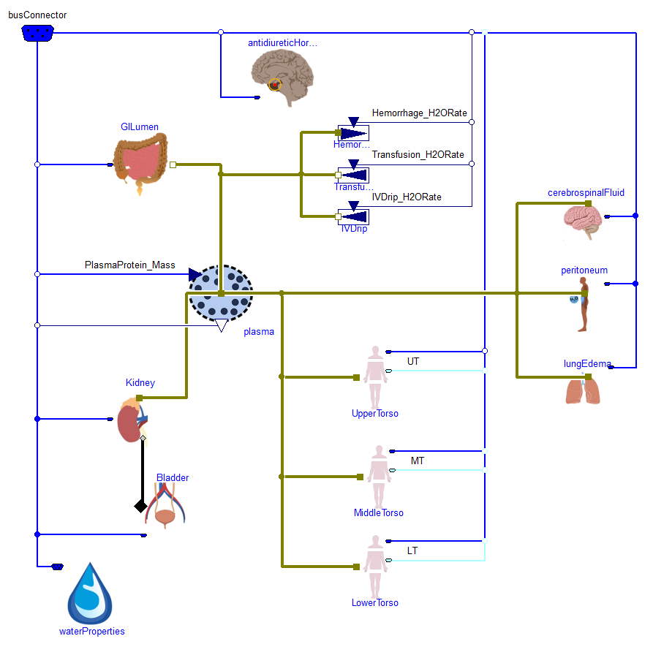

Table I, Typical steady-state water volume of compartments [l]

|  |  |  |  |  |  |  |  |
| --- | --- | --- | --- | --- | --- | --- | --- |
| Plasma | RBC | UT\_IST | UT\_ICF | MT\_IST | MT\_ICF | LT\_IST | LT\_ICF |
| 3.0 | 1.6 | 2.3 | 5.0 | 5.7 | 12.5 | 3.4 | 7.5 |

Typical mean water flows between all compartments are listed in Table II as described in many studies [44-47]. In gastrointestinal tract are absorbed, in each torso is metabolically produced and also excreted by sweating or by vaporization. Flows such as hemorrhage, transfusion, intravenous drip, to peritoneum, to lungs edema are zero at normal condition. Outflow of water to urine is modeled by kidney.

Table II,Typical steady-state water flows between compartments [ml/min]

|  |  |  |  |  |  |
| --- | --- | --- | --- | --- | --- |
|  | plasma | UT | MT | LT | Total |
| from diet | 1.4 |  |  |  | -1.4 |
| through capilaries | -3.01 | 0.38 | 1.23 | 1.40 |  |
| lymph | 2.41 | -0.32 | -0.75 | -1.34 |  |
| from metabolism |  | 0.06 | 0.11 | 0.06 | -0.23 |
| evaporation |  | -0.12 | -0.59 | -0.12 | 0.83 |
| to urine | -0.8 |  |  |  | 0.8 |

### Extracellular proteins

Usually are proteins calculated at mass units, but our implementation calculate their amount of substance, because the molar concentration *c* plays the role in osmotic pressure *p* by Eq1, where *R* is gas constant and *T* is temperature.

We can assume, that average molar mass of globulins is 34.5 kDa and molar mass of albumin is 66.5 kDa. And also that the mass of albumins is about 60% of total plasmatic protein mass.

Table I, Typical plasma proteins concentrations [mmol/l]

|  |  |  |
| --- | --- | --- |
| Total | Albumin | Globulins |
| 1.44 | 0.63 | 0.81 |

The model of proteins (Fig2) has four main compartments: blood plasma, upper torso interstitium, middle torso interstitium and lower torso interstitium. Normal concentrations at interstitial compartments are listed in table Table II. Normal proteins synthesis and degradation of 10 mg/min can be changed with deviation of their colloid pressure or plasmatic concentration. Movement between compartments is caused by capillary membrane concentration gradient or lymph flow from interstitium to blood as implemented in scheme of Fig2. And special changes of plasmatic concentration could be done by intravenous therapy, hemorrhage or pathological states, when proteins enter the peritoneum space or primary urine filtrate.

Table II, Typical protein concentrations in interstitium [mmol/l]

|  |  |  |
| --- | --- | --- |
| Upper torso | Middle torso | Lower torso |
| 0.6 | 0.48 | 0.4 |

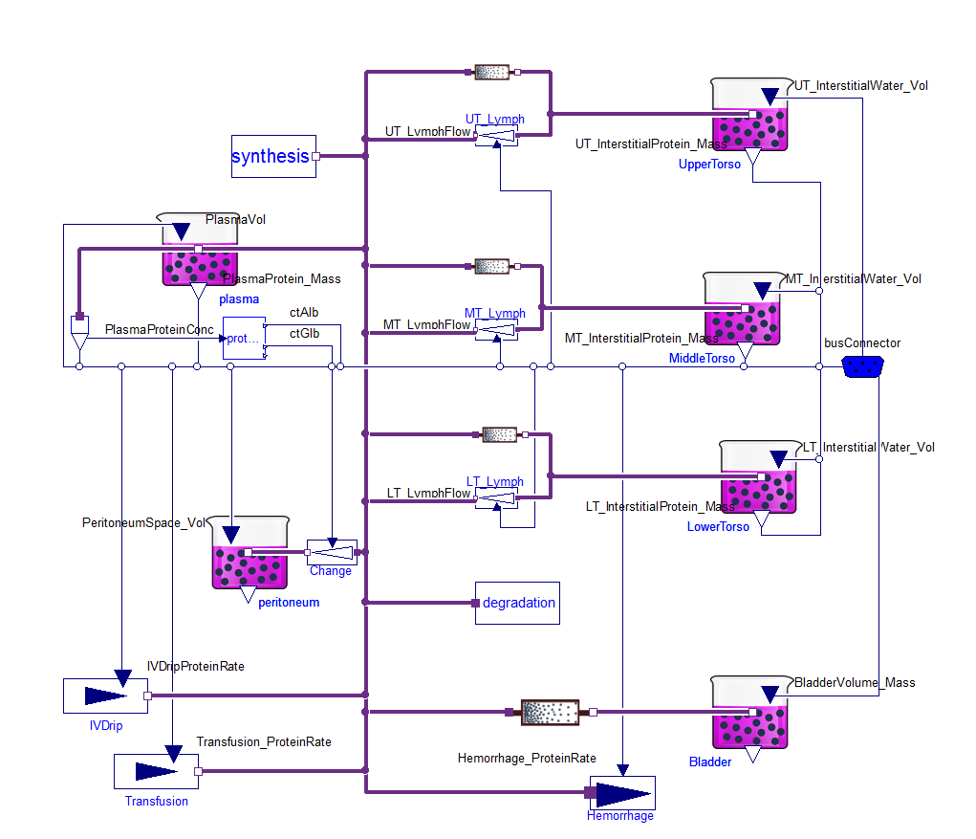

### Gastro intestinal water absorption

Mean water in diet should be about 2 l/day, which is the sum of water in food and drinks. Firstly is water accumulated in gastro intestinal lumen (GILumen), where it has the mean osmolarity about 253 mosm/l. This osmolarity is composed mostly with sodium with anions (160 mosm/l), dietary fiber (43 mosm/l) and potassium with anions (50 mosm/l). Water is sucked by gastrointestinal cells, where is the mean osmolarity about 286 mosm/l called OsmBody\_CellWall in Fig1.

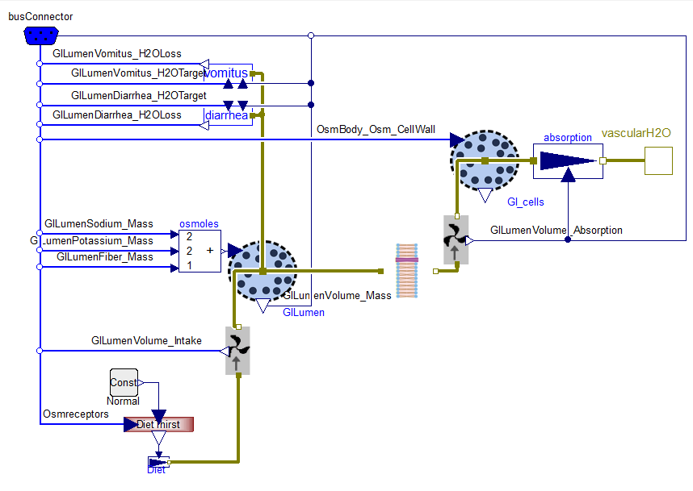

Because in original HumMod 1.6.1 model is the mean absorption from GILumen calculated by coefficient of osmotic gradient Absorption [ml/min] = 140 \* (0.286 [osm/l] - 0.253 [osm/l]), the pressure-gradient osmotic permeability (cond) of library membrane block has to be derived to have the same flow at the same settings. We know that the volumetric flow in this block is calculated by equation Eq1, so the recalculated parameter cond to value 0.14/(8.314\*310.15) [ml/(Pa.min)].

### Upper/Middle/Lower torso water

Flow between plasma and interstitium is determined by colloid osmolarity of extracellular proteins. Through the capillaries wall is distributed the water to or from the interstitium. Another way is the one directional lymph flow from interstitium to blood plasma [45-47], as presented in Table III. These flows can be influenced by the internal pressure in tissues caused by its volume and skin as examined by Gyuton [48] or Xie [44]. Water crowing the capillary wall is driven by hydrostatic-colloid pressure gradients, where the pressure elements are for each torso listed in table ?.

Table IV, Typical pressures at capillary walls [kPa]

|  |  |  |  |
| --- | --- | --- | --- |
|  | Upper | Middle | Lower |
| blood hydrostatic | 2.2 kPa | 2.2 kPa | 3.1 kPa |
| blood coloid | 3.7 kPa | 3.7 kPa | 3.7 kPa |
| interstitium hydrostatic | -0.6 kPa | -0.6 kPa | -0.6 kPa |
| interstitium coloid | 1.6 kPa | 1.2 kPa | 1 kPa |
| total gradient | 0.7 kPa | 0.3 kPa | 1.0 kPa |
| Permeability [ml/(kPa.min)] | 0.54 | 4.1 | 1.4 |
| capillary wall filtrate | 0.38 ml/min | 1.23 ml/min | 1.40 ml/min |

Table IV, Typical osmolarities of substances [mosm/l]

|  |  |  |  |  |
| --- | --- | --- | --- | --- |
|  | electrolytes | Urea | glucose | Unknown |
| ECF | 250 | 6 | 6 | 24 |
| ICF | 266 | 6 | 0 | 13 |

However the flow of water between interstitium and cells is determined by all substances. In cellular membrane the proteins osmolarity plays the minor role, because their concentration is only about 1 mosm/l. Here in extracellular space is osmolarity divided into electrolytes, urea, glucose and others solutes. And in intracellular space are electrolytes, urea and others solutes. Osmolarity in equilibrium must be the same in interstitium and in cells (typically 285 mosm/l).

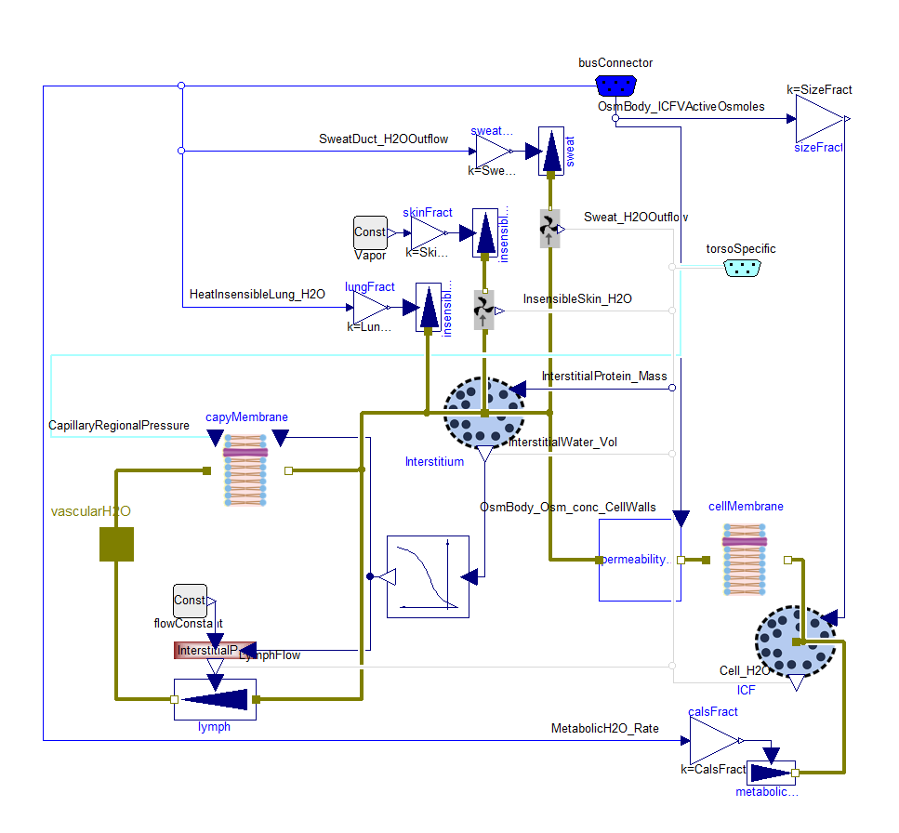

### Kidney

In kidney is water delivered by blood to the glomerulus, where is blood plasma filtrated to glomerular filtrate (GFR). Most of this filtrate is reabsorbed in nephron parts: proximal tubule (PT), loop of Henle (LH), distal tubule (DT) and collecting ducts (CD) and the rest is accumulated in bladder as urine.

Table V, Typical average steady-state flows through nephron [ml/min]

|  |  |  |  |  |
| --- | --- | --- | --- | --- |
| GFR | to LH | to DT | to CD | to Bladder |
| 120 | 57 | 41 | 4.6 | 0.8 |

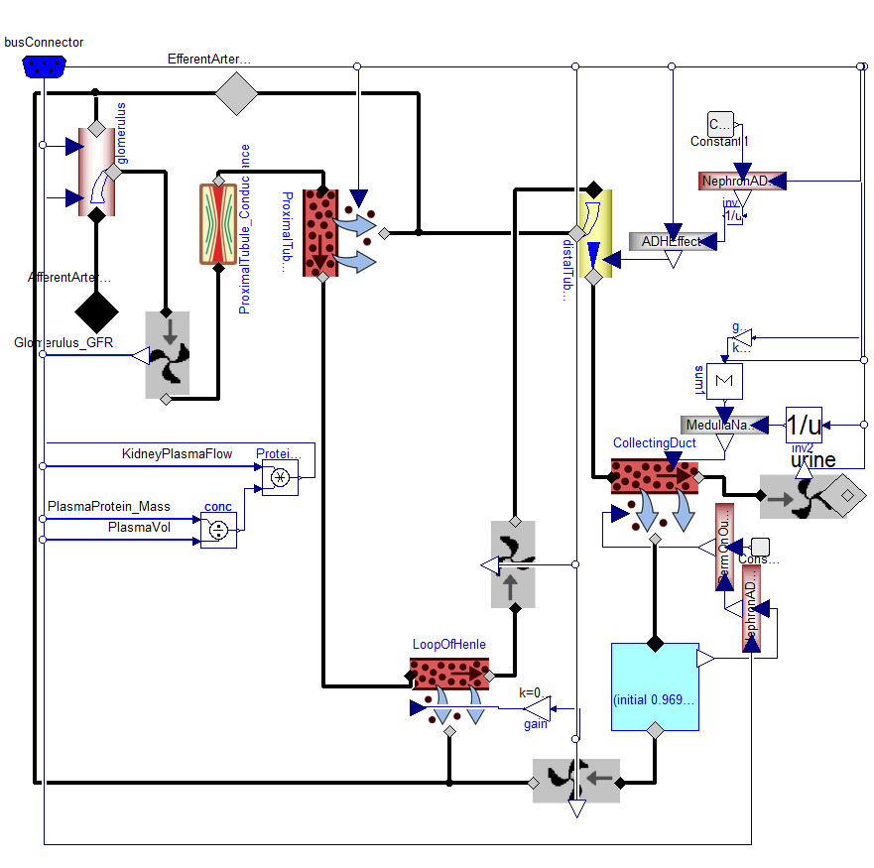

Proximal tubule:

Glomerular filtrate in glomerulus has the same pressure as blood in glomerulus and this pressure push it into nephrons. Reabsorption fraction in proximal tubule is determined only with sodium reabsorption in proximal tubule.

Loop of Henle:

Only the short coronary nephrons contains the aquaporin channels inside loop of Henle, which makes the water reabsorption fraction only 37% of sodium reabsorption fraction [49, 50].

Distal tubule:

Outflow of filtrate to collecting duct is determined by outflow of sodium, where it is dependent on ADH nephron concentration as was described in studies of Khokhar et al. and Atherton et al. [51, 52].

Collecting duct:

In collecting duct are the number of active aquaporin channels driven by ADH and it proportionally means the volumetric flow rate of reabsorbed water by collecting duct tubules [53, 54]. Changing the activity of aquaporin channels is modeled by integration of inactive channels driven by ADH concentration as simulating the process of their intracellular vesicular storage. Independently on aquaporin channels is calculated the minimal water outflow to urine, which is determined by sodium outflow to urine and medulla osmolarity.

## Hormones

### Vasopressin

Arginine vasopressin known as antidiuretic hormone (ADH) has molecular weight of 1084 Dalton and one international unit of ADH was measured to be 2.5ug [55]. ADH as a hypothalamic neurohormone is synthesized in the cell bodies of magnocellular neurons of paraventricular and supraoptic nucleui and it is intracellulary transported to the lower side of these neurons in posterior pituitary.

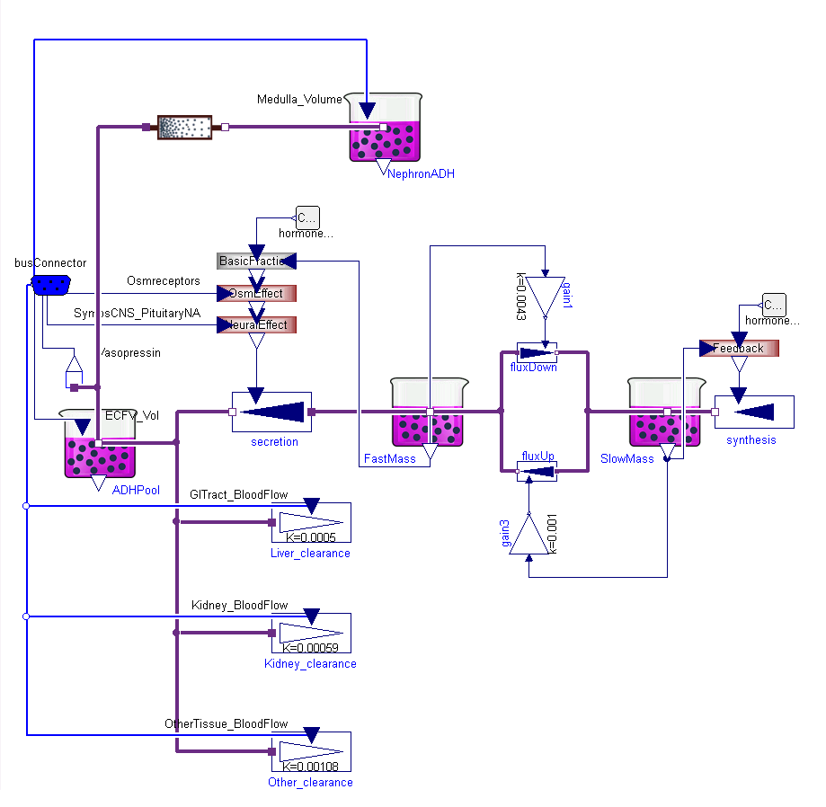

Figure 1

The model (Fig1) accumulates the amount of this hormone in four places: in the cell bodies of magnocellular neurons (Slow Mass), from where need to be transported to the posterior pituitary part of the cells; in the posterior pituitary side of neurons (Fast Mass), where ADH is prepared for secretion into blood; in the whole body extracellular fluid (ECF); and in the kidney nephron tissue, where it plays the role in water reabsorbtion. The normal amounts of ADH in these compartments are listed in table Tab1. The normal mean rate of synthesis, secretion and degradation is 3.2 ng/min (49.2 pmol/s) [56], where the secretion is determined by osmoreceptors and pituitary activity. Osmoreceptors are the cells in anterior hypothalamus near the supraoptic nuclei. When the osmolarity increase the osmoreceptors shrink and they send a neural signal to release ADH. Other possibility to regulate ADH secretion is cardiovascular centrum reflexes.

Table 1

|  |  |  |  |
| --- | --- | --- | --- |
| Slow Mass | Fast Mass | ECF | Medulla |
| 17 ug | 3.2 ug | 0.03 ug | 6.2e-5 ug |
| 15.7 nmol | 2.95 nmol | 0.028 nmol | 5.7e-5 nmol |
| 6.8 IU | 1.28 IU | 0.012 IU | 2.5e-5 IU |

Even the vasopressin inside cells is modeled using instances of chemical Substance class, the concentrations here do not have sense because ADH is transported by vesicles down the cell. The degradation is divided into liver, kidney and other tissue clearance.

Table 2

|  |  |  |
| --- | --- | --- |
| Liver degradation | Kidney degradation | Other degradation |
| 0.98 ng/min | 1.46 ng/min | 0.8 ng/min |
| 0.9 pmol/min | 1.35 pmol/min | 0.74 pmol/min |
| 0.39 mIU/min | 0.58 mIU/min | 0.32 mIU/min |

Clearance of ADH is divided into liver, kidney and other tissue [57]. To reach the mean constant level of ADH the sum of these changes from Tab2 must be the same as mean secretion during normal mean blood flow through liver (1.15 L/min), kidney (1.24 L/min) and other tissue (0.4 L/min), which are equivalents of clearances from table Tab3.

Table 3

|  |  |  |
| --- | --- | --- |
| Liver clearance | Kidney clearance | Other tissue clearance |
| 0.58 l/min | 0.73 l/min | 0.4 l/min |

A typical mean concentration in extracellular fluid is 2 ng/l, 1.8 pmol/l or 0.8 mIU/l [58]. Increasing of concentration will increase the water reabsorption in kidney.

### Renin

Renin is an enzyme for conversion of Angiotensinogen to Angiotensin I. From Michaelis-Menton equation (Eq1) is known, that the rate of enzymatic chemical reaction *v* is linearly proportional to the enzyme molar concentration *E* at defined substrate concentration *S*. So instead the extremely small molar concentration it is wildly used Goldblatt unit (GU) of Renin , which is equal to the reaction flow rate of one ng of AngiotensinI from one mg of Angiotensinogen per one hour (1 ng AI/h).

Molecular mass of Renin is 48 kDa [59], normal plasma concentration are written in table Tab2. We use the conversion between renin activity GU and international unit as 11.2 uIU/GU and assumption that 1000 IU are equal 0.6 mg of renin as proposed Simon et al [60]. Problem is, that the renin activity (GU) change with many other factors like acidity [61] or bounding of renin with other molecules. That means problem with GU definition, which may differs from research to research. Therefore the GU unit is more like unit for angiotensin I synthesis rate, not the right unit for renin amount.

Table 4

|  |  |  |
| --- | --- | --- |
| Lower limit | Upper limit | Normal |
| 290 GU/L | 5700 GU/L | 2000 GU/L |
| 3.3 IU/L | 63.8 IU/L | 22.4 IU/L |
| 2 ug/L | 38.3 ug/l | 13.4 ug/L |
| 0.04 nmol/l | 0.8 nmol/l | 0.28 nmol/L |

(<http://europepmc.org/abstract/MED/2856717>)

Because molar mass of Angiotensingen is 56.8 kDa and molar mass of Angiotensin 1 is 0.9 kDa.

### Insulin

Model of insulin obeys the same principle as the model of glucose-insulin homeostasis by Guyton et al. [62]. Insulin is synthetized and stored in beta-cells and its secretion is driven by glucose and keto-acids [63, 64]. Portal and peripheral vein insulin has different concentration [65], because insulin is transported just after secretion by portal vein to liver. Absorbance and clearance was measured by many infusion experiments [66-68].

The effects are parts of liver metabolism, glucose, keto-acid and lipid submodels [62, 69, 70], where the details of receptor binding are also described [71-73].

Problems with insufficient insulin secretion results in type 1 diabetes mellitus and with receptor resistance lead to type 2 diabetes mellitus [74-76], where many differences between normal and obese individuals should be included [70].

*Insulin is one of the most studies hormone. First standard international unit of insulin from year 1958 has 41.67ug/IU ( [http://whqlibdoc.who.int/trs/WHO\_TRS\_172.pdf](http://whqlibdoc.who.int/trs/WHO_TRS_172.pdf" \t "_blank)  , page 10), the last discontinued definition from year 1986 has 38.46ug/IU (*[*http://whqlibdoc.who.int/trs/WHO\_TRS\_760\_(part1).pdf?ua=1*](http://whqlibdoc.who.int/trs/WHO_TRS_760_(part1).pdf?ua=1)*, page 26). Using molar mass of 5808 Da it is possible to write also conversion such as 6.621pmol/IU.*

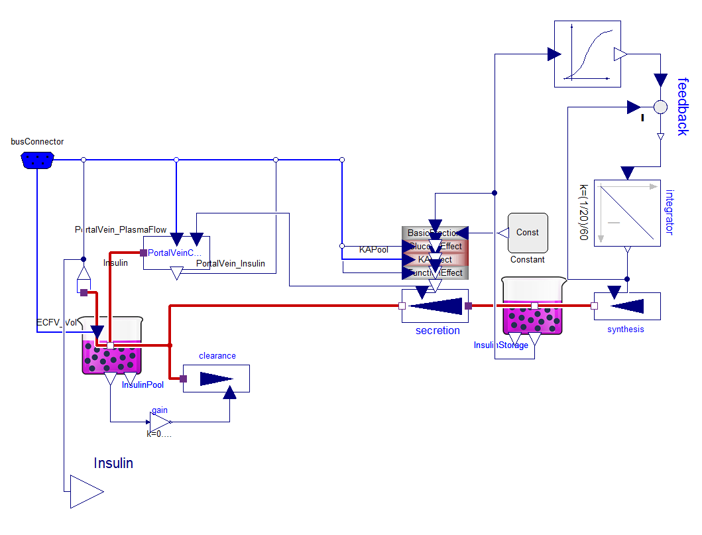

### Glucagon

Model of

### Leptin

Model of

### Thyroid hormones

The main purpose of thyroid hormones in our model is to maintain long-term thermoregulation [77]. The concentrations, secretions and clearance of thyroid hormones are well known because of relative easy measurement of iodine radioactive isotopes [78-81]. During cold months increasing of triiodothyronine (T3) [82] increase the basal metabolism [83] what improve the heat regulation in cold conditions. The impulse for the production and secretion of T3 and thyroxine (T4) is thyrothropin (TSH) [84]. And the secretion of TSH is driven by thermoreceptors and it is directly suppressed by T3 [82, 85-87]. The clearance of TSH is much quicker than clearance of T3 or T4  [88], as a result its concentration can be directly estimated from the secretion as implemented in FigX.

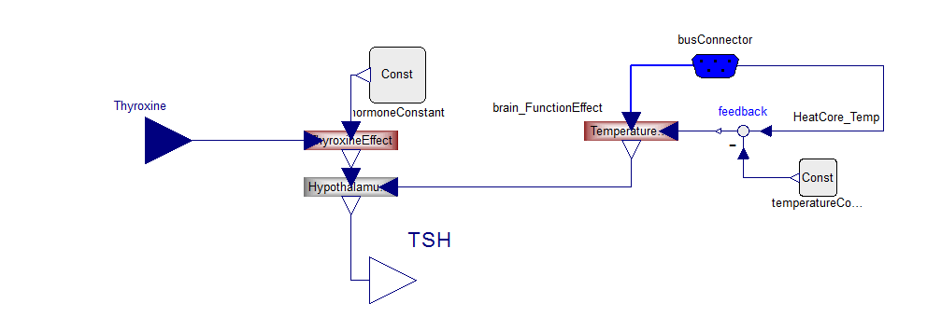

## Electrolytes and Acid-Base

### Acid-base

The blood acid-base balance calculation is based on electroneutrality. In plasma is calculated summary charge concentration for strong ions, which do not significantly change their charge at pH from 5 to 9. This is called strong ion difference (SID). From acid-base buffers (weak ions) is also calculated the summary charge concentration at normal conditions (prefix N) called normal strong ion difference (NSID), where the normal conditions defined as plasma pH=7.4, full oxygen saturation, CO2 partial pressure of 40mmHg and temperature of 37°C. Both SID and NSID can be calculated in plasma (suffix P) and inside erythrocytes (suffix E). The titration of one liter of blood to reach the normal conditions will use the amount of strong acid equal to Hct\*(SIDE-NSIDE)+(1-Hct)\*(SIDP-NSIDP). This measurable amount of titrant can be called also base excess of oxygenated blood (BEox) or as negative titratable hydrogen ions of oxygenated blood (-cTHox) used by Siggaard with Van-Slyke equation.

Using charges of strong electrolytes on SID side and charges of weak ions on NSID side of electroneutrality equation joins the acid-base submodel equilibrium with all charged substances.

The typical SIDP and NSIDP is 40 meq/l and typical SIDE and NSIDE is 30 meq/l. The typical SIDP is composed with Na (145), K(4), Cl (104), SO2(2mmol/l), Lactate(1) and the typical NSIDP is composed with bicarbonate (24.5), albumin(12.5meq/l), phosphates() and globilins(). In erythrocytes the SIDE is composed with K(102), Na(7.5), Mg(2mmol/l), Cl(68), SO2(1) and lactate (). The NSIDE is composed with bicarbonate(15), hemoglobin (21mmol/l), 2,3-DPG(5mmol/l), ATP(1.3mmol/l), ADP(0.2mmol/l), phosphates(). Other electrolytes and buffers are neglected because of their small concentration and/or small charge.

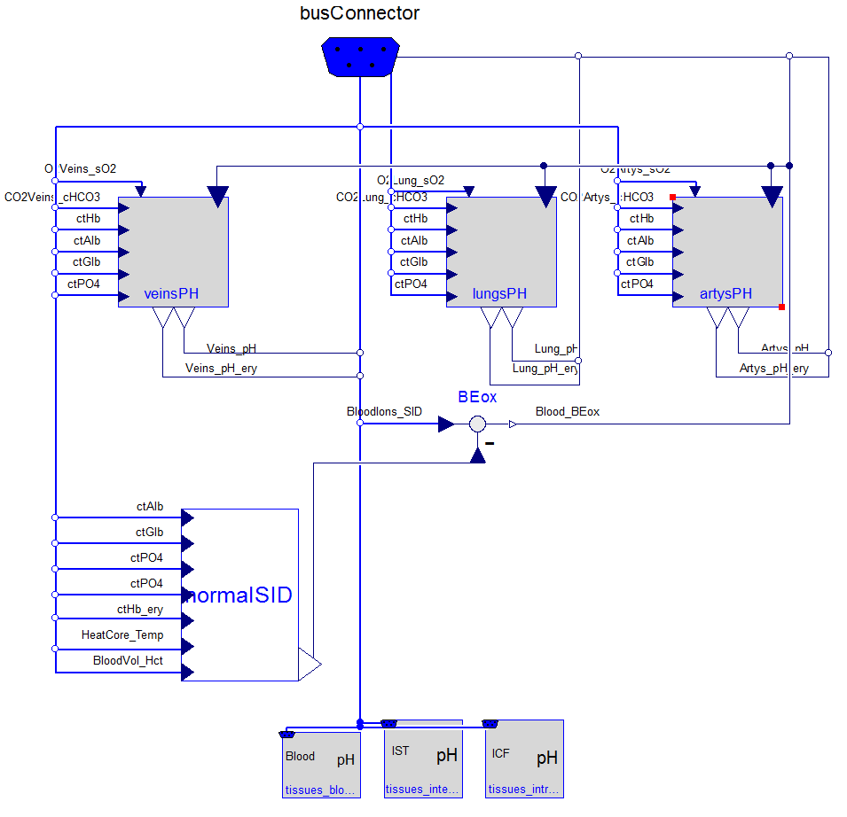

NormalSID is calculated from plasma and erythrocytes weak ions…

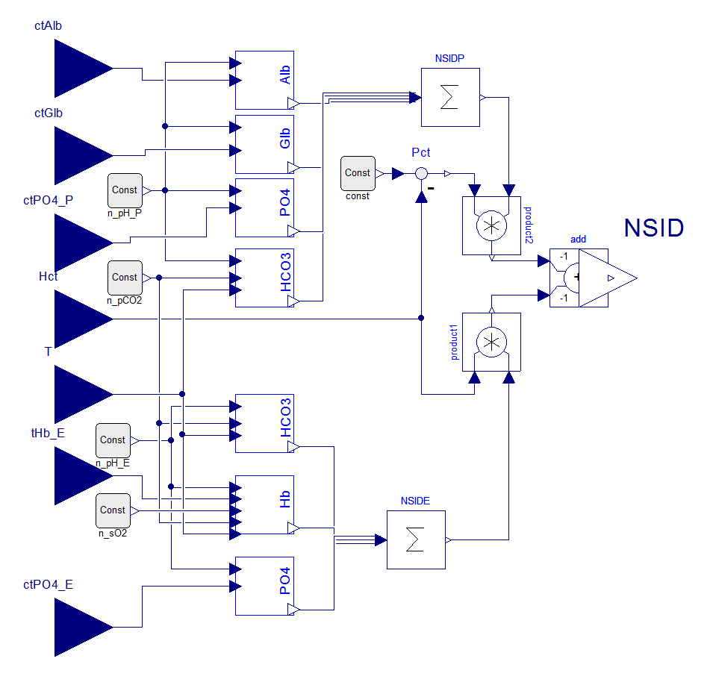

Intracellular pH is calculated only from intracellular potassium(151 mmol/L), bicarbonate(17-23 mmol/L), buffers(22-28 mmol/L) and lactate(1 mmol/L). Other cations (12 mmol/L) and anions (117 mmol/L) are assumed as constant. From electroneutrality can be calculated the current amount of bicarbonate as non-bicarbonate ions difference. And because the carbon dioxide partial pressure is also known, the acidity can be expressed from Hendersom-Hasselbalch EqX.

pH=7.2, pCO2 = 45mmHg – 60 mmHg:

HCO3=0.23\*(45\*101.325/760)\*10^(7.2-6.1)=0.386\*pCO2=17

HCO3=0.23\*(60\*101.325/760)\*10^(7.2-6.1)=23

## Gases

To support metabolism of each cell there must be delivered oxygen. And carbon dioxide must be transported out of the body. Both called blood gases transport are critical for life. It starts by lungs ventilation to reach optimal alveolar partial pressures of oxygen and carbon dioxide. These pressures play roles in gases dissolving in blood, but here is the total amount of transported gases dependent also on blood flow, binding properties of hemoglobin, temperature and hydrogen ion activity. In tissue microcirculation is blood delivered so close to cells that no other active delivery is needed and only diffusion take place here.

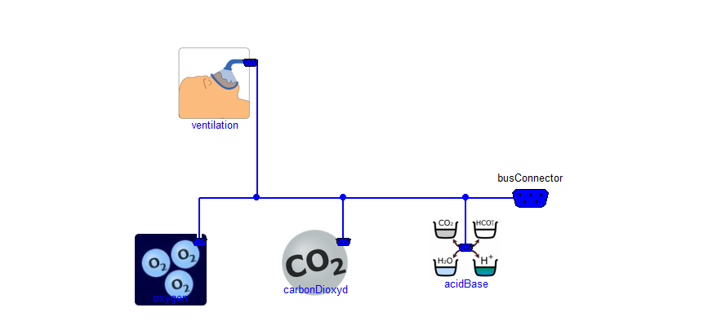

The submodels of gases transport are: ventilation, where is calculated the air flow, water vapor dilution, temperatures and pressures effect; oxygen transport; carbon dioxide transport; and acid-base as hydrogen ion activity calculations.

### Ventilation

Natural ventilation depends on many factors and are driven by neural reflexes. Their sensors are central chemoreceptors, which answer to change of intracellular pH; peripheral chemoreceptors located in arterial sinus and aorta detecting changes of arterial blood pH and pO2 and receptors of skeletal muscle metaboreflex. Whole afferent path of respiratory reflexes are in the model summarized into one normalized value called TotalDrive, from which is in efferent part calculated the respiratory rate (typical 11 per minute) and normalized respiratory center motoric nerve activity.

From the lungs properties are then calculated current tidal volume (450 ml at body conditions - temperature of 37°C and 100% humidity) and current dead space volume (150ml at body conditions). Because the temperature and humidity in lungs differs from surrounding air environment, the alveolar ventilation is recalculated to the inspired air conditions in submodel called alveolarVentilation.

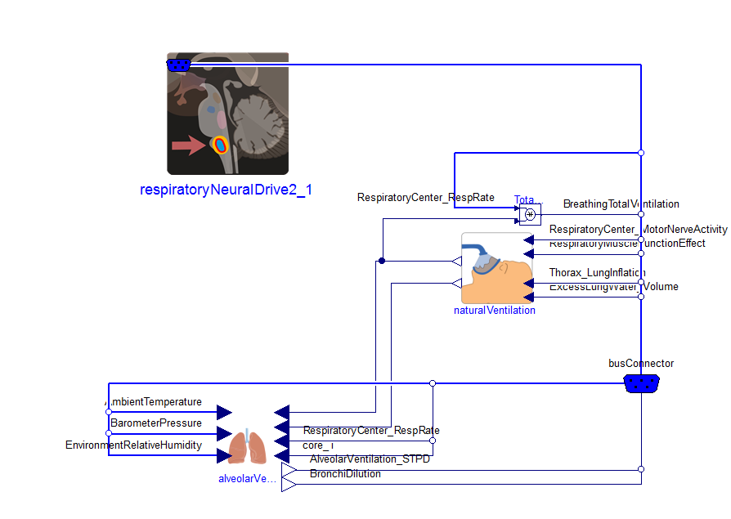

### Oxygen

Content of air oxygen in earth atmosphere is typically 21% with atmospheric pressure 101325 Pa, which give its partial pressure in air around 21 kPa. But the amount of oxygen molecules are still dependent on temperature driven by gas equation Eq1, where P is partial pressure, R is gas constant and T is temperature in Kelvins. For example in 0 degC (273.15 K) dry air is molar concentration of oxygen 9.2 mmol/l, while in 40 degC dry air is oxygen molar concentration only 8.1 mmol/l at the same oxygen partial pressure of 21 kPa.

In respiratory paths are air heated to body temperature and diluted by water. Volume of inspired air is changed, which is reflected in variable AlveolarVentilation recalculated to inspired air conditions. Once the air is transported to the alveolus, the exchange take place. Oxygen dissolve in blood plasma and chemically bound the hemoglobin molecules inside red cells. Dissolving of oxygen in water is driven by Henry’s law, where also take place the body temperature.

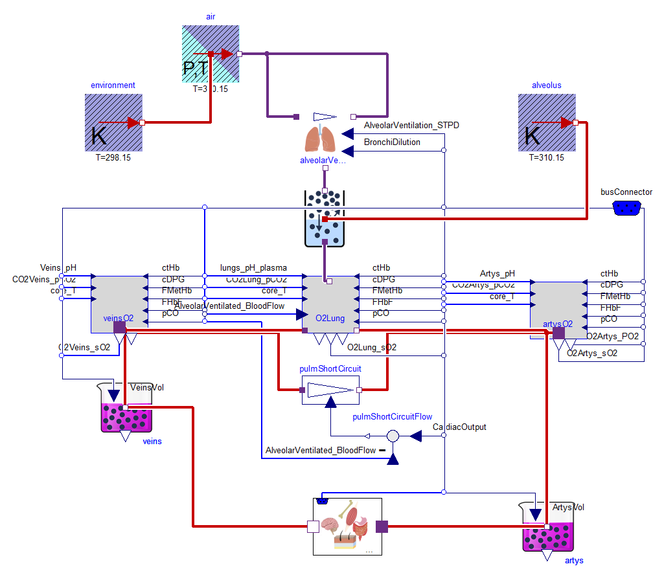

### Carbon dioxide

Production 200ml/min (STP) [89] = 8.8 mmol/min.

|  |  |  |  |  |
| --- | --- | --- | --- | --- |
|  | Arterial plasma | Arterial RBC | Venous plasma | Venous RBC |
| Dissolved CO2 | 1.2 mmol/l | 1.2 mmol/l | 1.4 mmol/l | 1.4 mmol/l |
| HCO3 | 24.4 mmol/l | 13.1 mmol/l | 26.3 mmol/l | 13.2 mmol/l |
| Carbamino | Neligible | 2.4 mmol/l | Neligible | 3.8 mmol/l |
| Total | 25.6 mmol/l | 16.7 mmol/l | 27.6 mmol/l | 18.4 mmol/l |

pCO2=40mmHg,pH=7.4,HCO3=24.5 mmol/l, aCO2= 0.231 (mmol/l)/kPa, pK=6.1 at 37degC

## Nutrients and Metabolism

Energy for human body is taken from food. The food is simplified to carbohydrates, proteins and fat. After eating are nutrients absorbed to body extracellular fluid. Nutrients can be also synthetized mostly by liver as gluconeogenesis, ketogenesis or lipogenesis .

exercise[90, 91]

lactate and pyruvate (hypoxia)[92, 93]

protein[94]

### Cellular metabolism

Kidney excretion

### Keto-acids

Kidney excretion

Brain metabolism[95]

## Thermoregulation

## Neural Reflexes

# Discussion

# Conclusion

# References

1. Carter, Y.M., et al., *Diastolic properties, myocardial water content, and histologic condition of the rat left ventricle: effect of varied osmolarity of a coronary perfusate.* The Journal of heart and lung transplantation : the official publication of the International Society for Heart Transplantation, 1998. **17**(2): p. 140-149.

2. Gaasch, W.H., et al., *Dynamic determinants of letf ventricular diastolic pressure-volume relations in man.* Circulation, 1975. **51**(2): p. 317-323.

3. NODA, T., et al., *Curvilinearity of LV end-systolic pressure-volume and dP/dt,-end-diastolic volume relations.* 1993.

4. SUGA, H., K. SAGAWA, and D.P. KOSTIUK, *Controls of ventricular contractility assessed by pressure-volume ratio, Emax.* Cardiovascular Research, 1976. **10**(5): p. 582-592.

5. Xenopoulos, N.P. and R.J. Applegate, *The effect of vagal stimulation on left ventricular systolic and diastolic performance.* American Journal of Physiology-Heart and Circulatory Physiology, 1994. **35**(6): p. H2167.

6. Collins-Nakai, R.L., D. Noseworthy, and G.D. Lopaschuk, *Epinephrine increases ATP production in hearts by preferentially increasing glucose metabolism.* Am J Physiol, 1994. **267**(5 Pt 2): p. H1862-71.

7. Kumagai, K. and I.A. Reid, *Angiotensin II exerts differential actions on renal nerve activity and heart rate.* Hypertension, 1994. **24**(4): p. 451-456.

8. Sagawa, K., et al., *Cardiac contraction and the pressure-volume relationship*. Vol. 480. 1988: Oxford University Press New York.

9. Guyton, A.C. and K. Sagawa, *Compensations of cardiac output and other circulatory functions in areflex dogs with large AV fistulas.* The American journal of physiology, 1961. **200**: p. 1157.

10. SUGA, H. and K. SAGAWA, *Instantaneous Pressure-Volume Relationships and Their Ratio in the Excised, Supported Canine Left Ventricle.* Circulation Research, 1974. **35**(1): p. 117-126.

11. Little, W.C. and C.P. Cheng, *Effect of exercise on left ventricular-arterial coupling assessed in the pressure-volume plane.* AMERICAN JOURNAL OF PHYSIOLOGY, 1993. **264**: p. H1629-H1629.

12. Bazett, H.C., *AN ANALYSIS OF THE TIME-RELATIONS OF ELECTROCARDIOGRAMS.* Annals of Noninvasive Electrocardiology, 1997. **2**(2): p. 177-194.

13. Raeder, E.A., et al., *Kinetics of Cycle Length Dependence of Ventricular Repolarization.* Journal of Cardiovascular Electrophysiology, 1995. **6**(3): p. 163-169.

14. Bootsma, M., et al., *Heart rate and heart rate variability as indexes of sympathovagal balance.* American Journal of Physiology, 1994. **266**: p. H1565-H1565.

15. Warner, H.R. and A. Cox, *A mathematical model of heart rate control by sympathetic and vagus efferent information*. Vol. 17. 1962. 349-355.

16. Ferguson, D.W., F.M. Abboud, and A.L. Mark, *Relative contribution of aortic and carotid baroreflexes to heart rate control in man during steady state and dynamic increases in arterial pressure.* The Journal of Clinical Investigation, 1985. **76**(6): p. 2265-2274.

17. Takeshita, A., et al., *Effect of central venous pressure on arterial baroreflex control of heart rate*. Vol. 236. 1979. H42-H47.

18. ROSS, J., J.W. LINHART, and E. BRAUNWALD, *Effects of Changing Heart Rate in Man by Electrical Stimulation of the Right Atrium: Studies at Rest, during Exercise, and with Isoproterenol.* Circulation, 1965. **32**(4): p. 549-558.

19. Sugimoto, T., K. Sagawa, and A. Guyton, *Effect of tachycardia on cardiac output during normal and increased venous return*. Vol. 211. 1966. 288-292.

20. Whittaker, S.R.F. and F.R. Winton, *The apparent viscosity of blood flowing in the isolated hindlimb of the dog, and its variation with corpuscular concentration.* The Journal of Physiology, 1933. **78**(4): p. 339-369.

21. Begg, T. and J. Hearns, *Components in blood viscosity. The relative contribution of haematocrit, plasma fibrinogen and other proteins.* Clinical science, 1966. **31**(1): p. 87-93.

22. Schrier, R.W., et al., *Influence of hematocrit and colloid on whole blood viscosity during volume expansion.* Am. J. Physiol, 1970. **218**(346): p. 77.

23. Stone, H., Thompson HK, and K. Schmidt-Nielsen, *Influence of erythrocytes on blood viscosity*. Vol. 214. 1968. 913-918.

24. Fan, F.C., et al., *Effects of hematocrit variations on regional hemodynamics and oxygen transport in the dog*. Vol. 238. 1980. H545-H522.

25. Jan, K.M. and S. Chien, *Effect of hematocrit variations on coronary hemodynamics and oxygen utilization*. Vol. 233. 1977. H106-H113.

26. Mellander, S. and J. Bjornberg, *Regulation of Vascular Smooth Muscle Tone and Capillary Pressure*. Vol. 7. 1992. 113-119.

27. Shigemi, K., M.J. Brunner, and A.A. Shoukas, *-and -Adrenergic mechanisms in the control of vascular capacitance by the carotid sinus baroreflex system.* AMERICAN JOURNAL OF PHYSIOLOGY, 1994. **267**: p. H201-H201.

28. Archer, S. and E. Michelakis, *The Mechanism(s) of Hypoxic Pulmonary Vasoconstriction: Potassium Channels, Redox O2 Sensors, and Controversies*. Vol. 17. 2002. 131-137.

29. Manning, R.D., *Renal hemodynamic, fluid volume, and arterial pressure changes during hyperproteinemia*. Vol. 252. 1987. F403-F411.

30. Manning, R.D., *Effects of hypoproteinemia on blood volume and arterial pressure of volume-loaded dogs*. Vol. 259. 1990. H1317-H1324.

31. Aukland, K., *Myogenic mechanisms in the kidney.* Journal of hypertension. Supplement: official journal of the International Society of Hypertension, 1989. **7**(4): p. S71-6; discussion S77.

32. Drummond, H.A., S.C. Grifoni, and N.L. Jernigan, *A new trick for an old dogma: ENaC proteins as mechanotransducers in vascular smooth muscle.* Physiology, 2008. **23**(1): p. 23-31.

33. Skarlatos, S., et al., *Spontaneous pressure-flow relationships in renal circulation of conscious dogs.* Am J Physiol, 1993. **264**(5 Pt 2): p. H1517-27.

34. Heyeraas, K.J. and K. Aukland, *Interlobular arterial resistance: Influence of renal arterial pressure and angiotensin II.* Kidney Int, 1987. **31**(6): p. 1291-1298.

35. Moore, L.C. and D. Casellas, *Tubuloglomerular feedback dependence of autoregulation in rat juxtamedullary afferent arterioles.* Kidney Int, 1990. **37**(6): p. 1402-1408.

36. Ito, S. and O.A. Carretero, *An in vitro approach to the study of macula densa-mediated glomerular hemodynamics.* Kidney Int, 1990. **38**(6): p. 1206-10.

37. Bradley, S.E., et al., *The circulating splanchnic blood volume in dog and man.* Trans Assoc Am Physicians, 1953. **66**: p. 294-302.

38. BRADLEY, S.E., F.J. INGELFINGER, and G.P. BRADLEY, *Hepatic Circulation in Cirrhosis of the Liver.* Circulation, 1952. **5**(3): p. 419-429.

39. Greenway, C. and G. Oshiro, *Effects of histamine on hepatic volume (outflow block) in anaesthetized dogs.* British journal of pharmacology, 1973. **47**(2): p. 282-290.

40. Greenway, C.V., K.L. Seaman, and I.R. Innes, *Norepinephrine on venous compliance and unstressed volume in cat liver*. Vol. 248. 1985. H468-H476.

41. Lautt, W.W., C.V. Greenway, and D.J. Legare, *Effect of hepatic nerves, norepinephrine, angiotensin, and elevated central venous pressure on postsinusoidal resistance sites and intrahepatic pressures in cats.* Microvascular Research, 1987. **33**(1): p. 50-61.

42. Greenway, C.V. and G.E. Lister, *Capacitance effects and blood reservoir function in the splanchnic vascular bed during non-hypotensive haemorrhage and blood volume expansion in anaesthetized cats.* The Journal of Physiology, 1974. **237**(2): p. 279-294.

43. Maass-Moreno, R. and C.F. Rothe, *Contribution of the large hepatic veins to postsinusoidal vascular resistance.* Am J Physiol Gastrointest Liver Physiol, 1992. **262**: p. G14-G22.

44. Xie, S., et al., *A model of human microvascular exchange.* Microvascular research, 1995. **49**(2): p. 141-162.

45. Engeset, A., et al., *Studies on human peripheral lymph. I. Sampling method.* Lymphology, 1973. **6**(1): p. 1-5.

46. Eisenhoffer, J., S. Lee, and M. Johnston, *Pressure-flow relationships in isolated sheep prenodal lymphatic vessels.* American Journal of Physiology-Heart and Circulatory Physiology, 1994. **36**(3): p. H938.

47. Henriksen, J.H., *Estimation of lymphatic conductance: A model based on protein-kinetic studies and haemodynamic measurements in patients with cirrhosis of the liver and in pigs.* Scandinavian journal of clinical & laboratory investigation, 1985. **45**(2): p. 123-130.

48. Guyton, A.C., *Interstitial fluid pressure: II. Pressure-volume curves of interstitial space.* Circulation research, 1965. **16**(5): p. 452-460.

49. Gottschalk, C.W. and M. Mylle, *Micropuncture study of the mammalian urinary concentrating mechanism: evidence for the countercurrent hypothesis.* American Journal of Physiology--Legacy Content, 1959. **196**(4): p. 927-936.

50. Nielsen, S., et al., *Key roles of renal aquaporins in water balance and water-balance disorders.* Physiology, 2000. **15**(3): p. 136-143.

51. Atherton, J., R. Green, and S. Thomas, *Influence of lysine-vasopressin dosage on the time course of changes in renal tissue and urinary composition in the conscious rat.* The Journal of physiology, 1971. **213**(2): p. 291-309.

52. Khokhar, A., et al., *Effect of vasopressin on plasma volume and renin release in man.* Clinical Science, 1976. **50**(Pt 5): p. 415-424.

53. Jamison, R.L., et al., *A micropuncture study of collecting tubule function in rats with hereditary diabetes insipidus.* Journal of Clinical Investigation, 1971. **50**(11): p. 2444.

54. Jamison, R. and F.B. Lacy, *Evidence for urinary dilution by the collecting tubule.* Am. J. Physiol, 1972. **223**: p. 898-902.

55. Glickson, J.D. and C. Pissiotis, *Vasopressin: Chemical and clinical aspects*. Vol. 1. 1974: Ardent Media.

56. Thrasher, T.N., H.-G. Chen, and L.C. Keil, *Arterial baroreceptors control plasma vasopressin responses to graded hypotension in conscious dogs.* American Journal of Physiology-Regulatory, Integrative and Comparative Physiology, 2000. **278**(2): p. R469-R475.

57. Share, L., *Control of vasopressin release: an old but continuing story.* News in physiological sciences, 1996. **11**: p. 7-12.

58. Raff, H., *Glucocorticoid inhibition of neurohypophysial vasopressin secretion.* American Journal of Physiology-Regulatory, Integrative and Comparative Physiology, 1987. **252**(4): p. R635-R644.

59. SEALEY, J.E., S.A. ATLAS, and J.H. LARAGH, *Prorenin and Other Large Molecular Weight Forms of Renin\*.* Endocrine Reviews, 1980. **1**(4): p. 365-391.

60. Simon, D., et al., *Two-site direct immunoassay specific for active renin.* Clinical chemistry, 1992. **38**(10): p. 1959-1962.

61. Guyene, T., et al., *Direct radioimmunoassay of human renin: comparison with renin activity in plasma and amniotic fluid.* Hypertension, 1980. **2**(4): p. 465-470.

62. Guyton, J.R., et al., *A Model of Glucose-insulin Homeostasis in Man that Incorporates the Heterogeneous Fast Pool Theory of Pancreatic Insulin Release.* Diabetes, 1978. **27**(10): p. 1027-1042.

63. Imai, J., et al., *Regulation of Pancreatic β Cell Mass by Neuronal Signals from the Liver.* Science, 2008. **322**(5905): p. 1250-1254.

64. Rutter, G.A. and E.V. Hill, *Insulin Vesicle Release: Walk, Kiss, Pause … Then Run*. Vol. 21. 2006. 189-196.

65. Blackard, W.G. and N.C. Nelson, *Portal and Peripheral Vein Immunoreactive Insulin Concentrations Before and After Glucose Infusion.* Diabetes, 1970. **19**(5): p. 302-306.

66. Dobson, H.L., et al., *Absorption of 131-I labeled modified insulin.* Metabolism, 1967. **16**(8): p. 723-732.

67. DOEDEN, B. and R. RIZZA, *Use of a Variable Insulin Infusion to Assess Insulin Action in Obesity: Defects in Both the Kinetics and Amplitude of Response.* The Journal of Clinical Endocrinology & Metabolism, 1987. **64**(5): p. 902-908.

68. GINSBERG, S., et al., *Serum Insulin Levels Following Administration of Exogenous Insulin.* The Journal of Clinical Endocrinology & Metabolism, 1973. **36**(6): p. 1175-1179.

69. Miles, P.D., et al., *Kinetics of insulin action in vivo: identification of rate-limiting steps.* Diabetes, 1995. **44**(8): p. 947-953.

70. Prager, R., P. Wallace, and J.M. Olefsky, *In vivo kinetics of insulin action on peripheral glucose disposal and hepatic glucose output in normal and obese subjects.* The Journal of Clinical Investigation, 1986. **78**(2): p. 472-481.

71. Iwanishi, M., M.P. Czech, and A.D. Cherniack, *The Protein-tyrosine Kinase Fer Associates with Signaling Complexes Containing Insulin Receptor Substrate-1 and Phosphatidylinositol 3-Kinase.* Journal of Biological Chemistry, 2000. **275**(50): p. 38995-39000.

72. Previs, S.F., et al., *Contrasting effects of IRS-1 versus IRS-2 gene disruption on carbohydrate and lipid metabolism in vivo.* J Biol Chem, 2000. **275**(50): p. 38990-4.

73. Rother, K.I., et al., *Evidence That IRS-2 Phosphorylation Is Required for Insulin Action in Hepatocytes.* Journal of Biological Chemistry, 1998. **273**(28): p. 17491-17497.

74. George, S., et al., *A family with severe insulin resistance and diabetes due to a mutation in AKT2.* Science, 2004. **304**(5675): p. 1325-1328.

75. Prager, R., P. Wallace, and J.M. Olefsky, *Hyperinsulinemia Does Not Compensate for Peripheral Insulin Resistance in Obesity.* Diabetes, 1987. **36**(3): p. 327-334.

76. Summers, R.L., et al., *Theoretical analysis of the mechanisms of chronic hyperinsulinemia.* Computers in Biology and Medicine, 1997. **27**(3): p. 249-256.

77. Edelman, I.S., *Thyroid Thermogenesis.* New England Journal of Medicine, 1974. **290**(23): p. 1303-1308.

78. Chopra, I.J., *An assessment of daily production and significance of thyroidal secretion of 3, 3', 5'-triiodothyronine (reverse T3) in man.* The Journal of Clinical Investigation, 1976. **58**(1): p. 32-40.

79. Larsen, P.R., *Direct immunoassay of triiodothyronine in human serum.* The Journal of Clinical Investigation, 1972. **51**(8): p. 1939-1949.

80. Nicoloff, J.T., et al., *Simultaneous Measurement of Thyroxine and Triiodothyronine Peripheral Turnover Kinetics in Man.* The Journal of Clinical Investigation, 1972. **51**(3): p. 473-483.

81. HAYS, M.T., *Colonic excretion of iodide in normal human subjects.* Thyroid, 1993. **3**(1): p. 31-35.

82. Hesslink, R.L., et al., *Human cold air habituation is independent of thyroxine and thyrotropin*. Vol. 72. 1992. 2134-2139.

83. Osiba, S., *THE SEASONAL VARIATION OF BASAL METABOLISM AND ACTIVITY OF THYROID GLAND IN MAN.* The Japanese Journal of Physiology, 1957. **7**: p. 355-365.

84. Jackson, I.M.D., *Thyrotropin-Releasing Hormone.* New England Journal of Medicine, 1982. **306**(3): p. 145-155.

85. Gross, J. and R. Pitt-Rivers, *3: 5: 3′-Triiodothyronine. 2. Physiological activity.* Biochemical Journal, 1953. **53**(4): p. 652.

86. SURKS, M.I. and J.H. OPPENHEIMER, *Incomplete Suppression of Thyrotropin Secretion after Single Injection of Large L-Triiodothyronine Doses into Hypothyroid Rats.* Endocrinology, 1976. **99**(6): p. 1432-1441.

87. SURKS, M.I. and B.M. LIFSCHITZ, *Biphasic Thyrotropin Suppression in Euthyroid and Hypothyroid Rats.* Endocrinology, 1977. **101**(3): p. 769-775.

88. Ridgway, E.C., B.D. Weintraub, and F. Maloof, *Metabolic Clearance and Production Rates of Human Thyrotropin.* The Journal of Clinical Investigation, 1974. **53**(3): p. 895-903.

89. Arthurs, G. and M. Sudhakar, *Carbon dioxide transport.* Continuing Education in Anaesthesia, Critical Care & Pain, 2005. **5**(6): p. 207-210.

90. Carlson, L., L. Ekelund, and S. Fröberg, *Concentration of triglycerides, phospholipids and glycogen in skeletal muscle and of free fatty acids and beta-hydroxybutyric acid in blood in man in response to exercise.* European journal of clinical investigation, 1971. **1**(4): p. 248-254.

91. Wahren, J., *Human forearm muscle metabolism during exercise. IV. Glucose uptake at different work intensities.* Scandinavian Journal of Clinical and Laboratory Investigation, 1970. **25**(2): p. 129-135.

92. Siesjö, B.K. and L. Nilsson, *The Influence of Arterial Hypoxemia upon Labile Phosphates and upon Extracellular and Intracellular Lactate and Pyruvate Concentrations in the Rat Brain.* Scandinavian Journal of Clinical & Laboratory Investigation, 1971. **27**(1): p. 83-96.

93. Bachelard, H.S., et al., *MECHANISMS ACTIVATING GLYCOLYSIS IN THE BRAIN IN ARTERIAL HYPOXIA.* Journal of Neurochemistry, 1974. **22**(3): p. 395-401.

94. Hannaford, M.C., et al., *Protein wasting due to acidosis of prolonged fasting*. Vol. 243. 1982. E251-E256.

95. Owen, O.E., et al., *Brain Metabolism during Fasting\*.* The Journal of Clinical Investigation, 1967. **46**(10): p. 1589-1595.